Frequent Mental Distress Prediction Using Air Pollution
SIADS 696 Final Project Report | Team 7
Jaeah Kim, Kyle Rodriguez, Sophia Boettcher

Introduction
This project asks whether county-level environmental and socioeconomic profiles can predict future mental health need. The outcome is CDC PLACES frequent mental distress (FMD), the share of adults reporting poor mental health for 14 or more days in the past month. The practical motivation is resource planning: if environmental and social indicators can help identify future mental-health burden, counties and public-health agencies could better target outreach, prevention, and behavioral-health capacity.
We used both supervised and unsupervised learning. The supervised task predicts next-year FMD from current-year county features using Dummy, ElasticNet, Random Forest, and Gradient Boosting regressors. The unsupervised task compares density-based DBSCAN clustering with centroid-based K-Means clustering to identify socio-environmental county profiles. Compared with related studies that focus primarily on individual cohorts or single exposure families, our contribution is an enriched county-year panel and a leakage-safe predictive/exploratory pipeline combining pollution, climate, ACS socioeconomic variables, industry composition, and health-access proxies.
The main supervised finding is cautious: the best model was Random Forest tuned with holdout RMSE 1.98, compared with the Dummy baseline RMSE 2.43. The improvement suggests weak signal, but the holdout R² remains near zero, so the model is not ready for policy forecasting. The main unsupervised finding is that both DBSCAN and K-Means separate a small set of structurally unusual counties from a dominant majority group; cluster-level FMD differences are exploratory rather than causal.

Related Work
Table 1. Related studies and how this project differs
Study / resource | 1-2 sentence summary | Difference from this project
Park et al., PM2.5/PM10 and depression risk in KLoSA | This study found that prolonged exposure to particulate matter was associated with elevated depression risk among middle-aged and older adults in South Korea. | It is individual/cohort-based and non-U.S.; our project is county-level, U.S.-wide, and predictive/exploratory rather than causal.
Lei et al., neighborhood environment and mental health in China | This work links perceived pollution, neighborhood conditions, and socioeconomic status to mental health outcomes. | Our project uses measured county-level AQI/climate variables and ML clustering rather than perception-based neighborhood measures.
Werder et al., Gulf Long-Term Follow-up Study | This U.S.-based study examines environmental exposures such as PM2.5 and greenspace in relation to depression in the Southeastern U.S. | Our project expands geographically across U.S. counties and adds supervised next-year prediction plus unsupervised county profiling.

Data Sources
The final enriched panel contains 14,748 county-year rows from 2019-2023. Data were merged by five-digit county GEOID. The supervised target uses year t features to predict year t+1 FMD, and the unsupervised analysis uses the latest available year for cross-sectional county profiling.
Table 2. Data sources, formats, variables, and coverage
Source | Location / format | Important variables | Coverage
CDC PLACES | data.cdc.gov CSV | FMD prevalence, lower/upper CI | County-level annual health estimates
EPA AirData annual | EPA CSV | Days with AQI, Max AQI, Median AQI, pollutant-day variables | Annual AQI summaries by county
EPA daily AQI | EPA ZIP/CSV | Daily AQI mean/std/p90/max, threshold days above 100/150/200 | Daily monitor counties; sparse coverage
ACS 5-year bulk tables | Census pipe-delimited .dat | Income, poverty, unemployment, education, insurance, industry composition | County socioeconomic controls
NOAA Climate at a Glance | JSON | Annual temperature, precipitation, anomalies | County climate profiles
Census boundaries | Shapefile ZIP | County geometries | Mapping and spatial visualization

Feature Engineering
- Merged CDC PLACES, EPA, ACS, NOAA, and Census geography by county GEOID.
- Engineered next-year FMD by shifting mental_health_prevalence forward within each county.
- Excluded FMD and FMD confidence intervals from unsupervised clustering; FMD is reintroduced only as a held-out outcome.
- Median-imputed sparse EPA daily AQI features in modeling pipelines.
- Cleaned sentinel missing values in income-like fields before the rubric-completion rerun.
- Standardized numeric features for ElasticNet and unsupervised clustering.
Table 3. Feature families and leakage controls
Feature family | Examples | Modeling role
Identifiers | geoid, county_name, state_name, year, geometry | Merge keys, splits, mapping only; not predictors
FMD outcome | mental_health_prevalence, lower_ci, upper_ci, next_year_fmd | Target/held-out outcome; excluded from clustering
Annual AQI | Max AQI, Median AQI, AQI category days, pollutant days | Supervised and unsupervised predictors from current year
Daily AQI | daily_aqi_std, daily_aqi_p90, daily_aqi_days_over_100 | Extreme-event and variability predictors
ACS socioeconomic | median_income, poverty_count, unemployed_count, population | Controls for community vulnerability
Education/health/industry | pct_uninsured, pct_bachelors_or_higher, pct_manufacturing | Infrastructure and industrial-trait predictors
Climate | annual_avg_temp_f, annual_precip_inches, anomalies | Environmental context beyond pollution

Part A. Supervised Learning

Methods
The supervised task is regression. We used a Dummy Regressor as a baseline, ElasticNet as a regularized linear model, Random Forest as a bagged tree ensemble, and Gradient Boosting as a sequential tree ensemble. These model families differ in assumptions and mechanisms: the Dummy model sets a minimum benchmark, ElasticNet tests linear signal under multicollinearity, Random Forest captures nonlinear interactions with lower tuning burden, and Gradient Boosting captures additive nonlinear structure.
Hyperparameter exploration used grouped cross-validation by feature year on the training period. The final holdout used 2022 features to predict 2023 FMD. Metrics are RMSE and MAE for error magnitude, plus R² for explained variance relative to a mean baseline.
Table 4. Supervised model comparison with cross-validation mean and standard deviation
Model | Holdout RMSE | Holdout MAE | Holdout R² | CV RMSE mean | CV RMSE SD
Random Forest tuned | 1.98 | 1.65 | -0.02 | 2.02 | 0.63
Gradient Boosting tuned | 2.30 | 1.91 | -0.37 | 2.16 | 0.49
ElasticNet tuned | 2.31 | 1.97 | -0.38 | 2.32 | 0.59
Dummy mean baseline | 2.43 | 1.95 | -0.54 | 2.73 | 0.46

Feature Importance and Ablation
For the best model, Random Forest, impurity-based feature importance ranked education and climate variables highly. A grouped ablation analysis retrained the model after removing each feature family. Removing education/health-access features increased holdout RMSE the most, suggesting that these variables contributed more consistently than annual or daily AQI features in the current panel.
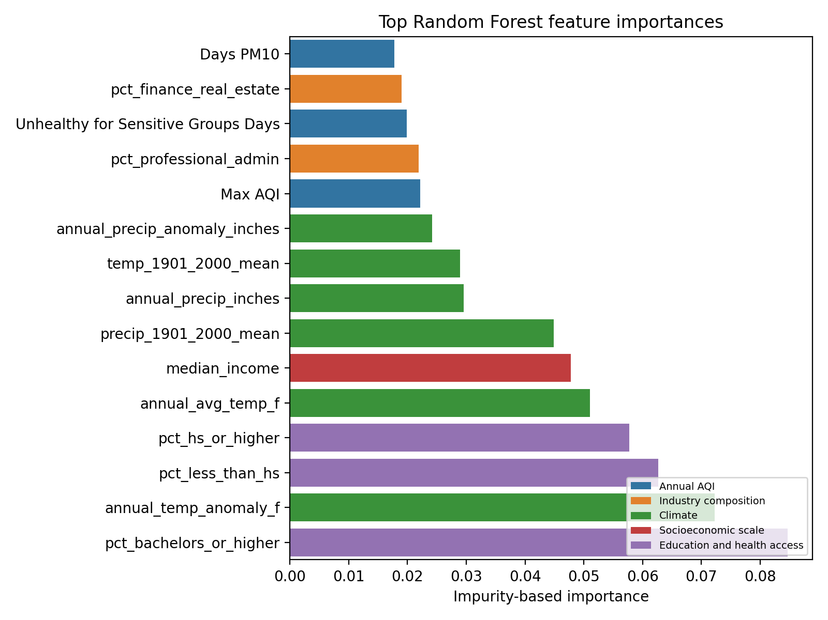
Figure 1. Top Random Forest feature importances.
Table 5. Random Forest grouped ablation
Removed feature family | Features removed | Holdout RMSE | RMSE delta
Education and health access | 5 | 2.06 | 0.08
Industry composition | 13 | 2.01 | 0.03
Annual AQI | 15 | 1.99 | 0.01
None (full model) | 0 | 1.98 | 0.00
Daily AQI exposure | 25 | 1.98 | -0.00
Socioeconomic scale | 9 | 1.94 | -0.04
Climate | 6 | 1.94 | -0.04

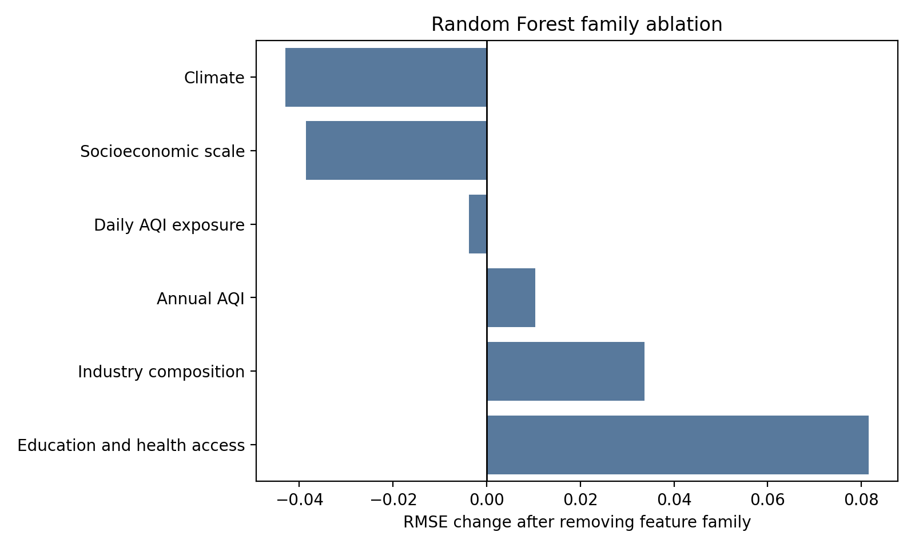
Figure 2. Family ablation for the Random Forest model.

Sensitivity, Tradeoffs, and Failure Analysis
Sensitivity analysis varied Random Forest minimum leaf size and max-feature sampling. The best setting used small leaves and sqrt feature sampling, while larger leaves generally reduced variance but worsened holdout RMSE. The tradeoff is interpretability and stability versus nonlinear flexibility: Random Forest performed best, but at the cost of reduced transparency relative to ElasticNet.
Table 6. Random Forest sensitivity analysis, top settings
min_samples_leaf | max_features | Holdout RMSE | Holdout R²
1 | sqrt | 1.98 | -0.02
3 | sqrt | 2.00 | -0.04
8 | sqrt | 2.02 | -0.06
15 | sqrt | 2.05 | -0.09
1 | 0.7 | 2.06 | -0.10
1 | 0.5 | 2.06 | -0.10

Failure analysis focused on the largest absolute residuals. The model mainly failed by underpredicting counties in the high-FMD tail, including Appalachian and rural counties where county-level pollution and ACS controls likely miss local behavioral-health infrastructure, disability burden, opioid-related distress, social isolation, and other contextual variables.
Table 7. Specific high-error supervised examples
County | State | Actual FMD | Prediction | Residual | Failure category
Roosevelt | Montana | 22.70 | 16.35 | 6.35 | High-distress tail underprediction
Big Horn | Montana | 22.90 | 16.74 | 6.16 | High-distress tail underprediction
Marshall | West Virginia | 23.00 | 16.96 | 6.04 | Appalachian high-FMD underprediction
Corson | South Dakota | 21.90 | 15.86 | 6.04 | High-distress tail underprediction
Hancock | West Virginia | 22.70 | 16.80 | 5.90 | Appalachian high-FMD underprediction
Ohio | West Virginia | 22.10 | 16.22 | 5.88 | Appalachian high-FMD underprediction

Part B. Unsupervised Learning

Methods
The unsupervised analysis used two methods with different mechanisms: DBSCAN, a density-based clustering method that can label noise/outliers, and K-Means, a centroid-based partitioning method. Both used standardized non-FMD features; FMD was held out and compared after clusters were formed. PCA was used for visualization and cluster-search diagnostics.
Table 8. Unsupervised method comparison
Method | Selected parameters | Clusters | Noise % | Silhouette embedding | Silhouette scaled features
DBSCAN | eps=1.43, min_samples=5 | 2 | 0.02 | 0.76 | 0.45
KMeans | k=2 | 2 | 0.00 | 0.89 | 0.75

Table 9. Held-out FMD ANOVA across unsupervised clusters
Method | F statistic | p-value | Groups
DBSCAN | 3.65 | 0.0563 | 2
KMeans | 8.63 | 0.0033 | 2

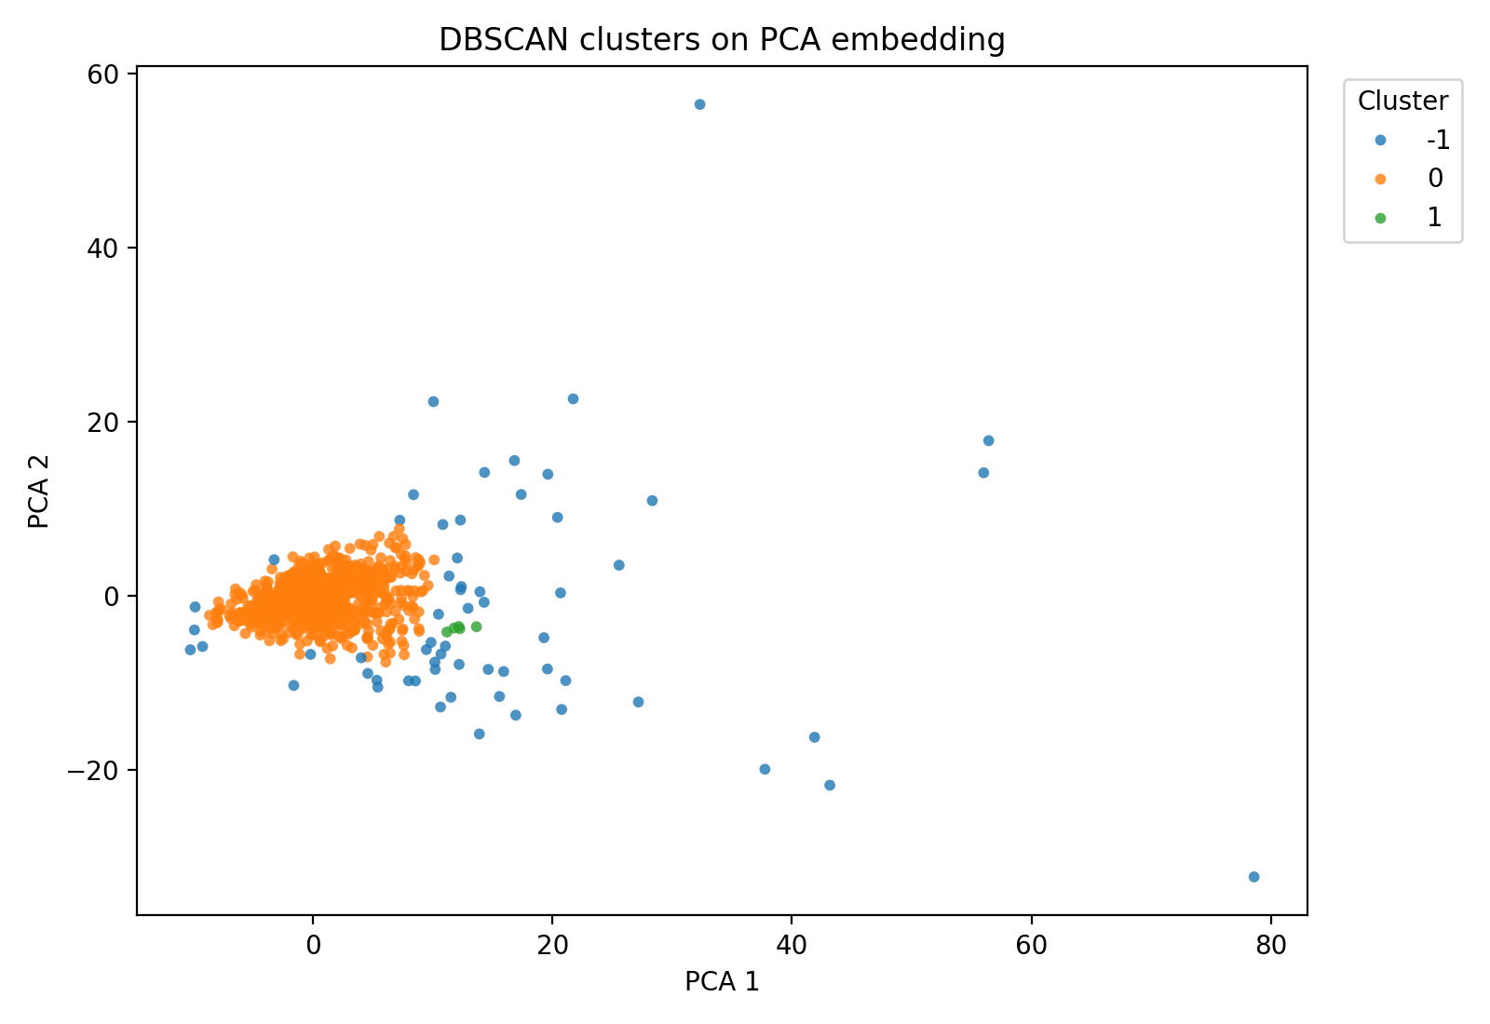
Figure 3. DBSCAN clusters on the PCA embedding.
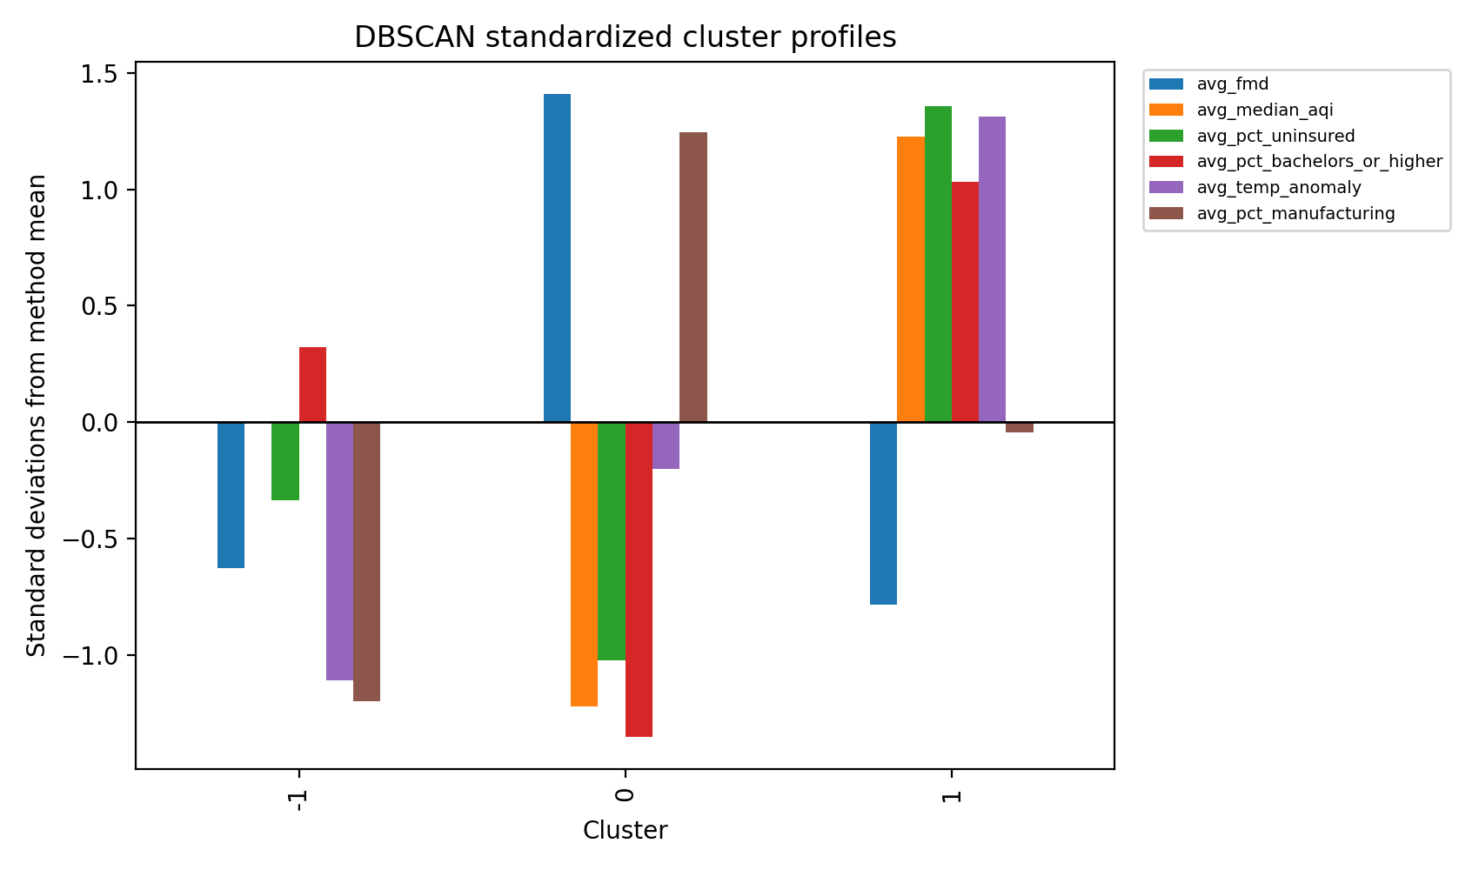
Figure 4. DBSCAN standardized cluster profiles.
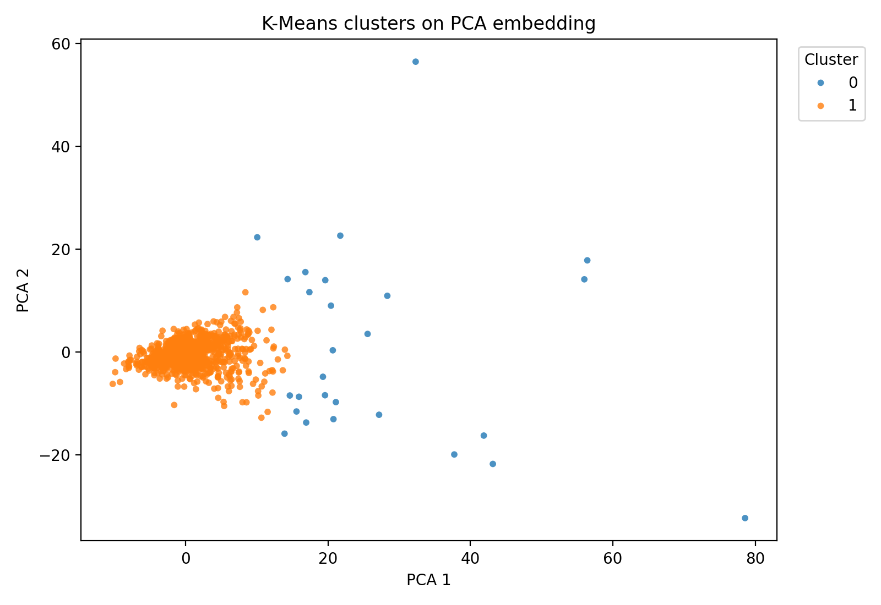
Figure 5. K-Means clusters on the PCA embedding.
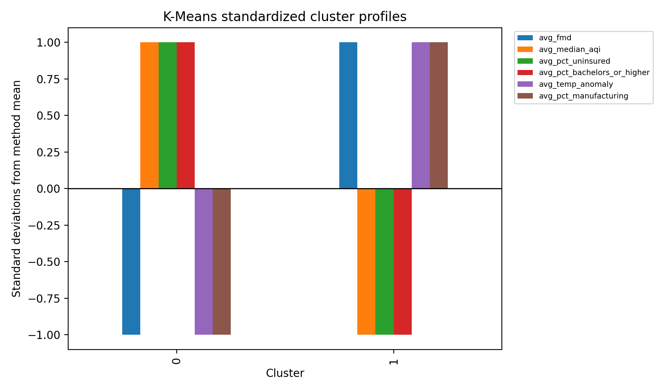
Figure 6. K-Means standardized cluster profiles.
DBSCAN found a dominant county group plus outliers and a very small second cluster. K-Means produced two clusters with stronger silhouette scores, but one cluster was still much smaller than the other. The held-out FMD comparison was stronger for K-Means in this rerun, while DBSCAN was more useful for identifying unusual counties. These results are exploratory and do not imply causality.

Discussion
Part A showed that the enriched feature set contains some predictive signal, but not enough for confident next-year FMD forecasting. The best model improved over the Dummy baseline and approached zero R², but large residuals remained in high-distress counties. This was surprising because adding ACS, climate, and daily AQI features helped performance but did not solve the high-FMD tail.
Part B showed that the county feature space is dominated by one large group with smaller outlier groups. The main challenge was that density-based clustering did not produce balanced archetypes. Comparing DBSCAN with K-Means helped clarify the tradeoff between outlier detection and partitioning all counties into interpretable groups.
With more time, the most important extensions would be provider-density and healthcare-access data, rurality/urbanicity classifications, opioid burden, disability prevalence, greenspace, disaster exposure, and finer monthly or daily exposure windows.

Ethical Considerations
- Predictions are county-level planning signals, not individual diagnoses or risk scores.
- High-FMD counties should not be stigmatized; outputs should guide support, outreach, and further investigation.
- Sparse monitor coverage and modeled PLACES estimates should be communicated as uncertainty.
- Cluster labels should not be used to rank communities or justify resource withdrawal.
- Because the project is predictive and exploratory, it should not be interpreted as causal evidence that pollution alone causes FMD.

Statement of Work
Table 10. Team member contributions
Team member | Contributions
Jaeah Kim | Unsupervised learning analysis, clustering workflow, preprocessing, interpretation support.
Kyle Rodriguez | Visualization support, model evaluation, residual and cluster interpretation, report synthesis.
Sophia Boettcher | Dataset integration, imputation workflow, supervised baselines, external enrichment, final report drafting.
All team members | EDA, data cleaning, model review, final interpretation, and presentation/report synthesis.

References
CDC. PLACES: Local Data for Better Health. https://www.cdc.gov/places/
EPA. AirData Download Files. https://aqs.epa.gov/aqsweb/airdata/download_files.html
U.S. Census Bureau. ACS Summary File. https://www2.census.gov/programs-surveys/acs/summary_file/
U.S. Census Bureau. Cartographic Boundary Files. https://www.census.gov/geographies/mapping-files/time-series/geo/carto-boundary-file.html
NOAA National Centers for Environmental Information. Climate at a Glance. https://www.ncei.noaa.gov/access/monitoring/climate-at-a-glance
Park et al. Particulate matters (PM2.5, PM10) and depression risk among middle-aged and older adults using KLoSA, 2016-2020.
Lei et al. The impact of neighborhood environment on mental health: Evidence from China.
Werder et al. Gulf Long-Term Follow-up Study research on PM2.5, greenspace, and depression in the Southeastern United States.

Project Submission Links
GitHub repository: [insert repository URL before submission]
Google Docs version with comments enabled: [insert Google Docs URL before submission]

Appendix A. Final Feature List
Table 11. Final modeling feature schema
Column | Feature family | Role
next_year_fmd | FMD outcome | Supervised target
mental_health_prevalence | FMD outcome | Held-out cluster evaluation
90th Percentile AQI | Annual AQI | Predictor
Days CO | Annual AQI | Predictor
Days NO2 | Annual AQI | Predictor
Days Ozone | Annual AQI | Predictor
Days PM10 | Annual AQI | Predictor
Days PM2.5 | Annual AQI | Predictor
Days with AQI | Annual AQI | Predictor
Good Days | Annual AQI | Predictor
Hazardous Days | Annual AQI | Predictor
Max AQI | Annual AQI | Predictor
Median AQI | Annual AQI | Predictor
Moderate Days | Annual AQI | Predictor
Unhealthy Days | Annual AQI | Predictor
Unhealthy for Sensitive Groups Days | Annual AQI | Predictor
Very Unhealthy Days | Annual AQI | Predictor
annual_avg_temp_f | Climate | Predictor
annual_precip_anomaly_inches | Climate | Predictor
annual_precip_inches | Climate | Predictor
annual_temp_anomaly_f | Climate | Predictor
precip_1901_2000_mean | Climate | Predictor
temp_1901_2000_mean | Climate | Predictor
daily_aqi_category_days_good | Daily AQI exposure | Predictor
daily_aqi_category_days_hazardous | Daily AQI exposure | Predictor
daily_aqi_category_days_moderate | Daily AQI exposure | Predictor
daily_aqi_category_days_unhealthy | Daily AQI exposure | Predictor
daily_aqi_category_days_unhealthy_for_sensitive_groups | Daily AQI exposure | Predictor
daily_aqi_category_days_very_unhealthy | Daily AQI exposure | Predictor
daily_aqi_days_over_100 | Daily AQI exposure | Predictor
daily_aqi_days_over_150 | Daily AQI exposure | Predictor
daily_aqi_days_over_200 | Daily AQI exposure | Predictor
daily_aqi_defining_param_days_co | Daily AQI exposure | Predictor
daily_aqi_defining_param_days_no2 | Daily AQI exposure | Predictor
daily_aqi_defining_param_days_ozone | Daily AQI exposure | Predictor
daily_aqi_defining_param_days_pm10 | Daily AQI exposure | Predictor
daily_aqi_defining_param_days_pm25 | Daily AQI exposure | Predictor
daily_aqi_max | Daily AQI exposure | Predictor
daily_aqi_mean | Daily AQI exposure | Predictor
daily_aqi_median | Daily AQI exposure | Predictor
daily_aqi_monthly_mean_max | Daily AQI exposure | Predictor
daily_aqi_monthly_mean_std | Daily AQI exposure | Predictor
daily_aqi_months_observed | Daily AQI exposure | Predictor
daily_aqi_observed_days | Daily AQI exposure | Predictor
daily_aqi_p90 | Daily AQI exposure | Predictor
daily_aqi_reporting_sites_mean | Daily AQI exposure | Predictor
daily_aqi_std | Daily AQI exposure | Predictor
daily_aqi_unhealthy_or_worse_days | Daily AQI exposure | Predictor
pct_bachelors_or_higher | Education and health access | Predictor
pct_hs_or_higher | Education and health access | Predictor
pct_insured | Education and health access | Predictor
pct_less_than_hs | Education and health access | Predictor
pct_uninsured | Education and health access | Predictor
pct_ag_mining | Industry composition | Predictor
pct_arts_food | Industry composition | Predictor
pct_construction | Industry composition | Predictor
pct_education_health | Industry composition | Predictor
pct_finance_real_estate | Industry composition | Predictor
pct_information | Industry composition | Predictor
pct_manufacturing | Industry composition | Predictor
pct_other_services | Industry composition | Predictor
pct_professional_admin | Industry composition | Predictor
pct_public_admin | Industry composition | Predictor
pct_retail_trade | Industry composition | Predictor
pct_transport_utilities | Industry composition | Predictor
pct_wholesale_trade | Industry composition | Predictor
acs_civilian_noninstitutionalized_total | Socioeconomic scale | Predictor
acs_education_25plus_total | Socioeconomic scale | Predictor
acs_employed_total | Socioeconomic scale | Predictor
acs_uninsured_count | Socioeconomic scale | Predictor
median_income | Socioeconomic scale | Predictor
population | Socioeconomic scale | Predictor
poverty_count | Socioeconomic scale | Predictor
total_population_numeric | Socioeconomic scale | Predictor
unemployed_count | Socioeconomic scale | Predictor

Appendix B. Artifact Catalog
Table 12. Project artifacts
Artifact | Purpose
Supervised_Unsupervised_FMD_Analysis.ipynb | Main modeling notebook
county_panel_enriched.csv | Final county-year modeling panel
generate_rubric_analyses.py | Supplemental analyses for rubric completion
outputs/rubric_completion/*.csv | CV, feature importance, ablation, sensitivity, failure, and unsupervised comparison tables
outputs/rubric_completion/*.png | Figures used in this report

