SIADS 696 Milestone II Project Report
Frequent Mental Distress Prediction Using Air Pollution
Jaeah Kim (jaeah@umich.edu), Kyle Rodriguez (kylerod@umich.edu), Sophia Boettcher (sboettch@umich.edu)
Introduction
The motivation behind this project aims to utilize previous findings from related literature and leverage supervised and unsupervised learning to answer two questions:
- Can a county’s air quality and profile reliably predict its mental health needs next year?
- Do high pollution or high distress clusters share common geographic or industrial traits?
Note that we do not aim to claim causality; we are conducting a predictive and exploratory exercise.

What problem are you trying to solve?
It’s well-known beyond anecdote that health outcomes are influenced by many environmental, economic, and social factors; yet, it remains unclear whether on a population-level (here, using county-level characteristics), if we can use data to anticipate future community mental health needs. Our project investigates whether annual air quality, climate, and socioeconomic conditions can predict next-year Frequent Mental Distress (FMD), defined by the CDC PLACES dataset as the percentage of adults reporting poor mental health for 14 or more days in the past month. As part of our project, we also explore if counties naturally group/cluster into distinct environmental and socioeconomic profiles along differing mental health outcomes. The problem we are trying to solve is if it’s at all possible to predict mental health distress at a county-level using pollution data as an informative tool.

What impact will solving the problem have?
If community mental health needs can be predicted even modestly (again, we’re not claiming causality regarding population), public health agencies could better allocate resources and identify at-risk regions pre-emptively downstream from this exploratory project. On the one hand, prediction is difficult and messy in real life. On the other hand, understanding the limits of county-level data additionally helps identify what additional information may be needed for reliable forecasting. Our work also provides an integrated county-year dataset that can support future research on environmental determinants of mental health.

What motivated you to work on it?
A growing body of literature suggests that air pollution, climate, and socioeconomic conditions are associated with mental health outcomes, but relatively few studies have examined whether these variables can predict future community-level mental distress using machine learning. Mental health needs exist at the intersection of societal and regulatory decision-making, where improved predictive ability could help governing figures with policy making and budget segmentation. We were interested in evaluating whether publicly available environmental and demographic data contain enough predictive signal to forecast next-year mental health and whether unsupervised learning could reveal meaningful county profiles beyond traditional statistical analyses.

Summarize your project’s supervised and unsupervised methods, highlighting any novel contributions.
As such, the primary objective of this project was to construct a predictive framework based on a county’s current socio-environmental and economic ecosystem. Specifically, the target variable was defined as Next-Year Frequent Mental Distress (FMD) prevalence, which is the percentage of adults in a given county reporting 14 or more mentally unhealthy days per month, measured one year following the observed features.
We constructed an enriched county-year panel containing 14,748 observations across 3,008 U.S. counties and county-equivalents from 2019–2023 by combining data from CDC PLACES, EPA AirData, NOAA climate records, the American Community Survey (ACS), and Census county geographies.
Predicting public health outcomes within a spatial panel structure introduces a critical methodological challenge: temporal data leakage. To address this, our supervised learning design employed a leakage-safe forecasting framework in which features from year t were used to predict FMD in year t + 1. We evaluated multiple regression models, including Linear Regression, Lasso, Ridge, Elastic Net, Random Forest, Gradient Boosting, and XGBoost, using cross-validation and a held-out test set.
For the unsupervised learning component, we standardized all non-FMD variables and compared two clustering approaches: DBSCAN, which is useful for identifying dense groups and outliers, and K-Means, which partitions every county into a centroid-based profile. FMD was intentionally excluded during clustering and reintroduced afterward to compare mental health outcomes across the discovered clusters. This design lets FMD function as an external validation outcome rather than a clustering variable.
Table 1. Research questions and modeling approach.
Research question | Modeling approach | Interpretation target
Can current-year county conditions predict next-year FMD? | Supervised regression with year-shifted target | Predictive usefulness and error patterns
Do counties form meaningful socio-environmental profiles? | UMAP/PCA-style embedding plus DBSCAN | Cluster differences in held-out FMD and profile variables
Are high-FMD areas geographically or economically distinctive? | Residual maps, cluster maps, and profile summaries | Exploratory evidence for follow-up study

What are your main findings for supervised and unsupervised learning?
Direct answer: the best supervised model was a tuned Random Forest, with holdout RMSE 1.98 and MAE 1.65, compared with the Dummy Regressor baseline RMSE of 2.43. Holdout R² remained near zero and slightly negative, however. This indicates that county-level environmental, climate, and socioeconomic variables contain some predictive signal, but not enough to reliably forecast next-year FMD. The result is useful as a weak-signal finding and as evidence about what the current annual county-level panel cannot yet do.
Direct answer: DBSCAN and K-Means both found a dominant county profile plus a smaller comparison group, but K-Means produced cleaner silhouette scores while DBSCAN was more useful for highlighting unusual counties. Because FMD was excluded from clustering and examined only afterward, differences in FMD across clusters can be interpreted as held-out outcome comparisons. These clusters should be treated as exploratory county profiles, not causal categories or definitive rankings.
Related Work
There is an extensive and rapidly growing body of research dedicated to the environmental determinants of mental health at the community and county levels in the United States. A lot of research revolves around the impact of environmental factors on mental illness risk. This is true for “Particulate matters (PM2.5, PM10) and the risk of depression among middle-aged and older population. Analysis of the Korean Longitudinal Study of Aging (KLoSA), 2016–2020 in South Korea” (Park, et al.) found that prolonged exposure of particulate matters increased risk of depression in the elderly. Additionally, “The impact of neighborhood environment on mental health: Evidence from China” (Lei, et al.) concluded that air pollution perception, coupled with socioeconomic status, was crucial for mental health in Chinese communities. Although these studies focus on age-based cohorts in Asian communities, our research will focus solely at population level across U.S. counties to model a possible correlation between air quality and mental health. The Gulf Long-Term Follow-up Study (Werder et al., 2024), explored how PM2.5 and greenspace impact depression in the Southeastern U.S., pointing to potentially similar vulnerabilities domestically. In addition, we will also use unsupervised learning (Which wasn’t utilized in these studies) to uncover latent socio-environmental archetypes across U.S. counties.
Data Sources
This project uses CDC PLACES CSV files from data.cdc.gov, EPA AirData annual and daily AQI files from the AQS AirData download portal, American Community Survey county enrichment files from Census ACS tables/API outputs, NOAA Climate at a Glance county climate records, and Census county boundary shapefiles. The final modeling panel is county-year and uses five-digit county GEOID as the primary merge key. The usable enriched panel contains 14,748 county-year rows, 83 columns, and 3,008 county/county-equivalent GEOIDs from 2019-2023. These source locations, formats, important variables, and roles are summarized below.
Table 2. Data sources, formats, variables, and project roles.
Source | Format | Key variables used | Coverage / role
CDC PLACES | CSV | FMD prevalence, lower and upper confidence intervals | Mental health outcome by county-year
EPA AirData annual summaries | CSV | Days with AQI, good/moderate/unhealthy days, Max AQI, Median AQI, pollutant-defining days | Annual air quality predictors
EPA AirData daily AQI | ZIP/CSV | Daily AQI mean, standard deviation, p90, max, days >100, >150, >200 | Exposure variability and extreme-event features
ACS 5-year bulk tables | pipe-delimited .dat | Income, poverty, unemployment, education, insurance, industry composition | Socioeconomic, health-access, and industrial controls
NOAA Climate at a Glance | JSON | Annual average temperature, precipitation, historical anomalies | County climate profile
Census county boundaries | Shapefile ZIP | County polygon geometries | Choropleth and spatial visualization support
Our enriched dataset contains 83 columns. ACS and NOAA features cover nearly all rows. EPA daily AQI features cover only counties with daily monitor reporting, so many missing daily features are imputed. Because of limitations in the years of data available across the main datasets (PLACES being a key bottleneck), in the harmonization step we had to accept losing granularity and also years. Although it was originally derived from BRFSS, PLACES was not a simple feature engineering downstream derivative dataset where we could have stitched together everything from scratch ourselves for the scope of the project.
Feature Engineering
The feature engineering pipeline included the following 10 major components:
- Merge CDC PLACES, EPA AirData, ACS, NOAA, and Census geography using county GEOID where available, with county/state names used only for validation and reporting.
- Perform geoimputation: use BallTree with a Haversine metric to impute missing environmental data across contiguous U.S. counties.
- Calculate demographic and pollution rates: engineer poverty rates, unemployment rates, ‘bad air day’ ratios, and ‘good air day’ ratios to encourage intensity-analysis rather than scale.
- Drop redundant raw counts: data in columns such as poverty_count were dropped to prevent multicollinearity.
- Next-year target: FMD was shifted forward within each county, so current-year features predict next-year FMD.
- Temporal holdout: 2022 features were used as the final holdout to predict 2023 FMD.
- Environmental features: annual AQI summaries, pollutant-defining days, daily AQI variability, and high-AQI threshold counts.
- Climate features: annual average temperature, annual precipitation, and 1901-2000 anomaly features.
- Socioeconomic features: income, poverty, unemployment, education attainment, insurance coverage, and industry composition.
- Unsupervised hold-out design: FMD and FMD confidence intervals were excluded from clustering and evaluated afterward.
The enriched panel contains 14,748 county-year rows across 83 columns before model-specific feature selection. The supervised and unsupervised notebooks then use leakage-controlled subsets of those features. Links to the notebooks are provided in Appendix C, and the schema tables below describe the variables used for modeling and interpretation.
Table 3. Feature families and leakage controls.
Feature family | Variable names | Data type | Data source | Notes
Geographic identifiers | geoid, county_name, state_name, year | Integer / Categorical | Census | County and temporal identifiers used for merging datasets.
Mental health outcome | mental_health_prevalence (Frequent Mental Distress, FMD) | numerical (float64) | CDC PLACES | Target variable for supervised learning and hold-out outcome for cluster evaluation. Frequent mental distress among adults; a.k.a rate wherein mental health is not good for >=14 days among adults aged >=18 years.
Air quality | median_aqi, max_aqi, ninety_percentile_aqi, days_with_aqi, days_pm25, days_pm10, days_ozone, days_no2, days_co, unhealthy_sensgroups_days | numerical (float64) | EPA AirData | Captures annual air quality burden, pollutant-specific exposure, and extreme pollution events.
Engineered air-quality features | bad_air_day_ratio, good_air_day_ratio | numerical (float64) | Engineered from AirData | Summarizes overall exposure to unhealthy versus healthy air quality days.
Climate | Annual temperature, precipitation, climate anomalies | numerical (float64) | NOAA | Provides environmental context beyond air pollution.
Socioeconomic | median_income, population, poverty_rate, unemployed_rate | Integer / Float | ACS | Represents county-level socioeconomic conditions associated with community vulnerability.
Education & healthcare access | Bachelor’s degree attainment, uninsured rate | numerical (float64) | ACS | Proxies for educational attainment, healthcare access, and community resources.
Industry composition | Manufacturing, agriculture/mining, education & health services, professional & administrative employment shares | numerical (float64) | ACS | Characterizes county economic structure and supports interpretation of discovered clusters.

Table 4. Final modeling data schema.
Column Name | Description | Data Type | Data Source
geoid |  | numerical (int64)
county_name | County name of interest | categorical
state_name | State name of interest | categorical
year | Year of data collection | numerical (int64)
median_income | Median income in USD | numerical (int64) | ACS
population | Number of people populating an area | numerical (int64) | ACS
mental_health_prevalence | Frequent mental distress among adults; a.k.a rate wherein mental health is not good for >=14 days among adults aged >=18 years | numerical (float64) | CDC PLACES
lower_ci | Lower confidence interval | numerical (float64) | CDC PLACES
upper_ci | Upper confidence interval | numerical (float64) | CDC PLACES
days_with_aqi | Number of days with AQI data | numerical (float64) | AirData
unhealthy_sensgroups_days | Number of days where air quality is unhealthy for sensitive groups | numerical (float64) | AirData
max_aqi |  | numerical (float64) | AirData
ninety_percentile_aqi |  | numerical (float64) | AirData
median_aqi | Median air quality index | numerical (float64) | AirData
days_co | Number of days where carbon monoxide levels were above threshold | numerical (float64) | AirData
days_no2 | Number of days where nitrogen oxide levels were above threshold | numerical (float64) | AirData
days_ozone | Number of days where ozone levels were above threshold | numerical (float64) | AirData
days_pm25 | Number of days where fine particulate matter (<2.5 microns) levels were above threshold | numerical (float64) | AirData
days_pm10 | Number of days where fine particulate matter (<10 microns) levels were above threshold | numerical (float64) | AirData
geometry
poverty_rate | The rate at which a population is in poverty | numerical (float64) | Engineered from ACS
unemployed_rate | The rate at which a population is unemployed | numerical (float64) | Engineered from ACS
bad_air_day_ratio | The ratio of unhealthy, very unhealthy, and hazardous AQI days to total AQI days | numerical (float64) | Engineered from AirData
good_air_day_ratio | The ratio of good and moderate AQI days to total AQI days | numerical (float64) | Engineered from AirData

What Jaeah's EDA adds
Direct answer: Jaeah's exploratory analysis adds the quality-control layer that makes the modeling choices defensible. Her missingness and geographic coverage checks explain why sparse EPA daily AQI monitor data should be imputed and interpreted cautiously; her rate-oriented checks support using county-intensity features rather than raw counts; and her exploratory county profiles motivated the unsupervised design, where counties are grouped by socio-environmental characteristics before FMD is examined as a held-out outcome.
Supervised Learning
Direct answer: the supervised task is a regression problem that predicts next-year FMD prevalence from current-year county features. We used four model families for complementary reasons: a Dummy Regressor to establish a mean-prediction baseline; ElasticNet because environmental, climate, and socioeconomic features can be correlated and benefit from L1/L2 regularization; Random Forest because it can model nonlinear interactions and provides feature-importance diagnostics; and Gradient Boosting because sequential tree ensembles can capture nonlinear structure through a different mechanism than bagging. Continuous predictors were imputed when needed, and ElasticNet used standard scaling. Hyperparameter tuning used grouped cross-validation over the training years, including regularization strength/mixing for ElasticNet, tree/feature-sampling settings for Random Forest, and learning-rate/tree-depth settings for Gradient Boosting. Final evaluation used the 2022-to-2023 temporal holdout, RMSE, MAE, R², and CV means with standard deviations.

Evaluation

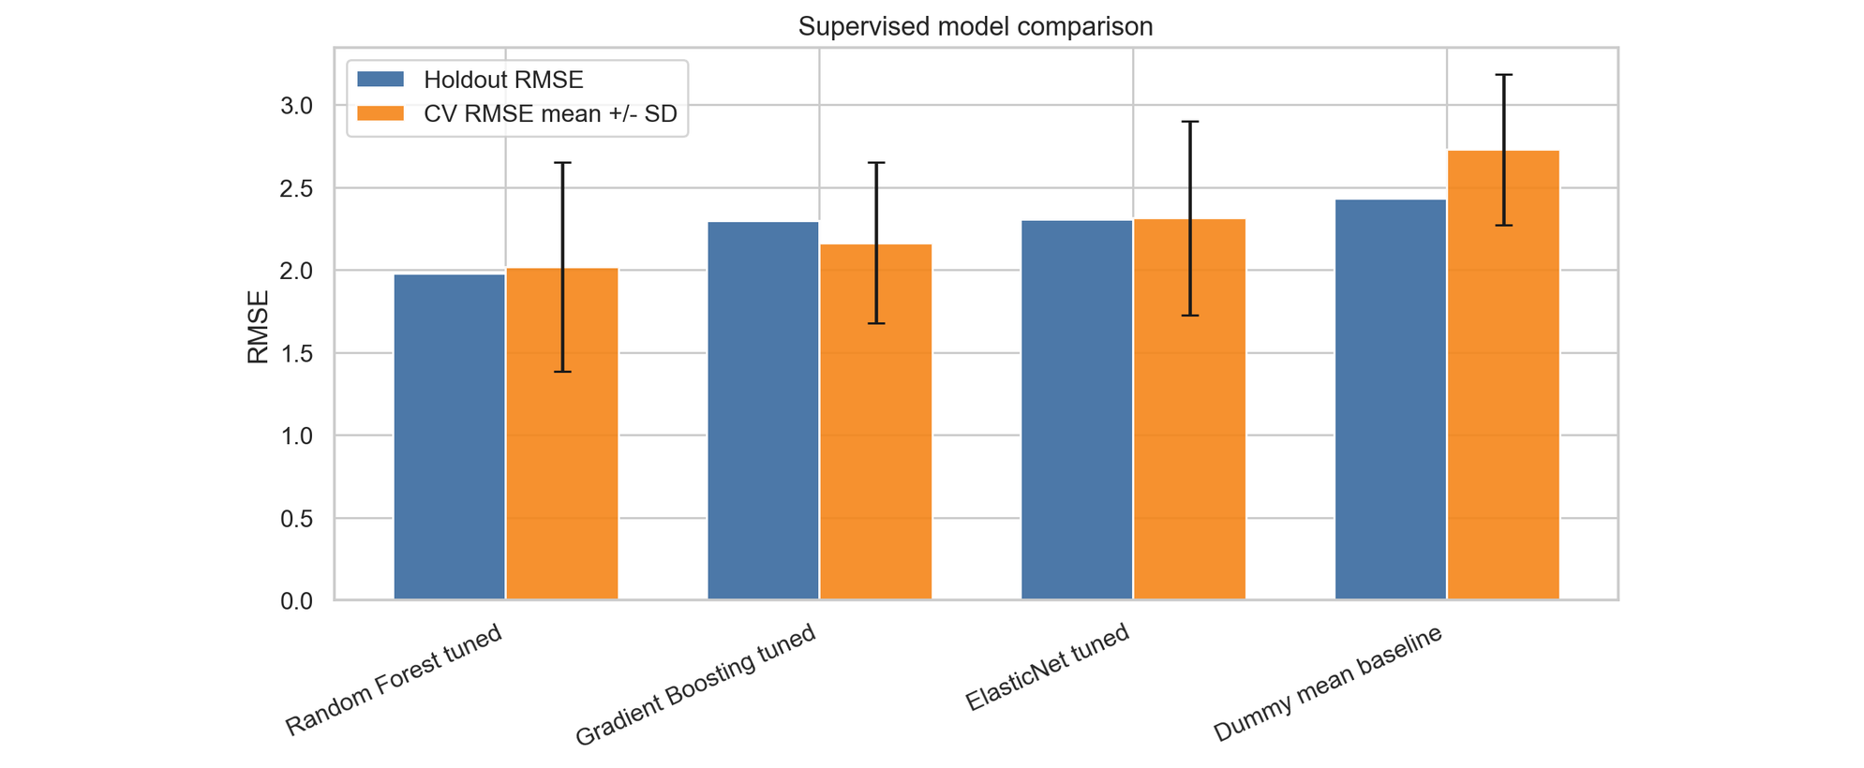
Figure 1. Supervised model comparison with grouped cross-validation mean and standard deviation. The tuned Random Forest has the best holdout RMSE, but the uncertainty across folds reinforces that predictive signal is modest.
Key feature engineering and implementation choices were designed to avoid misleading scale effects: absolute metrics were normalized to county intensities where appropriate, including poverty_rate, unemployed_rate, bad_air_day_ratio, and good_air_day_ratio. Redundant raw counters were dropped to reduce multicollinearity in linear estimators. Models were evaluated with temporal holdout testing and grouped cross-validation; the table reports mean and standard deviation across folds.

Findings
The best model, Random Forest tuned, reduced holdout RMSE by about 0.45 percentage points relative to the Dummy baseline. That improvement is useful as proof of signal, but it is not enough to support strong forecasting claims. The near-zero negative R² indicates that the model still does not explain holdout variation robustly under the strict temporal split.
The residual analysis is therefore one of the more useful supervised outputs to visualize. Ultimately, the model underpredicted several high-FMD counties, suggesting that important local drivers are missing from the current feature set. Potential missing predictors include healthcare provider density, rurality and lack of data collection, disability prevalence, greenspace, disaster exposure, and local behavioral health infrastructure. We want to be careful to not posit too much on everything that’s missing and simply put forth a very simple observation that, especially in underseen and underrepresented communities, averages tend to erase granularity and extremes. Granularity and extremes of outcome (here, mental health status at population-level) are especially what we would be interested in.
Table 5. Supervised model performance with grouped cross-validation uncertainty.
Model | Holdout RMSE | Holdout MAE | Holdout R² | CV RMSE / R² mean ± SD
Random Forest tuned | 1.98 | 1.65 | -0.02 | RMSE 2.02 ± 0.63; R² 0.01 ± 0.50
Gradient Boosting tuned | 2.30 | 1.91 | -0.37 | RMSE 2.16 ± 0.49; R² -0.09 ± 0.44
ElasticNet tuned | 2.31 | 1.97 | -0.38 | RMSE 2.32 ± 0.59; R² -0.27 ± 0.55
Dummy mean baseline | 2.43 | 1.95 | -0.54 | RMSE 2.73 ± 0.46; R² -0.70 ± 0.50

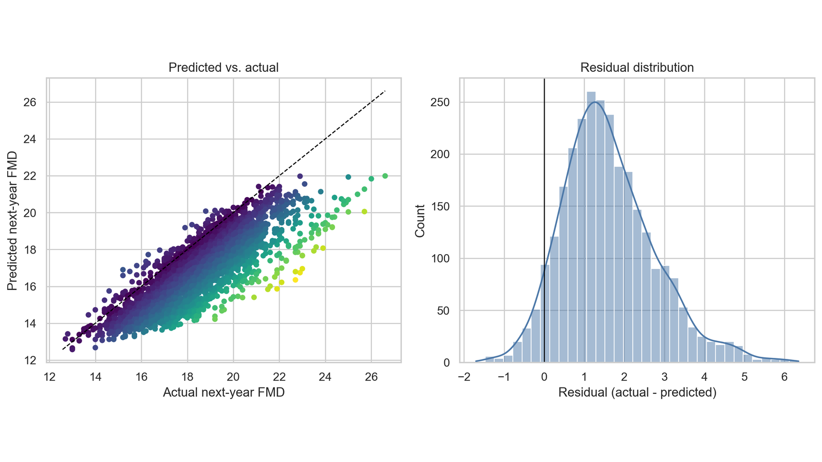Figure 2. Predicted versus actual next-year FMD and residual distribution on the 2022 to 2023 holdout. Predictions are compressed toward the mean, especially for high-FMD counties.

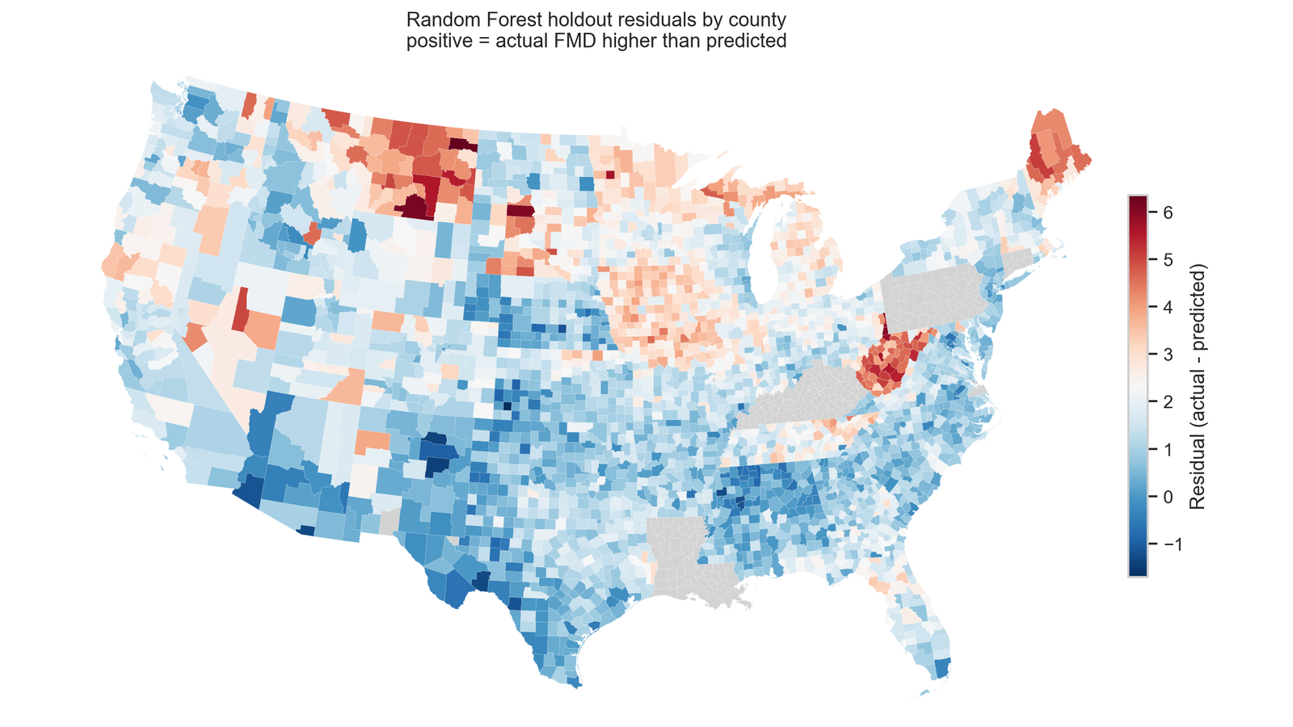Figure 3. Geographic residual map from project Census boundaries and model predictions. Positive residuals indicate counties where actual FMD was higher than the Random Forest prediction.
Methods & Motivation
Mental health needs exist at the intersection of community conditions, public-health planning, and regulatory decision-making. At a macro scale, even modest predictive ability could help agencies prioritize outreach, planning, and resource allocation, while a weak-signal result clarifies what additional data would be needed before such a model could be used responsibly.
As such, the primary objective of this phase is to construct a robust and predictive framework capable of forecasting next-year public mental health vulnerabilities based on a county’s current socio-environmental and economic ecosystem. Specifically, the target variable is defined as Next-Year Frequent Mental Distress (FMD) prevalence, which is the percentage of adults in a given county reporting 14 or more mentally unhealthy days per month, captured one year following the observed features.
Predicting public health outcomes within a spatial panel structure introduces a critical methodological challenge: temporal data leakage. To establish genuine predictive legitimacy, we used current-year features to predict next-year FMD and evaluated the final model on a temporal holdout.
Data Source
Please refer to the Data Sources section above for the details on data sources and features we’ve used.

In-Depth Evaluation

Random Forest Grouped Ablation
Table 6. Random Forest feature-family ablation.
Removed feature family | Features removed | Holdout RMSE | RMSE delta
Education and health access | 5 | 2.06 | 0.08
Industry composition | 13 | 2.01 | 0.03
Annual AQI | 15 | 1.99 | 0.01
None (full model) | 0 | 1.98 | 0.00
Daily AQI exposure | 25 | 1.98 | -0.00
Socioeconomic scale | 9 | 1.94 | -0.04
Climate | 6 | 1.94 | -0.04
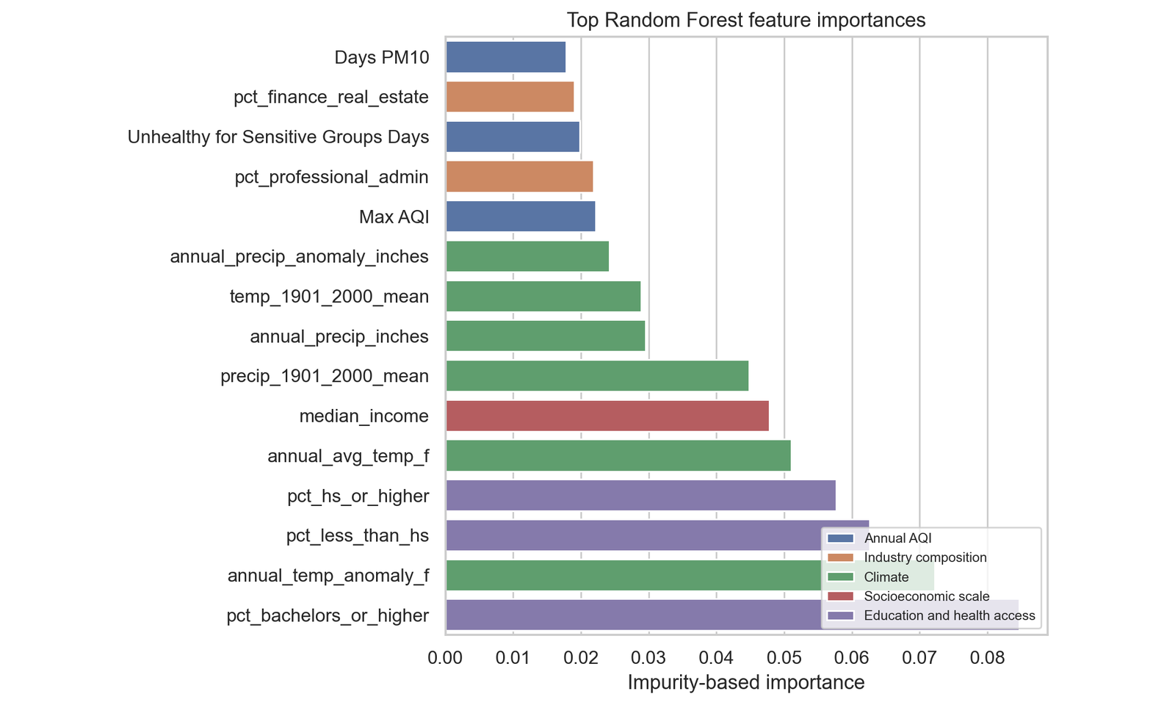
Figure 4. Random Forest feature importances.
For the chosen model, Random Forest, impurity-based feature importance ranked education and climate variables highly. A grouped ablation analysis retrained the model after removing each feature family. Removing education/health-access features increased holdout RMSE the most, suggesting that these variables contributed more consistently than annual or daily AQI features in the current panel.
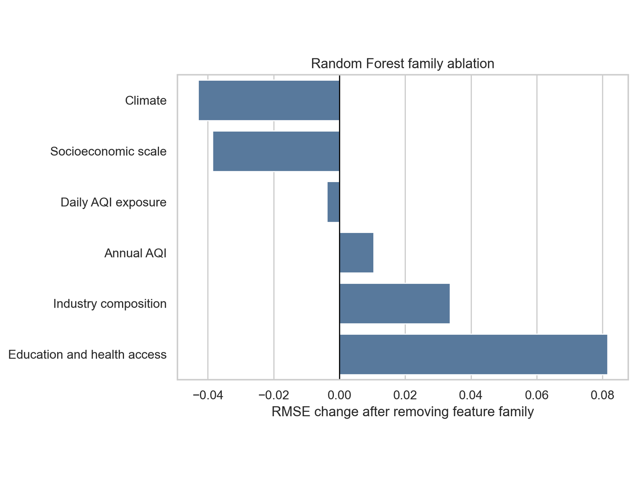
Figure 5. Feature-family ablation for the tuned Random Forest model.

Sensitivity, Tradeoffs, and Failure Analysis
Sensitivity analysis varied Random Forest minimum leaf size and max-feature sampling. The best setting used small leaves and sqrt feature sampling, while larger leaves generally reduced variance but worsened holdout RMSE. The tradeoff is interpretability and stability versus nonlinear flexibility: Random Forest performed best, but at the cost of reduced transparency relative to ElasticNet.

Random Forest sensitivity analysis, top settings
Table 7. Random Forest hyperparameter sensitivity settings.
min_samples_leaf | max_features | Holdout RMSE | Holdout R²
1 | sqrt | 1.98 | -0.02
3 | sqrt | 2.00 | -0.04
8 | sqrt | 2.02 | -0.06
15 | sqrt | 2.05 | -0.09
1 | 0.7 | 2.06 | -0.10
1 | 0.5 | 2.06 | -0.10
Our failure analysis focused on the largest absolute residuals. The model mainly failed by underpredicting high-FMD counties, but those failures were not all identical. We grouped them into three categories: high-distress tail compression, Appalachian high-FMD underprediction, and rural/sparse-feature underprediction. These categories suggest that county-level pollution, climate, and ACS controls likely miss local behavioral-health infrastructure, rurality, disability burden, opioid-related distress, social isolation, monitor coverage, and other hidden social/environmental variables.

Identified high-error examples
Table 8. High-error supervised prediction examples and failure categories.
County | State | Actual FMD | Prediction | Residual | Failure category
Roosevelt | Montana | 22.70 | 16.35 | 6.35 | High-distress tail underprediction
Big Horn | Montana | 22.90 | 16.74 | 6.16 | Rural/sparse-feature underprediction
Marshall | West Virginia | 23.00 | 16.96 | 6.04 | Appalachian high-FMD underprediction
Corson | South Dakota | 21.90 | 15.86 | 6.04 | Rural/sparse-feature underprediction
Hancock | West Virginia | 22.70 | 16.80 | 5.90 | Appalachian high-FMD underprediction
Ohio | West Virginia | 22.10 | 16.22 | 5.88 | Appalachian high-FMD underprediction
The three failure categories point to different fixes: high-distress tail compression calls for models or loss functions that better preserve extreme outcomes; Appalachian high-FMD underprediction calls for opioid burden, disability prevalence, provider density, and local economic-distress variables; and rural/sparse-feature underprediction calls for rurality classifications, monitor-coverage indicators, and satellite or reanalysis pollution estimates.
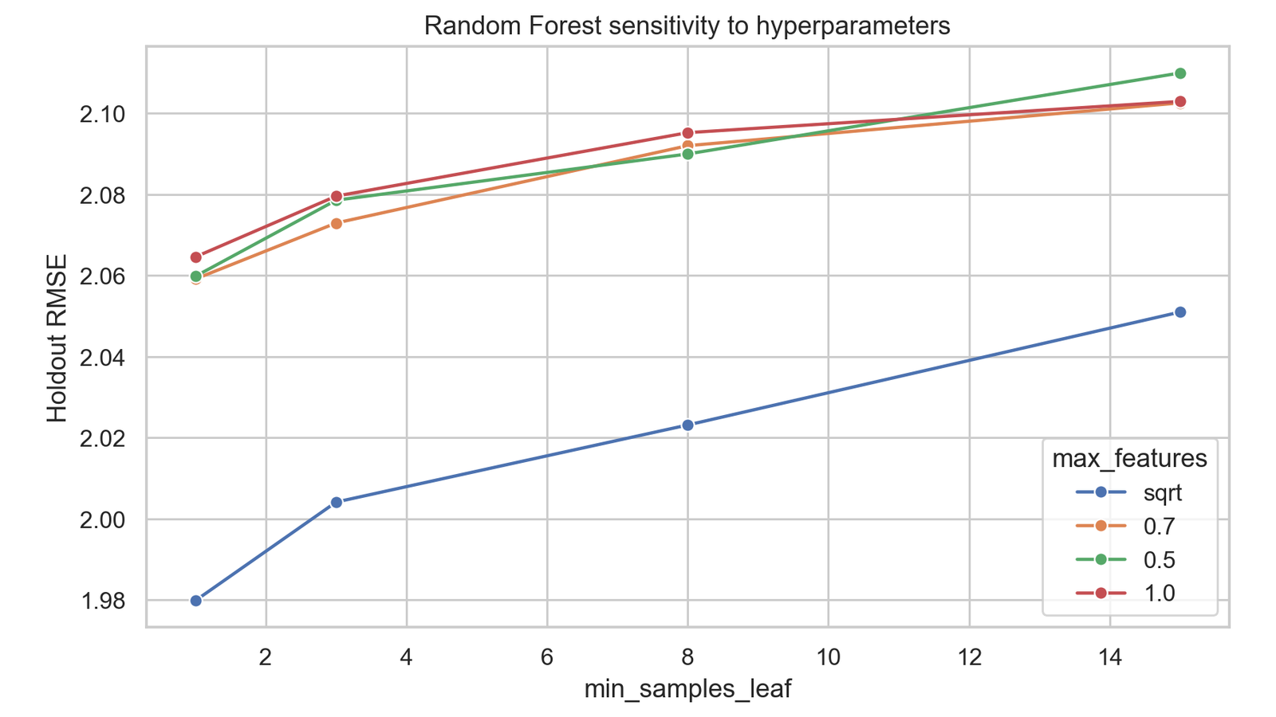
Figure 6. Random Forest hyperparameter sensitivity. Smaller leaves with square-root feature sampling performed best, while larger leaves were more stable but less accurate.
Unsupervised Learning

Methods & Motivation
Being able to form socio-environmental county profiles is important for the further study of mental health drivers. Using unsupervised learning for this can not only identify important features but can also orient the data geospatially, thereby making it easier to comprehend.
Direct answer: the unsupervised analysis used two methods with different clustering assumptions. DBSCAN was chosen because it is density-based and can label noise/outlier counties, which is useful when some counties may have unusual socio-environmental profiles. K-Means was chosen as a contrasting centroid-based method because it assigns every county to a cluster and provides a cleaner partition for comparison. Both methods used standardized non-FMD features so variables measured on different scales would contribute comparably. FMD was held out and compared only after clusters were formed, while PCA was used for visualization and cluster-search diagnostics.
The idea behind creating characterization profiles of counties by their environmental and socioeconomic attributes is that this may, in turn, help support future investigation into community mental health. In other words, unsupervised learning is a valuable step in exploratory data science to examine whether similar county profiles emerge from the available data thus far. Furthermore, it can ground us in understanding what additional data and what future directions we should pursue next.

Unsupervised method comparison
Table 9. Unsupervised method comparison.
Method | Selected parameters | Clusters | Noise % | Silhouette embedding | Silhouette scaled features
DBSCAN | eps=1.43, min_samples=5 | 2 | 0.02 | 0.76 | 0.45
KMeans | k=2 | 2 | 0.00 | 0.89 | 0.75

Held-out FMD ANOVA across unsupervised clusters
Table 10. Held-out FMD ANOVA across unsupervised clusters.
Method | F statistic | p-value | Groups
DBSCAN | 3.65 | 0.0563 | 2
KMeans | 8.63 | 0.0033 | 2
In order to address the curse of dimensionality prior to clustering, the data were normalized using standard scaling and visualized on a two-dimensional PCA embedding. The final clustering feature matrix used numerical county profile variables only, which allowed us to compare density-based and centroid-based clustering without including the FMD outcome.
For our unsupervised section, we clustered counties using environmental, climate, socioeconomic, healthcare access, education, and industry features. We first harmonized and standardized the features, then used PCA for visualization. DBSCAN was tuned across epsilon and minimum-sample values, while K-Means was searched across candidate k values. We selected settings using silhouette scores, cluster counts, noise percentage for DBSCAN, and interpretability. Because FMD was excluded from clustering, differences in FMD across clusters are post-hoc outcome comparisons rather than clustering inputs.
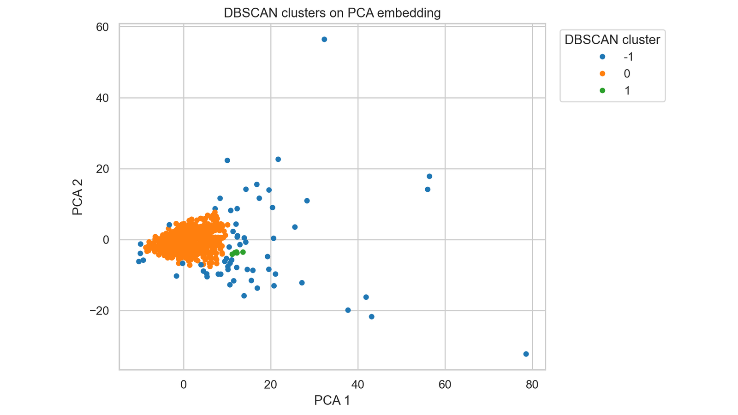
Figure 7. DBSCAN clusters on the PCA embedding. DBSCAN identifies one dominant group plus outlier/noise structure rather than balanced county archetypes.
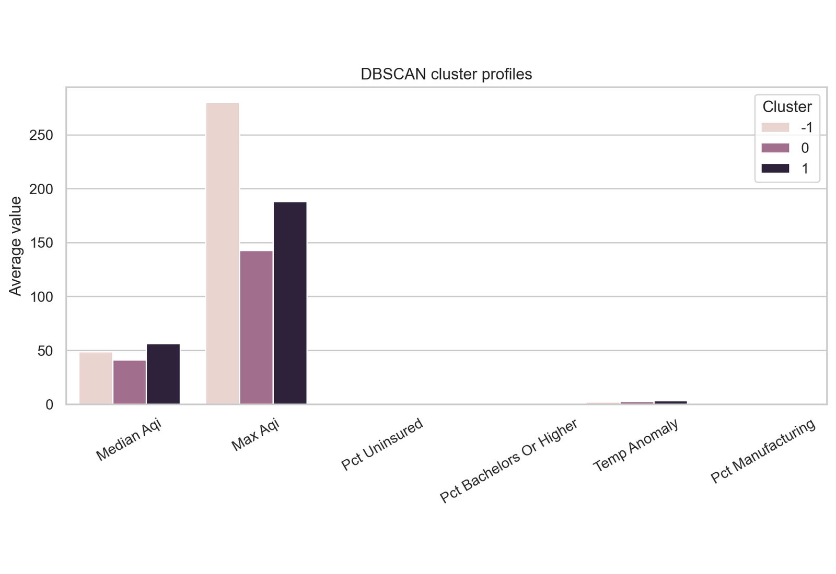
Figure 8. DBSCAN cluster profiles across selected standardized county features.
Table 11. DBSCAN cluster profile summary.
Cluster | Counties | Avg FMD | Median AQI | AQI days >100 | Temp anomaly | Uninsured | Bachelor+
-1 | 39 | 17.03 | 55.1 | 30.2 | 2.29 | 9.1% | 34.3%
0 | 2,768 | 18.60 | 41.4 | 5.3 | 2.67 | 9.5% | 24.0%
1 | 5 | 15.46 | 41.8 | 4.2 | 3.33 | 7.3% | 46.5%

Unsupervised Evaluation
Ultimately, the clustering output of our unsupervised learning section did not produce evenly sized archetypes. Instead, DBSCAN identified one dominant county group, a small low-FMD group, and a small set of noise/outlier counties. This result is still informative: it suggests that, after standardization and dimensionality reduction, most counties occupy a broad shared socio-environmental region, while a small number of counties are structurally distinct.
Because the small cluster sizes make formal statistical tests weak, the unsupervised results should be treated as exploratory. The notebook attached in our Github repo includes the ANOVA-style hold-out testing. However, the final interpretation should focus on effect direction, cluster profiles, and qualitative geography rather than strong inferential claims.
We began our project noting that we were not trying to prove causality. Still, we were optimistic about perhaps uncovering some sort of predictive capability. At this point, the interesting finding has emerged through both the clustering results and the imbalanced residuals: the residuals are not centered around zero, suggesting some sort of presence of systematic prediction bias (we can’t yet pinpoint what exactly) and indicating that the current body of county-level data does not fully capture the factors associated with next-year mental distress. Rather than pointing to a specific cause, these findings suggest there is additional information yet to be collected or incorporated, particularly for counties at the extremes. This, in turn, helps inform what future data and directions may be most valuable to future researchers/stakeholders interested in this space.
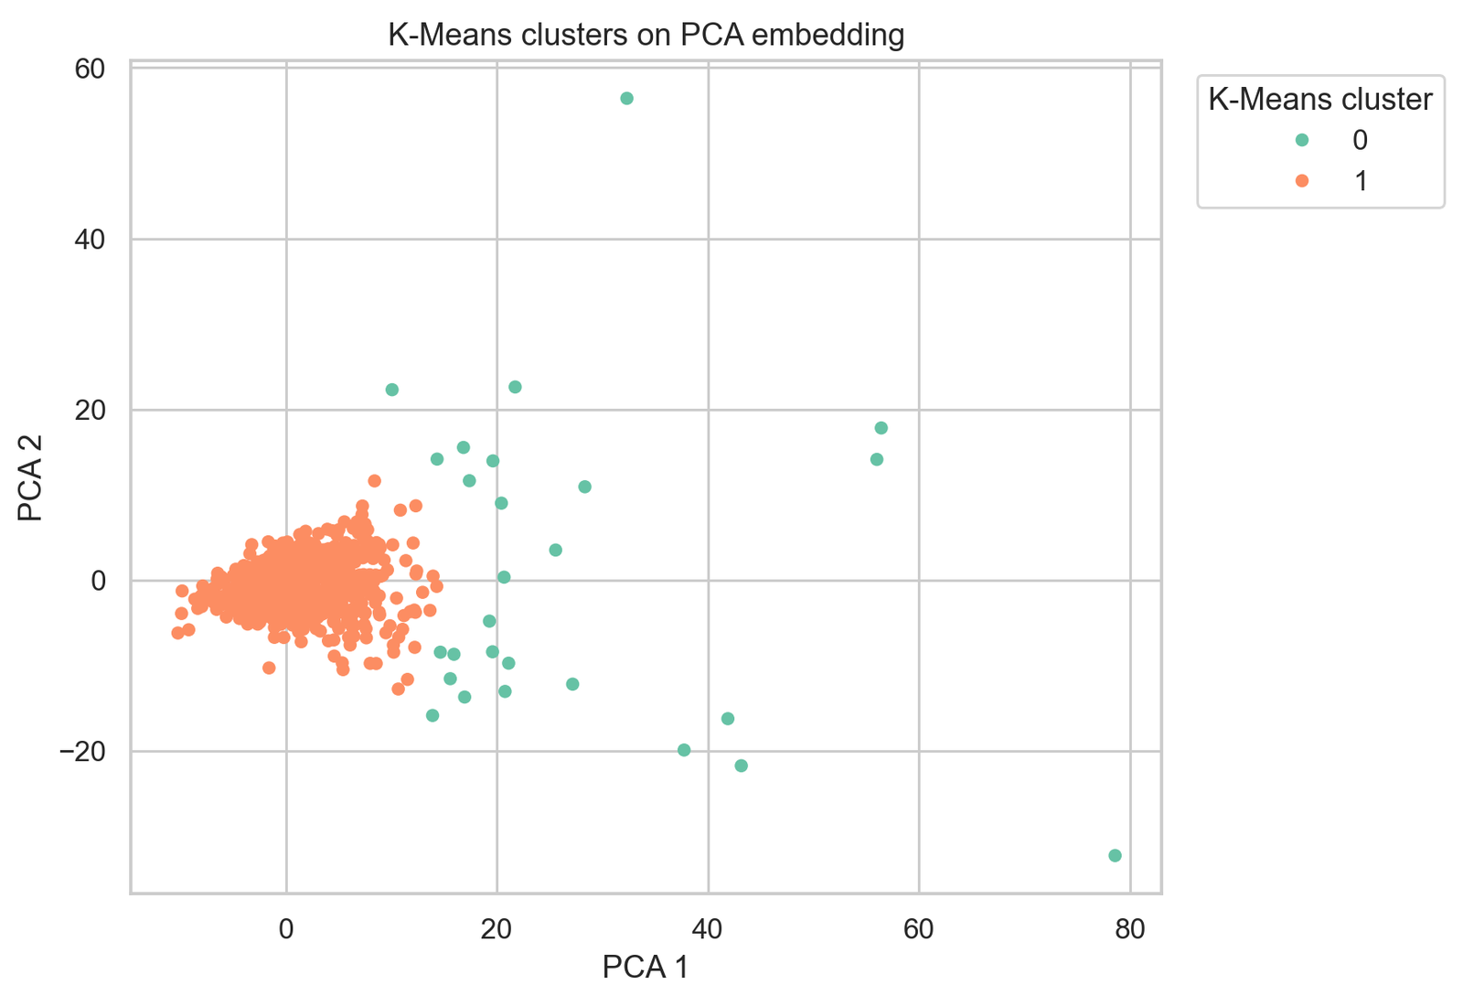
Figure 9. K-Means clusters on the PCA embedding. K-Means produced cleaner silhouette scores than DBSCAN, but one cluster was still much smaller than the other.
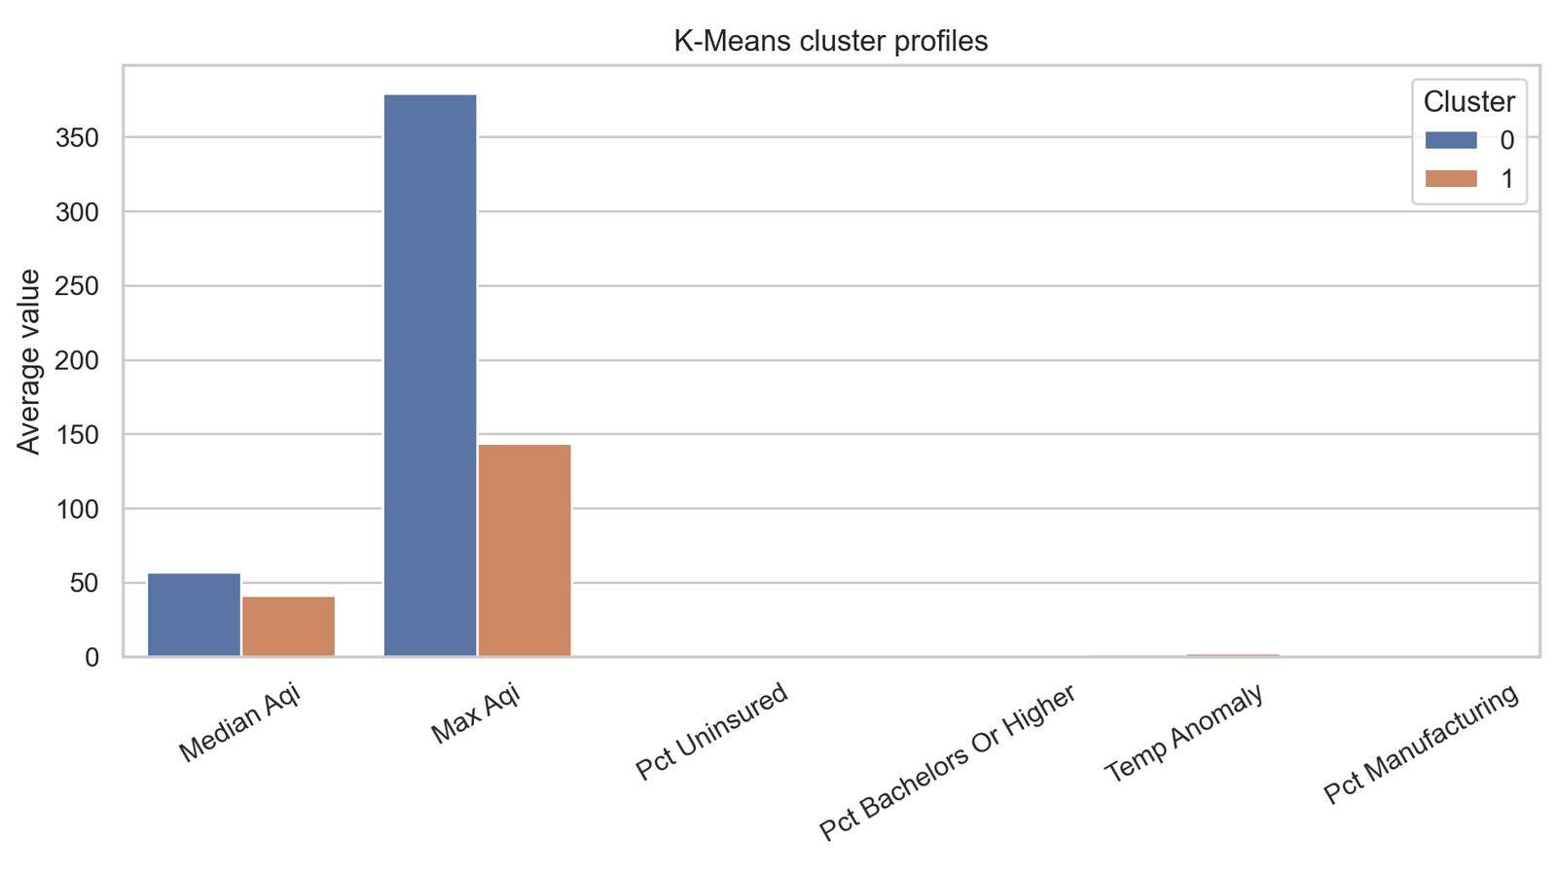
Figure 10. K-Means cluster profiles using the same variables as DBSCAN for direct comparison.
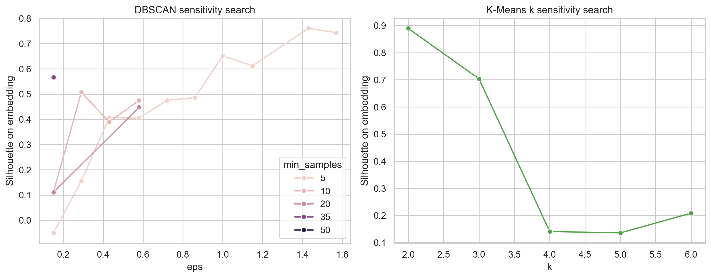
Figure 11. DBSCAN and K-Means unsupervised sensitivity search. K-Means k=2 had the strongest silhouette score, while DBSCAN was highly sensitive to eps and min_samples.
Discussion
The enriched feature set contains some predictive signal, but not enough for confident next-year FMD forecasting. The best model improved over the Dummy baseline and approached zero R², but large residuals remained in high-distress counties. This was surprising because adding ACS, climate, and daily AQI features helped performance but did not solve the high-FMD tail. Moreover, DBSCAN found a dominant county group plus outliers and a very small second cluster. K-Means produced two clusters with stronger silhouette scores, but one cluster was still much smaller than the other. The held-out FMD comparison was stronger for K-Means in this rerun, while DBSCAN was more useful for identifying unusual counties. (These are offered as observational and are not intended as implication).
Ultimately, the project’s empirical result is a negative finding: annual county-level air quality, climate, and socioeconomic variables did not provide strong next-year FMD prediction under a leakage-safe temporal holdout. This does not mean environmental conditions are irrelevant to mental health. We do admit that county feature space is dominated by one large group with smaller outlier groups. The main challenge was that density-based clustering did not produce balanced archetypes. Comparing DBSCAN with K-Means helped clarify the tradeoff between outlier detection and partitioning all counties into interpretable groups.
Rather, our study suggests that the current feature set, spatial scale, and annual aggregation are not enough for reliable forecasting. This is still a useful result because we do not want to overclaim, even though some interesting emergent insights arose from our exploratory analyses. A rigorous negative or weak-signal finding remains scientifically valuable, even if we do not have a policy-ready predictor to show for our work.
Overall, our work thus far suggests that county-level environmental and socioeconomic data can support exploratory mental health risk mapping, but the current annual panel is not sufficient for reliable next-year FMD forecasting. We found that stronger data are needed before county-level air quality can be used as a reliable predictor of next-year mental distress. The best supervised model only modestly improved over the mean baseline and retained negative holdout R². The unsupervised pipeline created a useful framework for county profiling, but DBSCAN produced highly unbalanced clusters, so its findings should be interpreted cautiously.
Future work should rerun the full modeling pipeline after cleaning sentinel missing values, adding healthcare access and rurality variables, and incorporating richer daily or monthly exposure data. It may be possible to rebuild essentially a bigger PLACES dataset using BFRSS data (covering more years). At this point, what we have is a harmonized county-year dataset, external data enrichment, a leakage-safe supervised forecasting framework, an unsupervised clustering pipeline with held-out outcome evaluation, and spatial residual analysis. Together, these provide a foundation for future work by identifying both what can currently be predicted and where additional data or richer features may be needed.
Ethical Considerations and Notes of Caution/Limitation
- Supervised-learning ethics: predictions are county-level planning signals, not individual diagnoses or risk scores. Because county aggregation removes individual-level details, the model should not be used to infer a resident’s mental-health status. False negatives are also ethically important: underpredicted high-FMD counties could be overlooked if model outputs were treated as resource-allocation truth rather than uncertain planning evidence.
- Unsupervised-learning ethics: cluster labels should not be interpreted as rankings, causal categories, or labels of community worth. DBSCAN noise counties and smaller K-Means clusters may reflect data coverage, monitor placement, or missing contextual variables rather than true community types. Cluster maps should therefore be paired with local expertise and used to guide further inquiry, not to stigmatize communities, withdraw resources, or blame counties for mental-health burden.
- Data and communication ethics: sparse EPA monitor coverage, modeled PLACES estimates, and imputed environmental values carry uncertainty that should be communicated alongside any map, prediction, or cluster profile. Because the analysis is predictive and exploratory, it should not be used as causal evidence for regulatory decisions without further study and community review.

Table 12. Modeling limitations and recommended next steps.
Limitation | Implication | Recommended next step
Annual county aggregation | Smooths short-term exposure events and local heterogeneity | Use monthly or daily exposure windows and spatially finer outcomes where possible
Sparse EPA daily AQI coverage | Daily AQI features are available only for monitored counties | Model monitor coverage explicitly or add satellite/reanalysis pollution estimates
ACS source-year backfill for 2019-2020 | Some supplemental variables use earliest available table-based ACS source year | Use a Census API key or historical ACS summary files for exact year matching
Negative income sentinel values in source panel | Requires cleaning before modeling and profile interpretation | Treat sentinel values as missing and rerun models
Missing healthcare and rurality variables | May explain residual patterns not captured by AQI/climate | Add provider density, RUCC/NCHS urban-rural class, opioid burden, disability, and greenspace
No causal identification strategy | Associations should not be framed as pollution effects | Use quasi-experimental or longitudinal causal designs for policy claims
Statement of Work
Table 13. Statement of work.
Team member | Primary contributions
Jaeah Kim | Exploratory data analysis, missingness and geographic coverage checks, rate-engineering insight, and county-profile interpretation that shaped imputation choices and the unsupervised framing.
Kyle Rodriguez | Visualization support, supervised and unsupervised evaluation, repository cleanup, data gathering, initial baselines for supervised learning report synthesis
Sophia Boettcher | Dataset integration, imputation workflow, supervised and unsupervised baselines support, final report drafting support
All team members | EDA, data cleaning, modeling review, interpretation, and final presentation/report synthesis
References
Centers for Disease Control and Prevention. (n.d.). PLACES: Local Data for Better Health. Retrieved June 27, 2026, from https://www.cdc.gov/places
Lei, K., Yang, J., & Ke, X. (2025). The impact of neighborhood environment on the mental health: Evidence from China. Frontiers in Public Health, 12, 1452744. https://doi.org/10.3389/fpubh.2024.1452744
Park, H., Kang, C., AiMS-CREATE Team, & Kim, H. (2024). Particulate matters (PM2.5, PM10) and the risk of depression among middle-aged and older population: Analysis of the Korean Longitudinal Study of Aging (KLoSA), 2016–2020 in South Korea. Environmental Health, 23(1), Article 4. https://doi.org/10.1186/s12940-023-01043-1
U.S. Census Bureau. (2009–2024). American Community Survey 5-Year Estimates [Data set]. Census Data API. https://api.census.gov/data
U.S. Environmental Protection Agency. (2026). Air Quality System (AQS) Data Mart: AirData [Data set]. https://aqs.epa.gov/aqsweb/airdata/download_files.html
Werder, E., Lawrence, K., Deng, X., Jackson II, W. B., Christenbury, K., Buller, I., Engel, L., & Sandler, D. (2024). Residential air pollution, greenspace, and adverse mental health outcomes in the U.S. Gulf Long-term Follow-up Study. Science of the Total Environment, 946, 174434. https://doi.org/10.1016/j.scitotenv.2024.174434

Appendix A - Bibliography

Appendix B - Data Schema

Appendix C - Notebook Catalog

