|  |
| --- |
| **OC Pizza Company**  **Information Management System**  Functional design file  Version 1.0 |
| **Author**  Scott Bolin  *Engineer* |

Table Of Contents

1 - Versions 3

2 - Introduction 4

2.1 - Document purpose 4

2.2 - References 4

2.3 - Client needs 4

2.3.1 - Context 4

2.3.2 - Stakeholders and Objectives 4

3 - General description of solution 5

3.1 - Operating principles 5

3.2 - Actors and Actions Performed 5

3.3 - General use cases 6

4 - Functional Area 7

4.1 - Frame of Reference 7

4.2 - Overall Architecture 8

5 - Workflows 9

5.1 - Workflow 9

6 - Application 11

6.1 - Actors 12

6.2 - Use cases 12

6.2.1 - Customer Use Cases 12

6.2.1.1 - UC1 – Customer Phone Order 12

6.2.1.2 - UC2 – Customer Online Order 13

6.2.1.3 - UC3 – Process Customer Order 13

6.2.1.4 - UC4 – Cook Customer Order 14

6.2.1.5 - UC5 – Delivery Customer’s Order 14

6.2.2 - Shop Manager Use Cases 15

6.2.2.1 - MUC1 – Manage Users Case 15

6.2.2.2 - MUC2 – Manage Stock 15

6.2.2.3 - MUC3 – Manage Notifications 16

6.3 - General management rules 16

6.4 - Workflow 16

# Versions

|  |  |  |  |
| --- | --- | --- | --- |
| Author | Date | Description | Version |
| SB | 03/10/2020 | Creation of document | 1.00 |
|  |  |  |  |

# Introduction

## Document purpose

This document outlines the functional design file for the OC Pizza Company information Management system application.

The objective is to document the functional and design requirements and considerations used as a basis for the OC Pizza Company Information Management System Application and Website.

The elements of this document include:

* General description of the proposed solution
* Functional details of the proposed solutions
* Workflow of the proposed solution, that is, the process to be followed in carrying out the solution
* Details of the Web and Mobile applications to be developed

## References

For further information, please refer also to the following items:

1. TDF – 1: Technical Design File
2. OF – 1: Operational File
3. DN – 1: Delivery Note File

## Client needs

### Context

The OC Pizza company would like to set up a management information system for its shops and associated DBMS (database management system). The DBMS will store the following:

1. User data (both customers and employees), including address, and login details;
2. Store data (shop name, shop location, stocks);
3. Employee data (position, salary, shop work at);
4. Order data;
5. Order status (Order Processed, Pizza Preparing, Pizza Cooking, Pizza Complete, Out for Delivery, Order Complete);
6. Stock/Ingredient data for each store;
7. Pizza recipe data with associated Stock/Ingredient data.

### Stakeholders and Objectives

The primary stakeholders include the CEO and IT management staff of OC Pizza Company. Secondary stakeholders include individual shop managers who will be the main users of the system, and staff at each shop, who will use and benefit from the system.

# General description of solution

## Operating principles

**Function:**

The system has many functions to carry out, including:

1. Track Order Lifecycle, including issuing notifications as milestones are met:
   1. Order Pizza (customer name/delivery Location, Order details, Payment method);
   2. Order issued to Store Manager nearest delivery Location;
   3. Store Manager issue order to Cashier for Payment;
   4. Store Manager issue order and recipe to Pizzaiolo*;
   5. Pizzaiolo makes Order with Ingredients*;
   6. Stock management system updates Stock list after Order complete;
   7. Customer last chance to modify/cancel order;
   8. Pizzaiolo sends completed Order to Cashier*;
   9. Cashier arranges Order delivery to Customer* (or gives Customer Order in event of in-store pickup);
   10. Delivery of Order to Customer*;
2. Track Stocks of supplies:
   1. Update in real-time;
   2. Notify Store Manager and Customer during order if pizza type cannot be made due to limited supplies;
   3. Notify Store Manager when supplies must be ordered;
3. Notify Pizzaiolo recipe (Ingredients and cooking instructions) for pizza ordered;
4. Manage System Users (both Employees and Customers);
5. Manage Payment - any method of payment, via web, in-store, or upon delivery.

(note, * items indicate notification of order status issued to Customer

## Actors and Actions Performed

|  |  |
| --- | --- |
| **Actor/Key Player** | **Action Performed** |
| Customer | Place order either via call to Call Center or via web site order system; modify or cancel order |
| Call Desk | Receive Customer order via call or web site order system, pass on to proper Store Manager |
| Store Manager | Controls store processes oversees orders, stock, and is IT Administrator |
| Cashier | Receive order from Store Manager along with payment details. Sees to delivery. |
| Pizzaiolo | Make pizza from order received by Store Manager, pass pizza back to Cashier when completed |
| Delivery Person | Receive pizza from Cashier, deliver to Customer |
| Stock System | Overseen by Store manager, keeps track of the stock and notifies Store Manager when stock is low or if orders cannot be completed due to low stock |

## General use cases

The basic use case revolves around a customer ordering a pizza, and the local OC Pizza Company shop processes to carry out and deliver the order, including tracking stocks to ensure the order is carried out properly. The actors and actions are noted in the table 1, while the use case diagram is indicated in Figure 1.

# Functional Area

## Frame of Reference

The main classes are the User class, Store class, and Order class (see Figure 2) – all other classes revolve around these three. The User class includes customers and employees, and contains identity information, location, and (for employees) work information. This next main class is the Order class, which manages customer orders and Pizza information – both for ordering and for stock keeping. These two classes are then tied to the main class, the Store class. This class manages all connections between customers, their order, the store which will fulfil the order, and store stock. In this way, the Store acts as the hub which the other classes revolve around.

Figure 2 – Class Diagram

## Overall Architecture

The proposed system is a three-tier architecture consisting of:

1. Presentation Tier: Employee and Customer ("User") Application and Web portal (an external system);
2. Application Tier: The Application Server, an internal system with node.js middleware;
3. Data Access Tier: Database Management System ("DBMS"), internal or external system running MySQL, depending on implementation.

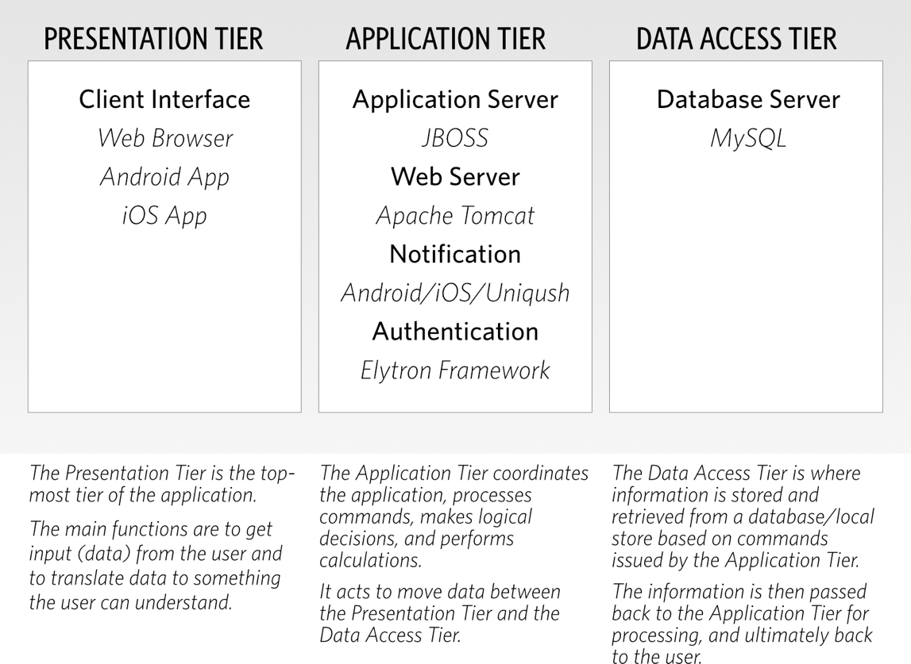This architectural layout is shown in Figure 3 below.

Figure 3 - Application Tier Structure Diagram

# Workflows

## Workflow

The main process of Customer Order is:

1. Customer contacts OC Pizza Store to Order Pizza;
2. Order Desk obtains phone number, looks up Customer data if prior customer, or gets customer details if first time ordering;
3. Customer chooses Pizza Type (toppings/crust) from menu (no special orders) and number of pizzas in Order;
4. Customer provides Delivery Location for Order;
5. Order Desk repeats Order to verify, including Total Cost;
   1. Revise Order if Order is not correct/changed;
6. Customer Payment method is determined:
   1. Customer pays in advance: payment details are obtained (credit card number, etc.);
   2. Customer pays delivery person: order total is provided and optionally ask if change will be needed;
7. Order Desk completes Order, Pass to Store Manager at Store nearest delivery address;
8. Customer can modify pizza type from menu, with applicable update in pricing;
   1. If customer paid by credit card, refund difference if revised order is less than original order or create new credit card bill for difference if order is more than original order;
   2. 8.2. If customer is to pay in cash/at in-store pickup, revise bill total;
9. Store Manager oversees Pizza making process (see below for Store Manager process):
   1. Pizzaiolos to make Order following pizza recipes;
   2. Pizzaiolos send complete Order to Cashier;
   3. Cashier Prepares Order for Delivery
      1. 9.3.1. In case of in-store pickup: Receives money from Customer and gives Customer Order
      2. 9.3.2. Otherwise, Delivery Person Delivers Order to Customer;

**Processes, cont.**

The main process of Store Manager is:

1. Manage Orders (per process above);
2. Manage Users in IT System, including
3. Staff (names, login name, password, storeID)
4. Customers (names, phone numbers, past delivery destinations, login name, password)
5. Oversee Stock Management System:
6. Track existing stock to determine items to be ordered;
7. Track recipes for current order (for Pizzaiolos);
8. System deducts ingredients from current Order from store stock:
   1. If at the time of the order it is determined (calculated) that the ingredients will not be sufficient, the Order desk will be notified, and the customer informed that they must change their order;
9. Manage Notifications:
10. Pizzaiolos to Notify current order status:
11. Notify Customer when Order cannot be changed (when pizza is about to be baked).
12. Notify Customer when Order is out for Delivery and Delivered.

# Application

The user application is an app that can be run on a mobile device or accessed via a web page. For simplicity, it will be referred to as 'the application' regardless the form it takes. The application acts as a gateway to the Application Server, with required login/password used to assess various functions. The functions, in turn, are dependent on the credentials of the User. In addition, the UI of the application will vary depending on the User credentials - Customers will only see data and functionality relevant to customers, employees will see data relevant for their position, etc. In this way a customer could only submit data specific to their use case (i.e., it would be impossible for a customer to make changes to the stock system as this functionality would not be present in the application).

The application allows customers to edit their personal information, such as login name/password, addresses for delivery, and possibly credit card information. In addition, the customer will use the application to create orders, and will receive notifications based on the status of their order.

Employees can access various functions depending on their login credentials. For example, a cashier/order desk (or similar position) will be allowed to create and edit orders, accepts payment for orders, and can update order status. The pizzaiolos will have access to specific orders to view order contents and recipes (but not be allowed to edit/alter orders). Finally, the manager will be able to do all the above, and in addition view store stock (inventory), and order status and details on the order. All data is passed on from the application to the AS using REST API utilizing HTTPs protocol.

*The Application Server*

The Application Server acts as communication center for all activities. The User accesses the AS via Representational State Transfer (REST) API, using HTTPs protocol for secure communication. Transactions via HTTPs include POST, PUT (for creating and updating records), GET (for retrieving records/results), and DELETE (for deleting records) commands. The AS will control User access based on user credentials. The application server receives commands from the User application, and processes them. Communication between the AS and the DBMS follows the DBMS required communication protocols, but ultimately, the AS creates SQL commands which the DBMS processes. Response from the DBMS depends on the system used, but typically consists of response tables which the AS then decodes and forwards on to the User application in JSON format.

*Database Management System*

The final element in the system is the database itself. The DBMS stores and retrieves data - no programming logic is involved, and no calculations on the data are carried out. Data is stored using a MySQL database.

*Physical AS/DBMS System*

The AS and DBMS server can be located at the OC Pizza headquarters or utilize a cloud-based system such as Amazon Web Services (AWS) or Microsoft Azure web services, among other similar services. While having the server located in-house seems to be the best choice, it requires professional support (security, server room, dedicated lease line, proper backups, etc.) which OC Pizza may not have or which would be too expensive. As such, a cloud-based system, provided by a reputable company such as Amazon or Microsoft is recommended.

## Actors

|  |  |
| --- | --- |
| **Actor/Key Player** | **Action Performed** |
| Customer | Place order either via call to Call Center or via web site order system; modify or cancel order |
| Call Desk | Receive Customer order via call or web site order system, pass on to proper Store Manager |
| Store Manager | Controls store processes oversees orders, stock, and is IT Administrator |
| Cashier | Receive order from Store Manager along with payment details. Sees to delivery. |
| Pizzaiolo | Make pizza from order received by Store Manager, pass pizza back to Cashier when completed |
| Delivery Person | Receive pizza from Cashier, deliver to Customer |
| Stock System | Overseen by Store manager, keeps track of the stock and notifies Store Manager when stock is low or if orders cannot be completed due to low stock |

## Use cases

### Customer Use Cases

#### UC1 – Customer Phone Order

|  |  |
| --- | --- |
| Identifier | UC1 – CPO |
| Description | Customer Contacts OC Pizza CO by phone to order pizza |
| Preconditions | * Call made during business hours; * Order desk available to take call; * Order system is online and functional; * Caller orders reasonable quantities and pizza type |
| Input data | * Order – Pizza type(s) and quantities * Customer information – Contact/Delivery details * Customer payment details – cash/credit card/payment on pickup |
| Main success scenario | 1. Customer Orders pizza |
| Result | Pizza Order is received and saved to order system |
| Errors | * Wrong number; * Call system failure * Order desk too slow to answer/unavailable; * Order system is offline; * Failure of payment processing system (if using credit card); * Pizza type/ingredient is unavailable |

#### UC2 – Customer Online Order

|  |  |
| --- | --- |
| Identifier | UC2 – COO |
| Description | Customer Contacts OC Pizza CO online (web or mobile app) to order pizza |
| Preconditions | * Order made during business hours; * Order desk available to process order; * Order system is online and functional; * Caller orders reasonable quantities and pizza type |
| Input data | * Order – Pizza type(s) and quantities * Customer information – Contact/Delivery details * Customer payment details – cash/credit card/payment on pickup |
| Main success scenario | 1. Customer Orders pizza |
| Result | Pizza Order is received and saved to order system |
| Errors | * Order system failure * Order desk unable to process order – pizza type/quantity incorrect; * Failure of payment processing system (if using credit card); * Order system is offline; * Pizza type/ingredient is unavailable |

#### UC3 – Process Customer Order

|  |  |
| --- | --- |
| Identifier | UC3 – PCO |
| Description | OC Pizza processes customer order |
| Preconditions | * UC1/UC2 Preconditions met and successful; * Order desk passes order to store manager at location nearest customer; * All ingredients available for fulfilling order; * Manager passes order to Pizzaiolos; |
| Input data | * Order – Pizza type(s) and quantities |
| Main success scenario | 1. Pizza Co processes customer order for pizza |
| Result | Pizza order passes manager and given to Pizzaiolos to cook |
| Errors | * Error in ingredient stock at shop making pizza, pizza can’t be made; * Store Manager makes error passing pizza order to Pizzaiolos; |

#### UC4 – Cook Customer Order

|  |  |
| --- | --- |
| Identifier | UC4– CCO |
| Description | OC Pizza prepares pizza/order items |
| Preconditions | * UC1/UC2/UC3 Preconditions met and successful; * Pizziaolos available to make pizza * Delivery available |
| Input data | * Order – Pizza type(s) and quantities |
| Main success scenario | 1. Pizza cooked properly and handed off for final delivery |
| Result | Pizza is cooked and readied for delivery |
| Errors | * Pizziaolo makes error in preparing/cooking pizza – known error resulting in delay * Pizziaolo makes error in preparing/cooking pizza – unknown error (ie, order incorrect or Pizziaolo does not know pizza is not prepared according to order; |

#### UC5 – Delivery Customer’s Order

|  |  |
| --- | --- |
| Identifier | UC5 – DCO |
| Description | OC Pizza delivers pizza and closes out order |
| Preconditions | * UC1/UC2/UC3/UC4 Preconditions met and successful; * Pizza delivery method known and followed (customer pick up or delivery); * Delivery available |
| Input data | * Order – Pizza type(s) and quantities * Order – Customer contact and Location of delivery |
| Main success scenario | 1. Pizza delivered successfully to customer |
| Result | Pizza is delivered and order completed |
| Errors | * Customer does not pick up pizza at shop (doesn’t show up or refuses order); * Customer pick up at shop but payment failure (CC not approved); * Deliver wrong order; * Delivery cannot be made – improper address or wrong address given; * Delivery cannot collect payment; |

### Shop Manager Use Cases

#### MUC1 – Manage Users Case

|  |  |
| --- | --- |
| Identifier | MUC1 – MUC |
| Description | Manage users in management system, including staff and customers |
| Preconditions | * Management System up; * Needed data readily available |
| Input data | * Customer: Name and Contact Information, login, password * Staff: As above, storeID, position |
| Main success scenario | 1. Update user information in management system |
| Result | Management system updated with new/revised user information |
| Errors | * Management system not available; * Incorrect information added; * Incorrect information provided to Manager |

#### MUC2 – Manage Stock

|  |  |
| --- | --- |
| Identifier | MUC2 – MS |
| Description | Manage stock at shop; |
| Preconditions | * Management System up; |
| Input data | * Output: Existing stock levels for all ingredients at store; * Output: Current orders being processed – track recipe quantities (to be provided to Pizzaiolo); * Output: Stock levels after current orders completed * Output: Stock warning levels when new stock is needed |
| Main success scenario | 1. Stock levels checked to ensure proper amount, order more if amount is too low |
| Result | Management system updated with current stock levels |
| Errors | * Management system not available; * Incorrect information in current orders – wrong pizza type, or recipe is wrong in system;; * Ignore notification to buy new stock |

#### MUC3 – Manage Notifications

|  |  |
| --- | --- |
| Identifier | MUC2 – MS |
| Description | Manage notification system; |
| Preconditions | * Management System up; * Notification system up; * Notifications pending |
| Input data | * Condition triggering notifications:   + Current Order Status changed   + Pizza assembled; customer cannot change order;   + Pizza being delivered;   + Stock level to be replenished |
| Main success scenario | 1. Notification issued properly |
| Result | Management system issued proper notification at the correct time |
| Errors | * Notification incorrect (wrong notification issued); * Notification not issued; * Notification sent at wrong time – prior to event or well after event; |

## General management rules

The OC Pizza company would like to set up an information technology measuring system for each of its existing five stores (and extended to at least eight stores by end of the year) which performs the following functions:

1. Efficiently manage all orders (web and phone);
2. Allow customers to modify existing orders (add ingredients to pizza);
3. Allow customers to cancel order;
4. Track orders placed and preparation in real time;
5. Track stock to know which pizzas are available/when additional stock must be ordered;
6. Assist Pizzaiolos in pizza recipe;
7. Allow customers to place orders by phone or on the website;
8. Allow customers to pay online or upon pizza delivery;
9. Allow customers to modify or cancel orders at any time prior to pizza being baked;

Notify customers of the status of their order;

## Workflow

The main process of Customer Order is:

1. Customer contacts OC Pizza Store to Order Pizza;
2. Order Desk obtains phone number, looks up Customer data if prior customer, or gets customer details if first time ordering;
3. Customer chooses Pizza Type (toppings/crust) from menu (no special orders) and number of pizzas in Order;
4. Customer provides Delivery Location for Order;
5. Order Desk repeats Order to verify, including Total Cost;
   1. Revise Order if Order is not correct/changed;
6. Customer Payment method is determined:
   1. Customer pays in advance: payment details are obtained (credit card number, etc.);
   2. Customer pays delivery person: order total is provided and optionally ask if change will be needed;
7. Order Desk completes Order, Pass to Store Manager at Store nearest delivery address;
8. Customer can modify pizza type from menu, with applicable update in pricing;
   1. If customer paid by credit card, refund difference if revised order is less than original order or create new credit card bill for difference if order is more than original order;
   2. If customer is to pay in cash/at in-store pickup, revise bill total;
9. Store Manager oversees Pizza making process (see below for Store Manager process):
   1. Pizzaiolos to make Order following pizza recipes;
   2. Pizzaiolos send complete Order to Cashier;
   3. Cashier Prepares Order for Delivery
      1. In case of in-store pickup: Receives money from Customer and gives Customer Order
      2. Otherwise, Delivery Person Delivers Order to Customer;

The main process of Store Manager is:

1. Manage Orders (per process above);
2. Manage Users in IT System, including
   1. Staff (names, login name, password, storeID)
   2. Customers (names, phone numbers, past delivery destinations, login name, password)
3. Oversee Stock Management System:
   1. Track existing stock to determine items to be ordered;
   2. Track recipes for current order (for Pizzaiolos);

The main process of Store Manager, continued…

* 1. System deducts ingredients from current Order from store stock:
     1. If at the time of the order it is determined (calculated) that the ingredients will not be sufficient, the Order desk will be notified, and the customer informed that they must change their order;

1. Manage Notifications:
   1. Pizzaiolos to Notify current order status:
   2. Notify Customer when Order cannot be changed (when pizza is about to be baked).
   3. Notify Customer when Order is out for Delivery and Delivered.