FINAL PROJECT - PHASE 1

Charlie Wilds and Steven Booksh

3/1/2021

student <- read.csv("ames_student.csv")

# CHECKING FOR MISSING DATA

vis_miss(student)

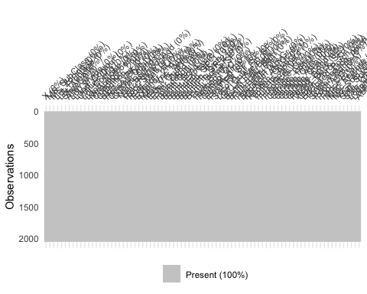

## OBSERVATION AND VARIABLE TOTALS

nrow(student)

## [1] 2053

ncol(student)

## [1] 82

## STRUCTURE AND SUMMARY OF DATA SET

# str(student)  
# summary(student)

## RECODING CHARACTER VARIABLES INTO FACTORS

student = student %>%  
mutate(MS_SubClass=as_factor(MS_SubClass), MS_Zoning=as_factor(MS_Zoning), Street=as_factor(Street), Alley=as_factor(Alley), Lot_Shape=as_factor(Lot_Shape), Land_Contour=as_factor(Land_Contour), Utilities=as_factor(Utilities), Lot_Config=as_factor(Lot_Config), Land_Slope = as_factor(Land_Slope), Neighborhood = as_factor(Neighborhood), Condition_1 = as_factor(Condition_1), Condition_2 = as_factor(Condition_2), Bldg_Type = as_factor(Bldg_Type), House_Style = as_factor(House_Style), Overall_Qual = as_factor(Overall_Qual), Overall_Cond = as_factor(Overall_Cond), Roof_Style = as_factor(Roof_Style), Roof_Matl = as_factor(Roof_Matl), Exterior_1st = as_factor(Exterior_1st), Exterior_2nd = as_factor(Exterior_2nd), Mas_Vnr_Type = as_factor(Mas_Vnr_Type), Mas_Vnr_Area = as_factor(Mas_Vnr_Area), Exter_Qual = as_factor(Exter_Qual), Exter_Cond = as_factor(Exter_Cond), Foundation = as_factor(Foundation), Bsmt_Qual = as_factor(Bsmt_Qual), Bsmt_Cond =as_factor(Bsmt_Cond), Bsmt_Exposure = as_factor(Bsmt_Exposure), BsmtFin_Type_1 = as_factor(BsmtFin_Type_1), BsmtFin_Type_2 = as_factor(BsmtFin_Type_2), Heating =as_factor(Heating), Heating_QC = as_factor(Heating_QC), Central_Air = as_factor(Central_Air), Electrical = as_factor(Electrical), Kitchen_Qual = as_factor(Kitchen_Qual), Functional = as_factor(Functional), Fireplace_Qu = as_factor(Fireplace_Qu), Garage_Type = as_factor(Garage_Type), Garage_Finish = as_factor(Garage_Finish), Garage_Qual = as_factor(Garage_Qual), Garage_Cond = as_factor(Garage_Cond), Paved_Drive =as_factor(Paved_Drive), Pool_QC = as_factor(Pool_QC), Fence = as_factor(Fence), Misc_Feature = as_factor(Misc_Feature), Sale_Type = as_factor(Sale_Type), Sale_Condition = as_factor(Sale_Condition))

## RANDOM FOREST MODEL

rf_recipe = recipe(Above_Median ~., student) %>%  
 step_dummy(all_nominal(), -all_outcomes())  
  
rf_model = rand_forest() %>%   
 set_engine("ranger", importance = "permutation") %>%   
 set_mode("classification")  
  
rf_wflow =   
 workflow() %>%   
 add_model(rf_model) %>%   
 add_recipe(rf_recipe)  
  
set.seed(123)  
rf_fit = fit(rf_wflow, student)  
  
rf_fit

## ══ Workflow [trained] ══════════════════════════════════════════════════════════  
## Preprocessor: Recipe  
## Model: rand_forest()  
##   
## ── Preprocessor ────────────────────────────────────────────────────────────────  
## 1 Recipe Step  
##   
## ● step_dummy()  
##   
## ── Model ───────────────────────────────────────────────────────────────────────  
## Ranger result  
##   
## Call:  
## ranger::ranger(x = maybe_data_frame(x), y = y, importance = ~"permutation", num.threads = 1, verbose = FALSE, seed = sample.int(10^5, 1), probability = TRUE)   
##   
## Type: Probability estimation   
## Number of trees: 500   
## Sample size: 2053   
## Number of independent variables: 682   
## Mtry: 26   
## Target node size: 10   
## Variable importance mode: permutation   
## Splitrule: gini   
## OOB prediction error (Brier s.): 0.0614444

## **VARIABLE IMPORTANCE**

rf_fit %>% pull_workflow_fit() %>% vip(geom = "point")

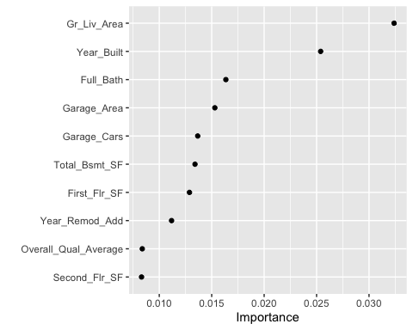

# **STRONG PREDICTORS OF Above_Median HOME SALES VARIABLE**

### *VISUALIZATION FOR Ground Living Area (Gr_Liv_Area)*

ggplot(student, aes(x=Gr_Liv_Area,fill=Above_Median)) + geom_histogram(binwidth=250) + theme_bw()

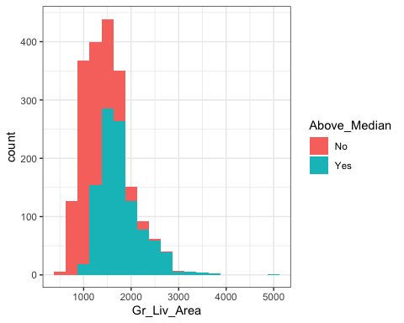

### *VISUALIZATION FOR Year Built (Year_Built)*

ggplot(student, aes(x=Above_Median,y=Year_Built)) + geom_boxplot(aes(fill=Above_Median)) + theme_bw() + geom_jitter(alpha=.2)

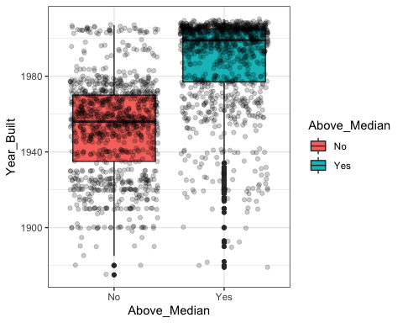

### *VISUALIZATION FOR Garage Cars (Garage_Cars)*

ggplot(student, aes(x=Garage_Cars,fill=Above_Median)) + geom_bar() + theme_bw()

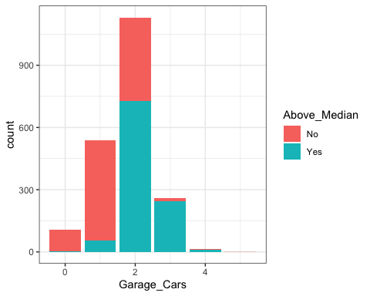

### *ADDITIONAL TABLE FOR Garage Cars (Garage_Cars)*

t1 = table(student$Above_Median, student$Garage_Cars)  
prop.table(t1, margin = 2)

##   
## 0 1 2 3 4 5  
## No 0.96296296 0.89610390 0.35632184 0.06130268 0.23076923 1.00000000  
## Yes 0.03703704 0.10389610 0.64367816 0.93869732 0.76923077 0.00000000

### *VISUALIZATION FOR Garage Area (Garage_Area)*

ggplot(student, aes(x=Garage_Area,fill=Above_Median)) + geom_histogram(binwidth=200) + theme_bw()

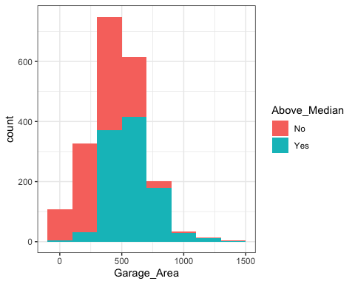

### *VISUALIZATION FOR Full Bathrooms (Full_Bath)*

ggplot(student, aes(x=Full_Bath,fill=Above_Median)) + geom_bar() + theme_bw()

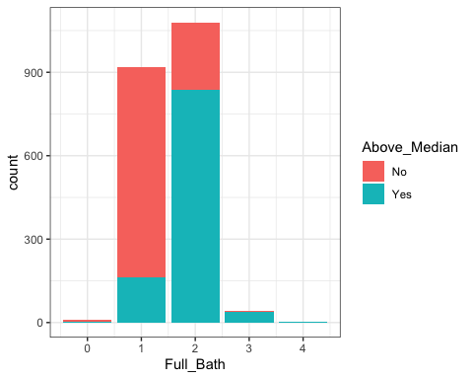

### *ADDITIONAL TABLE FOR Full Bathrooms (Full_Bath)*

t1 = table(student$Above_Median, student$Full_Bath)  
prop.table(t1, margin = 2)

##   
## 0 1 2 3 4  
## No 0.70000000 0.82500000 0.22500000 0.02439024 0.00000000  
## Yes 0.30000000 0.17500000 0.77500000 0.97560976 1.00000000

### *VISUALIZATION FOR Total Basement Square Footage (Total_Bsmt_SF)*

ggplot(student, aes(x=Total_Bsmt_SF,fill=Above_Median)) + geom_histogram(binwidth=300) + theme_bw()

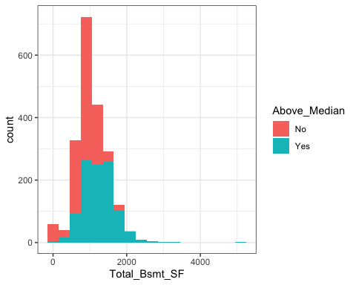

### *VISUALIZATION FOR First Floor Square Footage (First_Flr_SF)*

ggplot(student, aes(x=First_Flr_SF,fill=Above_Median)) + geom_histogram(binwidth=350) + theme_bw()

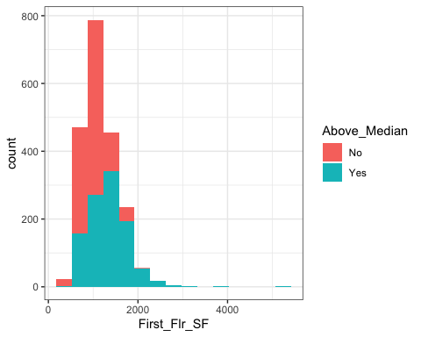

### *VISUALIZATION FOR Year Home was Remodeled (Year_Remod_Add)*

ggplot(student, aes(x=Above_Median,y=Year_Remod_Add)) + geom_boxplot(aes(fill=Above_Median)) + theme_bw() + geom_jitter(alpha=0.2)

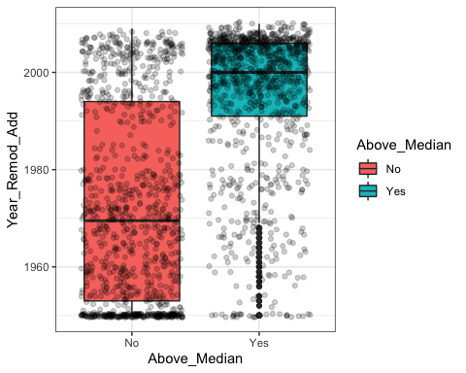

## **WEAK PREDICTORS OF Above_Median HOME SALES VARIABLE**

### *VISUALIZATION FOR Utilities (Utilities)*

ggplot(student, aes(x=Utilities, fill=Above_Median)) + geom_bar() + theme_bw()

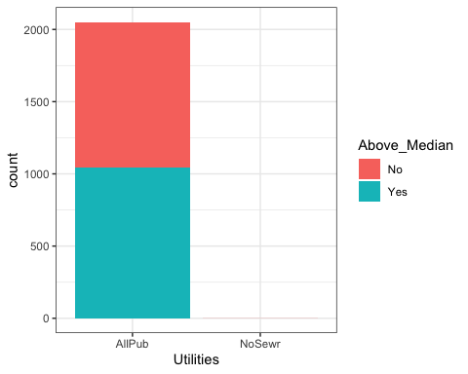

### *VISUALIZATION FOR Roof Style (Roof_Style)*

ggplot(student, aes(x=Roof_Style,fill=Above_Median)) + geom_bar() + theme_bw()

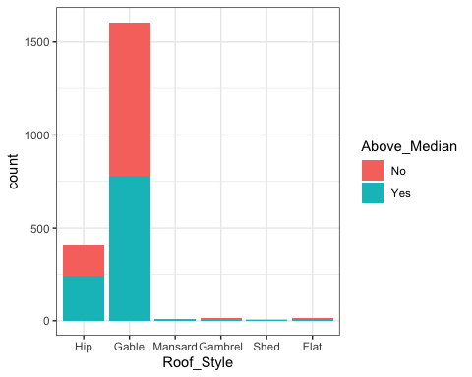

### *VISUALIZATION FOR Street Type (Street)*

ggplot(student, aes(x=Street, fill=Above_Median)) + geom_bar() + theme_bw()

