Encapsulation
Encapsulation is the process of binding both attributes and methods together within a class. Through encapsulation, the internal details of a class can be hidden from outside. It permits the elements of the class to be accessed from outside only through the interface provided by the class.

Data Hiding
Typically, a class is designed such that its data (attributes) can be accessed only by its class methods and insulated from direct outside access. This process of insulating an object’s data is called data hiding or information hiding.

Inheritance
Inheritance is the mechanism that permits new classes to be created out of existing classes by extending and refining its capabilities. The existing classes are called the base classes/parent classes/super-classes, and the new classes are called the derived classes/child classes/subclasses. The subclass can inherit or derive the attributes and methods of the super-class(es) provided that the super-class allows so. Besides, the subclass may add its own attributes and methods and may modify any of the super-class methods. Inheritance defines an “is – a” relationship.

Types of Inheritance
- Single Inheritance − A subclass derives from a single super-class.
- Multiple Inheritance − A subclass derives from more than one super-classes.
- Multilevel Inheritance − A subclass derives from a super-class which in turn is derived from another class and so on.
- Hierarchical Inheritance − A class has a number of subclasses each of which may have subsequent subclasses, continuing for a number of levels, so as to form a tree structure.
- Hybrid Inheritance − A combination of multiple and multilevel inheritance so as to form a lattice structure.

Polymorphism
Polymorphism is originally a Greek word that means the ability to take multiple forms. In object-oriented paradigm, polymorphism implies using operations in different ways, depending upon the instance they are operating upon. Polymorphism allows objects with different internal structures to have a common external interface. Polymorphism is particularly effective while implementing inheritance.
Example
Let us consider two classes, Circle and Square, each with a method findArea(). Though the name and purpose of the methods in the classes are same, the internal implementation, i.e., the procedure of calculating area is different for each class. When an object of class Circle invokes its findArea() method, the operation finds the area of the circle without any conflict with the findArea() method of the Square class.

Generalization and Specialization
Generalization and specialization represent a hierarchy of relationships between classes, where subclasses inherit from super-classes.

Generalization
In the generalization process, the common characteristics of classes are combined to form a class in a higher level of hierarchy, i.e., subclasses are combined to form a generalized super-class. It represents an “is – a – kind – of” relationship. For example, “car is a kind of land vehicle”, or “ship is a kind of water vehicle”.

Specialization
Specialization is the reverse process of generalization. Here, the distinguishing features of groups of objects are used to form specialized classes from existing classes. It can be said that the subclasses are the specialized versions of the super-class.
The following figure shows an example of generalization and specialization.
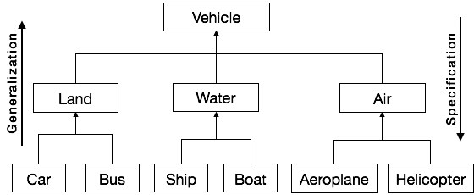

Links and Association

The features of message passing are −
- Message passing between two objects is generally unidirectional.
- Message passing enables all interactions between objects.
- Message passing essentially involves invoking class methods.
- Objects in different processes can be involved in message passing.

