
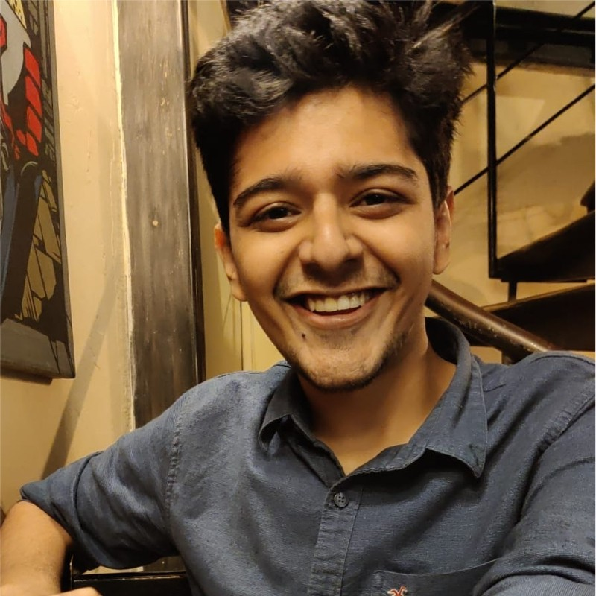
Shubhankar Borse
Staff AI Research Scientist

Generative AI, Multimodal Models, Video Generation, and Model Efficiency. 30+ papers, 120+ patent filings and ~1,000 citations.





470 343 3652 / shubhankar8@gmail.com / shubhankarborse / GoogleScholar


Patents / Webpage
U.S. Permanent Resident (Green Card holder) · No sponsorship required

EXPERIENCE Qualcomm AI Research, Santa Clara · Feb 2019 – Present

Staff AI Researcher Nov 2023 – Present
Heading and Directing Research & Commercial Projects
- Headed the vision-token compression project for multimodal models, directing research and commercialization efforts across multiple teams, with demonstrations on Snapdragon phones.
- Directed a year-long, cross-functional research initiative in multi-concept personalization using Reinforcement Learning, resulting in papers at NeurIPS 2025, CVPR 2026 and a live demo at NeurIPS 2025.
- Mentored research teams working on physically grounded video generation, motion-aware video retrieval, and relighting with video diffusion.
- Lead research on parameter-efficient finetuning and drove commercial efforts for zero-shot personalization and LoRA adapters.

Sr. AI Researcher Nov 2021 – Nov 2023
Cross-domain research & mobile demonstrations
- Built and demonstrated the 0.5-second Stable Diffusion running on phones.
- Led panoptic and semantic segmentation for camera, autonomous driving, and XR; built open-vocabulary panoptic segmentation showcased at CES 2024.
- Led a cross-team effort on multimodal camera–radar–LiDAR research for BEV and 3D perception presented at CVPR23 and WACV23.

Deep Learning Researcher Feb 2019 – Nov 2021
Individual project ownership & algorithm development
- Owned segmentation, depth estimation, and multi-task learning projects for autonomous driving and XR, presented at CVPR21, WACV21, BMVC21.
- Demonstrated an efficient real-time 4K mobile video segmentation running on a smartphone at NeurIPS 2020 and ICIP 2021.
- Designed an on-device CNN fingerprint anti-spoofing algorithm used in commercial smartphones.

KLA-Tencor, Milpitas · May – Aug 2018
Machine Learning Algorithms Intern
- Developed a layer-wise interpretability metric for CNNs, integrated it into a product, and used it to improve model performance.
PUBLICATIONS Some First-Authored Papers
- Ar2Can: An Architect and an Artist Leveraging a Canvas for Multi-Human Generation (CVPR 2026)
- Resolving the Identity Crisis in Text-to-Image Generation (CVPR 2026)
- MultiHuman-Testbench: Benchmarking Image Generation for Multiple Humans (NeurIPS Datasets & Benchmarks 2025)
- SubZero: Composing Subject, Style, and Action via Zero-Shot Personalization (arXiv preprint 2025)
- FouRA: Fourier Low-Rank Adaptation (NeurIPS 2024)
- PosSAM: Panoptic Open-vocabulary Segment Anything (arXiv preprint 2024; co-first author)
- DejaVu: Conditional Regenerative Learning to Enhance Dense Prediction (CVPR 2023)
- X3KD: Knowledge Distillation Across Modalities, Tasks and Stages for Multi-Camera 3D Object Detection (CVPR 2023; co-first author)
- X-Align: Cross-Modal Cross-View Alignment for Bird's-Eye-View Segmentation (WACV 2023)
- Panoptic, instance and semantic relations: A relational context encoder to enhance panoptic segmentation (CVPR 2022)
- HS3: Learning with Proper Task Complexity in Hierarchically Supervised Semantic Segmentation (BMVC 2021)
- InverseForm: A Loss Function for Structured Boundary-Aware Segmentation (CVPR (Oral) 2021)
Some Co-Authored Papers
- HiPhy: Hierarchical Alignment for Physically-Plausible Multi-Principle Video Generation (arXiv preprint 2026)
- Zero-Shot Adaptation of Parameter-Efficient Fine-Tuning in Diffusion Models (ICML 2025)
- LoRA-X: Bridging Foundation Models with Training-Free Cross-Model Adaptation (ICLR 2025)
Complete publication list on Google Scholar
PATENTS 120+ filings · 13+ granted patents
Research Areas:
- Generative AI: Diffusion models, zero-shot personalization, content–style composition, image editing, and blended output generation.
- Efficient Models & Adaptation: Fourier and sparse adapters, training-free adapter transfer, diffusion distillation, hardware-aware architectures, and test-time adaptation.
- Computer Vision: Panoptic and semantic segmentation, BEV perception, depth completion, point-cloud processing, and boundary-aware learning.
- Multimodal & Sensor Fusion: Camera–radar–LiDAR integration, occlusion handling, intermodal training, and adaptive confidence mechanisms.
- Security & Watermarking: Video and image watermarking, and adversarial robustness.
EDUCATION Master of Science in Electrical and Computer Engineering – December 2018
Georgia Institute of Technology, Atlanta
- GPA 4.0/4.0
- Specialization in Computer Vision and Machine Learning
Bachelor of Technology in Electronics and Telecommunication Engineering – May 2017
Veermata Jijabai Technological Institute, Mumbai
- GPA 9.1/10
- Specialization in Image and Signal Processing
AWARDS Awards & Recognition
- NeurIPS Top Reviewer 2026
- Qualcomm Distinguished Invention Award 2025
Recognized for the invention “Regional Island Attention in Multi-Human Generation.”
- CVPR Best Demo Award — Honorable Mention 2022
Real-time, accurate, and consistent video semantic segmentation on a mobile device.
- Qualcomm CTO Award 2022
- Qualcomm Qualstar Award 2019
On-device quantizable fingerprint anti-spoofing algorithm.
SERVICE Reviewing & Academic Service
- ~100 Papers Peer-Reviewed
          - NeurIPS 2022–2026: Reviewer.
          - CVPR 2022–2026: Reviewer.
          - ICLR 2025–2026: Reviewer.
          - AAAI 2024–2026: Committee member.
          - WACV 2023–2025: Reviewer.
          - Peer review for multiple journals.
- Workshop Chair, Omnidirectional Computer Vision (OmniCV), CVPR 2022 and 2023.
- Keynote speaker, OmniCV 2023: Detection and segmentation in BEV using near-field surround cameras.

