Chapter 1
INTRODUCTION
Cloud computing and storage solutions provide users and enterprises with various capabilities to store and process their data in third-party data centers. It relies on sharing of resources to achieve coherence and economies of scale, similar to a utility (like the electricity grid) over a network. At the foundation of cloud computing is the broader concept of converged infrastructure and shared services.
Cloud computing, or in simpler shorthand just "the cloud", also focuses on maximizing the effectiveness of the shared resources. Cloud resources are usually not only shared by multiple users but are also dynamically reallocated per demand. This can work for allocating resources to users. For example, a cloud computer facility that serves European users during European business hours with a specific application (e.g., email) may reallocate the same resources to serve North American users during North America's business hours with a different application (e.g., a web server). This approach should maximize the use of computing power thus reducing environmental damage as well since less power, air conditioning, rack space, etc. are required for a variety of functions. With cloud computing, multiple users can access a single server to retrieve and update their data without purchasing licenses for different applications.
In the shift from on-premises software to cloud computing, IT teams are still paying consulting and support fees that may be unnecessary. That's about to change. Businesses seem to have accepted that cloud computing leads to lower IT costs, and it’s true that many companies experience some savings in switching to the cloud. Yet, the total cost of ownership for most is still up to 50% more than it should be. Here’s why. Companies still assume that the software buying and deployment process is the same for cloud and on-premises products. They persist with the old model and end up paying for consulting and support services that are redundant or available for free.
In the world of on-premises software, the buying cycle typically begins with a consultant helping with software selection. The vendor then cashes the license check, and consultants charge for customizing and implementing the system. Once it’s deployed, support, upgrades and maintenance carry costs for years to come. In other words, a company starts paying for consulting before even buying the software, and continues to pay for services (or hire IT staff) throughout the life of the software. The total cost of services for selection, implementation, maintenance and support ranges from 40% to 100% of the cost of software.
In the world of cloud apps, it shouldn’t be that way. For one thing, it’s cheaper and less risky to try a cloud product than it is to perform software evaluation. Consultants have traditionally made lots of money helping companies with software selection. At $150 an hour, a consultant may charge $12,000 to $24,000 (two to four weeks) in consulting fees to help a company with its decision. This approach is now outdated. In the cloud, for $6,000 to $8,000 you can buy an annual subscription to most cloud products that a team can pilot test for a year. If it works, you can expand usage to the rest of the organization.
Cloud computing also enables a long tail of service providers. Small vendors can leverage public cloud infrastructure to serve niche markets. That means companies don’t need to customize a cloud platform like Salesforce or Google to meet their needs. Instead, they use marketplaces like Salesforce’s AppExchange or Google Apps Marketplace to find what they need and, in doing so, save significant consulting dollars.
Implementation costs for cloud products are 20% or less than those for on-premises software. That’s because cloud apps are multitenant, which means the IT platform – and costs – are shared by customers. Also, the great variety of commercial cloud products ensures a better fit out-of-the-box, which means implementation costs go down. In fact, several cloud providers don’t charge any implementation fees. Cloud apps are ready in days, sometimes hours. True cloud providers don’t charge for maintenance and support. They operate on a subscription model and, because they want you as a long-term customer, they will probably spend time and effort to keep your company happy. Choosing the right provider helps avoid maintenance and support costs altogether.
Recently, multi-cloud data hosting has received wide attention from researchers, customers, and startups. The basic principle of multi-cloud (data hosting) isto distribute data across multiple clouds to gain enhanced redundancy and prevent the vendor lock-in risk, as shown Recently, multi-cloud data hosting
has received wide attention from researchers, customers, and startups. The basic principle of multi-cloud (data hosting) Is to distribute data across multiple clouds to gain enhanced redundancy and prevent the vendor lock-in risk, The “proxy” component plays a key role by redirecting requests from client applications and coordinating data distribution among multiple clouds.
The system propose and implement CHARM, a novel, efficient, and heuristic-based data hosting scheme for heterogenous multi-cloud environments. CHARM accommodates different pricing strategies, availability requirements, anddata access patterns. It selects suitable clouds and an appropriate redundancy strategy to store data with minimized monetary cost and guaranteed availability.

Chapter 2
DOMAIN EXPLANATION

Cloud Computing:
Cloud computing describes a type of outsourcing of computer services, similar to the way in which electricity supply is outsourced. Users can simply use it. They do not need to worry where the electricity is from, how it is made, or transported. Every month, they pay for what they consumed.
The idea behind cloud computing is similar: The user can simply use storage, computing power, or specially crafted development environments, without having to worry how these work internally. Cloud computing is usually Internet-based computing. The cloud is a metaphor for the Internet based on how the internet is described in computer network diagrams; which means it is an abstraction hiding the complex infrastructure of the internet. It is a style of computing in which IT-related capabilities are provided “as a service”, allowing users to access technology-enabled services from the Internet ("in the cloud")without knowledge of, or control over the technologies behind these servers.
According to a paper published by IEEE Internet Computing in 2008 "Cloud Computing is a paradigm in which information is permanently stored in servers on the Internet and cached temporarily on clients that include computers, laptops, handhelds, sensors, etc."
Cloud computing is a general concept that utilizes software as a service (SaaS), such as Web 2.0 and other technology trends, all of which depend on the Internet for satisfying users' needs. For example, Google Apps provides common business applications online that are accessed from a web browser, while the software and data are stored on the Internet servers.
Cloud computing is often confused with grid computing (a form of distributed computing whereby a "super and virtual computer" is composed of a cluster of networked, loosely-coupled computers, working together to perform very large tasks), utility computing (the packaging of computing resources, such as computation and storage are provided as a measured service that have to be paid similar to a traditional public utility such as electricity) and autonomic computing (computer systems capable of self-management).
Many cloud computing deployments are powered by grids, have autonomic characteristics and are billed like utilities, but cloud computing can be seen as a natural next step from the grid-utility model. Some successful cloud architectures have little or no centralised infrastructure or billing systems at all including peer-to-peer networks like BitTorrent and Skype.
The majority of cloud computing infrastructure currently consists of reliable services delivered through data centers that are built on computer and storage virtualization technologies. The services are accessible anywhere in the world, with The Cloud appearing as a single point of access for all the computing needs of consumers. Commercial offerings need to meet the quality of service requirements of customers and typically offer service level agreements. Open standards and open source software are also critical to the growth of cloud computing. As customers generally do not own the infrastructure or know all details about it, mainly they are accessing or renting, so they can consume resources as a service, and may be paying for what they do not need, instead of what they actually do need to use. Many cloud computing providers use the utility computing model which is analogous to how traditional public utilities like electricity are consumed, while others are billed on a subscription basis. By sharing consumable and "intangible" computing power between multiple "tenants", utilization rates can be improved (as servers are not left idle) which can reduce costs significantly while increasing the speed of application development. A side effect of this approach is that "computer capacity rises dramatically" as customers do not have to engineer for peak loads. Adoption has been enabled by "increased high-speed bandwidth" which makes it possible to receive the same response times from centralized infrastructure at other sites.
Cloud computing is being driven by providers including Google, Amazon.com, and Yahoo! as well as traditional vendors including IBM, Intel, Microsoft and SAP. It can be adopted by all kinds of users, be they individuals or large enterprises. Most internet users are currently using cloud services, even if they do not realize it. Webmail for example is a cloud service, as are Facebook and Wikipedia and contact list synchronization and online data backups.
The underlying concept dates back to 1960 when John McCarthy expressed his opinion that "computation may someday be organized as a public utility" and the term Cloud was already in commercial use in the early 1990s to refer to large ATM networks. By the turn of the 21st century, cloud computing solutions had started to appear on the market, though most of the focus at this time was on Software as a service.

Chapter 3
EXISTING SYSTEM

In existing system, the system Existing clouds exhibit great heterogeneities in terms of both working performances and pricing policies. Different cloud vendors build their respective infrastructures and keep upgrading them with newly emerging gears. They also design different system architectures and apply various techniques to make their services competitive.

Such system diversity leads to observable performance variations across cloud vendors. The United States Library of Congress had moved its digitized content to the cloud, followed by the New York Public Library and Biodiversity Heritage Library. Now
they only have to pay for exactly how much they have used. Moreover, pricing policies of existing storage services provided by different cloud vendors are distinct in both pricing levels and charging items.

For instance, Rackspace does not charge for Web operations (typically via a series of RESTful APIs), Google Cloud Storage charges more for bandwidth
consumption, while Amazon S3 charges more for storage space. Facing numerous cloud vendors as well as their heterogenous performances/policies, customers may
be perplexed with which cloud(s) are suitable for storing their data and what hosting strategy is cheaper. The general status quo is that customers usually put their data into a single cloud and then simply trust to luck. This is subject to the so-called “vendor lock-in risk”, because customers would be confronted with a dilemma if they want to switch to other cloud vendors.

The vendor lock-in risk first lies in that data migration inevitably generates considerable expense. For example, moving100 TB of data from Amazon S3 (California datacenter) to Aliyun OSS (Beijing datacenter) would consume as much as 12,300 (US) dollars. Besides, the vendor lock-in risk makes customers suffer from price adjustments of cloud vendors which are not uncommon. For ex:, the fluctuation of electricity bills in a region will affect the prices of cloud services in this region. We notice that giant cloud vendors like Windows Azure and Google Cloud Storage have been adjusting their pricing terms.

Unexpected bankruptcy of cloud vendors further aggravates the situation. Nirvanix, which has thousands of customers including top 500 companies, suddenly shut down its cloud storage service in Sep. 2013. Ubuntu One, also a famous Player in the market of cloud storage service, escaped in Apr.2014. Finally, uncontrolled data availability is (in a sense) another type of vendor lock-in risk. Though the service quality is formally guaranteed by service level agreements (SLA), failures and outages do occur. Almost all the major cloud vendors experienced service outages in recent years.

The potential prevalence of multi-cloud is illustrated in three folds. First, there have been a few researches conducted on multi-cloud. DepSky guarantees data availability and security based on multiple clouds, thus allowing critical data (e.g.,medical and financial data) to be trustingly stored. RACS deploys erasure coding among different clouds in order to prevent vender lock-in risk and reduce monetary cost. Second, new types of cloud vendors (e.g., DuraCloud and Cloud Foundry have emerged and rapidly grown up to provide real services based on multiple clouds.

Disadvantages:
- It selects unnecessary clouds to store data. So it makes more cost.
- If the internet service suffers from frequent outages or slow speeds cloud computing may not be suitable for business.
- It has some security issues.

Chapter 4
PROPOSED SYSTEM

In proposed system, the system proposes a novel cost-efficient data hosting scheme with high availability in heterogenous multi-cloud, named “CHARM”. It intelligently puts data into multiple clouds with minimized monetary cost and guaranteed availability. The system combine the two widely used redundancy mechanisms specifically, i.e., replication and erasure coding, into a uniform model to meet the required availability in the presence of different data access patterns. Then systems design an efficient heuristic-based algorithm to choose proper data storage modes (involving both clouds and redundancy mechanisms).

Moreover, the system implements the necessary procedure for storage mode transition (for efficiently re-distributing data) by monitoring the variations of data access patterns and pricing policies. The system propose and implement CHARM, a novel, efficient, and heuristic-based data hosting scheme for heterogenous multi-cloud environments. CHARM accommodates different pricing strategies, availability requirements, and data access patterns. It selects suitable clouds and an appropriate redundancy strategy to store data with minimized monetary cost and guaranteed availability.

The system designs and implements a flexible transition scheme for CHARM. It keeps monitoring the variations of pricing policies and data access patterns, and adaptively triggers the transition process between different data storage modes. It also starts a data migration process among different clouds if necessary. The system evaluates the performance of CHARM using two typical real-world traces and prototype experiments. Both trace-driven simulation and experiment results confirm the efficacy of CHARM.

Workload Statistic keeps collecting and tackling access logs to guide the placement of data. It also sends statistic information to Predictor which guides the action of SMS. Data Hosting stores data using replication or erasure coding,
according to the size and access frequency of the data. SMS decides whether the storage mode of certain data should be changed from replication to erasure coding or in reverse, according to the output of Predictor. The implementation of changing storage mode runs in the background, in order not to impact online service.

Data Hosting and SMS are two important modules in CHARM. Data Hosting decides storage mode and the clouds that the data should be stored in. This is a complex integer programming problem demonstrated.
Advantages:
- It selects suitable clouds and an appropriate redundancy strategy to store data with minimized monetary cost and guaranteed availability.
- It keeps monitoring the variations of pricing policies and data access patterns, and adaptively triggers the transition process between different data storage modes.
- It also starts a data migration process among different clouds if necessary.

Chapter 5
DIAGRAMS
5.1 SYSTEM ARCHITECTURE
The overall logical structure of the project is divided into processing modules and a conceptual data structure is defined as Architectural Design.
5.2 FLOW DIAGRAM
A data flow diagram (DFD) is graphic representation of the "flow" of data through an information system. A data flow diagram can also be used for the visualization of data processing (structured design). It is common practice for a designer to draw a context-level DFD first which shows the interaction between the system and outside entities. DFD’s show the flow of data from external entities into the system, how the data moves from one process to another, as well as its logical storage.
The symbols used in the Flow diagram are:
1.Ovals representing processes,in other methodologies, may be called 'Activities', 'Actions', 'Procedures', 'Subsystems' etc. which take data as input, do processing to it, and output it.
2. Arrows representing the data flows, which can either, be electronic data or physical items. It is impossible for data to flow from data store to data store except via a process, and external entities are not allowed to access data stores directly.
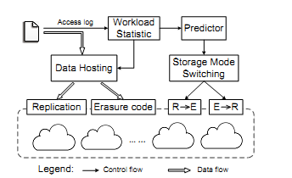
5.3 CLASS DIAGRAM
The class Diagram describes the structure of a system by showing the systems classes, their attributes, operations and the relationships among objects.

5.4 SEQUENCE DIAGRAM
Sequence diagram are an easy and intuitive way of describing the behavior of a system by viewing the interaction between the system and the environment. A sequence diagram shows an interaction arranged in a time sequence. A sequence diagram has two dimensions: vertical dimension represents time, the horizontal dimension represents the objects existence during the interaction.

5.5 USE CASE DIAGRAM
A use case defines a goal-oriented set of interactions between external entities and the system under consideration. The external entities which interact with the system are its actors. A set of use cases describe the complete functionality of the system at a particular level of detail and it can be graphically denoted by the use case diagram.

Chapter 6
TESTING

6.1 TESTING OF THE PRODUCT

System testing is the stage of implementation, which aimed at ensuring that system works accurately and efficiently before the live operation commence. Testing is the process of executing a program with the intent of finding an error. A good test case is one that has a high probability of finding an error. A successful test is one that answers a yet undiscovered error.
Testing is vital to the success of the system. System testing makes a logical assumption that if all parts of the system are correct, the goal will be successfully achieved. The candidate system is subject to variety of tests-on-line response, Volume Street, recovery and security and usability test. A series of tests are performed before the system is ready for the user acceptance testing. Any engineered product can be tested in one of the following ways.
Knowing the specified function that a product has been designed to from, test can be conducted to demonstrate each function is fully operational. Knowing the internal working of a product, tests can be conducted to ensure that “al gears mesh”, that is the internal operation of the product performs according to the specification and all internal components have been adequately exercised.
6.2 SYSTEM IMPLEMENTATION
Implementation of software refers to the final installation of the package in its real environment, to the satisfaction of the intended users and the operation of the system. The people are not sure that the software is meant to make their job easier.
- The active user must be aware of the benefits of using the system
- Their confidence in the software built up
- Proper guidance is impaired to the user so that he is comfortable in using the application
Before going ahead and viewing the system, the user must know that for viewing the result, the server program should be running in the server. If the server object is not running on the server, the actual processes will not take place.

6.3 SYSTEM MAINTAINANCE
The maintenance phase of the software cycle is the time in which software performs useful work. After a system is successfully implemented, it should be maintained in a proper manner. System maintenance is an important aspect in the software development life cycle. The need for system maintenance is to make adaptable to the changes in the system environment. There may be social, technical and other environmental changes, which affect a system which is being implemented. Software product enhancements may involve providing new functional capabilities, improving user displays and mode of interaction, upgrading the performance characteristics of the system. So only thru proper system maintenance procedures, the system can be adapted to cope up with these changes. Software maintenance is of course, far more than “finding mistakes”.
6.4 TEST CASES:
Test Case ID |  | 1
Description |  | Manual Testing on CHARM: A Cost-efficient Multi-cloud Data Hosting Scheme with High Availability
Module |  | (i) Data Hosting  (ii) Storage Mode Switching (SMS)  (iii) Workload Statistic & Predictor  (iv) Performance Evaluation
Prepared By |  |  |  | Date Prepared | Any Date after 25 April
Reviewed / Updated |  | Student Name |  | Date Reviewed | Any Date after 25 April
Tested By |  | Student Name |  | Date Tested | Any Date after 25 April

Test Activities
Sl. No. | Step Description |  | Expected Results |  |  | Actual Results
1 | User Registration |  | For every new user registration, generate an Unique userID and insert a new row into the table |  |  | Pass
2 | User Login |  | User enters userId and Password to login, User details is verified in registration table and if row exists then successful login else unauthorized access. |  |  | Pass
3 | User Data Hosting |  | User selects a text file that needs to be uploaded to the cloud. Also selects the datacenter location with Rack Number and Data Node Number |  |  | Pass
4 | User connecting with Cloud computer |  | User send request to cloud server and wait for connection |  |  | Pass
5. | Cloud accepting user connection |  | Cloud receives user request and accepts the connection request and establishes a channel to communicate |  |  | Pass
6. | Cloud check for Space available on DataCenter |  | If space available allow user to store the data else display a message saying there is no enough space and request later |  |  | Pass
7. | Workload statistic & Predictor |  | Check the existing files and folders in cloud space (rack no and data node) and check whether new incoming file can be store. Display user details and file details on the screen |  |  | Pass
8 | Invoke DataCenters to store the data on cloud (DropBox) |  | Collect the data from user. Find the cost of each Datacenter and select a DataCenter to store the data on the Cloud (DropBox) |  |  | Pass
9 | Store Data on DropBox |  | Using AppKey and SecretKey get connected with Dropbox and retrieve the authorization code. Using Authorization code upload the dataset on the cloud (DropBox) |  |  | Pass
10 | Performance Evaluation |  | Show a bar graph for performance evaluation |  |  | Pass

Chapter 8
MODULES

8.1 DATA HOSTING

Data Hosting decides storage mode and the clouds that the data should be stored in. Data Hosting and SMS are two important modules in CHARM. We ﬁrst formally deﬁne the mathematical model applied in Data Hosting. When talking about erasure coding, we usually mean m > 1 (not replication). However, replication is a special case of erasure coding (i.e., m = 1). So we combine the two storage mechanisms and deﬁne a uniﬁed model. Assuming we have N clouds that meet performance requirements.

We choose n cloud to store a ﬁle, the ﬁle should be encoded into n blocks of equal size (n <=N), including m data blocks and n m coding blocks. If m = 1 , the n- m coding blocks are the same with the data block, i.e., replication. Then the n blocks are distributed into the n clouds. We call a (m,n) pair with its corresponding clouds a storage mode.

We ﬁrst formally deﬁne the availability of a (m,n) pair. For the n clouds, which one stores data block, and which one stores coding block do not impact the availability. It is only impacted by the value of m.

Since read access can be satisﬁed by only m clouds, we use the cheapest m clouds for read access. The m clouds are right used for storing data blocks while the left n-m clouds for coding blocks.

8.2 STORAGE MODE SWITCHING (SMS):

Intuitively, when a ﬁle changes from “hot” to “cold”, we should change its storage mode. More speciﬁcally, when the read frequency of the ﬁle drops below or increases above a certain value, changing storage mode can save more money. The value is determined by the prices of clouds. Given the available clouds including their prices and availability, we can ﬁgure out the storage mode and the selected clouds with the input of ﬁle size and read count, using Algorithm 1. Heuristic algorithm of data placement.

We calculate the storage modes for different ﬁle sizes and read counts, in order to get a storage mode table. The table has two dimensions: ﬁle size and read count. There is one corresponding storage mode for each pair of ﬁle size and read count, but the storage modes are the same for many different pairs. There are explicit boundaries between different storage modes in the table.

However, it does not mean we should change the storage mode once a ﬁle’s storage mode crosses the boundary, because the transition of storage mode also generates cost, which is deﬁnitely not negligible. Bandwidth is (much) more expensive than storage space for online storage services. The cost of one read access for a ﬁle can afford this ﬁle to be stored for around 4 months with no read access. Thus, we should be prudent to deal with storage mode transition.

A good transition scheme can actually save large amount of money. We ﬁrst demonstrate the implementation of storage mode transition: the proxy gets the data from the clouds where the data is originally stored, and puts it into the newly selected clouds using new storage mode. The implementation consumes out-going bandwidth, in-going bandwidth, and several operations (i.e., GET, DELETE, and PUT). Since DELETE and in-going bandwidth are free, the transition cost T is composed of out-going bandwidth, GET, and PUT. Out-going bandwidth is more expensive than storage, so we have to make sure that the cost of transition can be earned back by the new storage mode. That is, the following inequality has to be met:
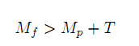
Where Mf and Mp are the monetary cost of the previous storage mode and new storage mode respectively. They are both calculated using the read frequency provided by Predictor.

8.3 WORKLOAD STATISTIC:

Workload Statistic keeps collecting and tackling access logs to guide the placement of data. It also sends statistic information to Predictor which guides the action of SMS. Data Hosting stores data using replication or erasure coding, according to the size and access frequency of the data. SMS decides whether the storage mode of certain data should be changed from replication to erasure coding or in reverse, according to the output of Predictor. The implementation of changing storage mode runs in the background, in order not to impact online service.

8.4 PREDICTOR

Predictor is used to predict the future access frequency of ﬁles. The time interval for prediction is one month, that is, we use the former months to predict access frequency of ﬁles in the next month. However, we do not put emphasis on the design of predictor, because there have been lots of good algorithms for prediction. Moreover, a very simple predictor, which uses the weighted moving average approach, works well in our data hosting model.

8.5 PERFORMANCE EVALUATION

Different types of data may require different availabilities For example, backup data usually requires relatively low availability, while documents in work folders demand high availability. The experiments prove the effectiveness of CHARM in this scenario since it performs best for various availabilities. However, a more complicated use case is that the availability is varying with the access frequency of data. For example,” hot” data may demand high availability while “cold” data does not have that strict requirement. In order to show that CHARM can also naturally adapt to this scenario, we run the two traces and assign different availabilities to the ﬁles according to their access frequency.

More speciﬁcally, in our experiments 3 read requests a month is the boundary between high (99.99999%) and low (99.99%) availabilities. In order to avoid switching back and forth frequently, when the frequency drops below 1 request a month we change the availability from high to low, and when the frequency rises above 5 requests a month, the availability is changed from low to high. Setting these threshold values is reasonable since there is no strict boundary between different availabilities. The other schemes also use the same way to switch the availability.

Chapter 9
ALGORITHM DESCRIPTION

Heuristic algorithm

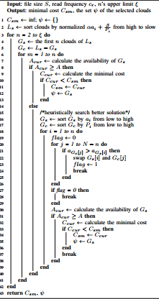

The term heuristic is used for algorithms which find solutions among all possible ones, but they do not guarantee that the best will be found, therefore they may be considered as approximately and not accurate algorithms. These algorithms, usually find a solution close to the best one and they find it fast and easily.

Sometimes these algorithms can be accurate, that is they actually find the best solution, but the algorithm is still called heuristic until this best solution is proven to be the best.
The method used from a heuristic algorithm is one of the known methods, such as greediness, but in order to be easy and fast the algorithm ignores or even suppresses some of the problem's demands. a heuristic is a technique designed for solving a problem more quickly when classic methods are too slow, or for finding an approximate solution when classic methods fail to find any exact solution. This is achieved by trading optimality, completeness, accuracy, or precision for speed. In a way, it can be considered a shortcut.
The objective of a heuristic is to produce a solution in a reasonable time frame that is good enough for solving the problem at hand. This solution may not be the best of all the actual solutions to this problem, or it may simply approximate the exact solution. But it is still valuable because finding it does not require a prohibitively long time.
Heuristics may produce results by themselves, or they may be used in conjunction with optimization algorithms to improve their efficiency (e.g., they may be used to generate good seed values).
Results about NP-hardness in theoretical computer science make heuristics the only viable option for a variety of complex optimization problems that need to be routinely solved in real-world applications.

Chapter 10
SYSTEM REQUIREMENTS
10.1 SOFTWARE REQUIREMENTS
- O/S : Windows XP and above
- Language : Java.
- IDE : Eclipse
- Data Base : MySql
10.2 HARDWARE REQUIREMENTS
- System : Pentium IV 2.4 GHz
- Hard Disk : 1 GB
- Monitor : 15 VGA color
- Ram : 1GB

Chapter 11
SOFTWARE DESCRIPTION

11.1 Java

Java is a programming language originally developed by James Gosling at Sun Microsystems (now a subsidiary of Oracle Corporation) and released in 1995 as a core component of Sun Microsystems' Java platform. The language derives much of its syntax from C and C++ but has a simpler object model and fewer low-level facilities. Java applications are typically compiled to byte code (class file) that can run on any Java Virtual Machine (JVM) regardless of computer architecture. Java is a general-purpose, concurrent, class-based, object-oriented language that is specifically designed to have as few implementation dependencies as possible. It is intended to let application developers "write once, run anywhere." Java is currently one of the most popular programming languages in use, particularly for client-server web applications.

11.2 Eclipse
Eclipse is a Java-based open source platform that allows a software developer to create a customized development environment (IDE) from plug-in components built by Eclipse members. Eclipse is managed and directed by the Eclipse.org Consortium.

Eclipse got its start in 2001 when IBM donated three million lines of code from its Java tools. The original goal of Eclipse was to create and foster an open source IDE community that would complement the community that surrounds Apache. Rumor has it that a secondary goal was to "eclipse Microsoft Visual Studio" which is how the platform got its name.
In the enterprise, a major advantage to an open source development platform is that it allows an IT department to mix and match development tools rather than being committed to a single vendor's suite of development products. Although the Eclipse Platform is written in Java, it supports plug-ins that allow developers to develop and test code written in other languages.
In addition to allowing the Eclipse Platform to be extended using other programming languages, such as C and Python, the plug-in framework allows the Eclipse Platform to work with typesetting languages like LaTeX and networking applications such as telnet and database management systems. Eclipse implements the graphical control elements of the Java toolkit called SWT, whereas most Java applications use the Java standard Abstract Window Toolkit (AWT) or Swing.

11.3 J2EE
A Java EE application or a Java Platform, Enterprise Edition application is any deployable unit of Java EE functionality. This can be a single Java EE module or a group of modules packaged into an EAR file along with a Java EE application deployment descriptor.

11.5 MySQL
The MySQL development project has made its source code available under the terms of the GNU General Public License, as well as under a variety of proprietary agreements. MySQL was owned and sponsored by a single for-profit firm, the Swedish company MySQL AB, now owned by Oracle Corporation.
Free-software-open source projects that require a full-featured database management system often use MySQL. Applications which use MySQL databases include: TYPO3, Joomla, WordPress, phpBB, Drupal and other software built on the LAMP software stack.

11.6 Platforms and interfaces
Many programming languages with language-specific APIs include libraries for accessing MySQL databases. These include MySQL Connector/Net for integration with Microsoft's Visual Studio (languages such as C# and VB are most commonly used) and the JDBC driver for Java. In addition, an ODBC interface called MyODBC allows additional programming languages that support the ODBC interface to communicate with a MySQL database, such as ASP or ColdFusion. The MySQL server and official libraries are mostly implemented in ANSI C/ANSI C++.

Chapter 12
LITERATURE SURVEY
Title 1:
An Ensemble of Replication and Erasure Codes for Cloud File Systems
Author: Yadi Ma, ThyagaNandagopal
Year: 2013
Geographically distributed storage is an important method of ensuring high data availability in cloud computing and storage systems. With the increasing demand for moving file systems to the cloud, current methods of providing such
enterprise-grade resiliency are very inefficient. For example, replication based methods incur large storage cost though they provide low access latencies. While erasure coded schemes reduce storage cost, they are associated with large access latencies and high bandwidth cost. In this paper, we propose a novel scheme named CAROM, an ensemble of replication and erasure codes, to provide resiliency in cloud file systems with high efficiency. While maintaining the same consistency semantics seen in today’s cloud file systems, CAROM provides the benefit of low bandwidth cost, low storage cost, and low access latencies. We perform a large-scale evaluation using real-world file system traces and demonstrate that CAROM outperforms replication based schemes in storage cost by up to 60% and erasure coded schemes in bandwidth cost by up to 43%, while maintaining low access latencies close to those in replication based schemes.
High data availability is an important property that most cloud storage services such as Amazon S3, and Windows Azure offer today. For instance, Amazon S3 offers four 9’s of availability. Today’s cloud storage services provide these availability SLAs (Service Level Agreements) by replicating full copies of a data object several times over geographically diverse data centers (referred to as M-way replication in the literature, or All Replicain this paper). When a copy of the data object in a data center is inaccessible, due to various transient failures, such as memory or disk overloads, network congestion, equipment failure or upgrades, or unplanned outages.
However, with increasing number of users and enterprises moving to the cloud, the cost of replicating and keeping the huge amount of data consistent
across multiple locations will only increase, driving up the bandwidth and storage costs. This necessitates a low-cost solution that can maintain high availability as well as low latency access times to this data object. The key idea behind the solution is to use different encoding schemes to divide an object into multiple data chunks (say m data chunks), and k redundant chunks are calculated based on the data chunks to tolerate up to k failures. These chunks, both data chunks and redundant chunks, are stored in different locations
Only m out of m + k chunks are necessary to reconstruct the object. This scheme (referred to as All Code thereafter) is efficient because instead of storing whole copies, it stores chunks and thus reduces the overall cost of storage. However, the problem is that it requires reconstructing the entire object and updating all the redundant chunks upon write requests. When erasure codes
are applied to CFSs with both read and write workloads, they lead to significantly high access latencies and large bandwidth overhead between data centers.
Specifically, we want to provide k-resiliency, defined as data is accessible even in the event of simultaneous failures of k different DCs (data centers). Note that a single failure in our model refers to when a DC is completely inaccessible to
the outside world. In reality, data stored in a particular DC is internally replicated (on different networks in the same DC) to tolerate equipment failures. A failure in our model could be due to either a network unreachability, or some other set of
events that make all copies of the data in a DC inaccessible. In addition, we would like to provide an access latency close to that of the All Replica scheme, and storage effectiveness close to that of the All Code scheme.
A Cloud File System (CFS) workload is particularly challenging to cope with because of the consistency requirements of the file system in supporting applications such as users’ desktop in the cloud, network file systems, email servers, document sharing portals, etc. These applications not only store data, but they also edit stored data and expect consistent response irrespective of where and when the data is accessed. Current CFSs provide “replication-on-close” semantics,
where all writes are kept at the local copy only, until the file is closed at which point replication occurs. We want to continue to provide the same consistency guarantees, but at a lower cost, lower latency and higher resiliency.
With an increase in the benefits of cloud computing, more and more users and enterprises are moving to the cloud, pushing critical systems such as file systems and applications atop the cloud. These applications not only demand high availability, but also require the consistency semantics provided by today’s file systems running on end-users’ machines. In this paper we propose CAROM for cloud based file systems which novelly combines the deployed replication schemes and erasure coded schemes. and also leads to significant monetary benefits to the provider of such an enterprise-grade file system.
Advantages: an elegant adaptation method that takes advantage of the potential convex nature of the total cost.
Disadvantages: it constantly probes for the optimal cache size

Title 2:
Rollerchain: a DHT for Efficient replication
Author: Joao Paiva
Year: 2013
In this paper we present Rollerchain, a novel Distributed Hash Table that data storage through the combination of gossip-based and structured overlay networks. The unstructured component maintains clusters of fully connected nodes, where each cluster acts as a virtual node in the structured component. This architecture simplifies the management of data replication and balances the load among nodes in the system. We have implemented a prototype of Rollerchain
that we have used to experimentally validate its performance against other state of the art solutions.
The cost of replication has been closely analysed, which shows that
the enforcement of data replication degrees accounts for a significant part of
the bandwidth consumption in a distributed storage system and effectively limits the amount of data that can be stored in a DHT. Therefore, the design of DHTs topologies and replication strategies that mitigate these costs is a matter of extreme practical relevance. This paper addresses exactly this problem. As we show in the evaluation section, our architecture can achieve significant savings when compared to previous solutions from the literature. Furthermore, these gains are not achieved by sacrificing or trading fault-tolerance. On the contrary, experimental results show that our architecture, maintains the keys reachable even under heavy churn while previous approaches fail to preserves data availability in such conditions.
In this paper we present an alternative implementation strategy to build
a topology similar to that of Scatter. We have named our implementation
Rollerchain. Contrary to Scatter, that heavily relies on consensus to implement
every operation, and therefore has higher signalling costs and may block under
heavy churn, Rollerchain heavily relies on gossip-based mechanisms. This alternative is interesting, because gossip-based approaches have proven to be a reliable strategy to cope with scenarios where pure structured approaches fail.
While Rollerchain provides weaker guarantees, by using a robust gossip scheme
and a clever topology maintenance, we show in the evaluation that it is able to
avoid the loss of keys even under heavy churn despite its best-e ↵ort model.
Neighbor Replication (also known as leaf set replication) keeps copies of each key in their neighbours of the key owner. A significant advantage of Neighbor Replication is that when its neighbors change, the key owner may trigger the creation of new replicas. Since each node keeps a different set of replicas, bookkeeping becomes costly if one attempts to use a flexible scheme where the number of replicas fluctuates. Therefore, most schemes use some variant of eager replication, where replicas have to be created when nodes fail and moved when nodes join. This work claims that through this symbiosis, the current state of the art on DHTs can be improved with new overlay designs that better reliability, lower bandwidth costs, or better geometry.
The target size of these clusters can be configured by the application to a given target Cluster Size value. However, the cost of ensuring that every generated cluster produced by the protocol has exactly the same size in highly dynamic and open environments can be prohibitively high. To overcome this challenge, Overnesia instead ensures that the size of clusters is .distributed between minClusterSize and maxClusterSize, with a predominance of clusters with the targetClusterSize(evidently, minClusterSize<targetClusterSize<MaxClusterSize). Each Overnesia cluster is assigned a random identifier that is known by all elements of that cluster.
A gossip-based anti-entropy mechanism, in which elements of each cluster periodically and randomly exchange messages among themselves, is employed to ensure that cluster members converge on a consistent view of the cluster membership, despite concurrent joins and failures in the system. Furthermore, this process is used to provide a minimal amount of coordination required to increase the diversity of external links maintained by different cluster members. Note that Overnesia does not any DHT support.
The uniform random distribution provides a baseline of comparison, while the Zipf distribution illustrates operation in scenarios where a portion of the identifier space becomes overloaded. Subsequently, 100 queries per object were triggered at random nodes to achieve a grand total of 5.000.000 queries. The results obtained with the Uniform (U) and the Zipf (Z) key distributions. We highlight that the results obtained for Rollerchain in the Zipf scenario are very similar to those obtained in the Uniform scenario. This shows that Rollerchain’s dynamic partitioning of the data can adapt to extremely skewed datasets, making it oblivious to the key distribution in the identifier space. This makes Rollerchain suitable for supporting applications that use non-uniform distributions of keys. Multi-Publication performs better than Neighbour Replication under the Zipf distribution.
Advantages: A significant advantage of Neighbour Replication is that when its neighbours change, the key owner may trigger the creation of new replicas.
Disadvantages: each node keeps a different set of replicas, bookkeeping becomes costly if one attempts to use a flexible scheme where the number of replicas fluctuates.

Title 3:
NCCloud: Applying Network Coding for the Storage Repair in a
Cloud-of-Clouds
Author: Yuchong Hu, Henry C. H. Chen, Patrick P. C. Lee, Yang Tang
Year: 2012
To provide fault tolerance for cloud storage, recent studies propose to stripe data across multiple cloud vendors. However, if a cloud suffers from a permanent failure and loses all its data, then we need to repair the lost data from other surviving clouds to preserve data redundancy. We present a proxy-based system for multiple-cloud storage called NCCloud, which aims to achieve cost-effective repair for a permanent single-cloud failure. NCCloud is built on top of network-coding-based storage schemes called regenerating codes.
Specifically, we propose
an implementable design for the functional minimum storage regenerating code (F-MSR), which maintains the same data redundancy level and same storage requirement as in traditional erasure codes (e.g., RAID-6), but uses less repair traffic. We implement a proof-of-concept prototype of NCCloud and deploy it atop local and commercial clouds. We validate the cost effectiveness of FMSR in storage repair over RAID-6, and show that both schemes have comparable response time performance in normal cloud storage operations.
Cloud storage provides an on-demand remote backup solution. However, using a single cloud storage vendor raises concerns such as having a single point of failure and vendor lock-ins. A plausible solution is to stripe data across different cloud vendors. While striping data with conventional erasure codes performs well when some clouds experience shorter m failures or foreseeable permanent failures there are real-life cases showing that permanent failures do occur and are not always foreseeable. This work focuses on unexpected cloud failures. When a cloud fails permanently, it is important to activate storage repair to maintain the level of data redundancy. A repair operation reads data from existing surviving clouds and reconstructs the lost data in a new cloud. It is desirable to reduce the repair traffic, and hence the monetary cost, due to data migration.
It is shown that regenerating codes reduce the data repair traffic over traditional erasure codes subject to the same fault-tolerance level. Despite the favorable property, regenerating codes are mainly studied in the theoretical context. It remains uncertain regarding the practical performance of regenerating codes, especially with the encoding overhead incurred in regenerating codes. In this paper, we propose NCCloud, a proxy-based system designed for multiple-cloud storage. We propose the first implementable design for the functional
minimum-storage regenerating code (F-MSR), and in particular, we eliminate the need of performing encoding operations within storage nodes as in existing theoretical studies. Our F-MSR implementation maintains double fault tolerance and has the same storage cost as in traditional erasure coding schemes based on RAID-6, but uses less repair traffic when recovering a single-cloud failure. On the other hand, unlike most erasure coding schemes that are systematic (i.e., original data chunks are kept), F-MSR is non-systematic and stores only linearly
combined code chunks. Nevertheless, F-MSR is suited to rarely-read long-term archival applications.
We show that in a practical deployment setting, FMSR can save the repair cost by 25% compared to RAID-6 for a four-cloud setting, and up to 50% as the
number of clouds further increases. In addition, we conduct extensive evaluations on both local cloud and commercial cloud settings. We show that our F-MSR implementation only adds a small encoding overhead, which can be easily masked by the file transfer time over the Internet. Thus, our work validates the practicality of FMSR via NCCloud, and motivates further studies of realizing regenerating codes in large-scale deployments.
This paper considers the baseline RAID-6 implementation using Reed-Solomon codes. Its repair method is to reconstruct the whole file, and is applicable for all erasure codes in general. Recent studies show that data reads can be minimized specifically for XOR based erasure codes. For example, in RAID-6, data reads can be reduced by 25% compared to reconstructing the whole file. Although such approaches are suboptimal (recall that F-MSR can save up to 50% of repair
traffic in RAID-6), their use of efficient XOR operations can be of practical interest.
a multiple-cloud storage file system that practically addresses the reliability of today’s cloud storage. NCCloud not only achieves fault tolerance of storage, but also allows cost-effective repair when a cloud permanently fails. NCCloud implements a practical version of the functional minimum storage regenerating code (F-MSR), which regenerates new chunks during repair subject to the required degree of data redundancy. Our NCCloud prototype shows the effectiveness of FMSR in accessing data, in terms of monetary costs and response times.

Advantages: it needs to download less data during repair.
Disadvantages: It is not always foreseeable

Title 4:
SLA-based Admission Control for a Software-as-a-Service
Provider in Cloud Computing Environments
Author: Linlin Wu, Saurabh Kumar Garg, and RajkumarBuyya
Year: 2011
With the increasing popularity of Cloud computing, the requirement for services supporting brokering across multiple infrastructure providers is growing rapidly. Cloud Computing environments are not only dynamic, but also heterogeneous with multiple types of Virtual Machine (VM) offered by various
infrastructure providers. Similarly, the demand on services can also vary with time, which affects the number of VMs to be initiated. In this environment, the aim of Software as a Service (SaaS) providers is to maximize their profit and enhance their reputation by meeting Service Level Agreement (SLA) requirements of all accepted requests. SLAs are signed between SaaS providers and the customers to
decide on the issues such as payment and Quality of Service (QoS). Thus, SaaS providers need effective strategies for accepting particular request, how many and what type of VMs to be initiated from suitable IaaS provider. This paper proposes admission control and scheduling algorithms that take into account dynamic parameters such as variation in VM’s initiation time and user’s QoS requirements such as budget deadline, and penalty rate ratio. This paper also presents an extensive evaluation study to analyse well suited algorithm for a particular scenario to maximise the SaaS provider's profit.
Cloud computing has emerged as a new paradigm for offering elastic access to dynamically provisioned IT resources on a pay-as-you-go model to multiple customers. It has been increasingly adopted in many areas, such as banking, e-commerce business, retail industry and academy due to its flexibility, scalability and cost-effectiveness. Cloud computing includes Software (SaaS), Platform (PaaS) and Infrastructure (IaaS) as a Service. This paper focuses on SaaS providers, who lease VMs provided by IaaS providers, to offer software services. For example, Animoto provides automated video generation with images using Amazon Cloud infrastructure services
The main objective of SaaS providers is to maximize their profit by either attracting large market share or minimizing the cost. Cloud computing provides a very effective platform for enhancing market share. The Cloud providers generally list their customers‟ applications on their web sites, which acts as an indirect advertisement for their customers. For instance, Amazon‟s Customer App Catalogue includes all the details about the customers‟ applications. Another way to enlarge market share is to improve reputation by accepting more user requests and improve user satisfaction level by meeting the contract terms defined in an SLA
In any case, with the profit maximization mechanisms, a SaaS provider
requires to leverage multiple user requests and multiple IaaS providers. In order to utilizing resources effectively and efficiently, admission control and scheduling capabilities at the platform layer to deal with various user requirements and heterogeneity at the infrastructure level. A high level system model for application service scalability using multiple IaaS providers in Cloud is illustrated. A user sends requests for utilizing software applications offered by a SaaS provider, who includes two infrastructure layers, namely application layer and platform layer, to satisfy the user‟s request. The application layer controls all application services which a SaaS provider can offer to users. The platform layer includes admission control and scheduling policies for making decision whether to reject or accept a request, and respond to the user‟s request. In addition, the platform layer also
schedules the processing of requests on VMs from IaaS providers. In academy and industry, pure PaaS maps to our scenario‟s platform layer.
Therefore, in this paper, we propose cost effective admission control and scheduling mechanisms with the goal of maximizing the SaaSprovider‟s profit, by optimizing the placement of customer‟s service request on the VMs leased from multiple IaaS providers. Our mechanisms take into account customer‟sQoS requirements such as deadline, SLA requirements, and infrastructure heterogeneity in terms of VM types, VM initiation time, data transfer time and pricing policies. The key contributions of this paper are the following: It defines two layers of SLAs - SLA(U) with users and SLA(R) with IaaS providers based on eight basic QoS parameters. It designs and implements admission control and scheduling mechanisms to maximize service provider‟s profit.
The admission control mechanism examines which user request be accepted with least effect on other accepted requests; especially, how incurred penalties will decrease profit. The scheduling mechanism determines where and which type of VM will be initiated by incorporating the heterogeneity of IaaS providers in terms of their price, dynamic VM initiation time, dynamic service time, and data transfer time.

Advantages: the service provider can exploit the advantages of one resource provider over others to satisfy the constrained user requests.
Disadvantages: the available resource capability is not able to complete request before its deadline.

Title 5:
Decision Support for Application Migration to the Cloud:
Challenges and Vision
Author: VasiliosAndrikopoulos, Steve Strauch, Frank Leymann
Year: 2013
The success of Cloud computing has encouraged many application developers to consider migrating their applications to the Cloud. Given the early market dominance of the IaaS service model, many existing works focus on selecting the best service provider for a set of criteria related to the virtualization and hosting of the application. In this work, we aim to progress the State of the Art by formulating a vision of a decision support system that incorporates multiple dimensions and different analysis tasks in feedback relationships with each
other. The research challenges that need to be addressed towards this direction are identified and related to the different aspects of migration of applications to the various Cloud service models.
The steadily increasing domination of Cloud computing in the software market means that existing applications may need to migrate to this environment in
order to reap the benefits of reduced infrastructural costs and dynamic access to computational resources. While software has already started being developed
specifically for the Cloud (forming Cloud-native applications), existing systems must be adapted to be suitable for the Cloud, requiring to make them Cloudenabled (Andrikopoulos et al., 2013). Existing work, e.g. (Li et al., 2010; Khajeh-Hosseini et al., 2012; Menzel and Ranjan, 2012), focuses on the IaaS service model (Mell and Grance, 2011), building on the success and early market dominance of infrastructure virtualization solutions like Amazon Web Services. In this context, providing decision support for the migration of applications to the Cloud is reduced to the selection of the appropriate IaaS provider that can support the best application performance for the least cost.
Beyond this VM-based migration of applications to the Cloud however, new PaaS and SaaS offerings of Cloud providers enable alternative migration options
for applications. Data stores like the Amazon Relational Database Service (Amazon RDS), and business logic executing environments like the Google App
Engine allow for partially or fully migrating the application. Decision support in this case needs also to include different options for segmenting and distributing the application in the Cloud, figuring out which parts of the application should scale, and how multitenancy can be implemented to maximize the return
of investment for application developers. The position that this work takes is that migrating to the Cloud is a multi-dimensional problem with multiple decision points that may create feedback loops with each other, and with various analysis tasks related to them. The contribution of this paper is to identify these decision points and analysis tasks, and define their dependencies. Based on these results,
a vision of a Cloud migration decision support system considering these aspects is provided. In order to reach this point however, a comprehensive analysis of the challenges related to migrating to the Cloud is required.
The work presented in (Khajeh-Hosseini et al., 2011) discusses two decision support tools implemented as spreadsheets: a cost calculation one, and a risk-benefit analysis one. The former is geared towards IaaS solutions, and allows users to calculate the cost for their infrastructure when virtualized and ran in one or more VMs on the Cloud. The latter surveys and categorizes a number of benefits and risks identified in the literature (also for IaaS solutions), and informs about potential consequences, mitigation approaches and indicators for each risk. The
two tools are then combined in the Cloud Adoption Toolkit (Khajeh-Hosseini et al., 2012) that supports decisions on technology suitability, cost, energy consumption, stakeholder impact and operational feasibility
The position we took in this work is that supporting the decision making process in migrating the application to the Cloud is a multi-dimensional problem with multiple decisions to be taken: how to segment and distribute the application, which Cloud service provider and offering to choose, which elasticity strategy fits better the application, and what are the requirements in implementing application multitenancy.
These decisions influence each other, and depend on a number of tasks like cost analysis and performance prediction that need to be performed in order to support them. Related to these decisions and tasks are a series of research challenges stemming from the need to adapt the application to operate in the Cloud environment that also need to be addressed. Our vision for a decision support system for migration of applications to the Cloud as discussed here considers all of the above points in order to advance the State of the Art in the field.

Advantages: It allows users to calculate the cost for their infrastructure
Disadvantages: They do not have any insight into how each design decision
affects the overall system.

Title 6:
On the Feasibility of Data Loss Insurance for Personal Cloud Storage
Author: Xiaosong Ma
Year: 2014
Personal data are important assets that people nowadays entrust with cloud storage services for the convenience of easy, ubiquitous access. To attract/retain customers, cloud storage companies aggressively replicate and geo replicate data. Such replication may be over-cautious for the majority of data objects and contributes to the relatively high price of cloud storage. Yet cloud storage
companies are reluctant to provide costumers with any guarantee against permanent data loss. In this paper, we discuss the viability for cloud storage service to provide optional data insurance. We examine major risks associated with cloud storage data loss and derive a crude model for premium calculation. The estimated premium level (per unit declared value) in most scenarios is found significantly smaller than that accepted in mature businesses like shipping. Therefore, optional insurance can potentially provide cloud storage services with more flexibility and cost-effectiveness in resource management, and customers with both peace of mind and lowered cost.
These wide-spread services provide users with multifold advantages compared with traditional personal data storage (on PCs, laptops, and/or household external storage devices such as USB hard disks). First, users can easily and transparently access/share their data across multiple devices. Second, remote cloud storage provides quite reliable file backup to recover data unavailable on local platforms. Third, cloud storage is elastic: users get charged for the actual usage while the capacity seamlessly grows with demand. Fourth, cloud storage is
(almost) maintenance free and works as a consolidation repository for the always upgrading collection of active devices in a family.
Finally, cloud storage comes with many value-added features such as integration with mobile applications, data sharing via social network, and direct connection with online media/software stores. However, it is hard for current cloud users to trust service providers with all their data or to use one cloud service as a sole household data repository. A 2012 Gartner report predicted that consumers would store more than a third of their digital content in the cloud by 2016.
Very commonly, people adopt cloud storage, but supplement it with traditional storage, self-administered backup, and/or third-party backup services. Sometimes
people use more than one cloud storage services simultaneously.
When doing so, users forfeit part of the benefits brought by cloud storage, in particular ease of maintenance and integrated storage. For example, if a user suddenly needs to find a set of Power-Point slides last modified fifteen years ago and could not remember where the file was saved, he/she may need to search through cloud storage, active and retired laptops, a dozen of old USB thumb drives, and backup CDs/DVDs. Users are responsible for scheduling backups and checking the functioning of storage devices. It might be challenging to find
devices that read old media types. Accessing replicated files (intentionally or not), without using a central repository, easily generates content divergence and may require tiresome manual reconciliation.
The reason for consumers’ partial adoption is likely associated with both cost and control. While cloud storage providers commonly provide a few GBs of free space, upgrades typically cost significantly more than commodity hard disks of similar capacity. For example, Dropbox charges $99.99 per year for 100GB space, while users can buy a 2TB external drive at the same price. The cost is non-trivial for a modern family to store its many TBs of data in cloud, with the majority
of which being cold media files that do not demand the distributed access convenience of cloud storage anyway. On the other hand, people hesitate to put the only digital copy of their great grandmother’s early pictures in the cloud (without local or secondary remote backup), for fear of data loss or corruption.
In this paper, we explore a solution that potentially eases both concerns. We observe that cloud storage providers strive to aggressively protect clients’ data with
multiple forms of redundancy, yet reluctant to provide concrete guarantee against the rare but apparently possible data loss. We reason that not only the premium is likely to be negligible compared to what customers are used to with similar services (such as shipping or security boxes), such insurance may allow providers to relax redundancy requirement for non-crucial data. As a result, resource utilization can be enhanced and customers can benefit from lower cloud storage cost.

Advantages: users can easily and transparently access/share their data across
multiple devices. loud storage is (almost) maintenance free and works as a consolidation repository for the always upgrading collection of active
devices in a family. loud storage is (almost) maintenance free and works as a consolidation repository for the always upgrading collection of active devices in a family.
Disadvantages: The cost is non-trivial for a modern family to store its many TBs of data in cloud, with the majority of which being cold media files that do not demand the distributed access convenience of cloud storage anyway

Title 7:
Erasure Coding in Windows Azure Storage
Author:Cheng Huang, HuseyinSimitci, YikangXu, Aaron Ogus, Brad Calder, ParikshitGopalan, Jin Li, and Sergey Yekhanin
Year: 2012
Windows Azure Storage (WAS) is a cloud storage system that provides customers the ability to store seemingly limitless amounts of data for any duration of time. WAS customers have access to their data from anywhere, at any time, and only pay for what they use and store. To provide durability for that data and to keep the cost of storage low, WAS uses erasure coding. In this paper we introduce a new set of codes for erasure coding called Local Reconstruction Codes (LRC).
LRC reduces the number of erasure coding fragments that need to be read when reconstructing data fragments that are offline, while still keeping the storage overhead low. The important benefits of LRC are that it reduces the bandwidth and I/Os required for repair reads over prior codes, while still allowing a significant reduction in storage overhead. We describe how LRC is used in WAS to provide low overhead durable storage with consistently low read latencies.
It is used inside Microsoft for applications such as social networking search, serving video, music and game content, managing medical records, and more.
In addition, there are thousands of customers outside Microsoft using WAS, and anyone can sign up over the Internet to use the system. WAS provides cloud storage in the form of Blobs (user files), Tables (structured storage), Queues (message delivery), and Drives (network mounted VHDs). These data abstractions provide the overall storage and work flow for applications running in the cloud.
Data is appended to the end of active extents, which are replicated three times by the underlying stream layer. The data is originally written to 3 full copies to keep the data durable. Once reaching a certain size (e.g., 1 GB), extents are sealed. These sealed extents can no longer be modified and thus make perfect candidates for erasure coding. WAS then erasure codes a sealed extent lazily in
the background, and once the extent is erasure-coded the original 3 full copies of the extent are deleted
The motivation for using erasure coding in WAS comes from the need to reduce the cost of storage. Erasure coding can reduce the cost of storage over 50%, which is a tremendous cost saving as we will soon surpass an Exabyte of storage. There are the obvious cost savings from purchasing less hardware to store that much data, but there are significant savings from the fact that this also reduces our data center footprint by 1/2, the power savings from running 1/2 the hardware, along with other savings.
The trade-off for using erasure coding instead of keeping 3 full copies is performance. The performance hit comes when dealing with i) a lost or offline data fragment and ii) hot storage nodes. When an extent is erasure-coded, it is broken up into k data fragments, and a set of parity fragments. In WAS, a data fragment may be lost due to a disk, node or rack failure. In addition, cloud services are perpetually in beta due to frequent upgrades. A data fragment may be offline for seconds to a few minutes due to an upgrade where the storage node process may be restarted or the OS for the storage node may be rebooted.
During this time, if there is an ondemand read from a client to a fragment on the storage node being upgraded, WAS reads from enough fragments in order to dynamically reconstruct the data being asked for to return the data to the client. This reconstruction needs to be optimized to be as fast as possible and use as little networking bandwidth and I/Os as possible, with the goal to have the reconstruction time consistently low to meet customer SLAs.
When using erasure coding, the data fragment the client’s request is asking for is stored on a specific storage node, which can greatly increase the risk of a storage node becoming hot, which could affect latency. One way that WAS can deal with hot storage nodes is to recognize the fragments that are hot and then replicate them to cooler storage nodes to balance out the load, or cache the data and serve it directly from DRAM or SSDs. But, the read performance can suffer for the potential set of reads going to that storage node as it gets hot, until the data
is cached or load balanced. Therefore, one optimization WAS has is if it looks like the read to a data fragment is going to take too long, WAS in parallel tries to perform a reconstruction of the data fragment (effectively treating the storage node with the original data fragment as if it was offline) and return to the client whichever of the two results is faster.
Erasure coding is critical to reduce the cost of cloud storage, where our target storage overhead is 1.33x of the original data. When using erasure coding, fast reconstruction of offline data fragments is important for performance. In Windows Azure Storage, these data fragments can be offline due to disk, node, rack and switch failures, as well as during upgrades

Advantages: it can achieve much higher reliability with the same storage,
or it requires much lower storage for the same reliability
Disadvantages: It cannot tolerate arbitrary

Chapter 13
FEASIBILITY STUDY
The feasibility study is carried out to test whether the proposed system is worth being implemented. The proposed system will be selected if it is best enough in meeting the performance requirements.
The feasibility carried out mainly in three sections namely.
• Economic Feasibility
• Technical Feasibility
• Behavioral Feasibility
13.1 Economic Feasibility
Economic analysis is the most frequently used method for evaluating effectiveness of the proposed system. More commonly known as cost benefit analysis. This procedure determines the benefits and saving that are expected from the system of the proposed system. The hardware in system department if sufficient for system development.
13.2 Technical Feasibility
This study center around the system’s department hardware, software and to what extend it can support the proposed system department is having the required hardware and software there is no question of increasing the cost of implementing the proposed system. The criteria, the proposed system is technically feasible and the proposed system can be developed with the existing facility.
13.3 Behavioral Feasibility
People are inherently resistant to change and need sufficient amount of training, which would result in lot of expenditure for the organization. The proposed system can generate reports with day-to-day information immediately at the user’s request, instead of getting a report, which doesn’t contain much detail.

Chapter 14
SNAPSHOTS
CLIENT:
1) Home Page
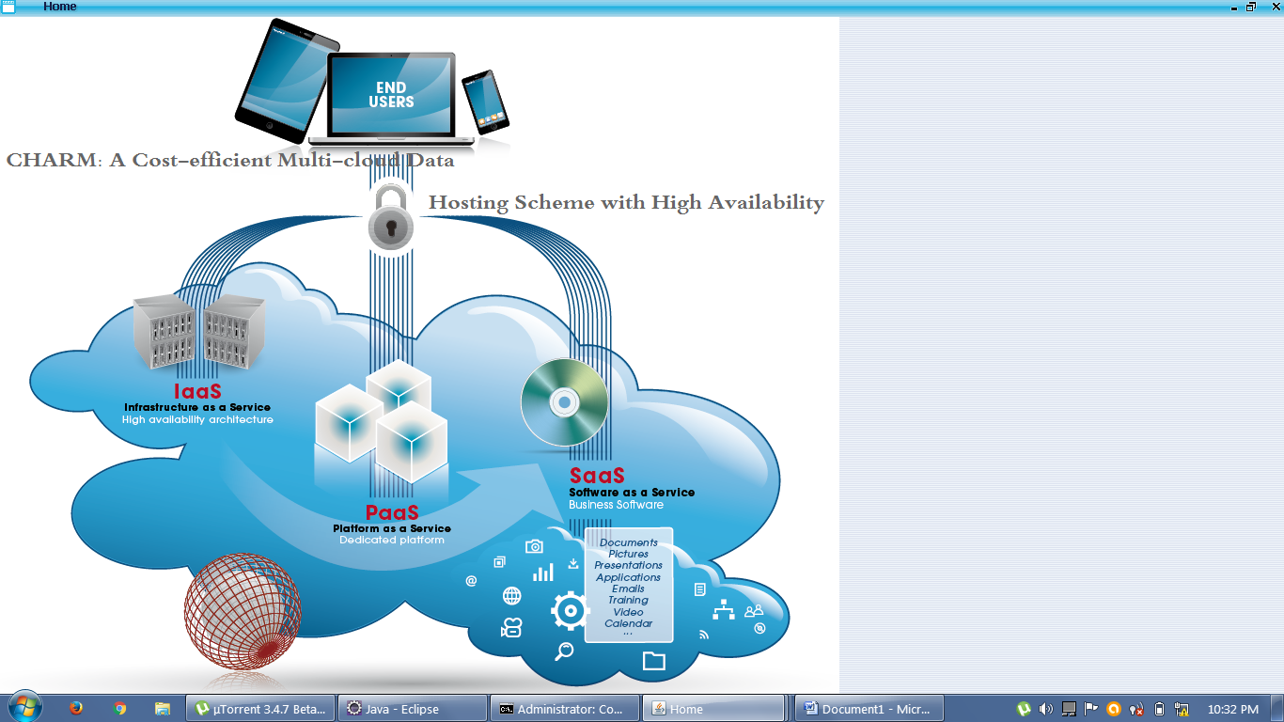

2) Log In/ Register
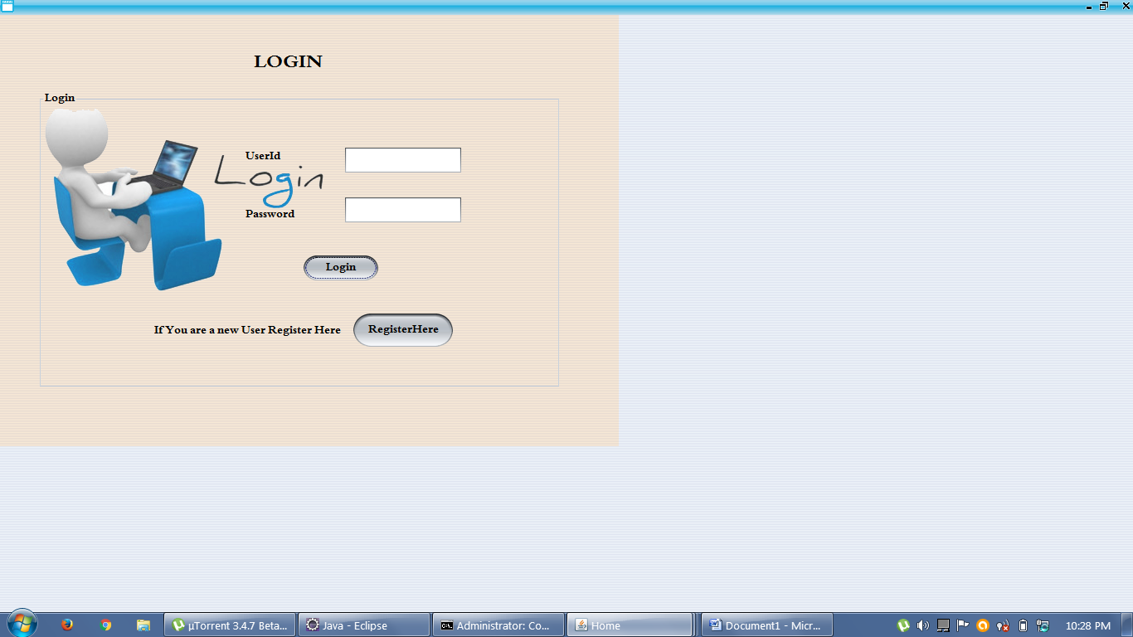

3) Register as a new user
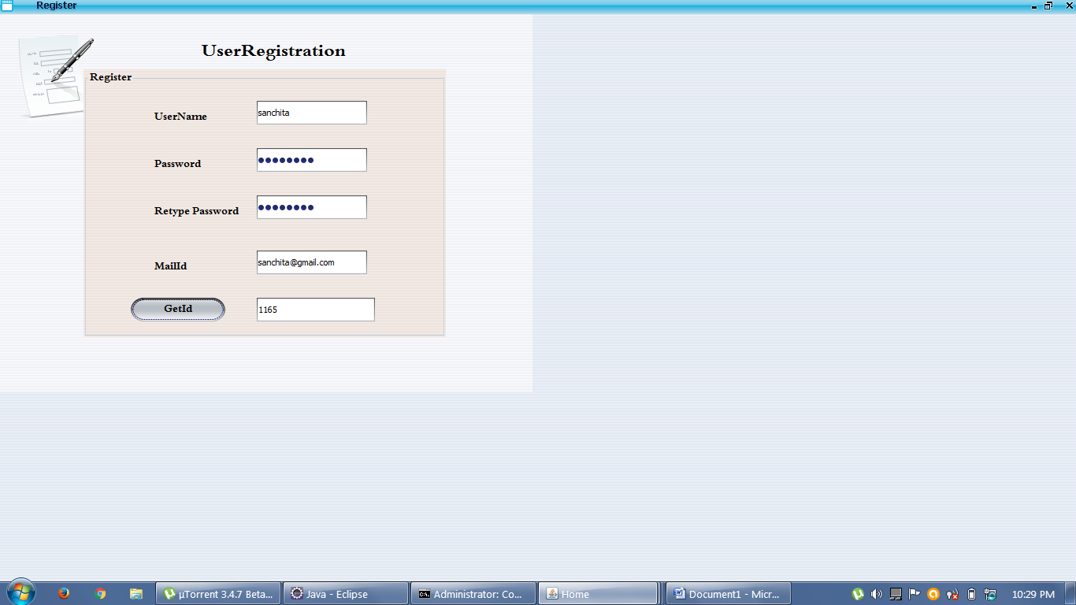

4) User Log in
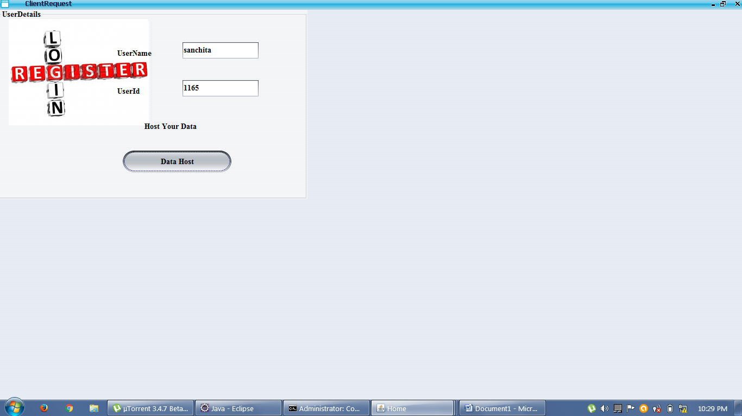

5) Data Hosting
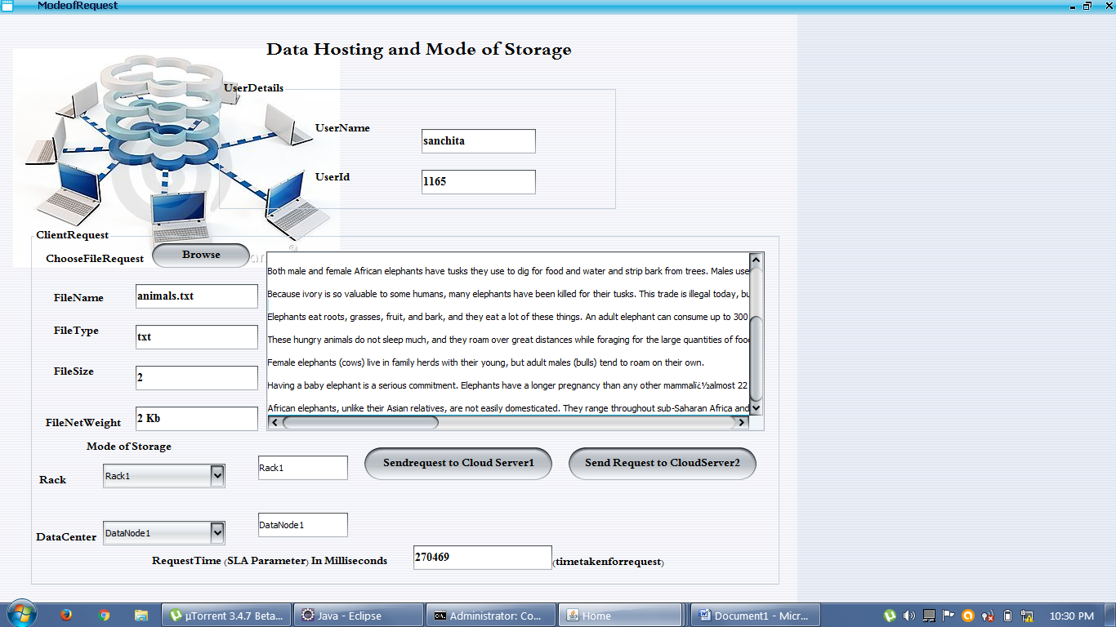

SERVER:
1) Cloud service waiting for user request
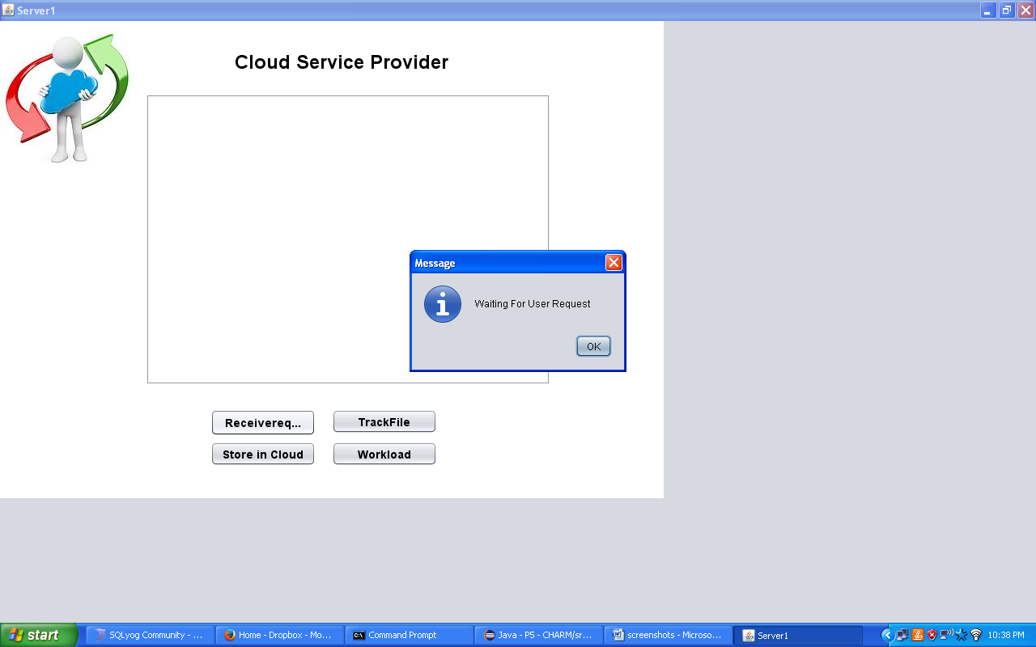
2) Request received from the client
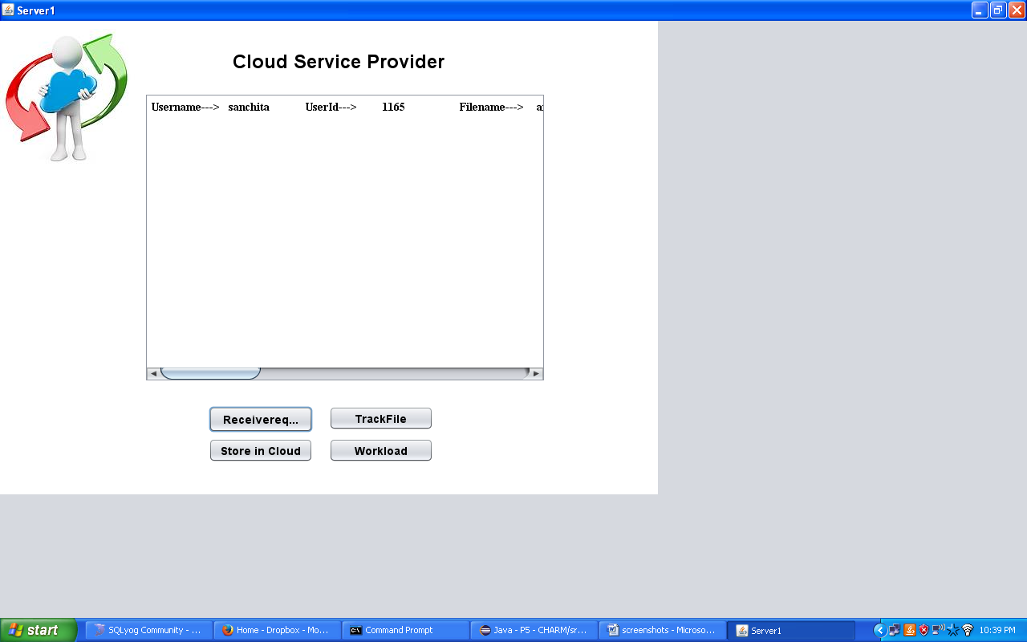
3) To store the file on the cloud
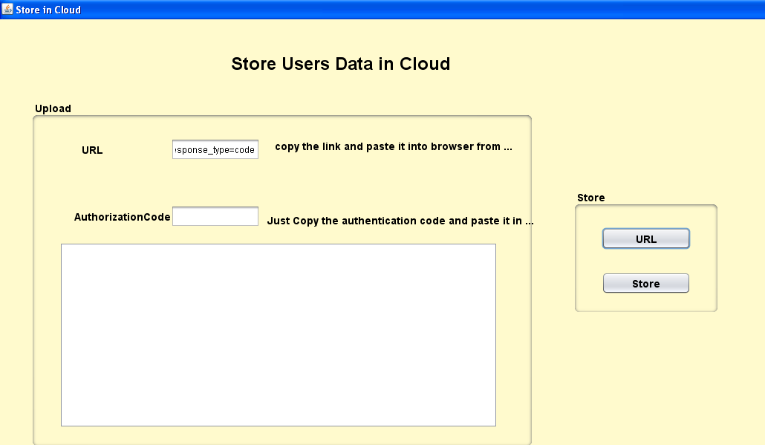
4) Cloud requests for Permission
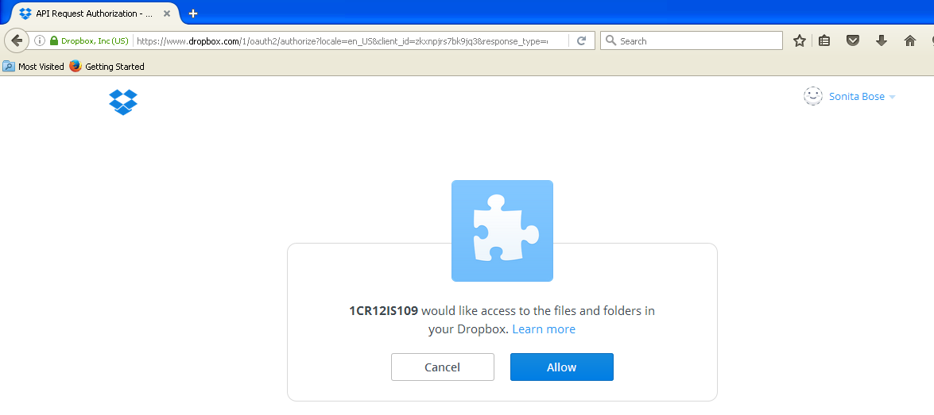
5) Generation of Authentication code
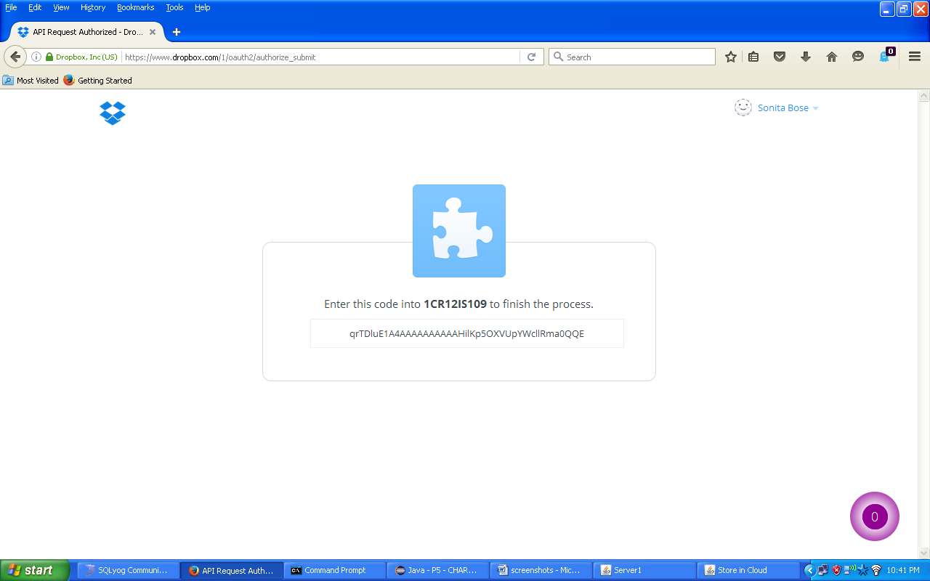
6) Linked to the cloud service provider
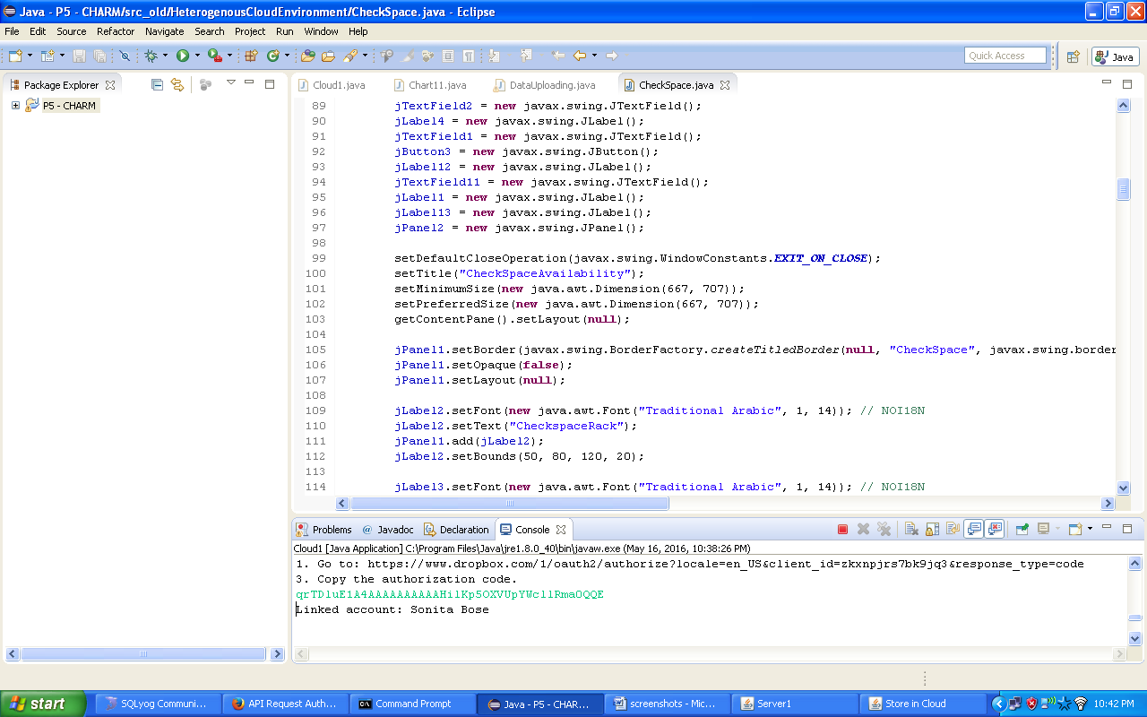
7) Data is stored on the cloud
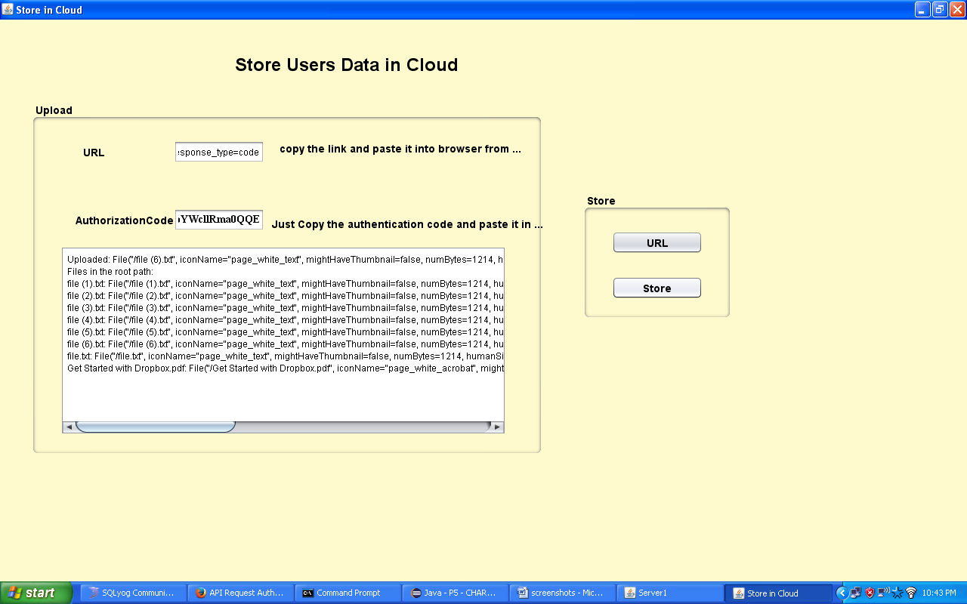
8) Workload statistics
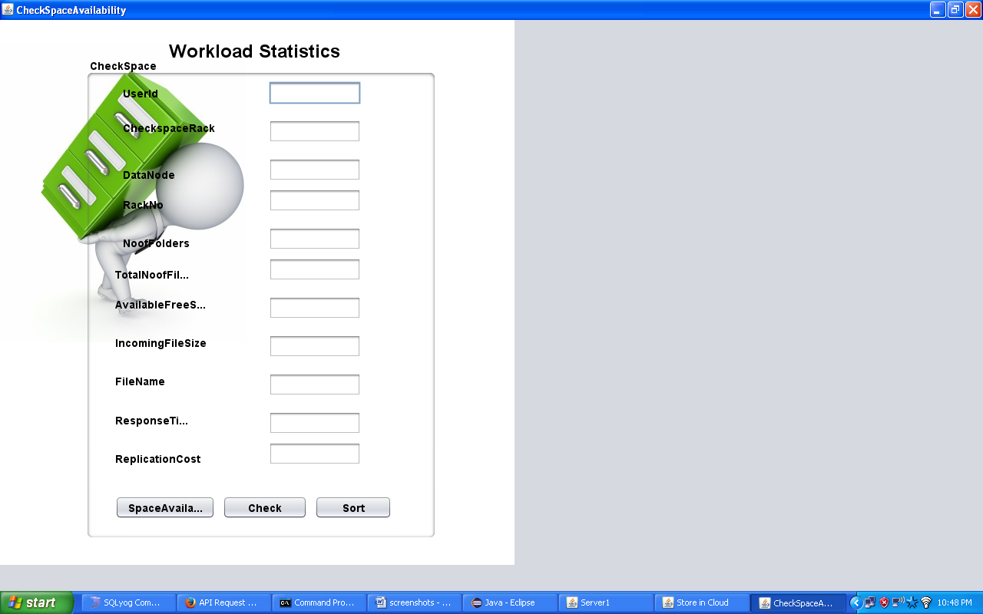
9) To check for availability of space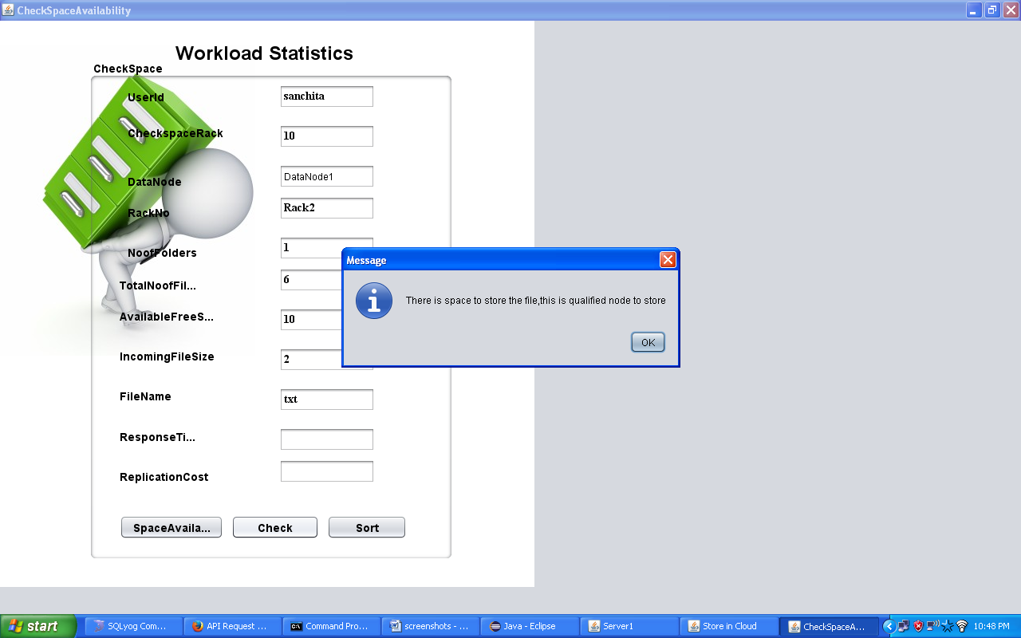
10) Response time calculated
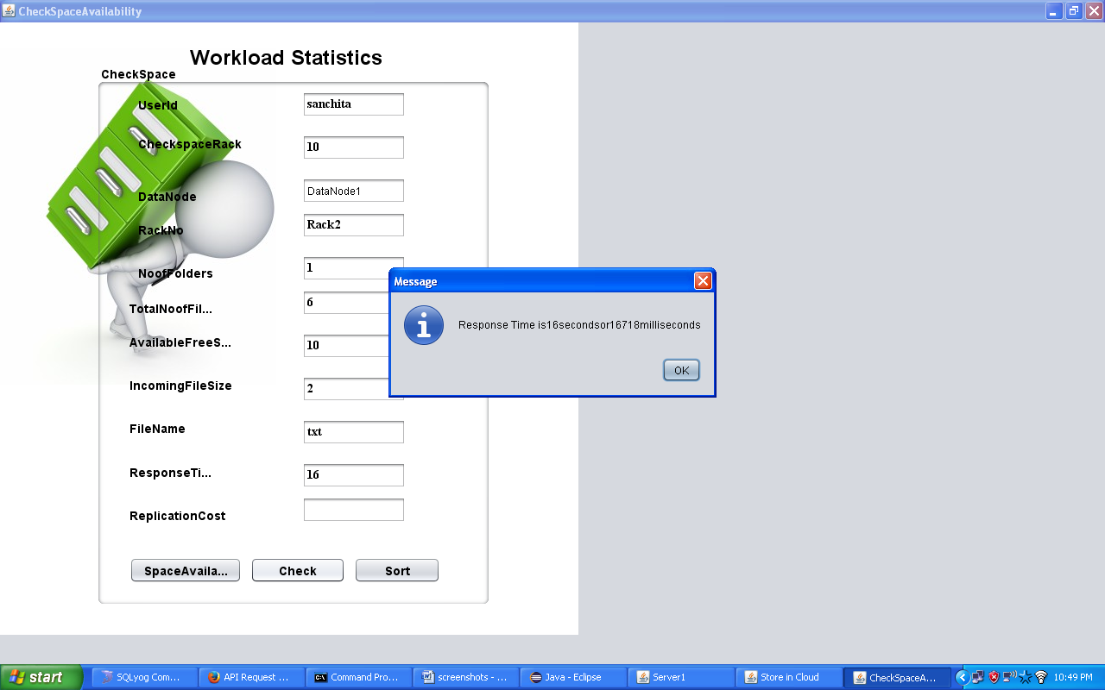

11) To check the network flow statistics
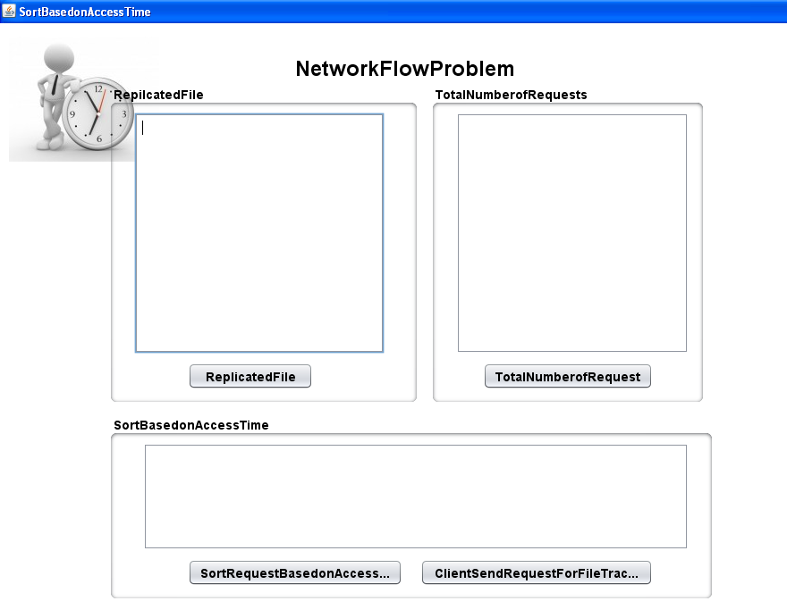
12)The total number of requests.
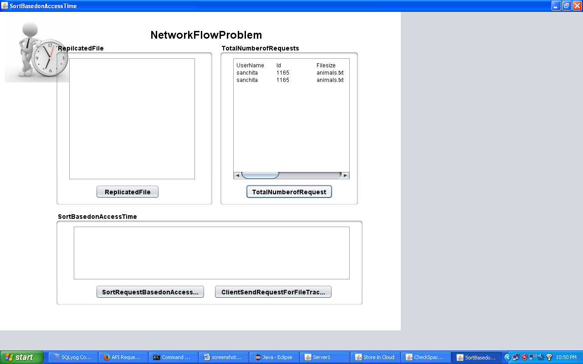

13)The replicated file
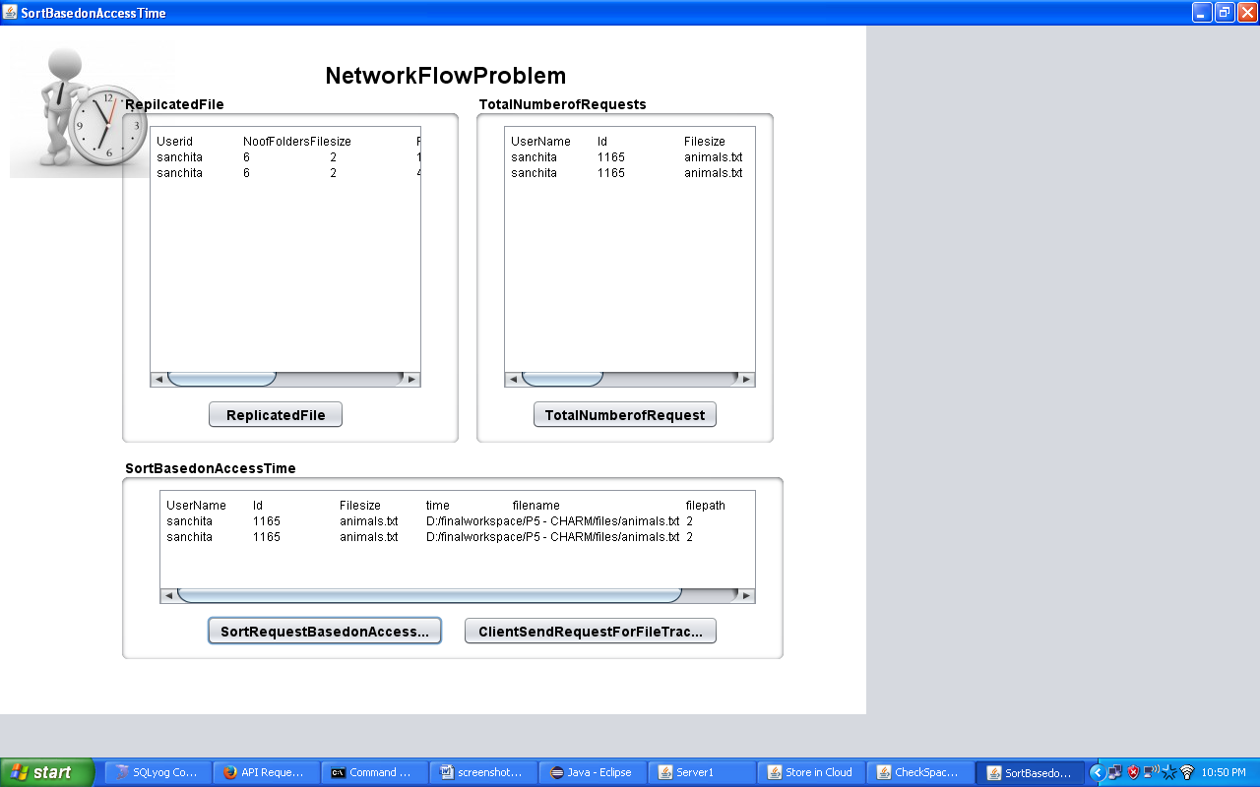
14)File Tracking forum
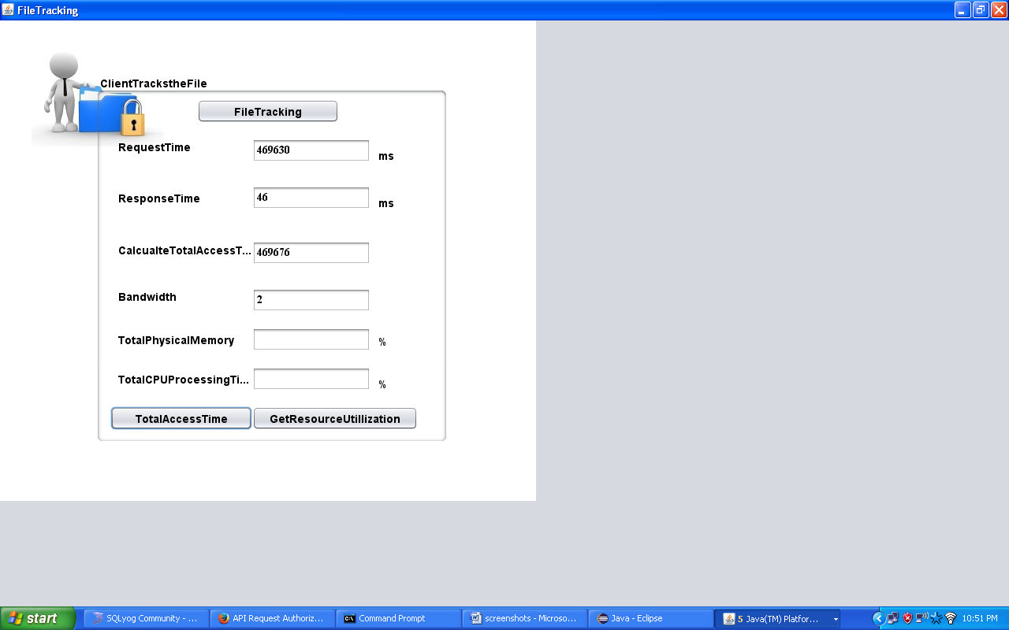
15)To calculate and estimate for the comparison
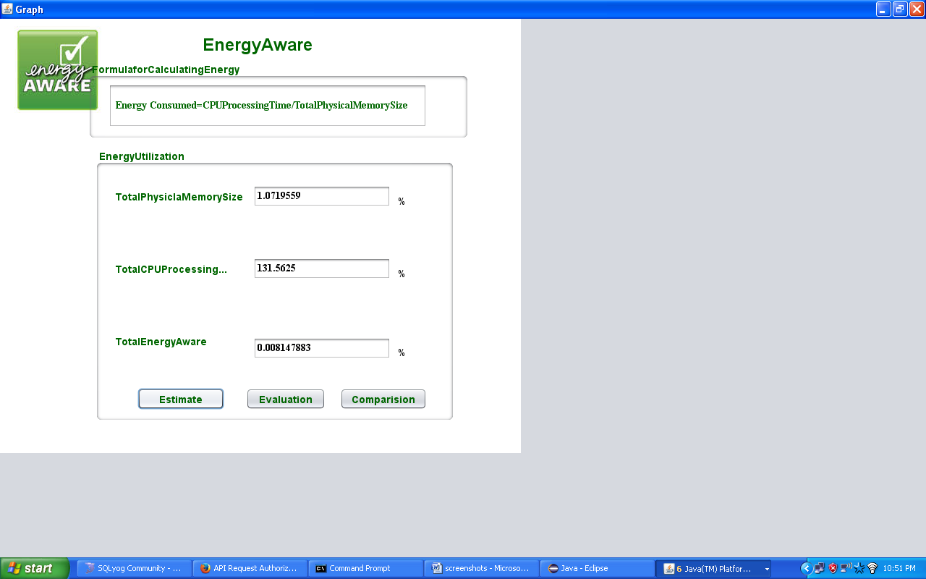

16)The Comparison between the existing and the proposed system
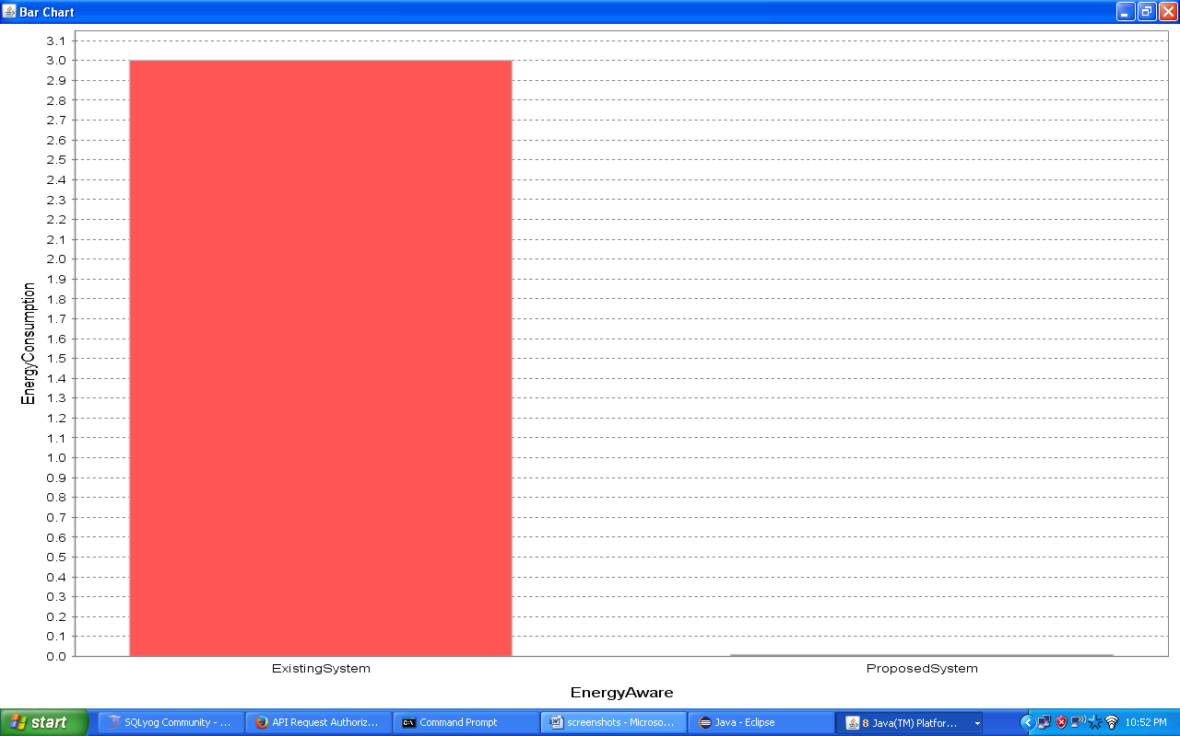

Chapter 15
CONCLUSION
This project proposed a cost effective Multi-cloud data scheme for reduce IT maintenance cost. One of the most concerns, when moving services into clouds, is capital expenditure. This project proposed this scheme for address that problem. It guides customers to distribute data among clouds cost-effectively. To reduce monetary cost, it applies this technique at the cloud storage level, which avoids vendor lock-in efficiently and reduces the cost of switching cloud vendors. And moves a step further that taking data access pattern into consideration, but it does not consider different redundancy mechanisms.

Cloud Foundry is an open platform as a service, providing a choice of clouds, developer frameworks, and application services. It becomes much faster and easier to build, test, deploy, and scale applications. The other one is that operation cost in the prototype experiments is higher than that in the simulations. It keeps monitoring the variations of pricing policies and data access patterns, and adaptively triggers the transition process between different data storage modes. It also starts a data migration process among different clouds if necessary. The evaluation proves the efficiency of this scheme.

REFERENCE

[1] An Ensemble of Replication and Erasure Codes for Cloud File Systems”, Yadi Ma, Thyaga Nandagopal, 2013.

[2] “Rollerchain: a DHT for Efficient replication”, Joao Paiva, 2013.

[3] “NCCloud: Applying Network Coding for the Storage Repair in a
Cloud-of-Clouds”, Yuchong Hu, Henry C. H. Chen, Patrick P. C. Lee, Yang Tang, 2012.

[4] “SLA-based Admission Control for a Software-as-a-Service
Provider in Cloud Computing Environments”, Linlin Wu, Saurabh Kumar Garg, and Rajkumar Buyya, 2011.

[5] “Decision Support for Application Migration to the Cloud:
Challenges and Vision”, Vasilios Andrikopoulos, Steve Strauch, Frank Leymann, 2013.

[6] “Evolution of Cloud Storage as Cloud Computing
Infrastructure Service”, R. Arokia Paul Rajan1, S. Shanmugapriyaa, 2012.

[7] “On the Feasibility of Data Loss Insurance for Personal Cloud Storage”, Xiaosong Ma, 2014.

[8] “XORing Elephants: Novel Erasure Codes for Big Data”, Maheswaran Sathiamoorthy, 2013.

[9] “Erasure Coding in Windows Azure Storage”, Cheng Huang, Huseyin Simitci, Yikang Xu, Aaron Ogus, Brad Calder, Parikshit Gopalan, Jin Li, 2012.

[10] Heading Off Correlated Failures through Independence-as-a-Service”, Ennan Zhai, Ruichuan Cheng, David Isaac Wolinsky, Bryan Ford, 2014.

