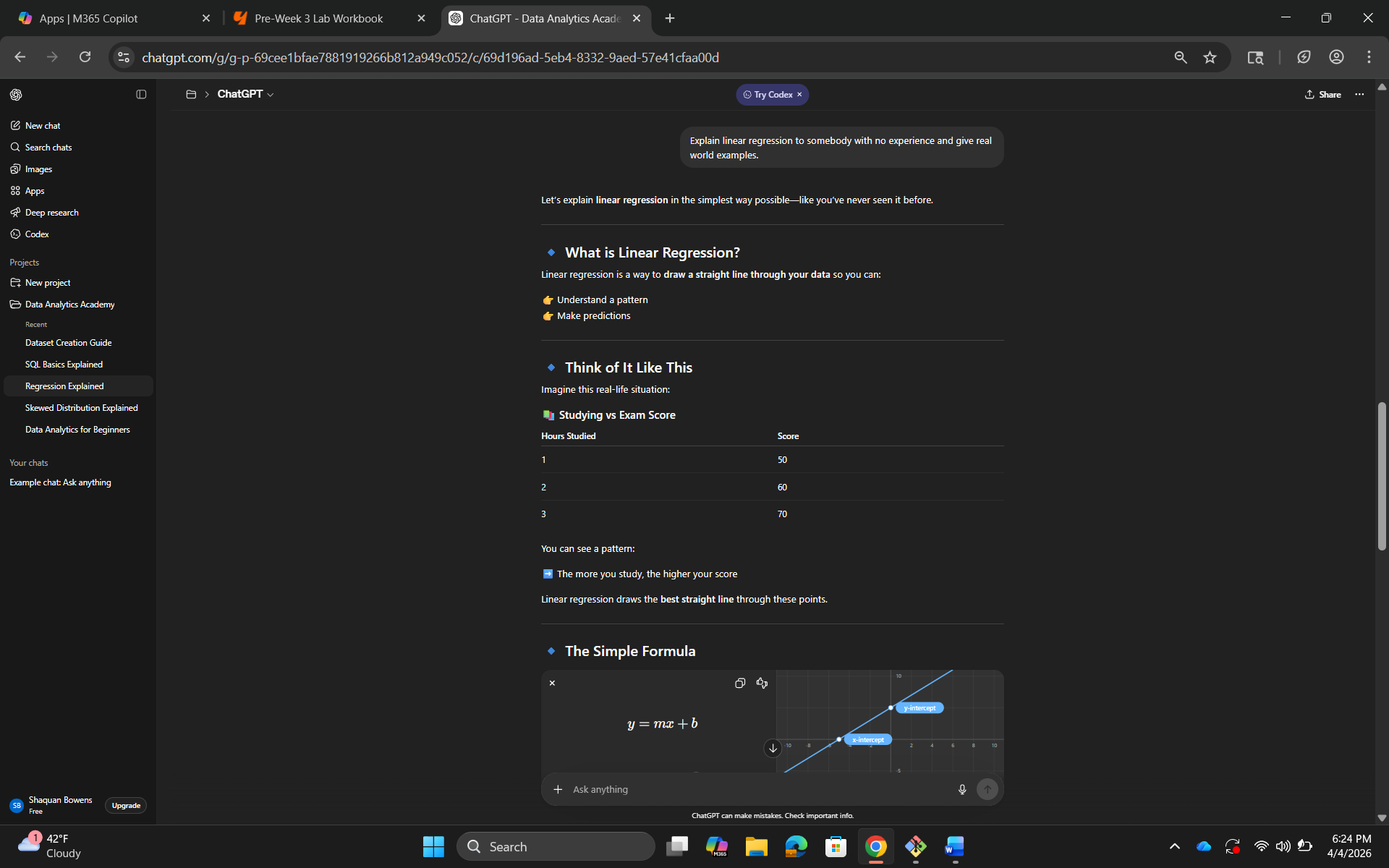
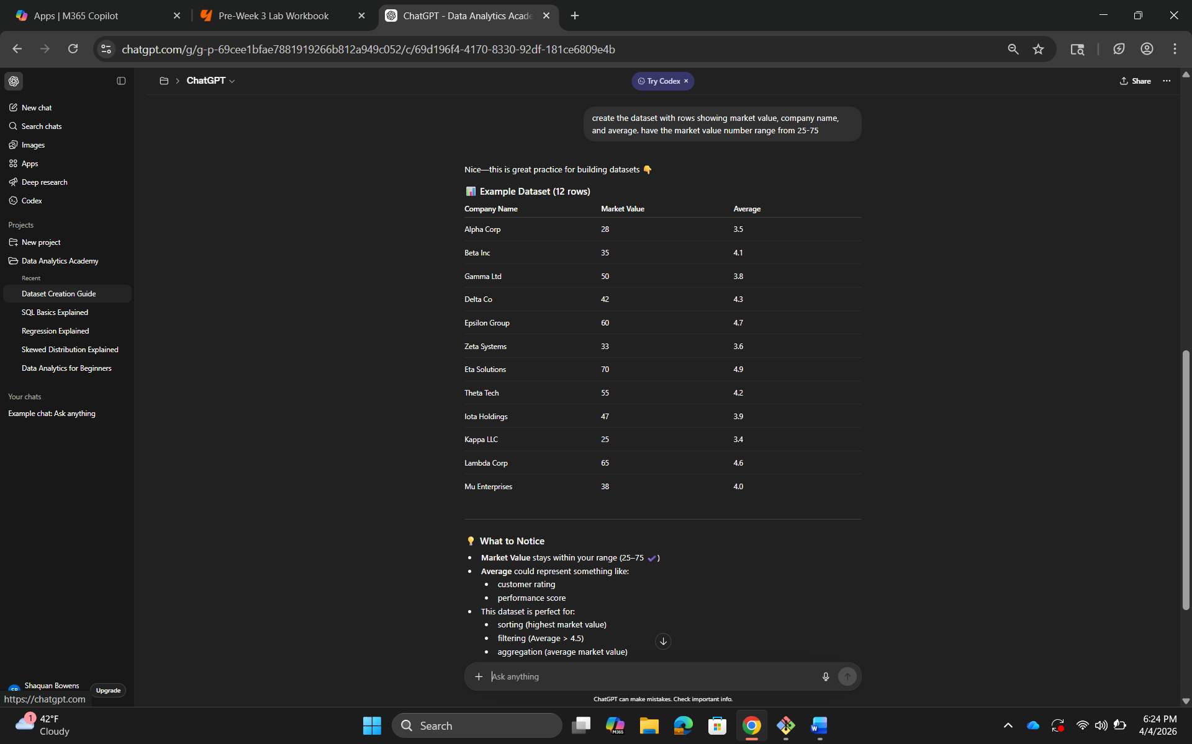
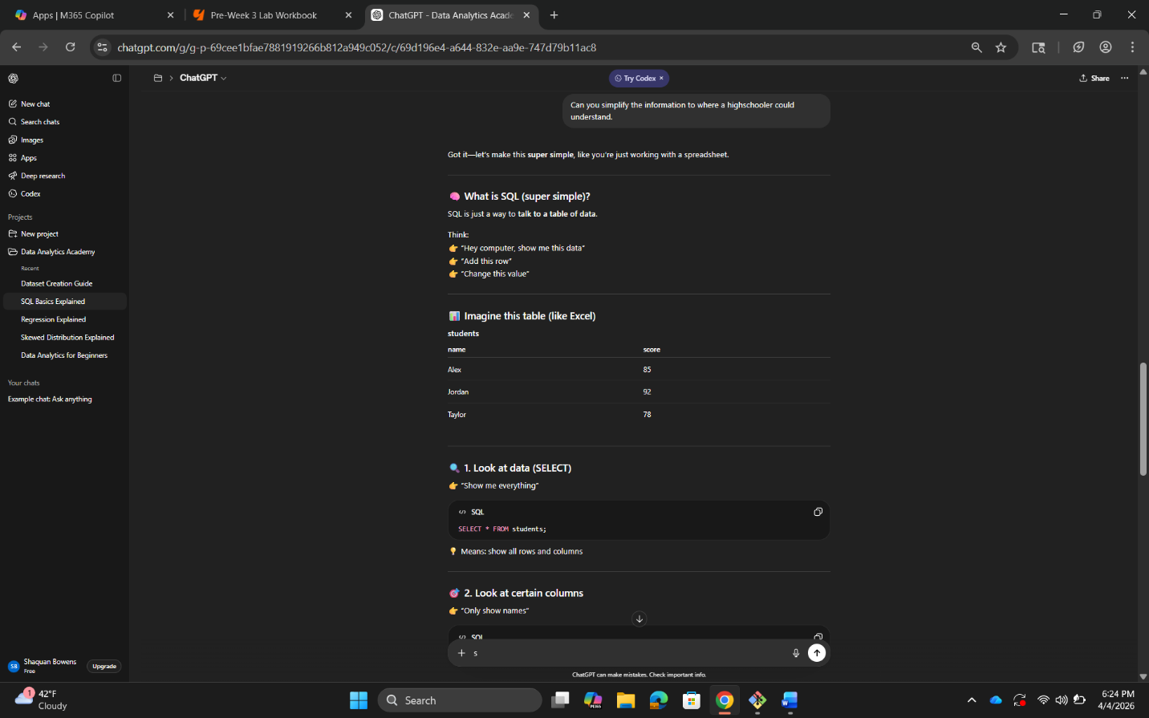

The revised prompts are stronger than the original ones because they go into more detail than the original prompts provided. The original prompts are so broad and if a beginner read the answers, they would likely not have a general idea.

