Univac 494 Emulator Reference

Introduction
This Univac 494 emulator was developed using the documentation that was publicly available on the internet as well as some documentation that was available from museums. As such, there is no way of knowing how completely the emulation mimics the original hardware. Having said that, the emulation is as faithful to the documentation as I could make it with any gaps or omissions in the documentation filled in with what seemed reasonable to me based and 40+ years as a programmer and 20+ years working with Univac, Sperry and Unisys hardware. See the Caveats section for a description on the things that I know are not as they should be.
At the time of writing, the emulator package includes:
- An assembler that runs under Windows which can be used to create memory images that can be loaded directly onto the emulated hardware and executables that can be run by the operating system.
- An FH880 drum utility program that allows you to create drum files, dump them to see what they hold and copy executable and text files from a Windows folder to the emulated drum.
- The 494 console program. This runs beside the CPU emulator and is used to communicate with the operating system.
- The 494 emulator itself. The performs the emulation for the CPU, memory and all peripheral devices. At the time of writing, the only emulated peripherals are the console, reader, punch, printer and FH880 drum.
- The emulator includes a debugger that allows you to step through your code to find out why it isn't working. If you're anything like me you will find this tool indispensable.
- A version of the original Cave adventure program written by William Crowther has been ported to 494 Assembler and can be run as a job under the operating system. I wasted many, many hours playing this game on an 1100 in the late 70's and early 80's.
- A minimal operating system (MOS) that allows programs to be written for the emulator without having to know anything about how the I/O or interrupts work. User programs are run as jobs under the OS and use Executive Return calls to perform I/O. It is possible to run up to 7 jobs simultaneously, depending on memory availability.
- The source code for the OS, Cave and various test programs that I developed to test the emulator.
- The manuals that I used to create this emulator.

Configuring the Emulator
Since the emulator is now has multiple personalities (494, 1230 and 490) it is necessary to configure the emulator's CPU mode and various peripherals. This is accomplished using simple XML files. There are 3 different configuration file supplied with the emulator: U494.cfg, U490.cfg and U1230.cfg. These are sufficient to run the emulator in each supported CPU mode with peripherals appropriate to the CPU type.
To run the emulator using a specific configuration is necessary to supply to -c option on the command line, as shown below:
u494 -c u494.cfg
In the absence of the -c option, the emulator will start in 494 mode.
Sample configuation file:
<?xml version="1.0" encoding="UTF-8"?>
<configuration>
<mode>494</mode>
<load>mos.mem</load>
<console>
<chan>0</chan>
<type>1232</type>
</console>
<rdrpun>
<chan>1</chan>
</rdrpun>
<printer>
<chan>2</chan>
</printer>
<drum>
<chan>5</chan>
<type>fh880</type>
<file>sysvol.drum</file>
</drum>
</configuration>

The Emulator
To start the emulator simply click the U494 icon in your start menu. When the emulator starts, two windows will open; the console and the virtual maintenance panel.

494 Console
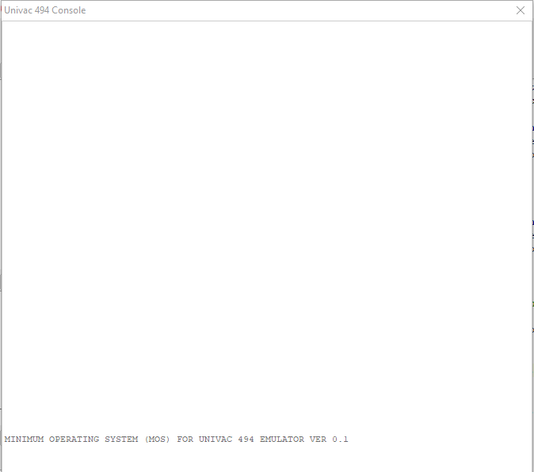
The console is a simple, TTY-like terminal that you can use to communicate with the operating system. When the operating system is running press ENTER to get its attention, then key in your command and press ENTER again. You can use the BACK key to correct typing mistakes. Otherwise everything but printable characters will be ignored.

494 Virtual Maintenance Panel
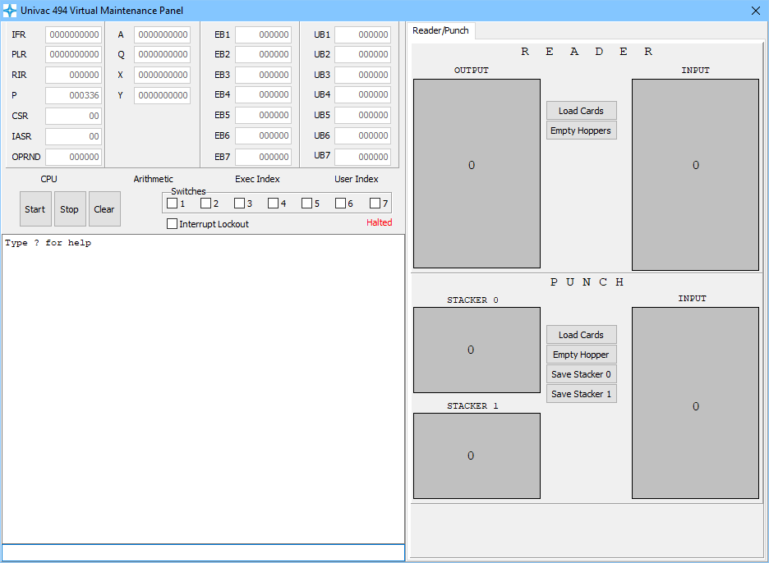
This is where you will spend most of your time if you choose to develop your own programs for the emulator. The top part of the window displays the contents of all of the CPU's registers while the lower half allows you to interact with the debugger. All of this will be covered in more detail later.
When the emulator is started it will automatically load the memory image of the operating system (MOS) into memory and mount the simulated drum on channel 5. To start the operating system just click the Start button. You will see the contents of the registers start to change in the top half of this window and you will see the operating system's introductory banner display in the console window. You will also see periodic informational message display in the bottom half of this window. Things like the time and so forth. This just lets you know that the OS is still happily processing interrupts.
The right half of the window is where you interact with the emulated paper peripherals. Click the tab at the top to switch between the reader/punch and the printer (not yet implemented).
You interact with the reader/punch in much the same way you would have interacted with the physical device. You can load cards into the reader by clicking the Load Cards button. You can load multiple files into the input hopper at one time. You can load either files or blank cards into the punch hopper. If you load a file into the punch hopper it will be “over punched” with the new data.
Plain text files should have an extension of .FD to denote that the file contains Fieldata text. Files with an extension of .H16 and .H12 contain Hollerith data which is useful if you want to read actual card files that have been converted to disc. Other extensions are used to hold data in various different encodings such as EBCDIC and XS3. This is used by other emulators that I have written and is likely not of much use for the 494.
To save data written to the punch use either of the 'Save Stacker' buttons as appropriate.

Playing Cave
Now for the really important part. How to play Cave.
To start Cave, click on the 494 console window to make sure it is selected. Press ENTER. The operating system will reply with a carriage return and '→'. Enter ST CAVE and press ENTER again. After a short pause you will see:
CAVE STARTED
CONFIGURATION SUCCESSFULLY LOADED
INITIALIZATION COMPLETE
WELCOME TO ADVENTURE!! WOULD YOU LIKE INSTRUCTIONS?
** 1-??
To interact with Cave, or any other job, you must press ENTER to get an OS prompt, enter the job number (in this case 1) a space and whatever you want to send to the job. So, to see the instructions for Cave you need to:
- Press ENTER
- Enter 1 Y
- Press ENTER
After reading the instructions I recommend that you send Cave the HELP command to get some more useful hints and then have at it. If at any time you get tired of Cave you can just send it the QUIT command and the job will exit. Of course, you can just close the main emulator window at any time without ill effect.

Operating System Operator Guide
There is a minimal operating system provided with the emulator named MOS. MOS stands for Minimum Operating System (obviously I never worked in marketing).
As mentioned early, to start the operating system all you need to do is click the Start button once the emulator has been loaded. Once the introductory banner has been displayed on the console you can begin to interact with the OS.
To send a command to the OS you first need to press ENTER to get its attention. When the OS is ready to talk to you it will reply with a carriage return and '→'. At this point enter the command and press ENTER again.
The OS recognizes the following commands:
- SS – Display the status of the Syspool. Syspool is a small number of small memory blocks that are used by the operating system as required.
- MS – Display the status of the main memory pool. This pool is used to allocate the memory required to run a user job and by the operating system when buffers larger that a Syspool block are required.
- TS – Display the status of all tasks. Since a user job is just another task it displays the status of user jobs as well.
- ST – start a job. Format: ST JOBNAME CHANNEL where JOBNAME is the 1-10 character name of a file on the simulated drum and CHANNEL is the channel number of the drum. This defaults to 5. Since the only drum the OS knows about is on channel 5 you can safely omit the CHANNEL parameter.
- CA – cancel (kill) a job. Format: CA JOBNUMBER where JOBNUMBER is the job number of the job to kill.

Programming the Emulator
The only advice I can give about writing programs for the 494 is this:
- Read the 494 Assembler Reference. If all you want to do is write user jobs this will probably suffice.
- Read the 494 Programmer Reference. If you are interested in delving into the operating read this. Then read it again. After you have done that, read the FH880 drum manual. This was written for the 490 so some of the stuff relating to BCWs is not compatible with the 494. Wherever there is a conflict I went with what was in the 494 Programmer Reference.
- Look at my source code. I'm certainly not the best 494 Assembler programmer that ever was but everything in there works and it will give you some clues.
Using the Assembler
You can write your programs using your favorite text editor. To compile them you just run them through U494Asm.exe. The command line looks like this
U494Asm file_name [-xref] [-noproc] [-mem] [-exe] [-P proc_folder]
where:
file_name is the name of your assembler source file
-xref will cause the assembler to print a label cross reference at the end of the list. Omitting this option will cause the cross reference to be suppressed.
-noproc will cause the assembler to NOT list expanded PROCs. Omitting this option will cause the code generated by PROC expansion to be shown in the listing.
-mem will produce a memory suitable for loading as an operating system. This is the default.
-exe will produce an exectable file suitable for loading as a user job. All this really does is force the program to start at address 140, which reserves space for the job's task control block.
-obj will produces a relocatable object file suitable for input to the linker.
-P proc_folder tells the assembler where to find your PROC library. Omitting this option will disable PROCs in your program since there will be no PROCs to be found. The emulator's PROC library is found in the Procs folder.
Every run of the assembler will produce a .LST file with the same name as your source file. This listing is where you will find your compile errors and all of the information you will need to debug your program. Error messages are preceded by '****' making them easy to find in the listing.
If your compile was successful the assembler will exit with ERRORLEVEL 0. Otherwise it exits with ERRORLEVEL 1.
To see some examples of assembler jobs look at BuildMOS.bat and BuildCave.bat.
Using SPURT
You can write your programs using your favorite text editor. To compile them you just run them through U494Spurt.exe. The command line looks like this
U494Asm file_name [-tab c] [-sep c] [-xref] [-noproc] [-mem] [-exe] [-P proc_folder]
where:
file_name is the name of your assembler source file
-tab is the character to substitute for the tab character. According the the 490 SPURT manual this should be a tab. The 1230 source files that I have use #. So, to compile monitor6 you need to specify -tab #.
-sep is the character to substitute for the dot separator. The 1230 source files that I have used *. So, to compile monitor6 you need to specify -sep *
-xref will cause the assembler to print a label cross reference at the end of the list. Omitting this option will cause the cross reference to be suppressed. Not currently implemented.
-noproc will cause the assembler to NOT list expanded PROCs. Omitting this option will cause the code generated by PROC expansion to be shown in the listing.
-mem will produce a memory suitable for loading as an operating system. This is the default.
-exe will produce an exectable file suitable for loading as a user job. All this really does is force the program to start at address 140, which reserves space for the job's task control block. Not currently supported.
-obj will produces a relocatable object file suitable for input to the linker. Not currently supported.
-P proc_folder tells the assembler where to find your PROC library. Omitting this option will disable PROCs in your program since there will be no PROCs to be found. The emulator's PROC library is found in the Procs folder. Not currently supported.
Every run of the assembler will produce a .LST file with the same name as your source file. This listing is where you will find your compile errors and all of the information you will need to debug your program. Error messages are preceded by '****' making them easy to find in the listing.
If your compile was successful the assembler will exit with ERRORLEVEL 0. Otherwise it exits with ERRORLEVEL 1.
To see some examples of assembler jobs look at BuildMOS.bat.

Copying Your Program to the Drum
Before you can execute your program as a user job you need to copy it to the simulated drum. To do this use the FH880Util program. You can either use the Window interface or you can use the command line. I find it more convenient to set up a .BAT file to compile my program and copy it to the drum in one step. Otherwise you find yourself wondering why all the changes you just slaved over are not showing up when you execute the program. The command line looks like this:
FH880Util -d drum -i import_file -f drum_file [-lt] -lp]
where:
drum - the name Windows file holding the simulated drum's data. The file provided with the emulator is Drums\sysvol.drum.
import_file – the name of the file to be imported. In this case your program.MEM.
drum_file – the name of the file as it is to appear in the drum's master file directory (MFD).
-lt – import the file as a text file.
-lp – import the file as a program file.

Operating System Programmer Reference
MOS is a cooperative multitasking operating system. What this means is that it relies on all executing tasks to play nice and yield control of the processor once in a while. If you put your job into an infinite loop the OS will hang and you will have to restart the emulator. If you write a compute bound job the OS will appear to take a nap until your job yields control of the processor either by using the YIELD PROC or by doing some kind of I/O.
User programs interact with the operating system through the use of Execute Return (EXRN) instructions. There are a limited number of Executive Returns functions available. There are macros available to make there use easier. These macros are:

Halt – Terminate a program
Parameters:
exit_code – an integer value that is displayed on the console when the job terminates.
HALT 0

Yield – Yield control of the processor
Use this to temporarily yield control of the processor to give other tasks a chance to get some work done. Unless your program is processor bound (IE. not doing any I/O) you should never need to use this. However, processor bound jobs will cause the entire emulator to seem to freeze until the job yields control of the processor in some way. Either by using Yield or by doing some kind of I/O.
Parameters:
none
YIELD

Type – Display text on the console
Use this to display some text on the console. All text must be terminated by a caret (^) to force a CR LF sequence to be sent. The caret must be the last character of the last word of the message otherwise any trailing characters will be displayed on the next line.
Parameters:
buffer_length_in_words,buffer_address
TYPE MLEN,MSG

Accept – Display text on console and wait for response
Use this to display a prompt on the console and what for a response. All text must be terminated by a caret (^) to force a CR LF sequence to be sent. The caret must be the last character of the last word of the message otherwise any trailing characters will be displayed on the next line.
Parameters:
prompt_len,prompt reply_len,reply
ACCEPT PLEN,PROMPT RLEN,REPLY

Dec2Int – Convert decimal text to integer
Converts a Fieldata string in AQ to a single word integer in A.
Parameters:
none

Int2Dec – Convert an integer to decimal text
Converts a single word integer in A to a Fieldata string in AQ.
Parameters:
none

GetToken – Separate a string into tokens
Use this to separate a Fieldata string into space and/or comma separated tokens. Each comma is also returned as a token. The token is returned in AQ.
Parameters:
current_buffer_offset,buffer_address
Where:
current_buffer_offset has the character within the word in the upper half word and the word within the buffer in the lower half word. Set this parameter to 0,0 to start at the beginning of the buffer. This word is updated when GetToken returns and must be passed unchanged to the next call to GetToken.
TKN1 GETTOKEN 0,BUFFER
LA,W TKN1+1
SA,W TKN2+1
TKN2 EXRN ERTOKEN$
+0
+BUFFER

Dayclock – Return the current value of the day clock
Parameters:
none
Returns the current value of the day clock in A.

Rtclock – Return the current value of the real time clock
Parameters:
none
Returns the current value of the real time clock in A.

File Management
Some basic file management is provided by the operating system. This is very loosely based on the OS/3 (and hence IBM 360) DTF (define the file) paradigm.

DTF – Define the file
The DTF macros define an area of storage which contains information about a file. There are several file organizations supported, each with its own DTF.
DTFCR – Card reader files
Parameters:
rec_size,rec_bfr eof_routine err_routine flags
Where:
rec_size is the record size
rec_bfr is the record buffer address
eof_routine is the address of a routine that will get control when end-of-file (/*) is reached
err_routine is the address of a routine that will get control in the event of an error
flags is used to set the translate mode. DTF$COLIMG or DTF$ROWIMG. If omitted Fieldata is assumed.
DTFCR 16D,RECBFR
- EOF
- ERR
DTFCP – Card punch files
Parameters:
rec_size,rec_bfr err_routine flags
Where:
rec_size is the record size
rec_bfr is the record buffer address
err_routine is the address of a routine that will get control in the event of an error
flags is used to set the translate mode. DTF$COLIMG or DTF$ROWIMG. If omitted Fieldata is assumed.
DTFCP 16D,RECBFR
- ERR

DTFSD – Sequential drum files
Parameters:
file_name,channel# flags rec_size,rec_bfr iobfr eof_routine err_routine
Where:
file_name is the name of the file
channel# is the channel number of the drum where the file is located. Defaults to 5.
flags denotes additional options for the file. DTF$INPUT, DTF$OUTPUT, DTF$VARREC
rec_size is the record size
rec_bfr is the record buffer address
iobfr is the address of a 1024 word I/O buffer
eof_routine is the address of a routine that will get control when end-of-file (/*) is reached. Ignored.
err_routine is the address of a routine that will get control in the event of an error
Drum files can be either input or output, but not both. They can have either fixed length (default) or variable length records. Variable length records are terminated by a word of -0 (all ones).
DTFSD 'TEST.DAT'
- DTF$INPUT+DTF$VARREC
- 16D,RECBFR
- IOBFR
- EOF
- ERR

OPEN – Open a file
Parameters:
dtf
OPEN DTFIN
CLOSE – Close a file
Parameters:
dtf
CLOSE DTFIN
READ – Read a record
Parameters:
dtf
READ DTFIN
WRITE – Write a record
Parameters:
dtf
WRITE DTFIN
STKSEL – Select the stacker for the next card to be punched
Parameters:
dtf stacker (0/1)
STKSEL DTFOUT 1

Virtual Maintenance Panel Guide
At any time while the processor is stopped (halted) you can interact with the virtual maintenance panel. This allows you to display memory, modify memory or registers and use the debugger.
There are 3 buttons: Start, Stop and Clear. The Start button puts the processor into a running state and starts execution at the address contained in P. Stop halts the processor. To start it again exactly where it stopped click Start. Clear is only active when the processor is halted. It clears the interrupt lockout switch and resets attached peripherals.
There are a collection of checkboxes which correspond the the Keys used by the J instruction to alter program behaviour based on operator input. Checking these boxes will only affect program execution if the programmer has made use of the appropriate options on a J instruction.
The virtual maintenance command recognizes the following commands:
?
Display a short help message showing all commands and their options.
G(oto) address
Resume execution at the given address. i.e. set P to address and start.
M(odify) address value
Modify memory at the given address with value. If address is one of the register names shown at the top of window the register will be modified. e.g. M A 123 with change the A register's value to 123 octal.
D(isplay) [address]
Display 5 words of memory starting at the given address. If address is omitted the display will start following the last word displayed by the previous Display command.
(L)oad memory_image_file
Loads the memory image contained in the given Windows file.
De(b)ug on|off trace|notrace os|job
Turns the debugger on or off. If trace is given the EVERY instruction executed will be disassemmbled and displayed as it is executed. This slows execution significantly. If notrace is given tracing is turned off. If os is given only the operating system instructions (i.e. those where RIR = 0) will be debugged. If job is given only user job instructions (i.e. thos where RIR <> 0) will be debugged. Specifying job also inhibits tracing of interrupt handlers.
The following commands only have effect when debugging is enabled.
(I)nterrupt_skip
This command toggles the debugging of interrupt handlers. If you are trying to debug the operating system I recommend inhibiting interrupt debugging. There is nothing more annoying that stepping through your code and having the processor start processor start handling an interrupt right in the middle of your debug session.
(N)ext
Execute the instruction currently being displayed, display the next instruction and stop.
(C)ontinue
Execute the instruction currently being display and keep executing until a breakpoint is reached.
B(r)eakpoint address
Toggle the breakpoint at the given address.
All numbers can be given as either octal or decimal. Decimal numbers are followed by D. i.e. 12345D. All other numbers are octal.
Sample Debugging Session
B ON JOB . debug a user job
Debug ON NOTRACE JOB Interrupts skipped
R 140 . break at 140 (first instruction)
Breakpoint added at 000140
C . start execution
Breakpoint @ 00140
335700/000140: 1143005524 LA,W 05524,,4
D 5524 . display address 5524
335700/005524: 0000000000 0000000001 0000000002 0000000003 0000000005
D . display next (5531)
335700/005531: 0000000007 0000000012 0000000013 0000000023 0000000024
N . step 1 instruction
335700/000142: 1100000001 LA 00001
N . step 1 instruction
335700/000143: 1503005524 SA,W 05524
C . continue execution

Caveats
- The console emulation is for the 1232 console. This is the console that was used with the 1230. This was not the console used with the 494. At the present only the keyboard and printer are implemented. The attached paper tape unit is scheduled for a future release.
- The real time clock interrupted a real 494 every 200 microseconds. Due to limitations of programming in Windows the real time clock only interrupts approximately every 2 milliseconds. The interval between interrupts is not entirely consistent either. For purposes of emulation I expect that this will make no difference whatsoever. In fact, my operating system makes no use of the real time interrupt at all.
- 490 family (490, 1230, 642, etc.) emulation is a work in progress. Some things are not yet implemented, such as 17-bit mode for the 1230. 1230 emulation is sufficient to allow the basic functions of monitor6 to run. 490 emulation has not been tested at all although given that it is very similar to the 1230 I expect that basic instructions and I/O should work correctly.
- There were two assemblers for the 494; SPURT and 494 Assembler. SPURT was a 490 compatible assembler while the 494 Assembler was specifically for the 494. Both assemblers are included included with this emulator.
494 Assembler caveats:
There are some things that were either implemented differently or not at all.
- The concept of multiple location counters is not implemented at all. There is a single location counter and its name is $.
- The concept of specifying literals in the operand field (a value preceded by a colon and followed by a semi-colon) is not implemented.
- The BLOCK-DATA directive is not implemented.
- The COMMON directive is not implemented.
- The DO directive is not implemented.
- The EXPRESSION directive is not implemented.
- The INPUT directive is not implemented.
- The LET directive is not implemented.
- The LIT directive is not implemented.
- It is not possible to embed a PROC definition inside another PROC definition. It is however possible to call a PROC from with another PROC.
SPURT caveats:
The SPURT assembler is a work in progress. As such there is not a definitive list of what is implemented and what isn't. Some of the most glaring omissions are:
- PROCs are not implemented.
- Literals are not implemented.
- Only absolute elements suitable for booting the emulator are supported.
- I'm sure there are issues.

