**CS412 PROJECT: HANDWRITTEN DIGITS CLASSIFICATION WITH MLP**

1. Import the essential libraries at first:

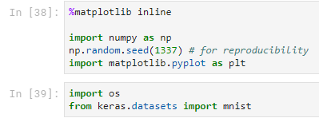

1. Load the MNIST dataset and split the data to training and test sets:



1. Process the data as required:

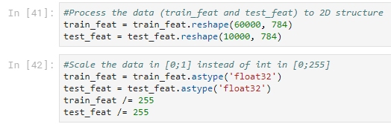

1. Check the shapes:

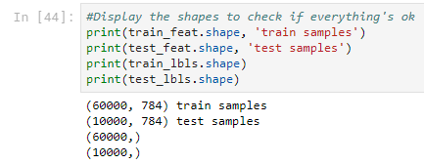

(a) train feat: Training features of size 60,000x784

(b) train lbls: Training labels of size 60,000x1

(c) test feat: Testing features of size 10,000x784

(d) test lbls: Testing labels of size 10,000x1

1. Display an example digit from the dataset:

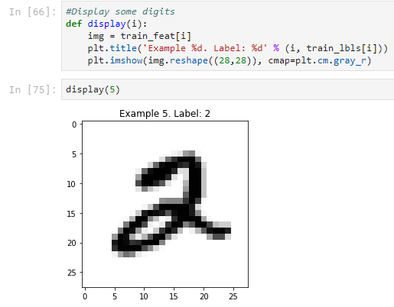

Here, the shape belongs to an example handwritten digit which is we know as 2 from the “Label” of it.

1. Plot 20 samples from training and testing data:

Training:

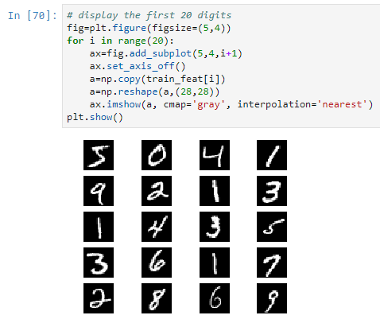

Testing:

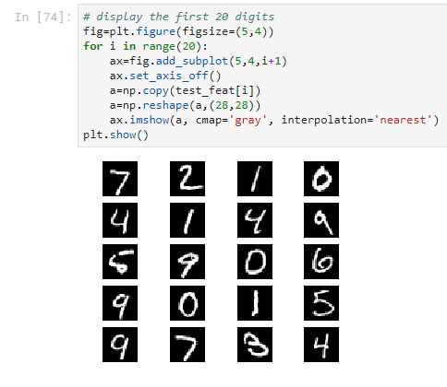

1. For training Multilayer Perceptron, import the essential libraries:

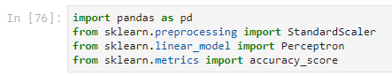

1. Apply the scaler:

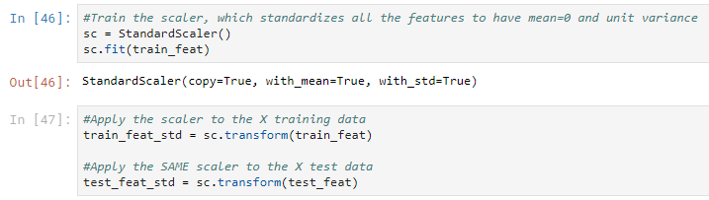

1. Create a perceptron object with 40 epochs and 0.1 learning rate:

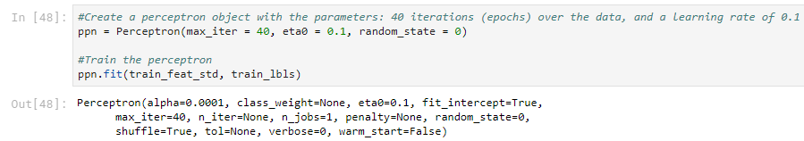

1. Apply the perceptron object and find its accuracy:

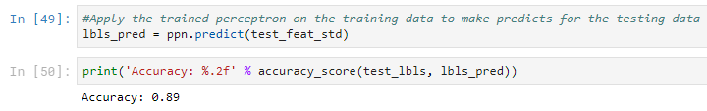

1. Now train the MLP with hidden layers of size 300 and 100, SGD solver and activation function:

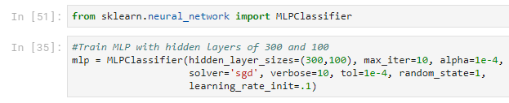

1. Fit the model and find the training and test accuracy scores:

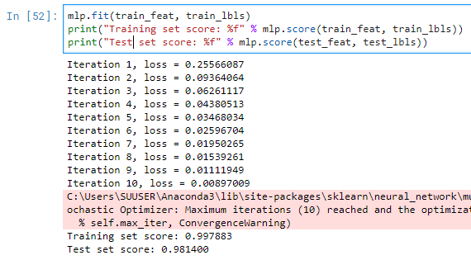

**Training accuracy score: 0.997883**

**Testing accuracy score: 0.981400**

We got a really high score on training accuracy but it decreased a little bit on the testing accuracy.

1. Report the confusion matrix(10x10):

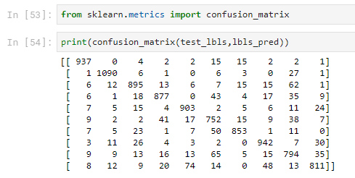

1. 20 examples from the misclassified digits:

