
HP Labs India

<UPX>
Schema Version 0.9.5
(Published 19th October 2006)
Working Draft

Sriganesh Madhvanath
Louis Vuurpijl
Kalika Bali
Mudit Agrawal
V. Jagannadan
Deepu Vijayasenan
Don Willems
Lambert Schomaker

Abstract
This document describes the syntax and semantics for UPX version 0.9.5. It is the result of a cooperation between HP labs Bangalore and the iUF. This document was first announced at IWFHR10, la Baule. It should be considered as working draft, open for review and comments. For submitting comments, up-to-date versions and news from UPX, see http://unipen.nici.ru.nl/upx.

Table of contents
- 1 OVERVIEW
  - 1.1 Need for a new Standard
  - 1.2 Representation for Annotated Handwritten Data
- 1 <upx> element
- 2 <datasetInfo> element
  - 2.1 <name> element
  - 2.2 <category> element
  - 2.3 <version> element
  - 2.4 <contact> element
  - 2.5 <source> element
  - 2.6 <setup> element
  - 2.7 <dataInfo> element
    - 2.7.1 <contentDesc>
    - 2.7.2 <numWriters>
    - 2.7.3 <quality>
    - 2.7.4 <style>
    - 2.7.5 <groundThruth>
  - 2.8 Example of <dataSetInfo>
- 3 <datasetDefs> element
  - 3.1 <writerDefs> element
  - 3.2 <writer> element
    - 3.2.1 <personal>
    - 3.2.2 <skillDevice>
    - 3.2.3 <skillContent>
      - 3.2.3.1 <skillText>
      - 3.2.3.2 <skillDrawing>
      - 3.2.3.3 <skillMusic>
      - 3.2.3.4 <skillMath>
      - 3.2.3.5 <skillChemistry>
  - 3.3 <labelSrcDefs> element
  - 3.4 <annotationDefs> element
    - 3.4.1 <annotationScheme> element
      - 3.4.1.1 <annotationLevel> element
  - 3.5 Example of <datasetDefs>
- 4 <hwdata> element
  - 4.1 <hLevel> element
    - 4.1.1 <label> element
      - 4.1.1.1 <alternate> element
  - 4.2 <uiInfo> element
  - 4.3 <imgInfo> element
    - 4.3.1 <roi> element
    - 4.3.2 <imgPrepro> element
      - 4.3.2.1 <crop> element
      - 4.3.2.2 <scale> element
      - 4.3.2.3 <rotate> element
  - 4.4 <hwTraces> element
  - 4.5 Examples of <hwData>

Overview
Online Handwriting Recognition refers to the interpretation of handwriting captured as digital ink from a suitable pen input device. Digital ink consists of a series of pen positions and optional attributes such as pen tilt and pressure sampled at (typically) uniform intervals of time. Annotated datasets of handwriting covering a variety of writing styles are essential for the development and evaluation of modern data-driven handwriting recognition engines. Early standards for digital ink such as ITU-T 150 (1988) and Jot (1992) focused on the representation of digital ink and did not address the issue of annotation of handwriting data for handwriting recognition research and development. The lack of a common annotation standard resulted in duplication of data collection efforts for each research effort, and made systematic evaluation and comparison of different recognition algorithms difficult. This issue was first addressed by the UNIPEN consortium [1]. The UNIPEN representation employed ASCII flat files to store handwriting data and associated annotation. The focus of the UNIPEN effort was on the recognition of cursive English, and the members of the consortium collected and annotated large amounts of handwriting data in the UNIPEN format. However, there have been attempts at creating datasets using the same standard in other languages such as Japanese (Kanji) and Arabic. UNIPEN also made available a set of tools to create annotated datasets from captured handwriting data [2].

Need for a new Standard
While research in online handwriting recognition in the context of Roman and many Oriental scripts has continued unbroken for over three decades and resulted in several commercial engines, the same cannot be said for the majority of the world's scripts especially in developing countries. The lack of significant and easily available linguistic resources in the form of annotated datasets of handwriting has been one of the obstacles to research in these scripts. It is clear that many of these resources need to be created, and the creation of such handwriting databases in different scripts calls for a standard representation that is independent of script and allows semantic interpretation of the writing at various user-defined logical levels (e.g. Word, Character). The representation should capture information about script, writing style, quality of writing and truth. It should also capture information about writers and the data capture environment. It should support automatic generation of annotation using recognizers, and subsequent manual validation processes. After considering use of the venerable UNIPEN standard and tools, as well as other ink formats, a decision was made to instead use the emerging Digital Ink Markup Language (InkML) standard from W3C's Multi-modal Interaction Working Group (W3C MMI) for the representation of the signal (digital ink) and develop a set of XML tags (called hwDataset) that described the ink (mainly ground-truth, but also script, style and other attributes). This activity was welcomed by the MMI WG as an important application of InkML. An initial version of the hwDataset representation was presented to the WG in Oct 2003. The representation makes use of the underlying InkML representa-tion of the raw handwriting data and contains many elements from UNIPEN.
InkML has been mooted to provide a platform independent data format for representing ink entered with an electronic pen or stylus. The markup is designed to support the input, storage and processing of handwriting, gestures, sketches, music and other notational languages in Web-based applications. It also provides a common format for the exchange of ink data between components such as handwriting and gesture recognizers, signature verifiers, and other ink-aware modules. InkML provides means for application-specific extensions. By virtue of being an XML-based language, users may easily add application-specific information to ink files to suit the needs of the application at hand.
The current InkML specification [3] defines a set of core primitive elements useful for any ink application. The <trace> is the basic element used to record the trajectory of the pen as the user writes digital ink. Details of the input device (digitizer), digitizer channels, and coordinate system comprise the context in which ink is recorded and are captured in the <context> element. The <brush> element captures certain attributes of the pen during ink capture. The <traceView> and <traceGroup> elements provide the basis for grouping traces. They allow as subelements <annotation> and <annotationXML> which may be used for text and XML annotations respectively. These elements are considered as core elements since they are useful for most pen-based applications. The XML representation described in this paper may be thought of an application-specific extension of the core InkML for the creation of annotated datasets of handwriting data or pen input data in general.
This UPX definition complies to InkML and has been influenced by UNIPEN. Furthermore, it builds on previous definitions of UPX, called hwDataset [4, 5, 6]. For the definition of elements describing scripts (<writer> element) and regions of interests (<imgInfo> element), the UPX scheme borrows concepts developed in Wanda [7, 8].

Representation for Annotated Handwriting Datasets
In general, a dataset may be organized as a collection of multiple UPX documents corresponding to different writers, trials, fields etc as appropriate, stored in an appropriate directory structure. For efficient storage, common information such as dataset information and descriptions of writers may be stored in a common UPX document, and referred to by other documents. One of the objectives of the specification is to support different implementations of such organizations of the dataset as a whole. Our representation for annotated datasets of pen input is called UPX, and it includes several elements for detailed annotation of handwriting.

<upx> element
The <upx> element is the root element of the XML document and captures meta-data about the dataset under <datasetInfo>, various definitions as part of <datasetDefs>, and hierarchical annotation of handwriting data using <hwData> blocks.

Attributes:
schemaVersion = “0.9”

Contents:
datasetInfo? | datasetDefs? | hwData+|
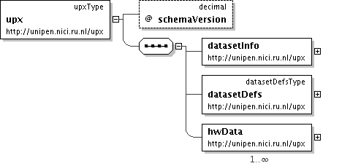

<datasetInfo> element
The <datasetInfo> element captures metadata of the dataset as a whole.

Attributes:
href = xsd:anyURI
Reference to datasetInfo element defined elsewhere (e.g. in a common location). This is overidden by any information provided as subelements.

Id = xsd:ID
The unique identifier for this element.

datasetId = xsd:string
The unique identifier for this dataset, derived from its unique name

Contents:
name? | category? | version? | contact? | source? | setup? | dataInfo? |

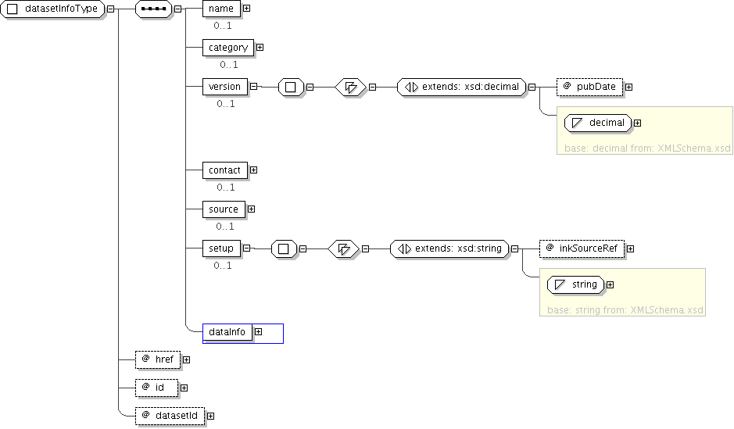

<name> element
The <name> element is used to refer to the Dataset, for example, the “iUF train_r01_v07 Dataset”

<category> element

The <category> element is used as a broad description of the dataset similar to InkML contentCategory. Examples: 1. text/language [/script][/sub-category] (e.g., text/jpn/Kanji, text/en/ssn) 2. drawing [/sub-category] Sub-category can be similar to Unipen categorization (numerals, isolated characters, words etc) or correspond to semantic categories such as SSN. [OPEN: Standardization of syntax. Also how to handle documents wherein multiple scripts or in general multiple (sub)categories are represented]

<version> element

The <version> element refers to the published version of the dataset.

Attributes:
pubDate: xsd:date
Date and year of publication of dataset.

<contact> element

The <contact> element gives the contact information of the publisher of the Dataset, such as name, email address, for Dataset related queries.

<source> element

The <source> element refers to the organization the data was collected from, if different from the publisher.

<setup> element

The <setup> element gives a description of data collection recording setup and conditions.

Attributes:
inkSourceRef: xsd:anyRI
Reference to <inkSource> element from InkML describing the device used for capture.

<dataInfo> element

The <dataInfo> element in turn gives more details about the data such as quality of writing, ground truth of what is captured, the data collection methodology etc.

Contents:
contentDesc | numWriters? | quality? | style? | groundTruth?

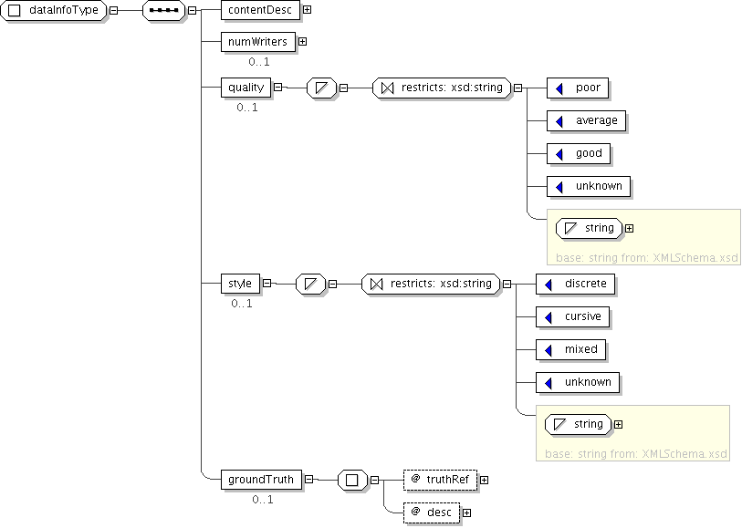

<contentDesc> element

The <contentDesc> element gives a top-level description of the contents of the Dataset, including information about script(s) used, writing styles, quality of writing etc. This is only meant to provide a brief consolidated picture of the data in the dataset, and is not a substitute for detailed annotation of ink.

<numWriters> element

The <numWriters> element gives the number of writers contributing data to the Dataset.

<quality> element
The <quality> element describes the overall quality of the handwriting data captured in the dataset. This element is an enumeration of poor|average|good|unknown.

<style> element
The <style> element specifies the overall writing style of the handwriting data captured in the dataset. Style is an enumeration of discrete|cursive|mixed|unknown. In addition, style labels may be specified as annotation of ink.

<groundTruth> element
The <groundTruth> element contains a verbatim description of the reference text. Alternatively, a reference (using the <truthRef> attribute) to a ground truth defined elsewhere can be made.

Example of <datasetInfo>
<datasetInfo id=”datasetInfo01” datasetId="HPL-ENGWD">
<name>HPL English Word Dataset</name>
<category>unipen/6 </category>
<version pubDate=”2006-10-23”>1.0</version>
<contact>HP Labs India, xyz@hp.com</contact>
<source>Indian Institute of Science, abc@iisc.ernet.in</source>
<setup sourceRef = “ sampleDoc.inkML#inkSource01”>Writing on a iPAQ PocketPC placed on a horizontal surface while seated</setup>
<dataInfo>
<contentDesc>100 most frequent English words
selected from ABC text corpus written 5 times by each
writer</contentDesc>
<numWriters>100</numWriters>
<quality>good</quality>
<style>mixed</style>
<groundTruth truthRef=http://www.abc.org/top100.html />
</dataInfo>
</datasetInfo>

<datasetDefs> element
The <datasetDefs> element captures information about different writers and sources of labels (annotation) represented in the dataset and provide the means for referring to them later in the document.
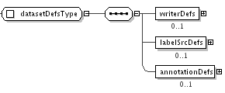

Contents:
writerDefs? | labelSrcDefs? | annotationDefs? |

<writerDefs> element
The <writerDefs> element captures the detailed profiles of writers contributing data to the Dataset. <writerDefs> can have one or more <writer> elements which effectively capture information about each writer. This element contains a <href> attribute, via which references to writer definition blocks defined elsewhere can be made.

<writer> element
The <writer> element contains information about the writer whose pen input appears in the dataset, comprising personal information, skill with the capture device, and skill with the content of the pen input.

Contents:
personal? | skillDevice* | | skillContent*

<personal> element

Contents:
hand? | educationlevel? | gender? | profession ?| region? | [ dateofBirth | age ]? ) |

<skillDevice> element
Familiarity with different types of capture devices used [Poor, Average, Good].

Attributes:
deviceType = xsd:string
Description of type of device

<skillContent> element
The <skillContent> element is used as a container for specifying the familiarity of the user with generating the digital ink that was captured during data collection. As specified in the inkML definition (http://www.w3.org/TR/InkML/#contentCategory), digital ink may represent text, drawing, math, music and chemistry. Note that specifications of inkML <contentCategory> are linked with the <hwTraces> through the inkML <traceView> element. See also <category> (3.2) and <contentDesc> (3.7.1).

Contents:
skillScript? | skillDrawing? | skillMusic? | skillMath? | skillChemistry? |

<skillText> element
The <skillText> element is used to capture information regarding the familiarity of the user on various texts featured in the data collection process. Attributes defining the script are language and type. Language refers to any of the languages defined in ISO 639-2. The script types are, e.g., Latin, Armenian, Devanagari, etcetera, as defined in Unicode.

Attributes:
language: xsd:string
Language used for data collection (see ISO 639-2 language codes)

Script: xsd:string
Script used for data collection (see Unicode script code charts)

Native: xsd:Boolean
whether the user is a native writer of the text or not

Contents:
Style? | usageFreq? | proficiency? |

Content Description
style: Writing style of the writer

usageFreq: Frequency of the usage of the script in last one year

proficiency: Level of skill of the writer in writing the script

<skillDrawing> element
The <skillDrawing> element is used to capture information regarding the familiarity of the user on various drawings featured in the data collection process.

Contents:
usageFreq? | proficiency? |

<skillMusic> element to be done

<skillMath> element to be done

<skillChemistry> element to be done

<labelSrcDefs> element

The <labelSrcDefs> element contains descriptions of annotators of the Dataset. Each labelSrc element captures information regarding a particular label source and the types of labels provided by that source.

<labelSrc> element
Captures information about a particular label source and the provided kinds of annotation provided by it.

Attributes:
href = xsd:anyURI
Reference to labelSrc element defined elsewhere (e.g. in a common location). This is overidden by any information provided as subelements.

Id = xsd:ID
Id given to the Label source

type = xsd:string
type of the label source, may be Human or Machine

Contents:
name | source | contact | desc | labelTypes |

Decsription:
name: Name of label source

source: Organization that label source represents

Contact: Contact information for label source: Name, email, etc

desc: General description of the label source (more suitable for machine sources)

<annotationDefs> element
The <annotationDefs> element defines and describes the various annotation schemes used in the dataset.

Attributes:
href = xsd:anyURI

id = xsd:ID to identify the block containing one or more annotation schemes

Contents:
annotationscheme+ |

<annotationScheme> element
The <annotationScheme> element can be compared to the .HIERARCHY specification in UNIPEN. In the scheme, one or more annotation levels are contained, which present a view on a collection of ink traces, at a certain hierarchy level. In the 0.9.5 version of UPX, the hierarchical organization of levels is completely left free. This allows for the specification of heterogeneous annotation levels, like in the freehand generation of drawing and text. On the other hand, it makes the automatic validation of UPX hierarchy specifications difficult. [open: do we need parent->child relationships to control the annotation hierarchy?]

Attributes:
id = xsd:ID

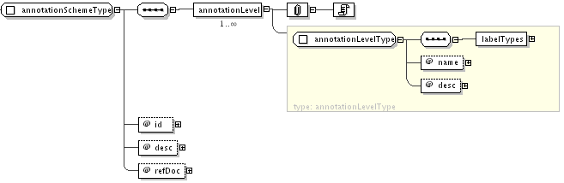

<annotationLevel> element

Description of level of the annotation hierarchy.

Attributes:
name= xsd:string
desc = xsd:string

Contents:
labelTypes: List of label types (e.g. segm, truth, style, quality, script, etc.) available at this level of annotation hierarchy

<labelName> element

This element refers to a type of label available at this annotation level.

Attributes:
labelFormat = xsd:string
Refers to the encoding scheme used for the label. E.g. UNICODE (for labels of type “truth”).

Example of <datasetDefs>
<datasetDefs>
<writerDefs>
<writer writerId=”writer01”>
<personal>
<hand>left</hand>
<education>graduate</education>
<gender>male</gender>
<profession>merchant</profession>
<region>india/bihar/patna</region>
<dateOfBirth>19-19-1999<dateOfBirth>
</personal>
<skillDevice>poor</skillDevice>
<skillContent>
<skillText language=”English” script=”latin”>
<style>mixed</style>
<usageFreq>everyday</usageFreq>
<proficiency>high</proficiency>
</skillText>
</writer>
</writerDefs>
<labelSrcDefs>
<labelSrc id=”labelsrc01” type=”machine”
<name>English Recognizer v1.0</name>
<source>HP Labs India</source>
<contact>Deepu V., deepu@hp.com</contact>
<desc>DTW recognizer for isolated characters</desc>
</labelSrc>
</labelSrcDefs>
<annotationDefs>
<annotationScheme id =”scheme01”
<annotationLevel name=”word”
desc = “instance of word”>
<labelTypes>
<labelName labelFormat= “UNICODE”>truth
</labelName>
<labelName>quality</labelName>
</labelTypes>
</annotationLevel>

<annotationLevel name=”letter”
desc = “instance of letter”>
<labelTypes>
<labelName labelFormat= “UNICODE”>truth
</labelName>
<labelName>quality </labelName>
</labelTypes>
</annotationLevel>
</annotationScheme>
</annotationDefs>
</datasetDefs>

<hwdata> element
The <hwData> element allows hierarchical organization of digital ink data and its annotation. It typically contains the root of the annotation hierarchy defined by the user, denoted by the element <hLevel>. At each hierarchy level indicated by the level attribute of <hLevel>, <hLevel> contains a label element that captures annotation information at that level. <hLevel> may also contain one or more nested <hLevel> elements. Furthermore, <hLevel> contains <hwTraces>, the element that refers to raw ink traces using InkML <traceView>. The <hLevel> elements are meant to be used to indicate the structural makeup of handwriting, and assign meaningful names such as PARAGRAPH and WORD using the corresponding attributes of the <hwData> element. One or more <label> elements at each level can be used to capture alternative choices of label with confidence values if any, and the timestamp of annotation. Although primarily intended to describe the truth value of a particular set of ink traces, it may also be used for describing other characteristics such as writing style, quality and script. The timestamp can be used to generate the history of annotation spanning different label sources of a particular unit of writing. The <alternate> element can be used to facilitate the process of manual validation by prompting options for human validation. Formally, the attributes of label are (i) id - identification of the label, (ii) labelSrcRef - reference to the label source defined earlier. This holds good for sub-levels of the current level except where explicitly overridden (iii( category, - category of label (e.g. truth, quality, script, style, etc), and (iv)timestamp - time of the act of annotation.
Alternatively, hwData can merely contain references to one or more hLevel elements defined in the same or other UPX document.

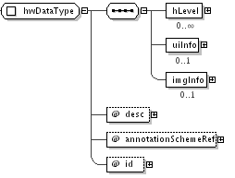

Attributes:
desc = xsd:string

annotationSchemeRef = xsd:anyURI

id = xsd:string

CONTENTS:
hLevel* | uiInfo* | imgInfo*

<hLevel> element

Attributes:
id = xsd:ID

href = xsd:String

writerRef = xsd:string

level = xsd:string

hierarchy = xsd:string

CONTENTS:
label* | uiInfo* | imgInfo* | hLevel* | hwTraces*

<label> element

Attributes:
id = xsd:ID

labelSrcRef = xsd:anyURI

labelType = xsd:string

timeStamp = datetime employing UTC as specified in inkML <timestamp>

Contents:
alternate+

5.1.1.1 <alternate> element
Alternative label values with rank and score. Alternates can be generated from a recognizer (in semi-automated labeling) or can be specified manually.

Attributes:
rank = xsd:positiveInteger

score: = xsd:float
confidence level, an output of the recognizer

<uiInfo> element

The <uiInfo> element is used to capture the User Interface information of the data collection software. The xOrigin and yOrigin give the coordinates in the ink coordinate system of the top-left corner of the ink capture box. The xDim and YDim give the width and height of the box respectively. The other attributes such as top, bottom, right and left which are of Boolean type indicate whether the edges were present in the sides or not. Currently, either <uiInfo> or <imgInfo> apply to specify background information that was available during data capture. We are considering <formInfo> for describing, e.g., the layout of forms used for data entry.

Attributes:
xOrigin = xsd:integer

yOrigin = xsd:integer

xDim = xsd:integer

yDim = xsd:integer

topBorder = xsd:boolean

bottomBorder = xsd:boolean

leftBorder = xsd:boolean

rightBorder = xsd:boolean

Contents:
hLines ? | vLines?

Content Description:
Information regarding the horizontal and vertical reference lines are stored in hLine and vLine elements of uiInfo respectively.

<imgInfo> element
The <imgInfo> element is used when the online traces were recorded with a so-called inking pen, where writers write on real paper positioned on top of the digitizer. Other situations where <imgInfo> applies are cases where online trajectories are collected on a tabletPC or LCD digitizer, where a digital image is used as background. Here, online trajectories are overlays on top of the background image as in, e.g., map annotations, route descriptions, music score annotations, or any other annotation of image material. Goal of this element is to be able to link online traces to offline image content. [open: do we require attributes for origin and orientation?]

Attributes:
id = xsd:ID

imgRef = xsd:anyURI
The href to the image

Contents:
roi | imgPreproc

<roi> element
The <roi> element describes the region of interest in the image that contains the corresponding ink coordinates. It is described as a list of (x,y) coordinate pairs in the image coordinate system.

Attributes:
id = xsd:ID

points = xsd:list

Examples:
<roi id=”bbheader” points=”10 10 10 100 100 100 100 10”/> <!-- bounding box -->
<roi id=”ch_paragraph” points=”…..” /> <!-- e.g., convex hull enclosing text -->

<imgPreproc> element

The <imgPreproc> element describes the processing performed on the image before it was displayed to the user. In UPX 0.9, an image may be cropped, scaled, or rotated. Distinct sub-elements are defined for these purposes to be able to specify the order of processing.

Attributes:
id = xsd:ID

Contents:
crop | scale | rotate

<crop> element

The <crop> element specifies the bounding box in original image coordinates.

Attributes:
boundingBox = xsd:list

<scale> element

The <scale> element specifies the scaling factors in X and Y direction

Attributes:
xFactor = xsd:float

yFactor = xsd:float

<rotate> element

The <rotate> element specifies the rotation angle in radians and rotation point in image coordinates. Rotating an image may apply when, e.g., an aerial photograph is calibrated to a N-E-S-W geographical orientation.

Attributes:
Angle = xsd:float

Pivot = xsd:list

Example:
<imgPrepro id=”prepro0”>
<rotate angle=”0.5” pivot=”10 85”/>
<crop boundingBox=”100 100 100 200 200 200 200 100”>
</imgPrepro>

<hwTraces> element

References to digital ink traces (list of InkML tracerefs). The hwTraces element contains the element called the traceView which carries a reference to a trace (or list of traces, or part of a trace) in an InkML document.

Contents:
traceView+ |

Content Description:
traceView: Reference to raw ink traces or traceGroups represented using InkML

Examples of <hwData>
Example 1: Character annotation with multiple alternatives
<hwdata desc = “field 1”
annotationSchemeRef = “#scheme01”
id = “FIELD01”>
<hLevel
id = “ID018485”
writerRef = “WRITER01”
level = “CHARACTER”>
<label
id = “char01”
labelSrcRef = “HPLRECOGNIZER”
labelType = “truth”
timestamp = “100000234”>
<alternate rank = “1” score = “0.97”>a</alternate>
<alternate rank = “2” score = “0.92”>u</alternate>
</label>
<hwtraces>
<traceRef href = “sampleDoc.inkml#trace1></traceRef>
</hwtraces>
</hwdata>

Example 2: Data description containing references to hLevel defined elsewhere
<hwdata desc = “all characters from the UNIPEN set” id = “iUF-train_r01_v07/chars”>
<hLevel href=” iUF-train_r01_v07/1a/aga/amywldrp.upx#char_012”>
<hLevel href=” iUF-train_r01_v07/1a/aga/annzchrl.dat#char_017”>
<hLevel href=” iUF-train_r01_v07/1a/aga/crlmtchl.dat#char_003>
….
</hwdata>

References
- For an overview and history about UNIPEN, see http://www.unipen.org

- Guyon, I., Schomaker, L., Plamondon, R., Liberman, M. & Janet, S. UNIPEN project of on-line data exchange and recognizer benchmarks, in Proceedings of the 12th International Conference on Pattern Recognition, ICPR'94, pp. 29-33, Jerusalem, Israel, October 1994.

- For the latest public draft of InkML, see http://www.w3.org/TR/InkML. The UPX 0.9.5 version complies with InkML version 20061023.

- A. S. Bhaskarabhatla and S. Madhvanath. An XML Representation for Annotated Handwriting Datasets for Online Handwriting Recognition. In Proceedings of the 4th International Conference on Language Resources and Evaluation, Lisbon, Portugal, May 2004.

- A. S. Bhaskarabhatla, M. Pavan Kumar, A. Balasubramanian, C. Jawahar, and S. Madhvanath. Representation and Annotation of Online Handwritten Data. In Proceedings of the Ninth International Workshop on Frontiers in Handwriting Recognition (IWFHR-9), Tokyo, Japan, October 2004.

- Mudit Agrawal, Kalika Bali, Sriganesh Madhvanath, Louis G Vuurpijl. UPX: A New XML Representation for Annotated Datasets of Online Handwriting Data. In Proc. Intl. Conf. Document Analysis and Recognition, ICDAR`05, Seoul, Korea, pages 1161-1165, Aug 29 - Sept 1, 2005.

- K. Franke, I. Guyon, L.R.B. Schomaker, and L.G. Vuurpijl, WandaXML - A data standard for the annotation and storage of handwriting samples in the context of (computer-based) forensic handwriting analysis and writer identification, Technical Report, International Unipen Foundation, <http://www.unipen.org>, 2003

- K. Franke, I. Guyon, L.R.B. Schomaker, and L.G. Vuurpijl, Wanda ML, a markup language for digital document annotation, In Proceedings of the Ninth International Workshop on Frontiers in Handwriting Recognition (IWFHR-9), Tokyo, Japan, October 2004.

