Software Requirements Specification
<Requirement Engineering>
Version 13.0 approved
Prepared by <Eng.Suliman Albraim>
Supervised by <Dr. Zayed>
<15/10/2022>

Table of Contents
Table of Contents ii
Revision History ii
1. Introduction 1
1.1 Purpose 1
1.2 Project Scope 1
2. Overall Description 1
2.1 Product Features 1
2.2 Operating Environment 1
3. System Features 2
3.1 Functional Requirements 2
3.2 NonFunctional Requirements 3
4. Interface Requirements 3
4.1 User Interfaces 3
4.2 Hardware Interfaces Error! Bookmark not defined.
5. Other Requirements Error! Bookmark not defined.
5.1 Appendix A: Use case Diagram Error! Bookmark not defined.
5.2 Appendix B: Use case Description “Identify new face” 6
5.3 Appendix C: Use case Description “Identify new plate number” 7
5.4 Appendix D: Use case Description “Trigger by plate number” 8
5.5 Appendix E: Use case Description “Trigger by phone” Error! Bookmark not defined.

Revision History
Name | Date | Reason For Changes | Version
Fatimah Alrehely | 15/10/2022 | First version | V 1.0

List of Tables:

Table 1 – Functional requirements of SHAS
Table 2 – Non-Functional requirements of SHAS
Table 3– Use-Case description for identify new face
Table 4– Use-Case description for Identify new plate
Table 5– Use-Case description for trigger by plate
Table 6– Use-Case description for trigger by phone

List of Figures:

Figure 1 SHAS Use-Case Diagram
Figure 2 - SHAS system architecture diagram
Figure 3 - SHAS Hardware interface diagram

Acronym:
SHAS: Smart Home Automation System
DB: Data Base

Introduction

Purpose
The goal of this project is to build a smart home system to make the daily life easier and smoother to use the smart devices around the home through a web application, when the goal of this project achieved will make a huge benefit especially for people who are with disabilities [3]. Moreover, the project will make houses more secure in case of robbery because the main door will unlock with face recognition technology and the garage door will unlock by scanning the plate licenses [4]. –

Project Scope
Providing a comprehensive system that consists of interconnected electronic devices to the application to conveniently providing accessibility to the whole house’s controls. What is out of scope since the time is limited, this project also requires a dashboard for the virtual company that we are building our idea on will not be implemented or thought of since it’s totally separated from the main purpose of our idea.

References
[1] RFP file location: Documents\General\Project\RFP\RFP-Smart Home Automation-4010363.pdf

Overall Description

Product Features
In our daily life, people might lose their house keys, or forget to leave the door open for their kids when they come from school, also people might forget some light on when they leave their house. Furthermore, it is not easy to watch and control all devices at home from long distance. On the other hand, people with disabilities having difficulty in their daily life to use any device around the home such as unlock the main door or even turn-on the light. To solve these problems, an advanced and automated software solution that allows a user to control all the devices around the home from their smart phone with high level of security and performance. This software will include pairing new smart devices to your house also you will have the ability to control them over distance and controlling them through AI recognition technologies.

Operating Environment
This software will be built as a web application that can be used through any type of device.

System Functional Requirements
Functional requirement
The user shall be able to login to the system
The user shall be able to change login info
The user shall be able to create new rooms
The user shall be able to edit existing rooms
The user shall be able to delete existing rooms from the system
The user shall be able to add family members
The user shall be able to edit family members
The user shall be able to delete family members
The user shall be able to modify family identification methods
The user shall be able to pairs new device to the system
The user shall be able to edit existing device
The user shall be able to delete paired device
The user shall be able to control paired devices (garage door\ front door\ plugs \lights)
The system shall be able to detect the plate numbers of family cars
The system shall be able to recognize family members faces
The user shall be able to receive notification from the system

Non-Functional Requirement

Non-Functional requirement
The system shall be built based on separate components (reusable components ).
The system shall be maintainable, if there is a problem it should be easy to get noticed and fixed (maintainability).
The user shall be able to stay logged in to the system.
The system must be secure against SQL injection
The software must ensure the integrity of the database information.

Interface Requirements

User Interfaces
URL: < https://www.figma.com/file/YxHRjpFTI3JC6Z87p1lS6R/Capstone-UI?node-id=0%3A1&t=QaXfks9WZzQXkFn1-1 >

Hardware Interfaces

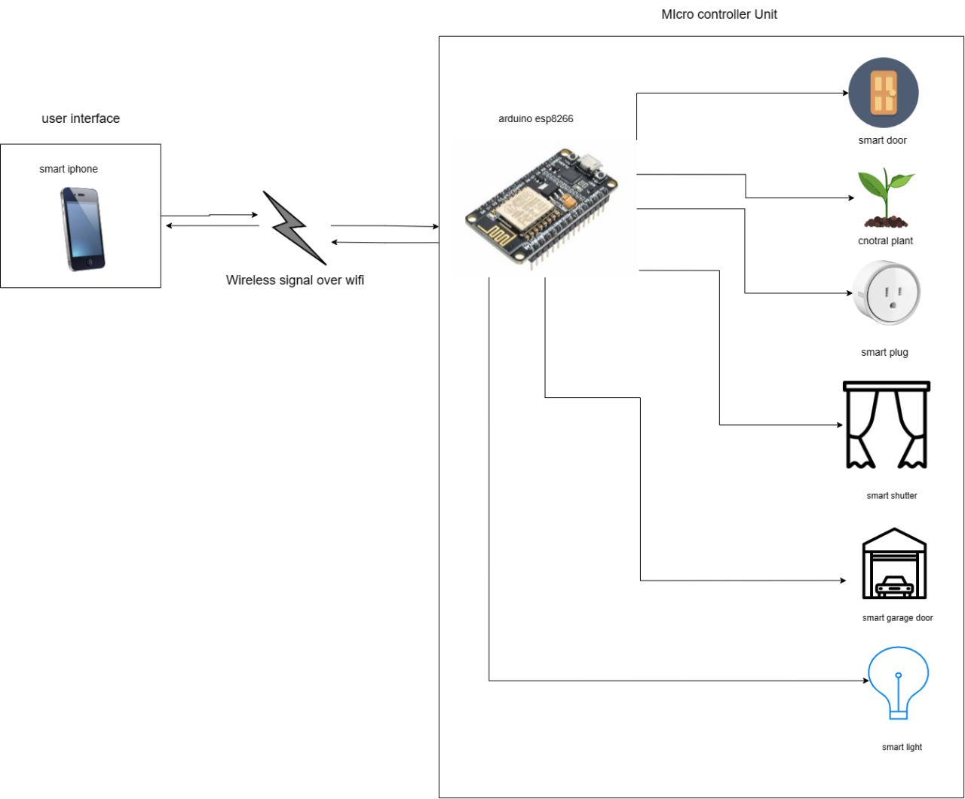
This figure shows how our software will be communicating with the hardware devices around the house.

Context Diagram
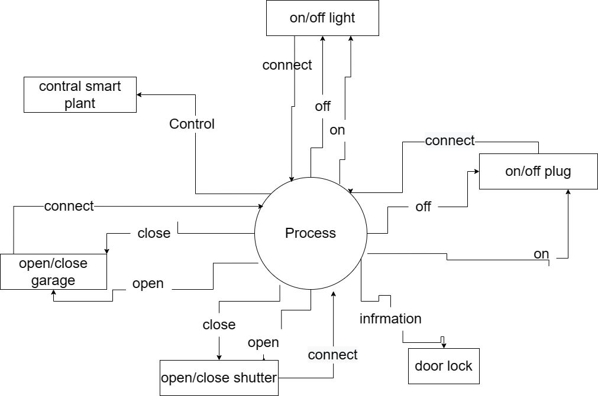

Other Requirements
Appendix A: Use case Diagram
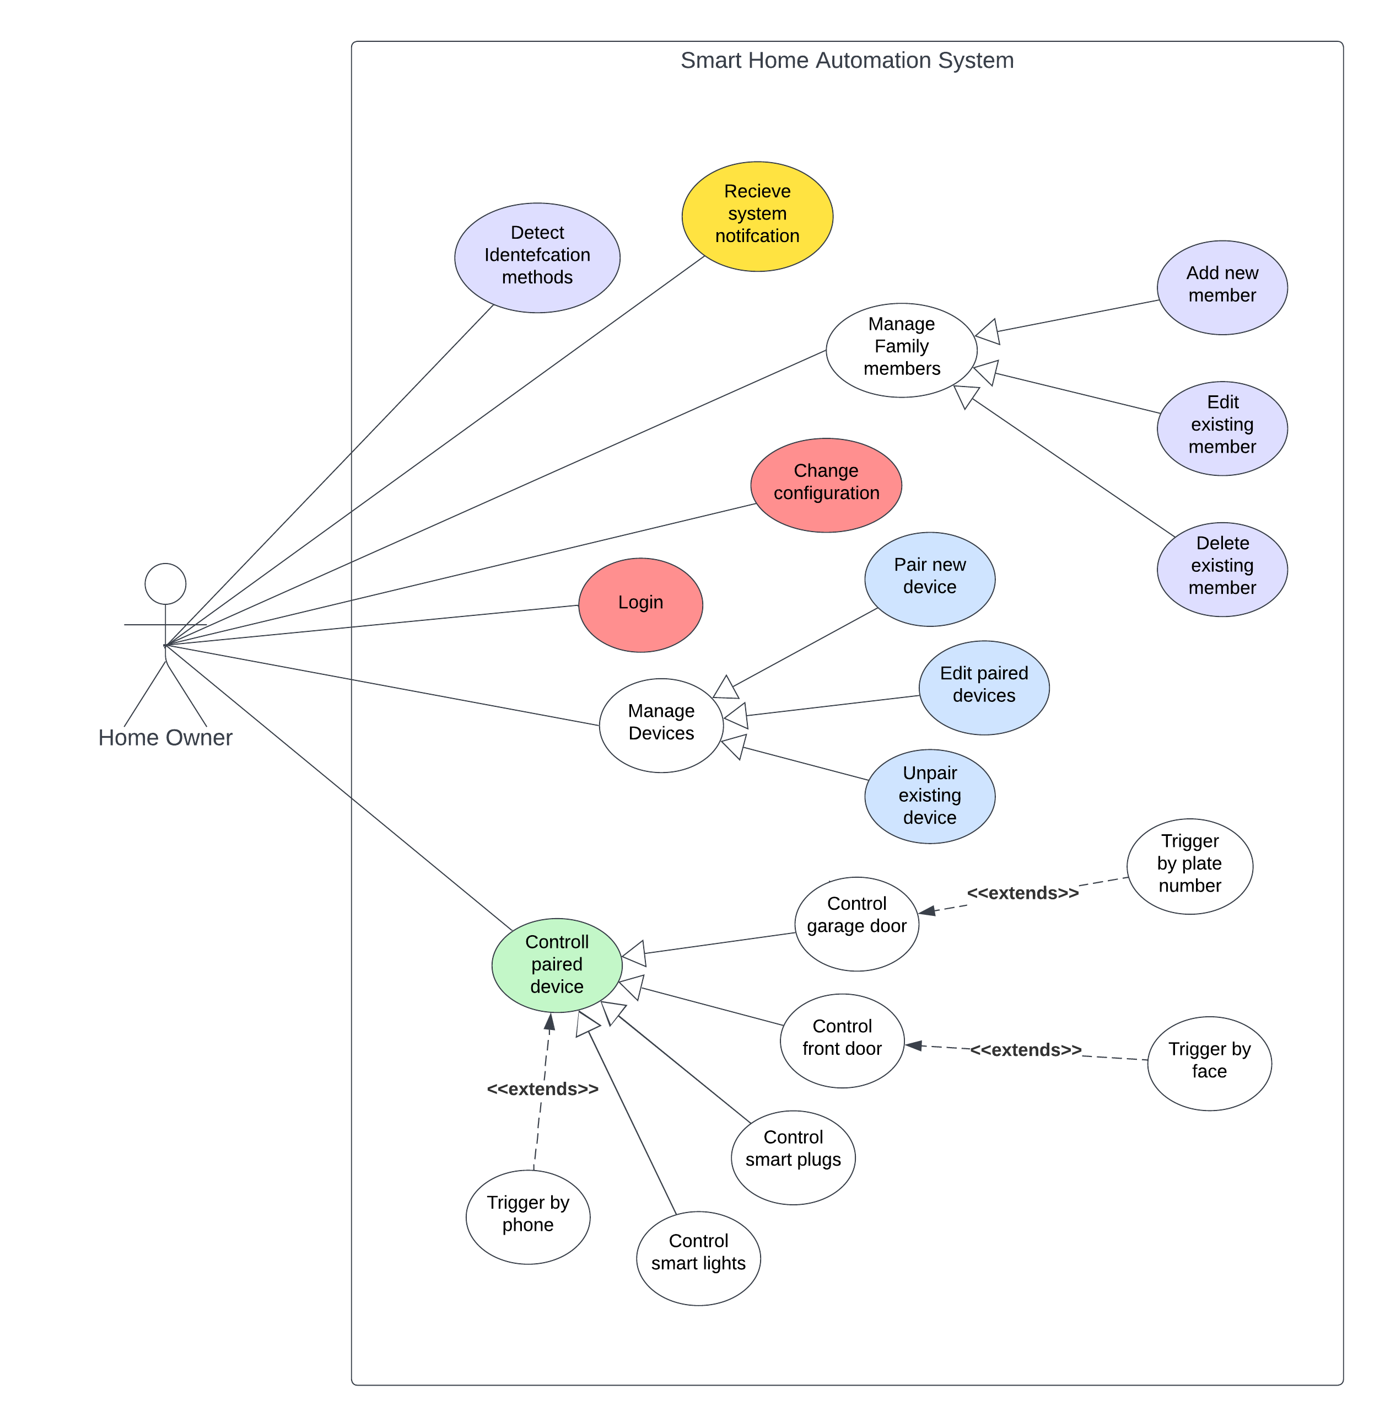

Appendix B: Use case Description “Identify new face”

Use-Case Name: | Identify new face
Primary Actor: | Homeowner
Other Actors: | None
Description: | This use-case is responsible of identifying family members faces
Assumptions: | None
Precondition: | 1-Adding new family members to the system.  2-The user chooses to identify new detection method for specific family member.
Initiation/Trigger: | This use case is used when a family member wants to make the system recognize their faces to open their home door using it.
Typical Course Of Events /Dialog: | Actor Action | System Response
Typical Course Of Events /Dialog: | Step 1: The user chooses to Identify new detection method.  Step 3: The user chooses a family member. | Step 2: The system asks the user to choose one of the available family members.  Step 4: The system opens the camera and ask the user to set in front of it.  Step 5: The system notify the user that their face has been recognized  Step 6: The system adds the detected family member face to the database.
Alterative action | None
Conclusion: | This use case concludes when the identification method is uploaded to the database correctly
Post Condition: | The user detection method has been registered to the database

Appendix C: Use case Description “Identify new plate number”
Use-Case Name: | Identify new plate number
Primary Actor: | Homeowner
Other Actors: | None
Description: | This use-case is responsible of identifying family members cars plate number
Assumptions: | None
Precondition: | 1-Adding new family members to the system.  2-The user chooses to identify new detection method for specific family member.
Initiation/Trigger: | This use case is used when a family member wants to make the system recognize their cars plate number to open their garage door using it.
Typical Course Of Events /Dialog: | Actor Action | System Response
Typical Course Of Events /Dialog: | Step 1: The user chooses to Identify new detection method.  Step 3: The user chooses a family member. | Step 2: The system asks the user to choose one of the available family members.  Step 4: The system asks the user to input the car plate number.  Step 5: The system notifies the user that their plate number has been recognized  Step 6: The system adds the detected family member plate number to the database.
Alterative action | None
Conclusion: | This use case concludes when the identification method is uploaded to the database correctly
Post Condition: | The user detection method has been registered to the database

Appendix D: Use case Description “Trigger by plate number”
Use-Case Name: | Trigger by plate number
Primary Actor: | Homeowner
Other Actors: | None
Description: | This use-case is responsible for controlling the garage door
Assumptions: | None
Precondition: | 1-Identifying at least one family member plate number
Initiation/Trigger: | This use case triggered when a car plate number sets in front of the garage door camera
Typical Course of Events /Dialog: | Actor Action | System Response
Typical Course of Events /Dialog: | Step 1: The user drives the car to the front of the garage door | Step 2: The system detects the car plate number  Step 3: The system checks if the car plate number is registered in the database  Step 4: The system opens the garage door  Step 5: The system notifies the homeowner  Step 6: The system updates the state of the garage door to open in the database
Alterative action | Alt-Step 4: The plate number is not registered in the database  Alt-Step 5: The garage door does not do any action
Conclusion: | This use case concludes when the garage door is open
Post Condition: | The garage door is open

Appendix E: Use case Description “Trigger by phone”
Use-Case Name: | Trigger by phone
Primary Actor: | Homeowner
Other Actors: | None
Description: | This use-case is responsible for controlling the devices paired to the system.
Assumptions: | None
Precondition: | 1-Pair at least one device to the system
Initiation/Trigger: | This use case triggered when the homeowner wants to turn on or off any of the paired devices
Typical Course of Events /Dialog: | Actor Action | System Response
Typical Course of Events /Dialog: | Step 1: The user chooses to control a paired device  Step 3: The user chooses a device to control  Step 5: The user turns on the device | Step 2: The system shows the paired devices to the user  Step 4: The system shows to the user the state of the device.  Step 6: The system turns on the device  Step 7: The system notifies the homeowner  Step 8: The system updates the state of the device to turned on, in the database
Alterative action | Alt-Step 5: The user turns off the device  Alt-Step 6: The system turns off the device  Alt-Step 8: The system updates the state of the device to turned off, in the database
Conclusion: | This use case concludes when the chosen device is controlled
Post Condition: | The device state has been changed in the database

System Architecture

