Regular grammars and finite automata

Write a program that:
1. Reads a grammar (from keyboard or from file)
2. Displays the elements of a grammar, using a menu: set of non-terminals, set of terminals, set of productions, the productions of a given non-terminal symbol
3. Verifies if the grammar is regular
4. Reads the elements of a FA (from keyboard or from file)
5. Displays the elements of a finite automaton, using a menu: the set of states, the alphabet, all the transitions, the set of final states
6. Given a regular grammar constructs the corresponding finite automaton.
7. Given a finite automaton constructs the corresponding regular grammar.

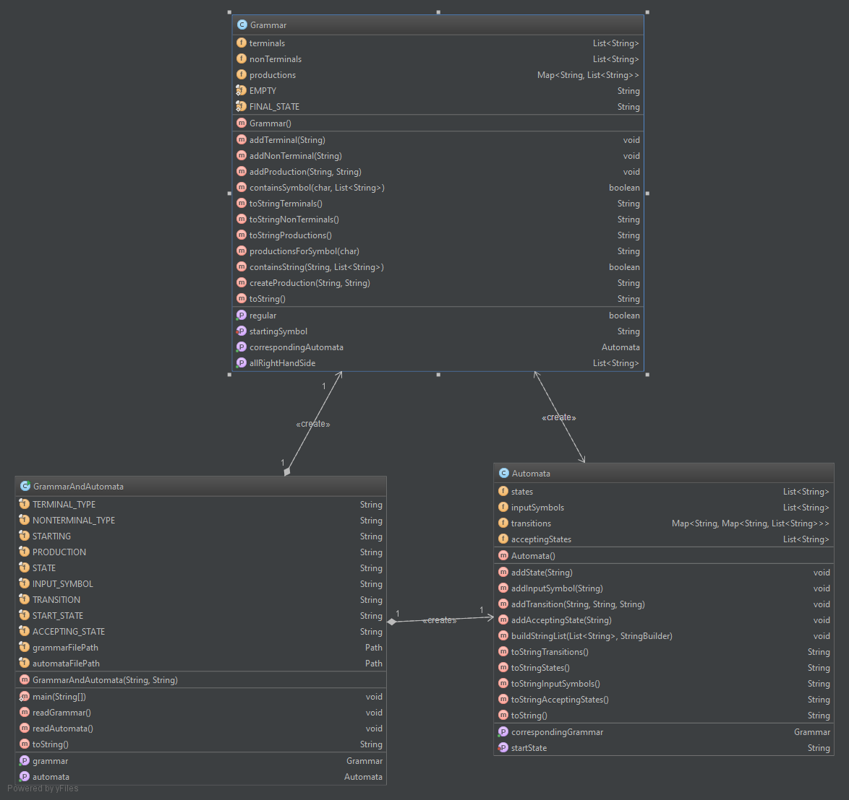

Grammar

- addTerminal(String): adds the string to the list of terminal symbols
- addNonTerminal(String): adds the string to the list of non-terminals
- addProduction(String, String): adds the production corresponding to the two strings to the productions list
- productionsForSymbol(char): returns a string containing all the production which have the char parameter on the left hand side
- isRegular(): returns true if the grammar is regular or false otherwise
- getCorrespondingAutomata: transforms the grammar in an automata and returns it; if the grammar is not regular throws UnsupportedOperationException

Automata

- addState(String): adds the string to the list of states
- addInputSymbol(String): adds the string to the list of input symbols
- addTransition(String, String, String): adds a transition from the first parameter, a state, to the third paramater, another state, through the input symbol, second parameter
- addAcceptingState(String): adds the string state to the list of accepting (final) states
- getCorrespondingGrammar(): transforms the automata in a grammar and returns it

GrammarAndAutomata

The program entry point, reads the grammar and the automata from the files and displays a menu that exposes the functionalities requiered. The menu options are the following
1 - Print terminals
2 - Print non terminals
3 - Print productions
4 - Print production for symbol
5 - Check grammar regularity
6 - Print the set of states
7 - Print the set of input symbols
8 - Print all the transitions
9 - Print the set of final states
10 - Print the corresponding automata for grammar
11 - Print the corresponding grammar for automata
0 - Exit

