**Entire population**

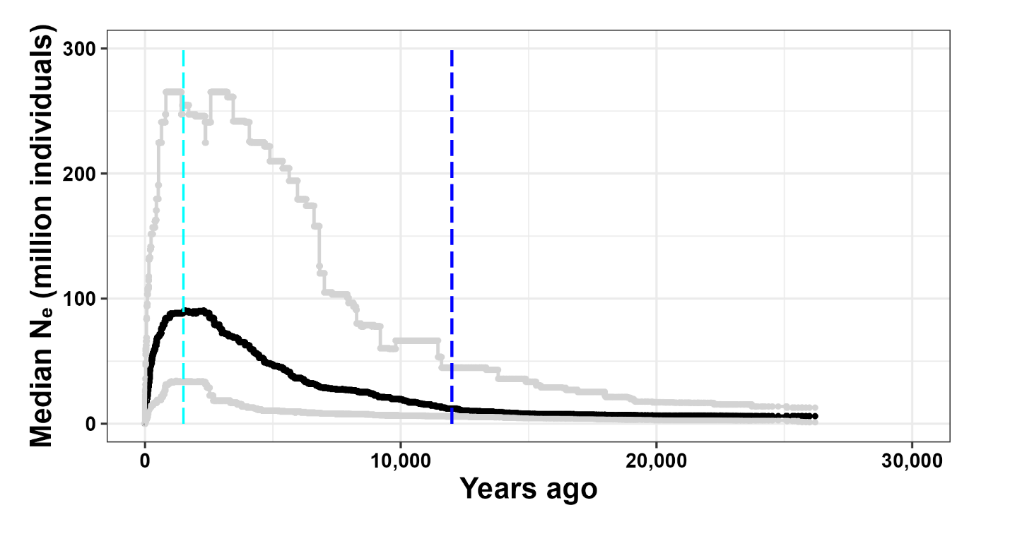

Modern Ne: Median = 18,000. CI: [4,000, 110,000]

The vertical lines represent the approximate timings of the following events: **dark blue** (12,000 ya) indicates the approximate end of the last glacial maximum; **cyan** (500 AD) indicates when corn cultivation had begun along the Grand River in Southern Ontario; **green** (1300 AD) indicates when Iroquois started cultivated crops in Halton, Ontario; **orange** (1600 AD) represents European introduction of disease to Eastern North America, followed by widespread deforestation and rewilding; **red** (1900 AD) indicates the beginning of large-scale reforestation efforts.

**Urban group**

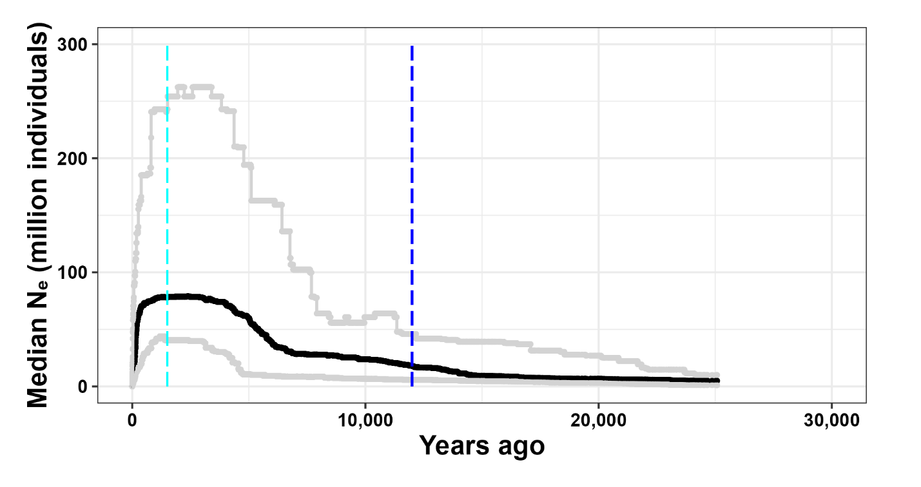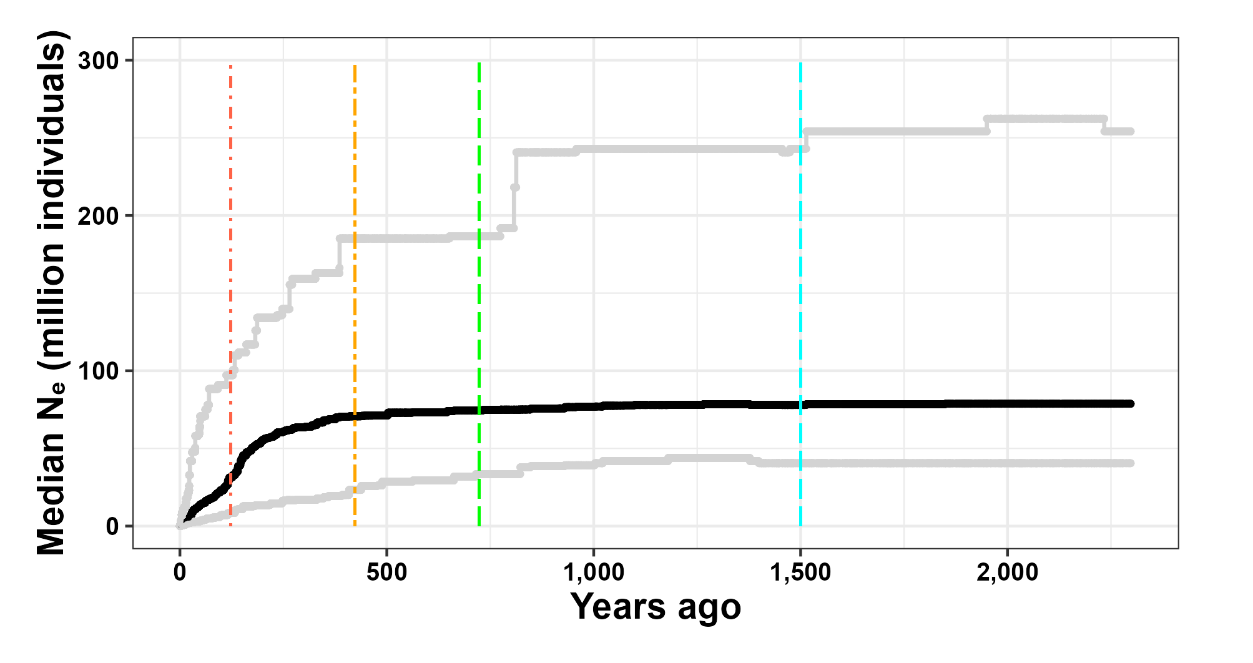

Modern Ne: Median = 57,000. CI: [6,000, 345,000]

**Rural group**

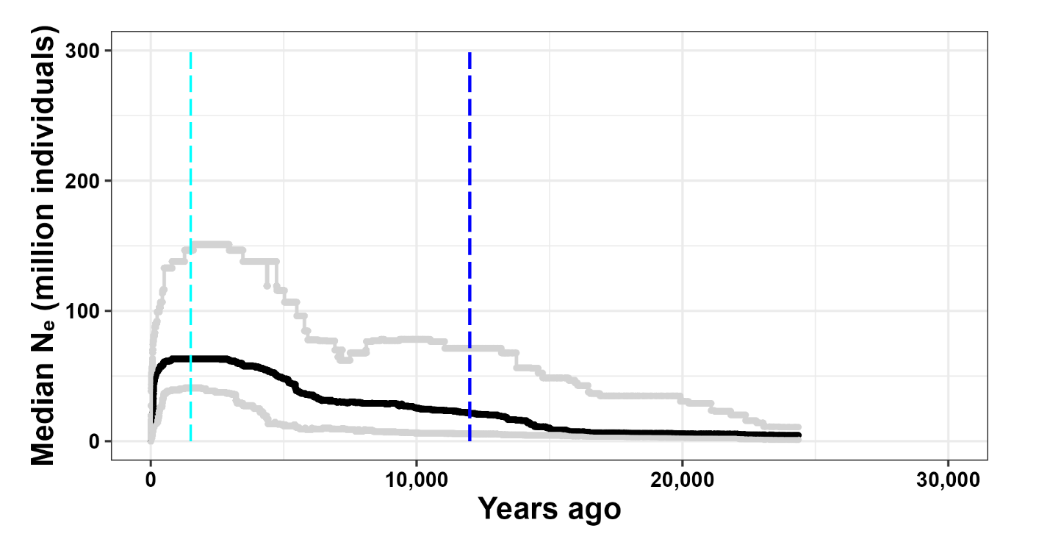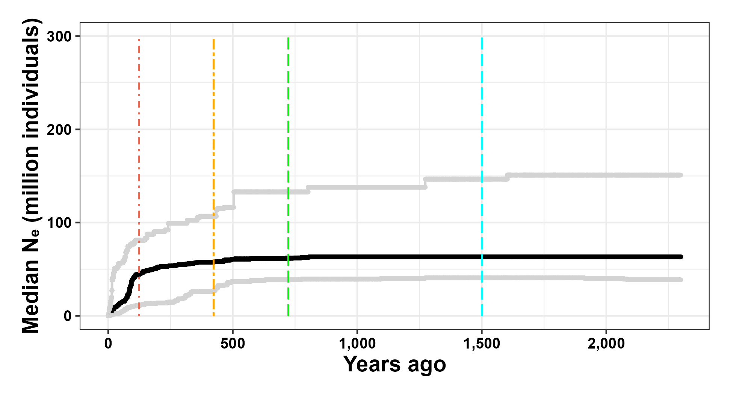

Modern Ne: Median = 110,000. CI: [27,000, 507,000]