SN1a, solutions

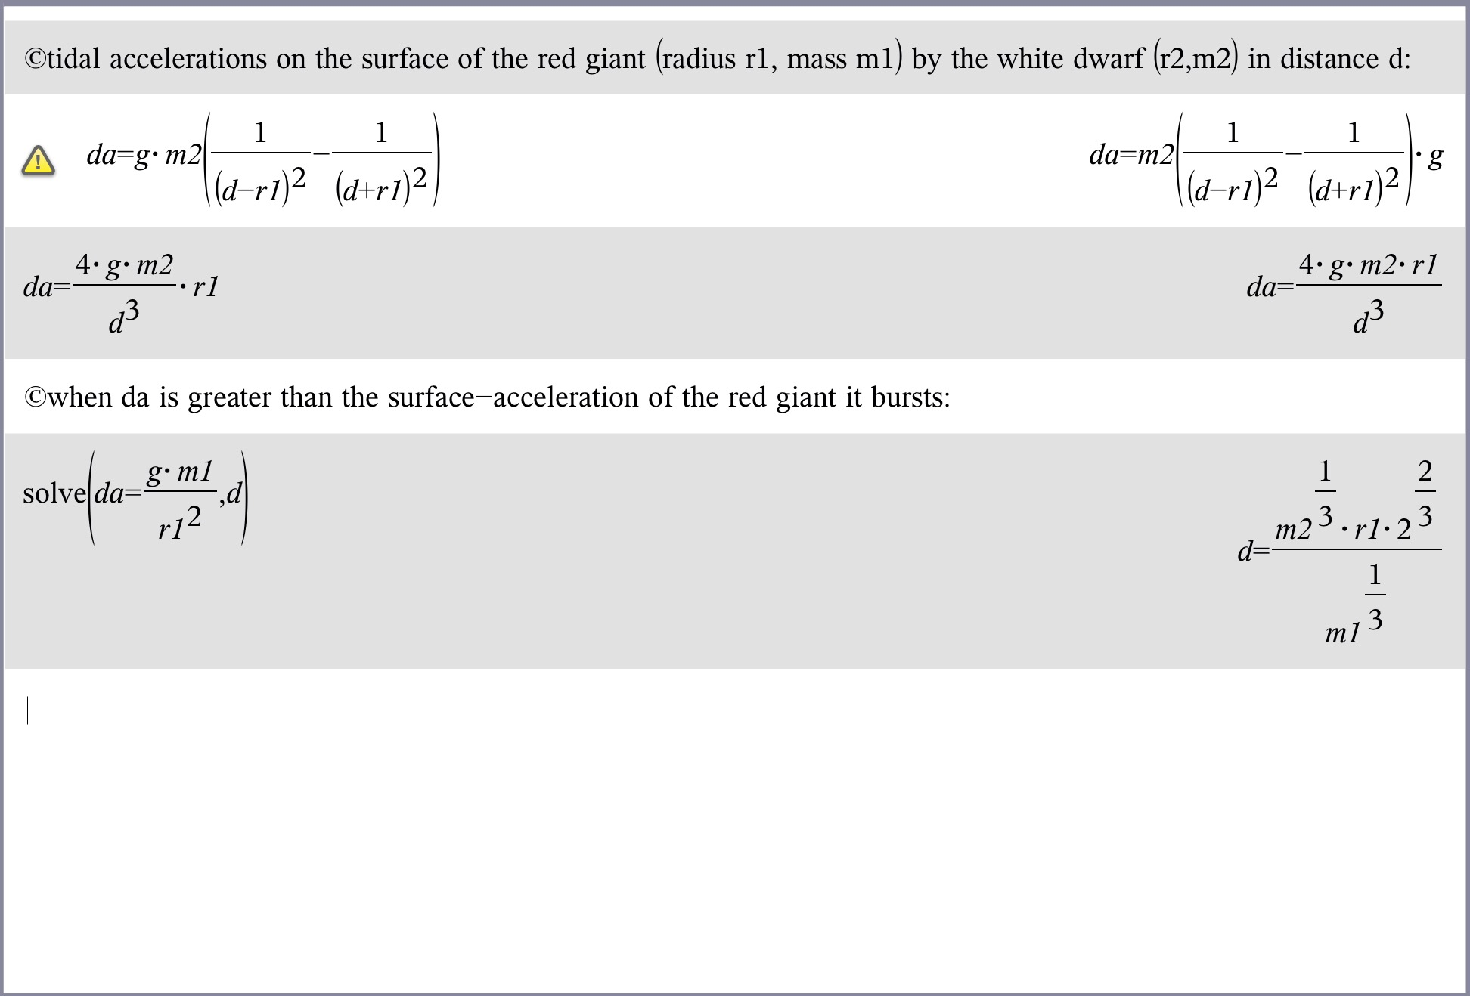3.

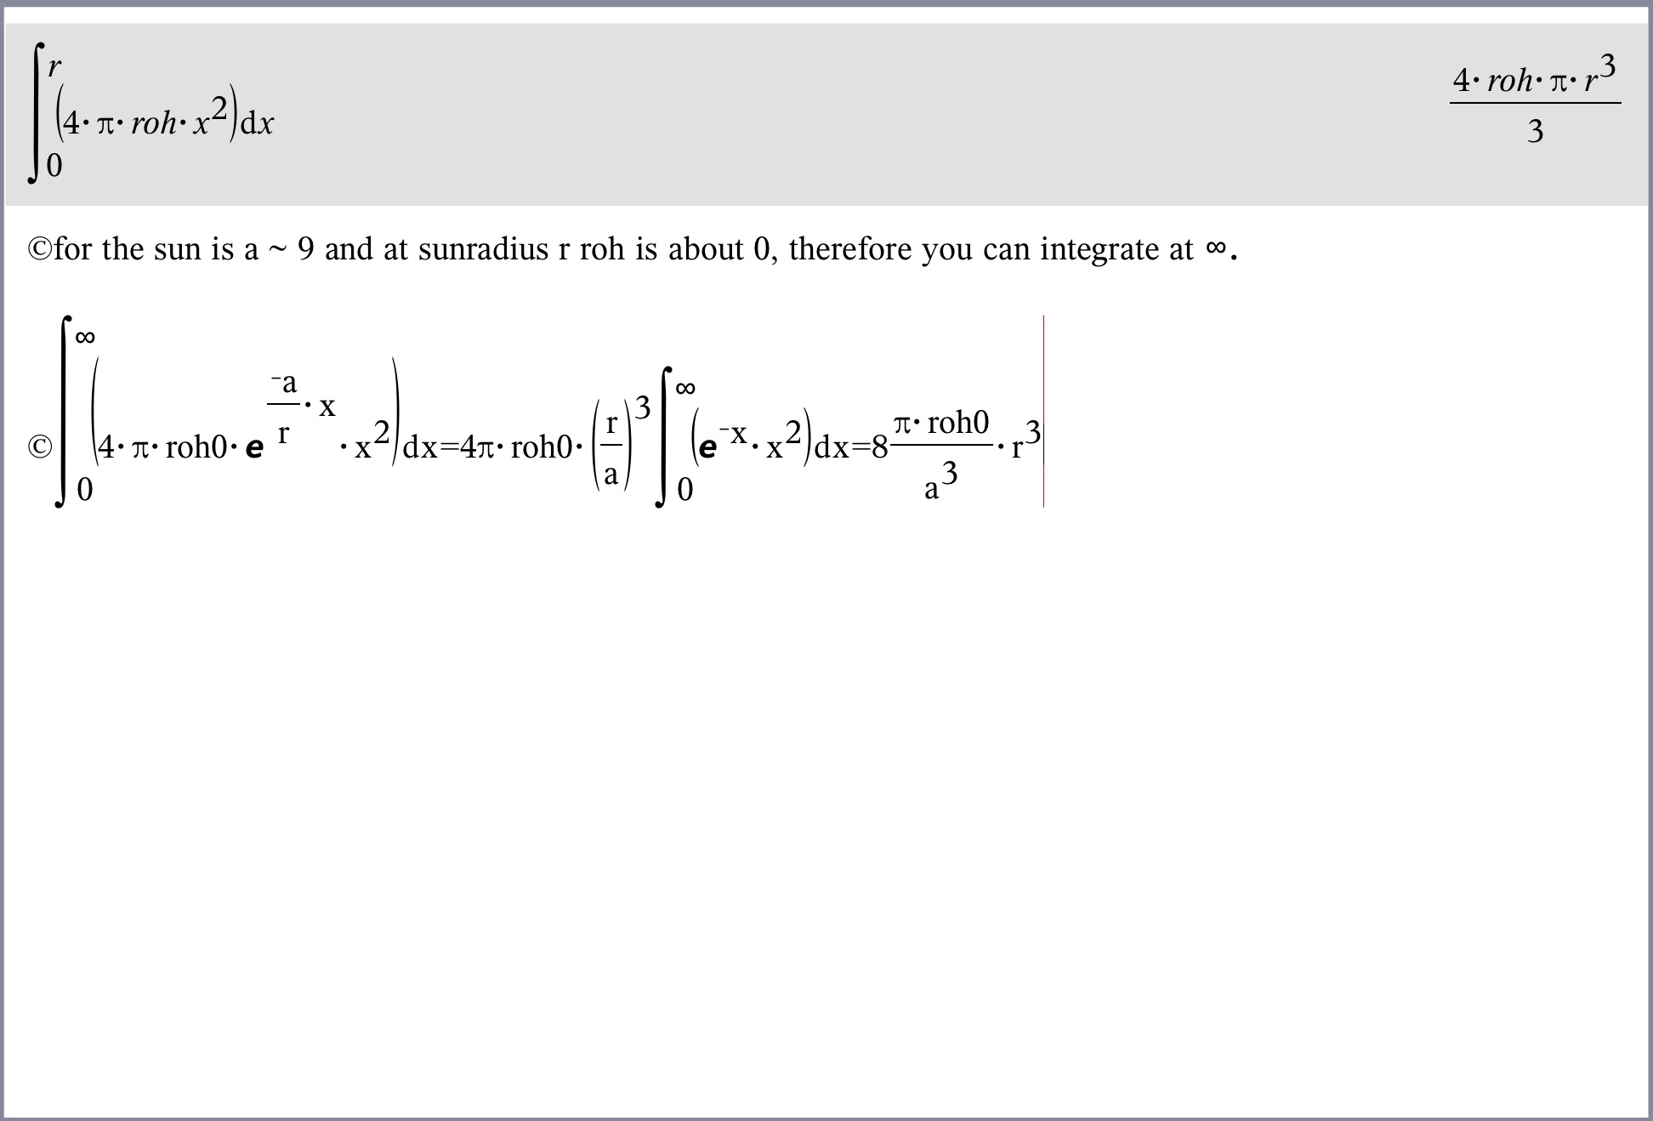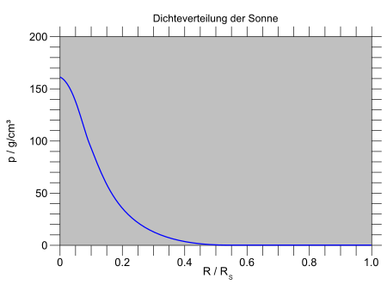4.

5. Number N of Electrons is equal to the number of Protons, my\*N\*mp = m is the mass of the star.

Therefore, every electron hast the space dr^3 = V/N = V\*my\*mp/m = my\*mp/roh with protonmass mp. The Fermi-Energy is:

dE = h²/(8pi²\*m\*dr²) = h²/(8pi²\*me\*dr²) = h²/(8pi²\*me)\*(roh/my\*mp)^2/3

and if it is much greater than the termal Energy the gas is „entartet“.

From gas-theory we know p = n\*kb\*T with particle density n = N/V and Boltzmann konstant, and the thermal Energy is E = 1.5\*kb\*T. Than p = 2/3\*n\*E and we suppose it is valid for Fermi-Energy, too.

Then follows the estimated equation.

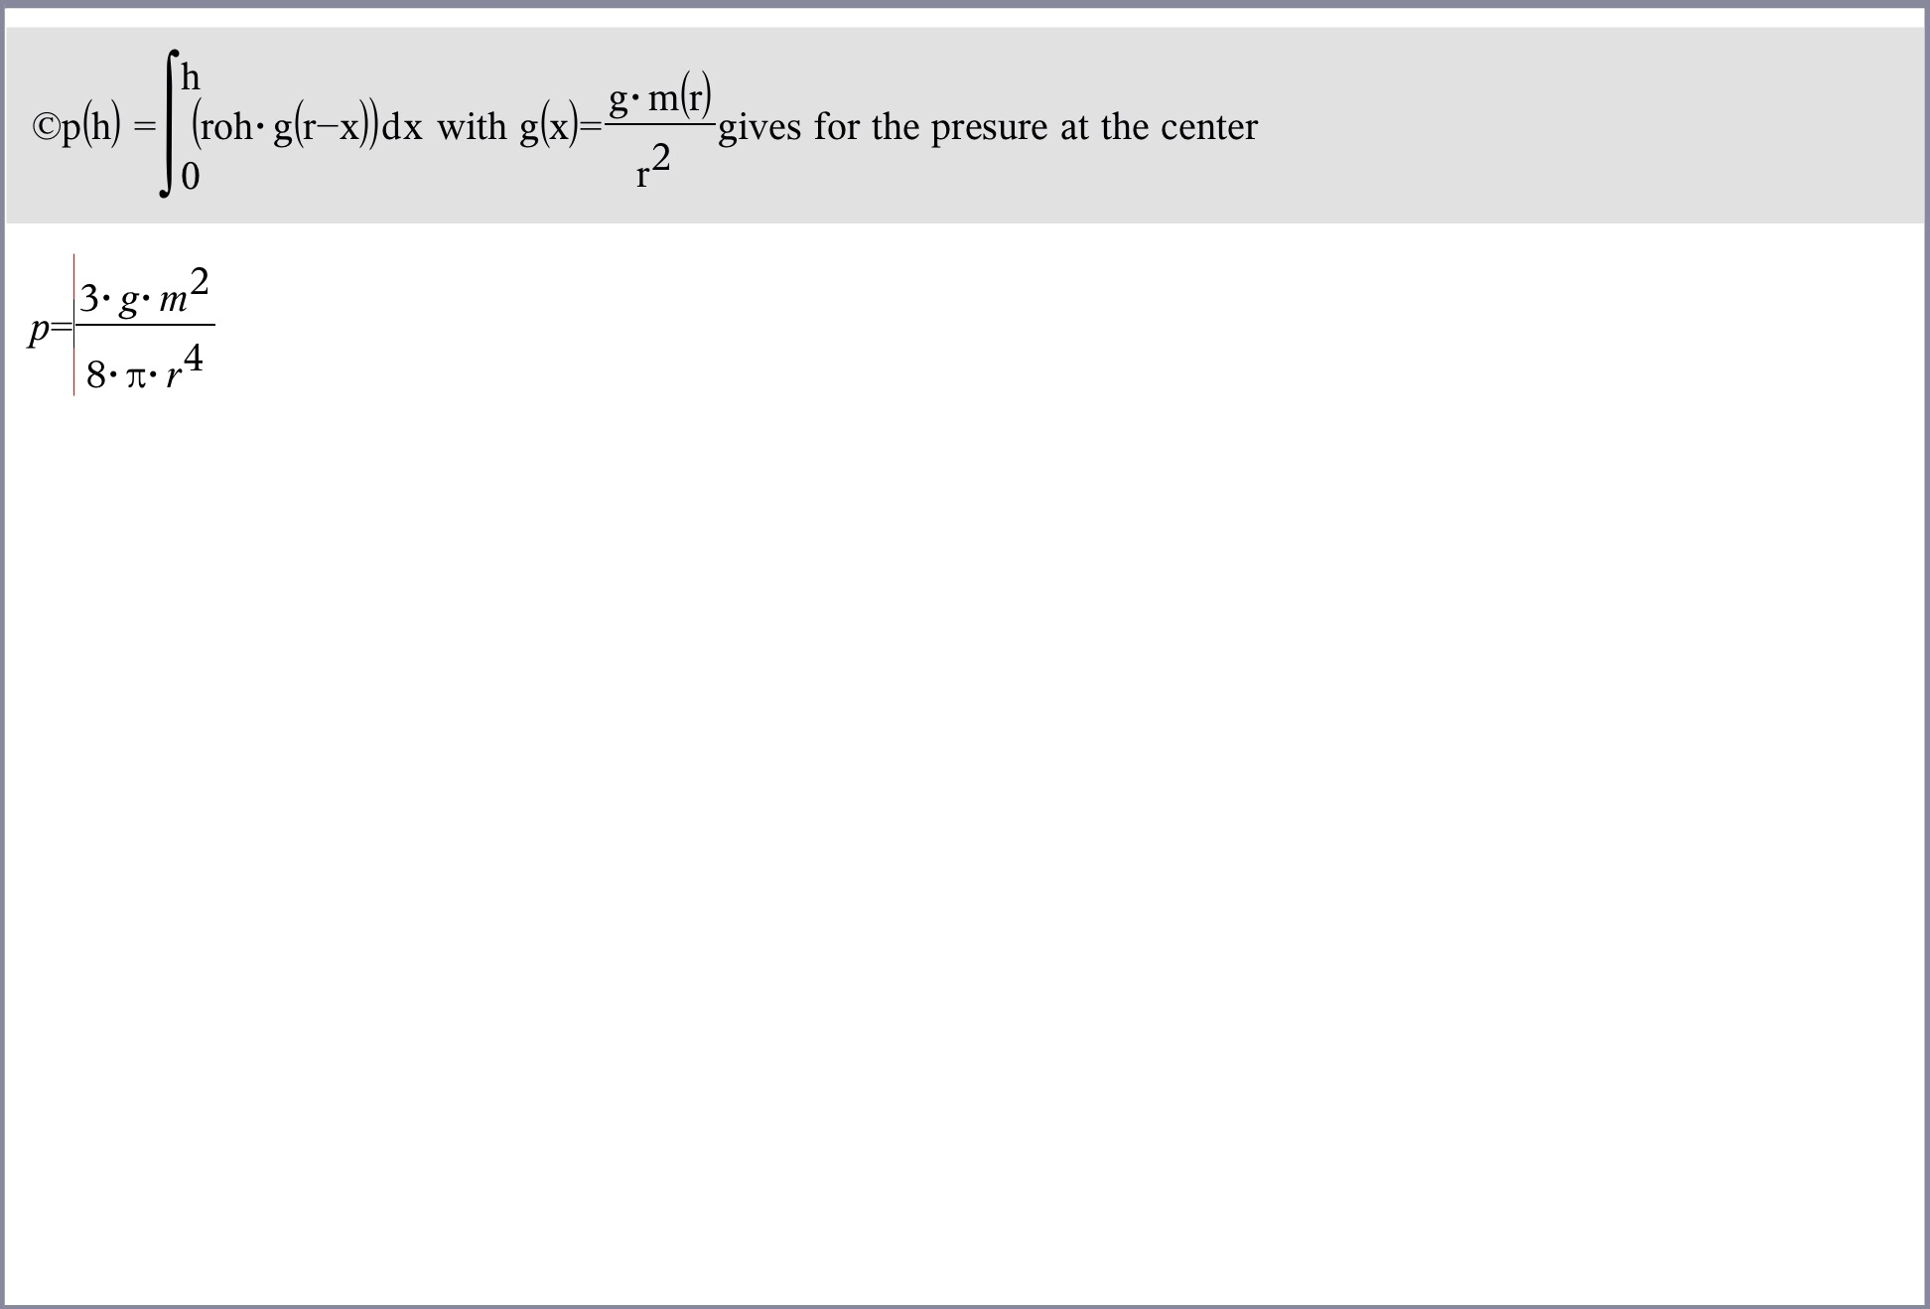Compare with the „Entartung“ pressure you geht the law

r ~ m^-(1/3)

If the Star gets more massiv it shrinks.