Radial Recursion: A Computational Framework for the Morphology of French Gothic Apses
Abstract:
This study examines the morphology of French Gothic cathedral apses through a computational framework based on graph abstraction and recursive algorithms. A corpus of twenty-four French cathedral and church apses, centered on the twelfth- and thirteenth-century development of French Gothic chevets and supplemented by boundary cases, is analyzed to identify recurring spatial relationships between ambulatories and radiating chapels. Methodologically, the model is positioned between shape grammar, graph-based representation, and Lindenmayer-system thinking: the apse is abstracted as a rooted radial graph and transformed through local production rules for ambulatory subdivision and chapel protrusion. The resulting model generates a reduced morphospace that situates comparable historical examples within a field of variation defined by these two parameters. By formalizing the generative logic underlying Gothic apse plans, the study demonstrates how computational modeling can support comparative analysis of architectural morphology while remaining distinct from metrological, structural, or liturgical histories of the buildings.
Keywords: Gothic Architecture, Morphology, Graphs, Shape Grammar, Recursion
1. Introduction
Gothic architecture has long attracted architects, designers, and historians for its distinctive structural logic and cultural significance. Emerging in medieval Europe, it produced monuments that continue to attract scholarly attention (Bony, 1983). As a style, it evolved across different regions of Europe, with distinct trajectories in England, France, and Germany (Panofsky, 1957; Mignon, 2015). In France, the development of Gothic architecture aligned closely with the consolidation of ecclesiastical and royal authority, with cathedrals serving as visible symbols of institutional and cultural achievement (Frankl, 1962). Rather than characterizing the design principles of medieval cathedrals as an unresolved “ongoing debate” on the basis of early twentieth-century sources alone, this paper situates them within contemporary scholarship that increasingly combines historical analysis with geometry, computational theory, and digital modeling (Spuybroek, 2011; Samper and Herrera, 2014; Fehér et al., 2019).
Architectural historians and theorists have offered differing interpretations of the Gothic system. Panofsky described Gothic architecture as a “system of scholasticism,” in which diverse forms of knowledge are synthesized into ordered spatial structures (Panofsky, 1957), while Worringer interpreted the style as an expression of a psychological drive toward the infinite and the divine (Worringer, 1927). Historical studies typically reconstruct the development of Gothic architecture through comparative analyses of individual buildings (Frankl, 1962; Bony, 1983; Von Simson, 1980). More recently, technological interpretations have framed Gothic architecture through generative processes. Spuybroek (2011), for example, discusses the “digital nature” of Gothic architecture, interpreting the rib as a generative architectural element grounded in processes of growth. Medieval design practices documented in sources such as the sketches of Villard de Honnecourt (1979) similarly demonstrate the geometric reasoning underlying Gothic construction. Together, these perspectives suggest that computation can assist not only in the visualization of Gothic form, but also in the formal analysis of its recurrent morphological rules (Ginovart et al., 2013; Fehér et al., 2019).
This paper examines the morphology of French Gothic cathedral apses in order to investigate the rule-based mechanisms underlying the geometric development and variation of their plans (Thompson, 1942; Fingesten, 1961; Hensel et al., 2004). The study analyzes twenty-four French cathedral and major church apses associated with the development and transformation of the chevet with radiating chapels. The corpus is intentionally typological rather than statistical: most cases belong to the early and High Gothic development of the twelfth and thirteenth centuries, while Angers functions as a Romanesque boundary case and later examples such as Pontoise and Beauvais test the persistence and transformation of the same radial logic. The selection follows two criteria: the buildings belong to the Île-de-France and surrounding regions where the chevet with radiating chapels became a defining architectural feature, and their plans present comparable radial apse configurations documented in the architectural literature (Bony, 1983; Von Simson, 1980). Construction dates and historical attributions are taken from these secondary sources rather than from new archival research. The corpus is intentionally narrow. It isolates a comparable family of French chevets rather than the whole range of Gothic plans, allowing morphological variation to be examined within a consistent architectural tradition.
The apse plans of these buildings provide a basis for analyzing radial symmetry through graph-based representations and recursive production models (Gardner, 1990). The aim of this paper is to develop a computational framework for describing and generating the morphology of French Gothic apses through graph abstraction, recursive production rules, and parametric variation. Methodologically, the model is positioned between shape grammar, graph grammar, and L-system thinking: the plan is first abstracted as a radial graph and then transformed through local rules for ambulatory subdivision and chapel protrusion. While previous computational studies have examined geometric construction (Fehér et al., 2019), fractal characteristics (Samper and Herrera, 2014), and proportional systems (Ginovart et al., 2013), the present study seeks to formalize algorithmic rules that capture recurring spatial patterns within cathedral plans.
This paper contributes to the intersection of architectural history, morphology, and computational design by introducing a graph-based framework for modeling the recursive organization of French Gothic apses. The study demonstrates how ambulatory subdivision and chapel expansion can be encoded as parametric rules, enabling historical plans to be interpreted as generative systems rather than static diagrams. Through this approach, the research constructs a morphospace in which canonical Gothic examples can be situated within a broader field of formal variation. The contribution of the paper therefore lies not in rediscovering known historical differences among cathedrals, but in adapting formal grammar methods to an underexplored topic in architectural history and using them to describe, compare, and generate apse morphology as a rule-based design system.
2. Gothic Morphology
Architectural morphology primarily focuses on the computational analysis of typologies and generative rules for the geometric modeling of the built environment (Steadman, 1983). In formal terms, production rules specify how one spatial configuration is transformed into another. Shape grammars apply this logic directly to shape and spatial composition (Stiny and Mitchell, 1978; Stiny, 1980), graph-based approaches reduce plans to nodes and edges in order to compare connectivity, branching, and symmetry (Harary, 1994; Ostwald, 2011), and Lindenmayer systems model branching form through recursive rewriting rules (Lindenmayer, 1968; Prusinkiewicz and Lindenmayer, 1990). In this paper, morphogenesis is used in a restricted design-research sense: the emergence of plan form through iterative, rule-based transformations, not a claim of literal biological growth. Morphospace similarly denotes a parameter space of formally possible configurations rather than an evolutionary territory. Recent studies utilize shape grammar approaches for generative variation and rule-based analysis of plans (Grasl and Economou, 2013; Park and Economou, 2019), graph-based analysis of radial symmetry in plan morphology (Author, 2020), and computational analysis of fractal patterns in Gothic cathedrals (Samper and Herrera, 2014). The present study draws from all three traditions because French Gothic apses combine radial order, branching differentiation, and repeatable local transformations.
This distinction is operationalized below in the formal rule set, where recursive branching is treated as a graph-based rewriting process rather than as biological simulation.
a. Development of the French Gothic
The history and origin of French Gothic architecture dates to the medieval governance of Île-de-France, the region around Paris bounded by the Seine, Oise, Marne, and Beuvronne rivers (Von Simson, 1980). One of the early examples of Gothic architecture emerges in the reconstruction of the Basilica of Saint-Denis, begun under Abbot Suger in the 1130s and dedicated in part in 1144. The construction brings together elements with earlier Romanesque and monastic precedents, including pointed arches and radiating chapels, but reorganizes them as a coordinated chevet system with ambulatory, rib-vaulted bays, buttressing, and tall clerestory windows (Von Simson, 1980; Bony, 1983). The chevet of Saint-Denis, with its radiating chapels, becomes a prototype for the royal architecture of northern France.
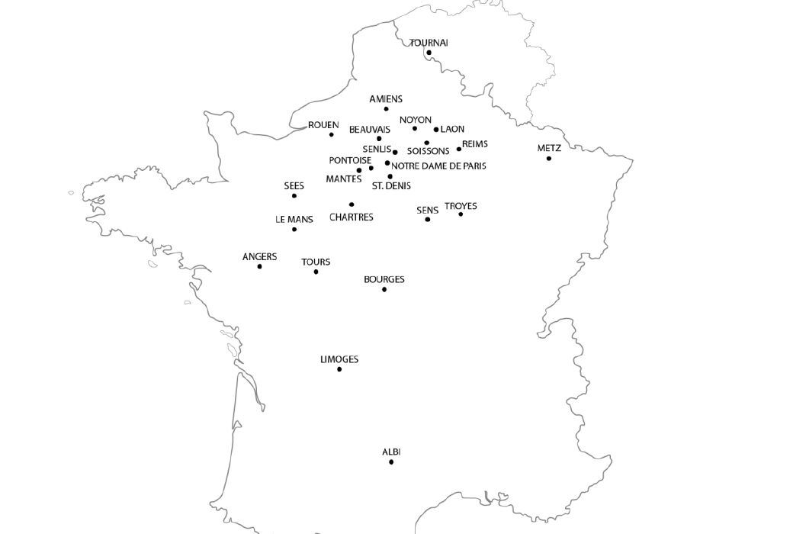
Figure 1. Geographical scope of the studied twenty-four French cathedral and church apses included in the typological corpus: Angers, Rouen, Le Mans, Sens, Saint-Denis, Noyon, Tournai, Senlis, Mantes, Laon, Tours, Soissons, Notre-Dame de Paris, Chartres, Bourges, Troyes, Sées, Reims, Metz, Amiens, Limoges, Albi, Pontoise, and Beauvais.
Following the success of Saint-Denis, the early Gothic period marks the construction of cathedrals such as Sens, Noyon, Laon, Senlis, Notre-Dame de Paris, Chartres, and Bourges. Among these, Chartres (Figure 2, no. 6) and Bourges (Figure 2, no. 5) show two influential trajectories for later apse development. The Chartres family employs a seven-sided hemicycle with more pronounced chapel articulation, whereas the Bourges family employs a five-sided hemicycle with more compact chapel niches (Bony, 1983). These two families are treated here not as exhaustive stylistic categories but as recurrent radial templates from which later plans depart, combine, or intensify.
b. Morphological Development of Apses
The development of ambulatory space follows the historical evolution of Gothic architecture from more compact Romanesque apses to increasingly differentiated chevets. In Romanesque architecture, the massing of the cathedral follows a progressive rise toward the central tower, while in early Gothic there is a “compact three-tier formula,” a stacked elevation in which arcade, gallery or triforium, and clerestory are coordinated as a compact vertical system, as exemplified in Noyon Cathedral (Bony, 1983). In Bourges, this formula is further expanded with protruding chapels, a double ambulatory, and flying buttresses. The elongation of the apse in plan can also be traced in later examples such as Sées, Tournai, Troyes, Rouen, and Metz (Von Simson, 1980; Bony, 1983). For the present paper, however, the important continuity is narrower than the total history of Gothic architecture: despite differences in elevation, ornament, and regional emphasis, many French examples share a comparable plan logic composed of a polygonal hemicycle, one or two ambulatories, and radiating chapels attached through rib-vaulted bays (Frankl, 1962; Bony, 1983; Fehér et al., 2019). It is this recurring plan logic, rather than the entire Gothic system or the full social and liturgical function of the church, that is treated as stable enough for computational comparison. Chapel position and scale are shaped by devotion, circulation, relic display, patronage, and site history; the model abstracts only their plan relationships.
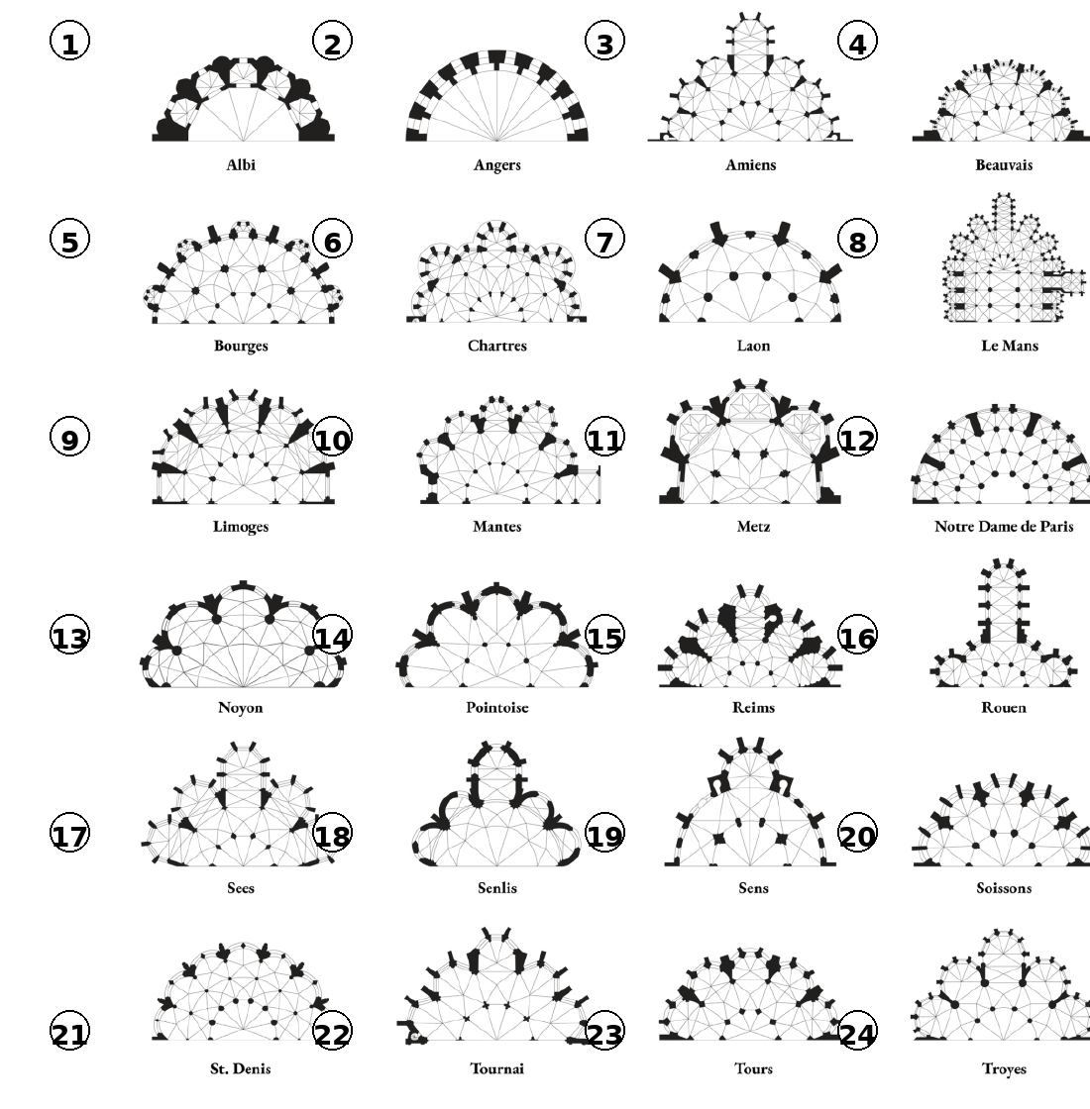
Figure 2. Taxonomy of the twenty-four selected French cathedral and church apse plans showing different radial morphologies with protruding chapels, segmented ambulatories, and vault connectivity lines. Each case is numbered in the figure so the discussion can refer to individual examples by number.
To visualize the highly proliferative nature of the French Gothic apses, an array of cathedral plans spanning different centuries is presented in Figure 2. All the samples are retraced from historical plan drawings, normalized to common size, and aligned to the liturgical axis in order to discuss topological and morphological variation rather than metric proportion or geographic orientation. The samples mainly show the five-fold and seven-fold radial symmetry of the apses, while Angers (Figure 2, no. 2), as an early Romanesque example, retains a semicircular ten-fold arrangement. The focus of the current study isolates apses from the choir for the analysis of radial symmetry; however, Le Mans (Figure 2, no. 8) is included with part of its choir because a total of thirteen chapels continue the same radial logic beyond the apse proper.
Most of the selected samples showcase radial symmetry of chapels with similar protrusions. However, local asymmetries can be observed in Sées (no. 17), Troyes (no. 24), Tournai (no. 22), Rouen (no. 16), Le Mans (no. 8), Reims (no. 15), and Mantes (no. 10). Among these, Mantes offers a particularly clear perspective on the differentiation of chapels as individual outward protrusions, while in Bourges (no. 5) this protrusion is more suppressed, producing a niche-like expansion. In Le Mans (no. 8), each bay of the ambulatory grows outward more independently. These deviations are significant for the rule system because they show that the apse is not generated by a single rigid template. Individual bays can differentiate through uneven chapel width, depth, or segmentation while still remaining within an overall radial framework. The model registers these conditions as morphological variation; it does not infer their historical causes, which may involve earlier fabric, site constraints, or local construction histories.
c. Radial Graphs: Ambulatory and Chapels
To further analyze the French Gothic apses, a diagrammatic study of plan organization is carried over the collected samples. These diagrams are produced as connectivity graphs of the apse starting from its base, which overlaps with the apex points of the vaults (Author, 2020; Ostwald, 2011; Dawes et al., 2021). The trajectory follows two routes to capture the connectivity network of the ambulatory and chapels (Harary, 1994). Formally, each apse is translated into a rooted planar graph G = (V, E, R), where the root R coincides with the center of the apse, internal vertices represent vault centers and junctions, and terminal vertices mark the termination of chapel growth along the outer boundary. In cases without protruding chapels, such as Notre-Dame de Paris, terminal vertices mark bay terminations rather than chapel volumes so that the graph does not imply a chapel where none exists. The ambulatories appear as polygonal offsets that grow the graph linearly in the form of rays originating from the center of the apse. In contrast, the chapels are treated as outward extensions that grow the polygonal boundary. Like the ambulatory, the chapels can have multiple series of vaults along their growth axis, further extending the radial rays.
While the architectural plans of Gothic cathedrals already reveal geometric order, the graph abstraction serves a different analytical purpose. Rather than representing the plan as a continuous geometric drawing, the graph reduces it to a network of spatial relationships between vault bays, columns, and chapel extensions. This abstraction makes it possible to identify recurring branching patterns and hierarchical connections that are difficult to compare directly across plans of different sizes and proportions. In effect, the graph acts as the intermediate representation that makes the transition from historical drawing to production rule possible.
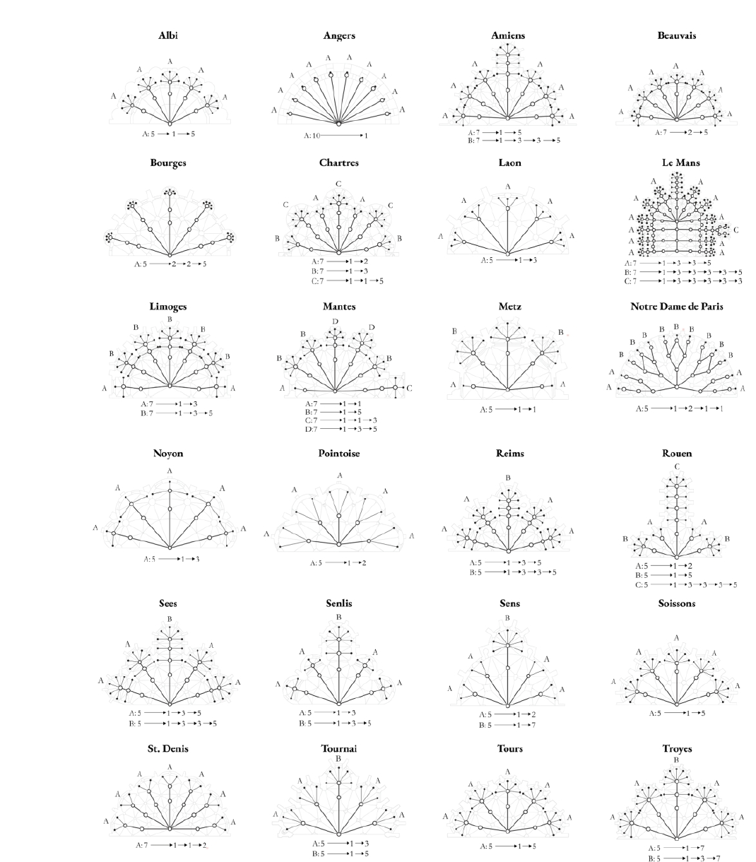
Figure 3. Graph-based analysis of apses showing radial branching patterns following the polygonal organization of plans, vaults, and chapels. Growth patterns are shown as rooted branching sequences R(n)→a→b, where n denotes the apse symmetry and a and b denote outgoing connections at successive depths. The letters identify recurrent bay-level rhythms: A = linear continuation, B = bifurcation, C = tripartite expansion, and D = compound axial extension.
The overall diagramming logic follows the predominant radial symmetry among the apse plans, which can be divided into individual triangular bays. The growth sequence of each tree graph is notated by tracing branching symmetries along a single bay of the apse in the form R(n)→a→b, where R(n) denotes the root with n radial branches and a and b are internal nodes showing the total count of connected outgoing nodes from that level (Gerlach, 2017). The letters A–D function as a shorthand for recurring patterns rather than as stylistic labels. A denotes a 1→1 continuation, B a 1→2 bifurcation, C a 3→3→5 or comparable tripartite expansion, and D a compound extension in which multiple segments continue along an axial line. This notation allows the same plan family to be compared without claiming that every local asymmetry has the same historical cause.
By abstracting the overall apse plan geometry as a graph, the analysis identifies which spatial relationships recur across the corpus and which remain exceptional. Because the choir is generally outside the scope of the study, the graphs are not used to claim a complete church-wide recursion. They instead isolate bay-level relationships inside the apse: ambulatory rings, vault-bay junctions, and chapel protrusions. The value of the abstraction is therefore comparative and operational. It produces a consistent intermediate representation that can be translated into the computational rules developed in the next section.
3. Computational Modeling of Gothic Apses
The computational workflow of this study proceeds in three stages. First, the plan drawings of the selected cathedrals were retraced and simplified to isolate the apse, ambulatory, and chapel boundaries. From these plans, column centers and vault bays were identified and translated into nodes and edges within a graph representation describing the spatial connectivity of the apse. Second, the resulting graphs were analyzed to identify recurring branching sequences that characterize the segmentation of ambulatories and the outward extension of chapels. Third, these sequences were implemented as recursive rules within a parametric model capable of generating variations of apse configurations by controlling radial subdivision and chapel protrusion. Through this workflow, historical plans are interpreted not only as geometric drawings but as generative systems that can be computationally modeled and explored. The workflow is analytical and generative rather than archaeological: it does not reconstruct construction sequence, patronage, or liturgical use.
Formally, each apse is treated as a rooted radial graph Gₙ with symmetry n, most commonly 5 or 7. The model is adjacent to L-system thinking because it uses recursive local rules, but it is not a classical L-system in the strict string-rewriting sense: it does not rewrite every symbol in parallel at each iteration. Instead, two families of rules operate selectively on the radial graph. Segmentation rules Sₖ subdivide the ambulatory by increasing the number of nodes along a ring and reconnecting them through diagonals. Chapel rules C(w,h) offset the outer boundary by a controllable width w and depth h, producing configurations that range from shallow niches to more autonomous pavilion-like projections. When adjoining rings contain unequal node counts, Delaunay triangulation (de Berg et al., 2008) resolves the diagonal connectivity. In this restricted sense, global form arises from repeated local transformations, while the historical interpretation remains limited to plan morphology.
a. Axial construction: Apse, Ambulatory and Chapel
Prior to the introduction of the algorithm, the morphology of the apse is further analyzed using Rouen Cathedral as a case study to reveal distinct parts of the radial plan. The bays in Rouen Cathedral show three unique growth rhythms following the five-fold Bourges family where the bays are symmetrically organized in the sequence B, A, C, A, B (Figure 3). In Figure 4, the apse is decomposed into three coupled zones: chapel, apse core, and ambulatory. This tripartite reading does not imply three independent objects; rather, it identifies the zones upon which the rule system acts. The ambulatory continues the lateral movement of the nave around the choir, the apse core stabilizes the radial center, and the chapel registers outward protrusion along the boundary.
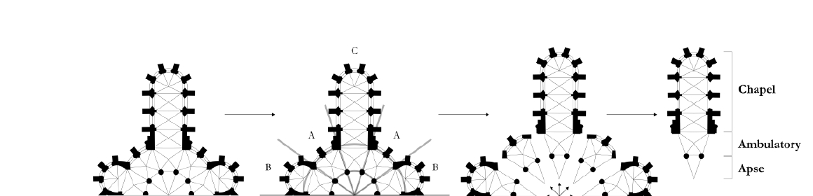
Figure 4. Morphological analysis of Rouen Cathedral apse showing fivefold radial symmetry. The tripartite structure separates chapel, apse core, and ambulatory so that the zones addressed by the rule system can be read explicitly.
In this sense, the ambulatory can be considered the result of recursive segmentation within the apse, while the chapel acts as a local outward extension whose width and depth may vary from bay to bay. Since this structure can be isolated analytically from the radial symmetry of the apse, it can generate different spatial outcomes for its program. The distinction is analytical but operational: it allows the model to separate inner subdivision from outer protrusion without losing the continuity of the plan.
b. Ambulatory Segmentation
The historical samples in Figure 3 reveal consistent radial symmetry in the geometric distribution of columns within apses. Each bay extends outward like a ray, adding rib-vaulted spaces along the perimeter. In many cases, this rule follows a simple 1→1 sequence, where bays are repeated without further subdivision and the space shows repeating vaults in plan. At Notre-Dame de Paris (Figure 2, no. 12), however, the enlarged apse requires additional segmentation due to the increasing distance between columns on the sides of the bay. This results in a progression of 1→2→3→3, in which bays split into two and then three colonnade segments. This subdivision reduces column spacing, establishing a denser structural rhythm. The importance of this sequence is methodological: it shows that increasing radius does not simply enlarge the bay but triggers a change in the rule set governing node distribution and vault connectivity. The contribution of the paper is not the observation of bay and vault geometry itself, which has a long historiography in construction manuals and historical analysis (Ungewitter and Mohrmann, 1901–03; Bony, 1983), but the translation of these relationships into a consistent graph-based rule system.
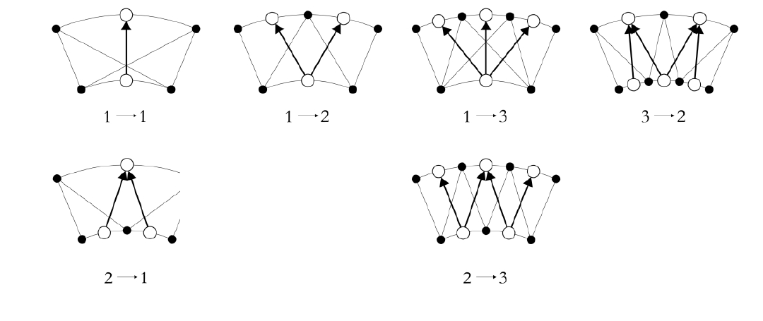
Figure 5. Reduced set of vault-connection configurations used in ambulatory segmentation. The equal-division cases 2→2 and 3→3 have been omitted as redundant higher-order repetitions of the 1→1 identity condition.
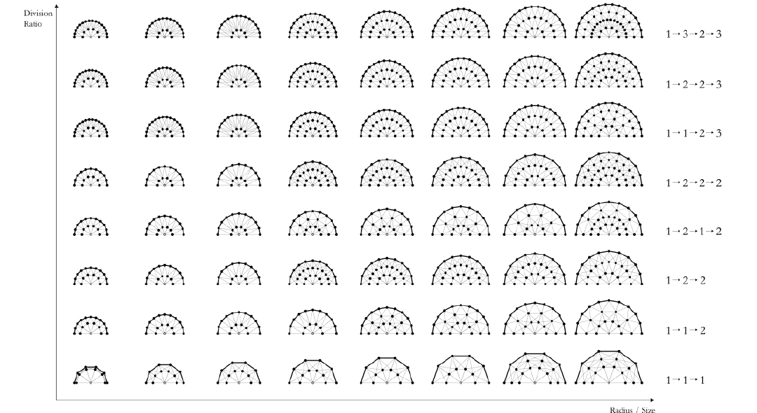
Figure 6. Enlarged parametric exploration of ambulatory segmentation showing recursive subdivision patterns generated through variations in apse radius and division ratio.
Our algorithm builds on this principle by encoding column distribution as numerical sequences. As shown in Figure 5, successive apse offsets generate alternative column-vault networks, with diagonal vault connections prioritized. In this diagram the columns are shown as black dots, while the connectivity graph is shown using white dots and arrows. Symmetrical transitions between radii produce regular vault configurations (e.g., 1→1). Asymmetric transitions (e.g., 3→2 or 1→3) are computationally resolved through Delaunay triangulation (de Berg et al., 2008), ensuring structural coherence while reflecting historical variation. In the revised model, the configuration set focuses on the non-redundant transitions actually used by the grammar; equal-division cases such as 2→2 and 3→3 are treated as higher-order repetitions of 1→1 and are therefore omitted from Figure 5. The parameters explored in Figure 6 are apse radius and division ratio: the first controls when additional segmentation is triggered, and the second regulates the relation between ambulatory space and apse core.
c. Expansion of Chapels
The second part of the algorithm focuses on the behavior of chapels that populate the boundary of the apse. This follows the analysis of Mantes (no. 10), Le Mans (no. 8), Amiens (no. 3), and Rouen (no. 16), where chapels are allowed to differentiate through varying widths and lengths. A common pattern observed in the apse samples is the dominant extension of the central bay that aligns with the nave. This axial emphasis has functional and liturgical significance within the church, but the present model treats it only as a plan-morphological condition. In Mantes, this behavior is partially redistributed, allowing the chapels to act more independently.
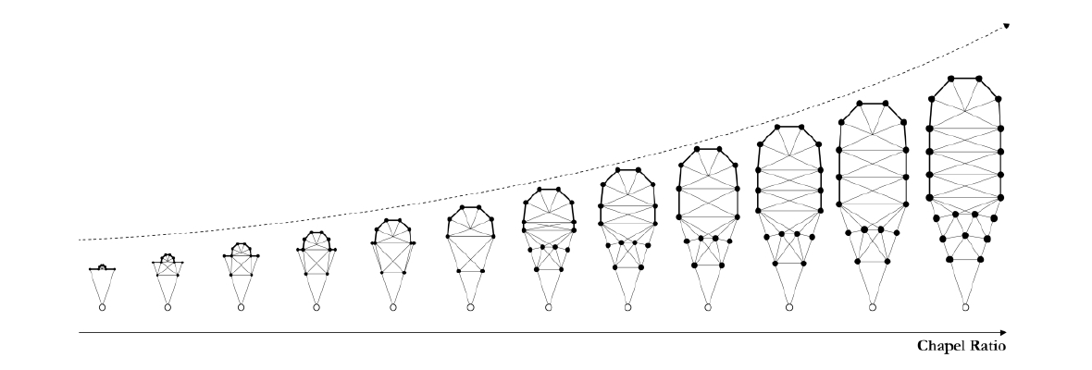
Figure 7. Progressive development of an apse bay showing chapel protrusion and ambulatory segmentation as a sequence of topological variations along radial symmetry.
For the algorithm, the parametric behavior of chapels is established in proportion to the apse using thresholds that determine both lateral occupation of the bay edge and outward offset depth. Figure 7 shows the progressive development of chapel morphology starting from a small niche-like condition and moving toward broader protrusions and more autonomous pavilion-like extensions. At low values the chapel acts as a niche on the wall (e.g., Albi, no. 1; Bourges, no. 5). At intermediate values it becomes a broader bulging boundary (e.g., Noyon, no. 13; Pontoise, no. 14; Soissons, no. 20). At higher values it forms a more independent pavilion-like extension (e.g., Rouen, no. 16; Metz, no. 11; Sens, no. 19; Amiens, no. 3). These thresholds are analytical descriptors of plan configuration. They do not claim to recover the functional or symbolic reasons for chapel placement, which depend on historical program and use.
d. Apse Morphospace
The final stage of the study examines the parametric variation of apses as a morphospace to enable comparative analysis of historical samples. Morphospace is used here in Steadman and Mitchell’s sense: a structured space of formally possible configurations generated by a consistent set of parameters, not a literal biological territory (Steadman and Mitchell, 2010). Using the ambulatory and chapel rules derived from the algorithm, a 5×8 matrix of variations was generated that plots increasing ambulatory ratios controlling inner segmentation and chapel ratios controlling outward protrusion (Figure 8). Additional parameters regulate column size, chapel connection to the apse boundary, and segmentation thresholds. Although the algorithm can generate any number of radial branches, the variations shown here are limited to seven-fold symmetry for consistency among cases, while the apse radius is held constant to isolate the effects of segmentation and chapel expansion.
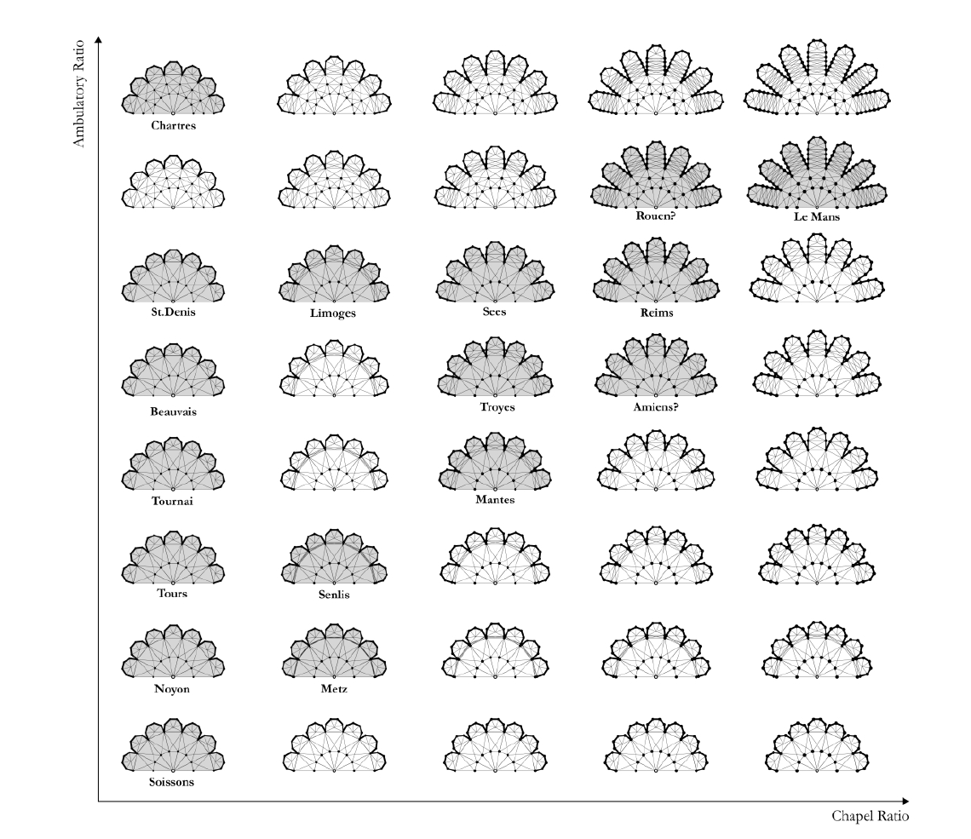
Figure 8. Reduced seven-fold apse morphospace using ambulatory and chapel ratio coefficients. The horizontal axis controls chapel expansion and the vertical axis controls ambulatory segmentation; cases outside the seven-fold rule family are excluded rather than forced into the matrix.
The resulting morphospace reveals continuous topological variation in which several historical examples can be located. Apses with strongly protruding chapels, such as Rouen, Reims, and Le Mans, occupy the upper-right region where both ambulatory segmentation and chapel expansion are high. More compact configurations appear toward the lower-left, represented by examples such as Noyon, Tours, and Soissons. Intermediate cases including Metz, Senlis, Mantes, Troyes, and Limoges demonstrate gradual increases in both segmentation and chapel protrusion, while Chartres and Saint-Denis emphasize ambulatory subdivision with comparatively restrained chapel growth.
The morphospace in Figure 8 should therefore be read as a reduced slice through the larger design space rather than as an exhaustive map of all twenty-four apses. Because the matrix fixes seven-fold symmetry and the most recurrent branching sequence, only sixteen of the historical cases can be plotted directly within this field. Five-fold Bourges-family examples, the semicircular Angers plan, and atypical cases such as Notre-Dame de Paris require parallel morphospaces or alternative rule sequences. This limitation is useful rather than accidental: it makes explicit which historical examples belong to the dominant seven-fold family and which fall outside it. Cases outside the matrix are not treated as failures of the model but as indicators that multiple rule families coexist within the broader corpus.
4. Conclusion
This study presents a graph-based production system for the morphological study of French Gothic apse plans. By analyzing a typological corpus of twenty-four French cathedrals and major churches, the research formalizes the subdivision of ambulatories and the outward differentiation of chapels as algorithmic rules. When encoded computationally, these principles generate a reduced morphospace that situates comparable historical examples within a continuous spectrum of variation. The main contribution of the paper is therefore methodological: it adapts formal grammar thinking to a comparatively underexplored corpus in architectural history.
By abstracting apse geometry into graph-based diagrams, we demonstrate that the morphology of bays, vaults, and chapels can be described as branching sequences with comparable rule structure (Ostwald, 2011; Author, 2021). The paper uses the terms growth and morphogenesis in the limited analytical sense of iterative form generation. Ambulatory segmentation illustrates a rhythmic logic of column redistribution, while chapel proliferation behaves as a controlled sequence of outward extensions rather than as a free biological metaphor. Together, these processes generate a wide spectrum of spatial outcomes, from the dense inner subdivision at Notre-Dame de Paris to the expansive protrusion at Le Mans. The proposed morphospace situates these historical examples within a continuous field of variation, illustrating both ambulatory-oriented and chapel-oriented developmental series.
The revised framework supports historical analysis by offering a rule-based rather than merely descriptive reading of Gothic plans. It also clarifies its own limits. The current model operates in two dimensions, fixes one dominant symmetry family in the morphospace, and does not yet incorporate vault elevation, structural behavior, liturgical function, patronage, or construction chronology. These limits are part of the scope of the article rather than claims about the whole building. Future work should therefore expand the model through parallel five-fold and seven-fold morphospaces and, only after the plan grammar is stabilized, toward three-dimensional vault and section systems. Even within its present scope, however, the paper shows that French Gothic apses can be understood not only as historical artifacts but as formal systems whose generative logic can be described, compared, and computationally explored.
Acknowledgements
We gratefully acknowledge the assistance of [Student A] and [Student B], undergraduate researchers who contributed to data collection, diagram preparation, and initial analysis.
Data Availability
The datasets generated and analyzed during this study include reconstructed cathedral plan diagrams, graph representations of apse morphology, and parametric model outputs used to generate the morphospace analysis. These materials were produced by the author based on the historical plan sources cited in the article. To facilitate reuse, the dataset is organized as traced drawings, graph files, and parametric rule definitions; these materials are available from the corresponding author upon reasonable request and are being prepared for deposit in an open online repository following FAIR data principles.
Use of Generative AI
The author used ChatGPT (OpenAI) for limited language editing, stylistic suggestions, and editorial restructuring during the preparation and revision of this manuscript. All conceptual development, analysis, computational modeling, figures, and interpretations presented in the article were produced by the author. The author reviewed and edited all outputs and takes full responsibility for the content of the manuscript.
References
Author (2020).
Author (2021).
Bony J (1983) French Gothic Architecture of the Twelfth and Thirteenth Centuries. Berkeley: University of California Press.
Dawes MJ, Ostwald MJ and Lee JH (2021) Examining control, centrality and flexibility in Palladio’s villa plans using space syntax measurements. Frontiers of Architectural Research 10(3): 467–482.
de Berg M, Cheong O, van Kreveld M and Overmars M (2008) Computational Geometry: Algorithms and Applications. Berlin: Springer-Verlag.
Fehér K, Szilágyi B, Bölcskei A and Halmos B (2019) Pentagons in Medieval Sources and Architecture. Nexus Network Journal 21(4): 681–703.
Fingesten P (1961) Topographical and Anatomical Aspects of the Gothic Cathedral. The Journal of Aesthetics and Art Criticism 20(1): 3–23.
Frankl P (1962) Gothic Architecture. Baltimore: Penguin Books.
Gardner M (1990) The New Ambidextrous Universe: Symmetry and Asymmetry from Mirror Reflections to Superstrings. New York: W.H. Freeman.
Gerlach JR (2017) Generating homeomorphically irreducible trees (solving the blackboard problem in the movie “Good Will Hunting”). In: PharmaSUG 2017 Conference Proceedings, Baltimore, MD, 14–17 May 2017.
Ginovart JLl, Fortuny Anguera G, Costa Jover A and de Sola-Morales Serra P (2013) Gothic Construction and the Traça of a Heptagonal Apse: The Problem of the Heptagon. Nexus Network Journal 15(2): 325–348.
Grasl T and Economou A (2013) From Topologies to Shapes: Parametric Shape Grammars Implemented by Graphs. Environment and Planning B: Planning and Design 40(5): 905–922.
Harary F (1994) Graph Theory. Reading: Addison-Wesley.
Hensel M, Menges A and Weinstock M (eds) (2004) Emergence: Morphogenetic Design Strategies. Architectural Design 74(3). London: Wiley Academy.
Lindenmayer A (1968) Mathematical models for cellular interactions in development. II. Simple and branching filaments with two-sided inputs. Journal of Theoretical Biology 18(3): 300–315.
Mignon O (2015) Architecture des Cathédrales Gothiques. Rennes: Éditions Ouest-France.
Ostwald MJ (2011) The mathematics of spatial configuration: Revisiting, revising and critiquing justified plan graph theory. Nexus Network Journal 13: 445–470.
Ostwald MJ and Dawes M (2013) Differentiating between line and point maps using spatial experience: Considering Richard Neutra’s Lovell House. Nexus Network Journal 15: 63–81.
Panofsky E (1957) Gothic Architecture and Scholasticism. New York: New American Library.
Park J and Economou A (2019) The Dirksen Grammar: A Generative Description of Mies van der Rohe’s Courthouse Design Language. Nexus Network Journal 21(3): 591–622.
Prusinkiewicz P and Lindenmayer A (1990) The Algorithmic Beauty of Plants. New York: Springer-Verlag.
Samper A and Herrera B (2014) The Fractal Pattern of the French Gothic Cathedrals. Nexus Network Journal 16(2): 251–271.
Spuybroek L (2011) The Sympathy of Things: Ruskin and the Ecology of Design. Rotterdam: V2_Publishing.
Steadman P (1983) Architectural Morphology: An Introduction to the Geometry of Building Plans. London: Pion.
Steadman P and Mitchell LJ (2010) Architectural morphospace: Mapping worlds of built forms. Environment and Planning B: Planning and Design 37(2): 197–220.
Stiny G (1980) Introduction to shape and shape grammars. Environment and Planning B: Planning and Design 7(3): 343–351.
Stiny G and Mitchell WJ (1978) The Palladian grammar. Environment and Planning B: Planning and Design 5(1): 5–18.
Swaan W (1980) The Gothic Cathedral. New York: Crescent Books.
Thompson DW (1942) On Growth and Form. 2nd ed. Cambridge: Cambridge University Press.
Ungewitter GG and Mohrmann K (1901–03) Lehrbuch der gotischen Konstruktionen. 4th ed. Leipzig: H. Tauchnitz.
Villard de Honnecourt (1979) The Sketchbook of Villard de Honnecourt. Edited and translated by Theodore Bowie. Bloomington: Indiana University Press.
Von Simson O (1980) The Gothic Cathedral: Origins of Gothic Architecture and the Medieval Concept of Order. Expanded ed. Princeton: Princeton University Press.
Worringer W (1927) Form in Gothic. Translated by H Read. New York: G.P. Putnam’s Sons.

