# Feb 2023 – SB+ - MSc in Data Analytics

Author: Sajjan Bhattarai

e-mail: [sbs23010@student.cct.ie](mailto:sbs23010@student.cct.ie)

Student ID: sbs23010

# Abstract

# Introduction

# Materials and Methods

## Selection of Programming Language and Libraries

For this study, two programming languages Python and R were considered for their simplicity and availability of wide range of libraries for Data Analytics and Machine Learning. Ultimately, Python was chosen because it provides more human readable syntax, and versatility in terms of object-oriented and modular programming. Additionally, it has a larger ecosystem of libraries and frameworks, that offer more choices and easy integration with other technologies. Therefore, for the purposes of performing statistical analysis, machine learning and visualization on dashboard, Python is the most effective language within the scope of this study.

Similarly for data manipulation, three Python libraries Pandas, PySpark and NumPy were considered. The study will mainly utilize Pandas, along with NumPy in some situations. PySpark was also explored and tested, however it was deemed infeasible for the scale of data being analyzed in this study. Additionally, the differences and limitations in PySpark’s syntax made it more challenging to perform small or basic tasks. For example, lack of *apply()* method in PySpark DataFrame requires the use of User Defined Functions (UDF). Such additional complexities would have been justified if the concerned dataset was huge and required distributed processing (SparkByExamples, 2023). Nevertheless, it was kept as an option during this study in case a much larger dataset needs to be processed.

## Project Management Framework

Two commonly used frameworks CRISP-DM and SEMMA were considered for this study. CRISP-DM stands for Cross Industry Standard Process, and was developed by a consortium of numerous data-mining companies (Kotu and Deshpande, 2014). It comprises of iterative phases that include business/research understanding, data understanding, modelling, evolution and deployment. On the other hand, SEMMA stands for Sample, Explore, Modify and Assess, was developed by Statistical Analysis System (SAS).

Both frameworks follow similar model of iterative progress and feedback loop. CRISP-DM was chosen for this study because it offers a more comprehensive framework from understanding of research requirements to final deployment of the model. Whereas business/research understanding isn’t a defined phase in SEMMA framework. With this, the project deliverables were planned as below:

1. Understanding the problem domain and exploring the available datasets during first week
2. Performing descriptive and inferential statistical analysis on the relevant datasets, and working with Machine Learning models during second week
3. Further Machine Learning testing and optimization, along with Sentiment Analysis on Reddit data during third week
4. Improving code quality with reusable functions and unit tests, as well as preparing the dashboard visualization in the fourth week

### Research Understanding

Construction sector is one of the key drivers of the economy globally. In the context of European Union, it accounts for 18 million jobs and almost 9% of GDP. It is estimated that a full-scale digitalization can contribute up to 20% annual global savings in the design and construction phases, and up to 15% in the operational phases (Arthur, 2022). Hence, applying the concepts of Data Analytics on to Construction industry could help further our understanding of the relationship between different components, and to potentially optimize the sector.

This research seeks to analyze and establish relationship between construction material prices and production in construction. Although it is primarily focused on the context of Ireland’s construction sector, it also makes a high-level comparison with other countries.

### Data Understanding

The datasets used in this study were mostly published by Central Statistics Office of Ireland under Creative Commons Attribute 4.0 license (Government of Ireland, 2023). Other datasets were published by Eurostat under Public access type (European Commission, 2023) and Reddit API data (Reddit, 2023). All datasets that were explored and considered during this study can be found in attached Jupyter Notebook (data-exploration.ipynb).

After searching for relevant datasets, the Production in Construction Indices and Wholesale Price Indices of Construction Materials datasets from Ireland were selected for further analysis. Additionally, the Production in Construction Indices from Eurostat, and Building Construction Costs from Netherlands were selected for high-level comparison with Ireland. Lastly, the Reddit APIs were used to search for relevant topic and conversations from concerned sub-reddits to perform public sentiment analysis. All these analysis and results are available in the attached Jupyter Notebook (construction-materials-and-production.ipynb).

#### Descriptive Statistics

The first dataset represented the monthly wholesale price indices and percentage change over 1 and 12 months for 40 major construction materials from January 2015 to April 2023. After filtering the required statistic label and pivoting the table to put the materials as columns, there were 100 rows in total. Out of these records, 2 materials had null values for the last 3 months, and no duplicates were present. Upon performing descriptive statistical analysis on this dataset, 10 materials had standard deviation value greater than 20, which implies higher volatility in their prices. Their mean/average price indices were also higher than the median, thus implying positive skew or presence of outliers or extreme values in the right tail.

Table : Statistical Description of Some Materials

|  |  |  |  |  |  |  |
| --- | --- | --- | --- | --- | --- | --- |
| **Type of Material** | Other structural steel | Other treated timber | Plaster | Structural steel | Structural steel and reinforcing metal | Structural steel fabricated metal |
| **count** | 100.0000 | 100.0000 | 100.00000 | 100.00000 | 100.00000 | 100.00000 |
| **mean** | 119.3100 | 122.3140 | 122.01200 | 127.65400 | 124.53800 | 128.67800 |
| **std** | 32.48594 | 44.93026 | 26.717203 | 31.898473 | 31.227089 | 32.694406 |
| **min** | 95.70000 | 95.30000 | 98.400000 | 97.600000 | 98.800000 | 97.300000 |
| **25%** | 99.60000 | 95.30000 | 104.12500 | 110.35000 | 106.32500 | 111.75000 |
| **50%** | 104.6500 | 102.8000 | 112.80000 | 120.45000 | 113.60000 | 122.70000 |
| **75%** | 121.1750 | 104.7000 | 125.62500 | 124.12500 | 120.57500 | 124.50000 |
| **max** | 210.5000 | 216.6000 | 206.30000 | 222.40000 | 205.70000 | 229.90000 |

The presence of outliers or extreme price indices for some construction materials can also be demonstrated in below BoxPlot.

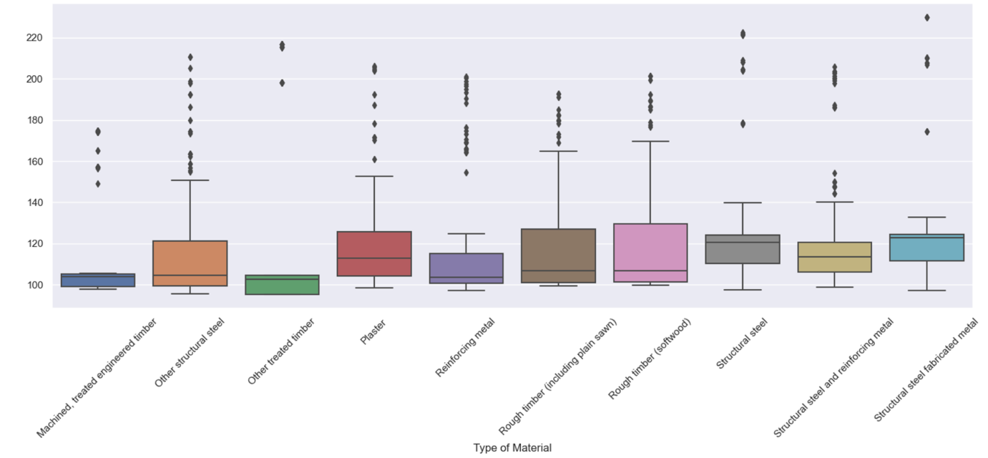

Figure : BoxPlot of Construction Materials with High Variation

It is preferable to address such outliers when applicable, using methods like transformation, removal, Winsorization, etc. BoxCox Transformation was applied on these features, which helped to reduce the outliers. However, with such approaches, it is important to consider aspects such as interoperability, impact on relationships, and reversibility. Therefore, depending on the use case, it may not always be useful to transform the data.

Similarly, the second dataset represents the Production in Construction Indices with same base of 100 for 2015. It is also mainly positive skewed, with Residential Buildings standing out. This construction type had highest maximum of 789.9 and lowest medium of 55. It also had highest mean at 268.5 with standard deviation of 219.3.

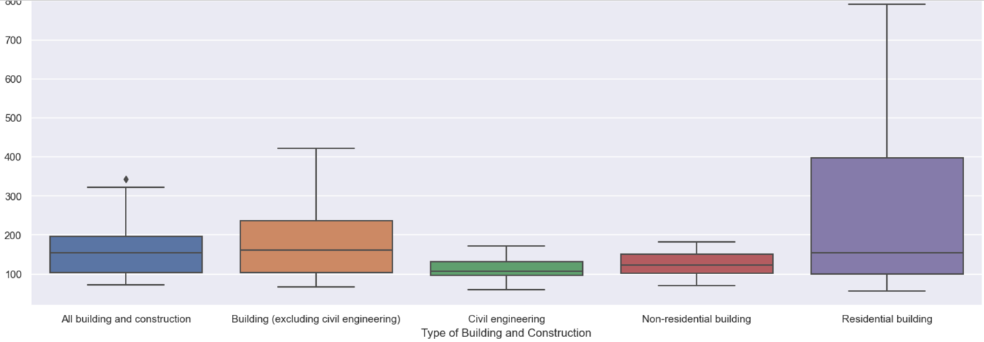

Figure : BoxPlot of Production in Construction by Types

In overall, only Non-residential Building type had relatively balanced distribution.

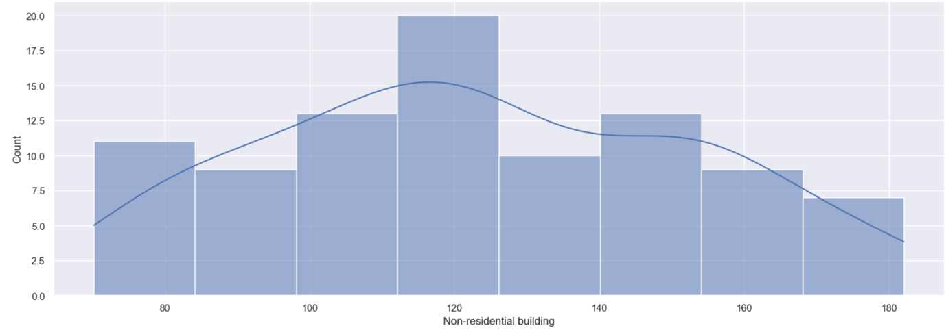

Figure : HistPlot of Production in Construction Indices for Non-residential Building

#### Inferential Statistics

Below inferential statistical analysis were performed to gain more insight and to make inferences about a population based on available sample data.

##### Pearson Correlation Coefficient Test

10 construction materials were shortlisted based on their Pearson correlation coefficient and target feature i.e. Production in Construction index for Non-residential buildings (Sheposh, 2022). Below test calculates the p-value and confidence interval for each of these materials and the target variable.

Stating the Null Hypothesis:

* **Null Hypothesis (H0):** There is no correlation between each of the 10 selected construction materials and the value of production in Non-residential buildings.
* **Alternative Hypothesis (H1):** There is a correlation between each of the 10 selected construction materials and the value of production in Non-residential buildings (the population correlation coefficient is not zero for at least one construction material).
* **Significance Level (alpha):** 5% (0.05)

Table : Pearson Correlation Coefficient Test results

|  |  |  |  |  |
| --- | --- | --- | --- | --- |
| Material | Coefficient | p-value | Accept H0? | Confidence interval |
| All other metal fittings | 0.814911 | 5.419483e-24 | False | 0.733-0.873 |
| Cement | 0.750128 | 1.421157e-18 | False | 0.645-0.827 |
| HVAC (heating and ventilation equipment) | 0.742812 | 4.573935e-18 | False | 0.636-0.822 |
| Other steel products | 0.735394 | 1.438152e-17 | False | 0.626-0.817 |
| PVC pipes and fittings | 0.698355 | 2.589154e-15 | False | 0.577-0.789 |
| Paints, oils and varnishes | 0.797549 | 2.381846e-22 | False | 0.709-0.861 |
| Plaster | 0.700247 | 2.024512e-15 | False | 0.58-0.791 |
| Precast concrete | 0.729288 | 3.589822e-17 | False | 0.618-0.812 |
| Rough timber (hardwood) | 0.687658 | 1.004452e-14 | False | 0.563-0.782 |
| Wooden windows and doors | 0.687138 | 1.071252e-14 | False | 0.563-0.781 |

For all selected materials, the calculated p-values are lower than the significance level 0.05, so the null hypothesis is rejected. Hence, there is statistically significant correlation between the materials price and production in construction. Additionally, the confidence interval doesn't include 0, so the correlation coefficient is statistically significant and shouldn’t have occurred by coincidence alone.

##### T-test to Calculate Confidence Intervals for Population

Assuming the population mean as 110 for each selected materials, below test tried to infer whether there is significant difference between sample mean and population mean.

* **Null Hypothesis H0:** There is no difference between the sample mean and population mean.
* **Alternative Hypothesis H1:** The sample mean and population mean are different.
* **Significance Level (alpha):** 5% (0.05)

Table : T-test for Sample Mean and Population Mean

|  |  |  |  |  |
| --- | --- | --- | --- | --- |
| Material | T-statistic | p-value | Accept H0 | confidence interval |
| All other metal fittings | -3.502 | 0.00071 | False | (107.016, 109.175) |
| Cement | 3.190 | 0.00193 | False | (112.034, 118.739) |
| HVAC (heating and ventilation equipment) | -12.498 | 0.00000 | False | (103.421, 105.225) |
| Other steel products | -11.535 | 0.00000 | False | (102.627, 104.792) |
| PVC pipes and fittings | 2.591 | 0.01108 | False | (111.064, 118.044) |
| Paints, oils and varnishes | 3.144 | 0.00222 | False | (111.614, 117.146) |
| Plaster | 3.989 | 0.00013 | False | (114.295, 122.805) |
| Precast concrete | 1.987 | 0.04980 | False | (110.002, 115.548) |
| Rough timber (hardwood) | -3.649 | 0.00043 | False | (104.665, 108.425) |
| Wooden windows and doors | -2.006 | 0.04765 | False | (105.667, 109.977) |

##### Independent Samples T-test

In this independent samples t-test (Gio and Rosmaini, 2018), the yearly average cost for construction materials were compared between Ireland and Netherlands. Since the Dutch dataset contained yearly records for all materials combined, matched the Irish dataset by grouping the data on year and calculating the mean of all materials.

* **Null Hypothesis H0:** There is no difference between the mean cost indices.
* **Alternate Hypothesis H1:** There is a difference.
* **Significance Level (alpha):** 5% (0.05)

It returned the t-statistic as -2.28 and p-value as 0.029, which suggest a significant difference between the mean building material cost indices of these two countries. The Null hypothesis is rejected with p-value lower than 0.05.

##### Analysis of Variance with Levene’s Test

It is helpful to compare the production in construction across Ireland and other European countries. Therefore, an equivalent dataset from Eurostat was used for this analysis, and aggregated to quarterly from monthly basis. While comparing more than two groups, Levene’s Test can be used to assess the equality of variances.

* **Null Hypothesis H0:** Population variances are equal.
* **Alternate Hypothesis H1:** Population variances aren't equal.
* **Significance Level (alpha):** 5% (0.05)

The returned p-value was less than 0.05 in both cases of using mean and median as center. Therefore the Null hypothesis is rejected, which indicates difference in the variances.

##### Welch’s ANOVA Test

Based on results of above Levene’s Test, the variances between chosen countries aren’t same. Therefore, the use case doesn’t meet one of the criteria for using ANOVA (Holt, 2023). Therefore, a more flexible Welch’s ANOVA Test was performed to compare the means across more than two groups (Delacre, 2019).

* **Null Hypothesis H0:** There is no difference in means of production in construction across different countries.
* **Alternate Hypothesis H1:** There is a difference between means across countries.
* **Significance Level (alpha):** 5% (0.05)

From above test results, the f-value of 355.27 suggests there might be some differences in means of the countries. And the p-value is less than the chosen significance level of 0.05, so the Null hypothesis is rejected. Therefore, there is sufficient evidence to suggest statistically significant differences across the means of these countries.

##### Mann-Whitney U Test

Similar comparison was also made using non-parametric test called Mann-Whitney U test.

* **Null Hypothesis H0:** There is no significant difference between the production in construction indices between Ireland and Netherlands.
* **Alternate Hypothesis H1:** There is difference between the two countries
* **Significance Level (alpha):** 5% (0.05)

The resulting p-value was 0.028, which is lower than the chosen significance value. Therefore, the Null Hypothesis is rejected.

##### Wilcoxon Signed-rank Test

Another non-parametric test was used to compare two groups of production in construction indices for Netherlands.

* **Null Hypothesis H0:** There is no significant difference between the production in construction indices in Netherlands before and after 3rd quarter of 2022.
* **Alternate Hypothesis H1:** There is difference between the group of production in construction indices.
* **Significance Level (alpha):** 5% (0.05)

It resulted in p-value of 0.50, so the Null Hypothesis is accepted.

#### Data Preparation

After shortlisting the relevant datasets and performing statistical analysis, they were pivoted to put the independent and target features as columns and joined together. This resulted in a data containing price indices for 40 construction materials, and production in construction indices for 5 types. This was done to understand the relationship between the materials and certain construction types. At the end of the study, the objective was to identify key materials affecting a construction type, and to perform prediction and/or classification. Such information could help to better plan the supply of proper materials as per the needs of each construction type and their demands.

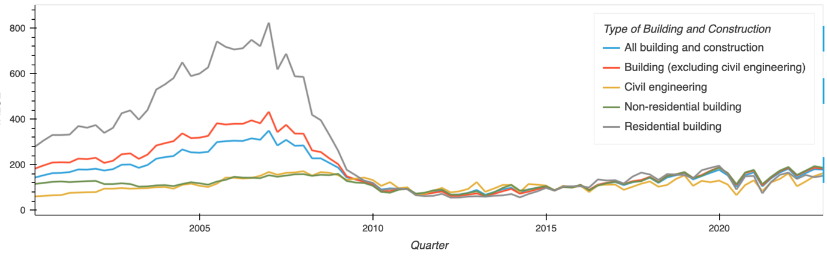

# Results

# Discussion/Conclusions

# References

* SparkByExamples (2023). *Pandas vs PySpark DataFrame With Examples*. Available at: <https://sparkbyexamples.com/pyspark/pandas-vs-pyspark-dataframe-with-examples/> (Accessed: 14 April 2023).
* Kotu v. and Deshpande B. (2014) Predictive Analytics and Data Mining : Concepts and Practice with RapidMiner. Amsterdam: Morgan Kaufmann. Available at: <https://search.ebscohost.com/login.aspx?direct=true&db=e250xww&AN=919334&site=eds-live> (Accessed: 12 April 2023).
* Arthur I. Tsarev (2022) ‘Implementation of BIM technologies in the construction sector: the European experience’, Stroitel’stvo: Nauka i Obrazovanie, 12(3), pp. 125–136. doi:10.22227/2305-5502.2022.3.8.
* Government of Ireland (2023). Datasets, Publisher: Central Statistics Office. Available at: https://data.gov.ie/dataset/beq04-onstruction-sector-base-2015100-by-type-of-building-and-construction-year-and-statistic-fb86?package_type=dataset (Accessed: 27 April 2023).
* European Commission (2023). Datasets, Publisher: Eurostat. Available at: <https://data.europa.eu/data/datasets/sb1sa3jwwgiu0buqjyq5g?locale=en> (Accessed: 28 April 2023).
* Reddit Inc. (2023). Data API Terms. Available at: <https://www.redditinc.com/policies/data-api-terms> (Accessed at: 23 May 2023).
* Sheposh, R. (2022) ‘Pearson correlation coefficient (PCC)’, Salem Press Encyclopedia of Science [Preprint]. Available at: <https://search.ebscohost.com/login.aspx?direct=true&db=ers&AN=155876503&site=eds-live> (Accessed: 23 May 2023).
* Prana Ugiana Gio and Elly Rosmaini (2018) ‘The Robustness of Two Independent Samples t Test Using Monte Carlo Simulation with R’, IOP Conference Series: Materials Science and Engineering, 300, p. 012030. Available at: <https://search.ebscohost.com/login.aspx?direct=true&db=edsair&AN=edsair.doi...........7fc4a5ce2ebec8a7cf2573c0cef7776a&site=eds-live> (Accessed: 23 May 2023).
* Holt, M.P.. Ms. (2023) ‘Analysis of variance (ANOVA)’, Salem Press Encyclopedia of Science [Preprint]. Available at: <https://search.ebscohost.com/login.aspx?direct=true&db=ers&AN=113931283&site=eds-live> (Accessed: 23 May 2023).
* Marie Delacre et al. (2019) ‘Taking Parametric Assumptions Seriously: Arguments for the Use of Welch’s ’F’-test instead of the Classical ’F’-test in One-Way ANOVA’, International Review of Social Psychology, 32(1). doi:10.5334/irsp.198.