## seaEchoTargetStrengthCalculator

Instructions

The seaEchoTargetStrengthCalculator (v0.1) is a CLI tool based on python 3.8 to determine Target Strength, particularly focused towards bubbles underwater, along with a portion used to determine target strength of solid elastic spheres.

**Installation**

1. Obtain the code.
   1. Clone repository to a suitable directory.

git clone <https://github.com/.../..../>

* 1. Download version0.1 and unzip to a suitable directory in the system.

1. Navigate to repository’s root directory.

cd seaEchoTargetStrengthCalc/

1. Setup an isolated python environment using the following in terminal

python -m venv venv

1. Activate virtual environment.

source venv/bin/activate [For macOS/Linux]

.\env\Scripts\Activate.ps1 [For windows(powershell)]

1. Install dependencies for the code.

pip install -r requirements.txt

**Operation**

**For bubble**, workflow is as following,

1. Navigate your required directory. (Bubble/Sphere)

cd Bubble

1. Launch the CLI using following command.

python main.py

1. After executing the main.py file, available models are provided. User can input the numeric value provided to select their preferred models.

1. Following this, user is prompted for frequency configuration.
   1. Single Frequency Analysis.



* 1. Custom Frequency Range

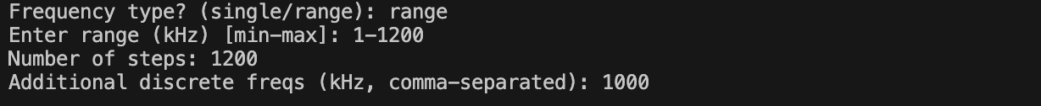

User can also input any additional discrete frequency to mark in the plot.

1. Following this you will be prompted to provide environmental parameters and bubble diameter.

1. Results Output printed in the terminal.

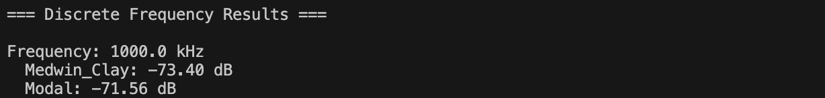

1. A graph of TS vs Frequency within the range of ±10KHz of the user input frequency (For single frequency analysis) or range of custom frequency selected will be generated automatically at the root directory as ts_vs_frequency_plot.png as shown in Figure 1 and Figure 2.

Figure 1: Output plot for single frequency.

Figure 2: Output plot for range of frequency.

**For sphere**, workflow is as following,

1. Navigate your required directory. (Bubble/Sphere)

cd SolidSphere

1. Launch the CLI using following command.

python main.py

1. User will be prompted to provide the following input.

1. Upon inputting and executing the script, following outputs will pop out.



1. A graph of TS vs Frequency will also be generated as shown in the figure 3.

Figure 3: Output plot for a range of frequency for solid sphere.

**N.B.**: In v0.1, our solid sphere code is only limited to Tungsten Carbide (WC) as target material.