Store Sales Prediction

Wireframe Documentation

Store Sales Prediction

User Interface:

1. The user can view the following web page once entering the web application.

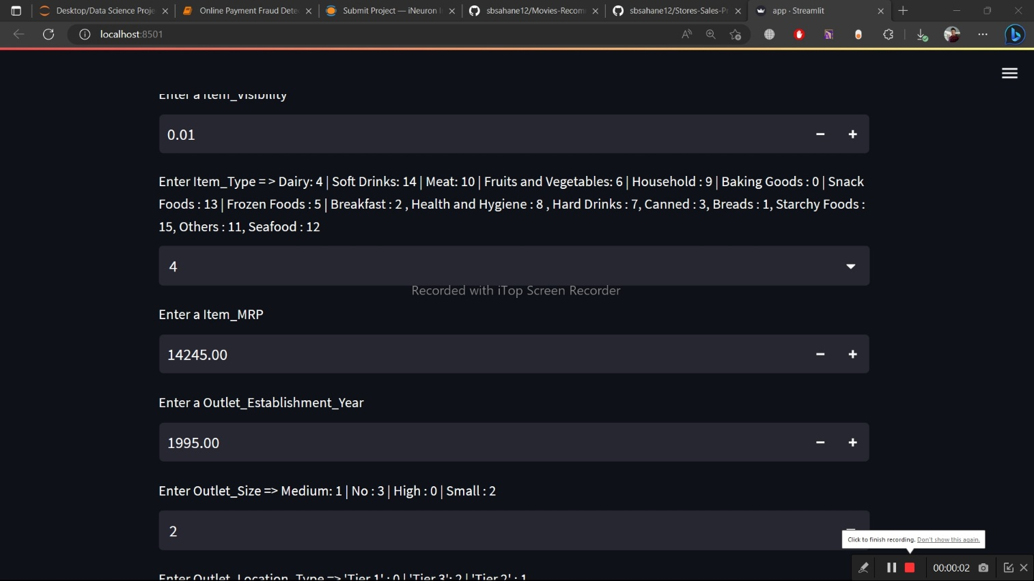

2. Change the values in the fields as needed:

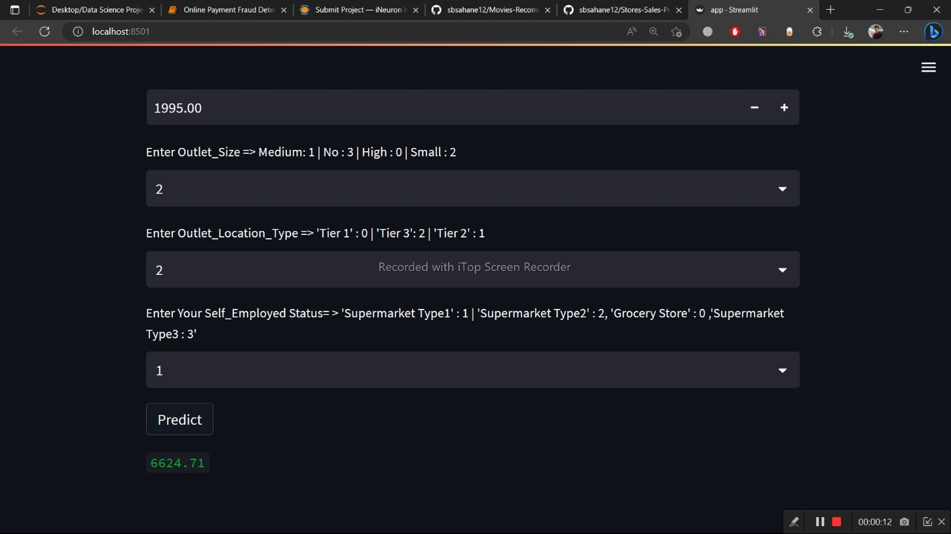

3.After clicking the “Predict ” button, User can see the prediction result on the home page with auto navigation.

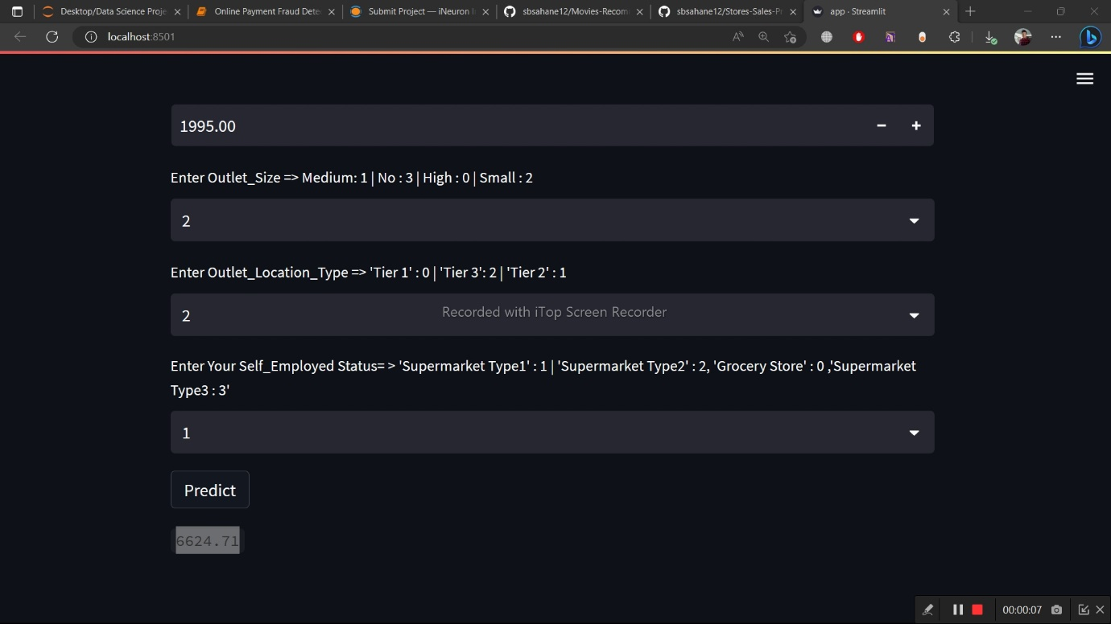

Based on User Inputs, Store Sales Prediction will predict the Item Outlet Sales and user will get predicted