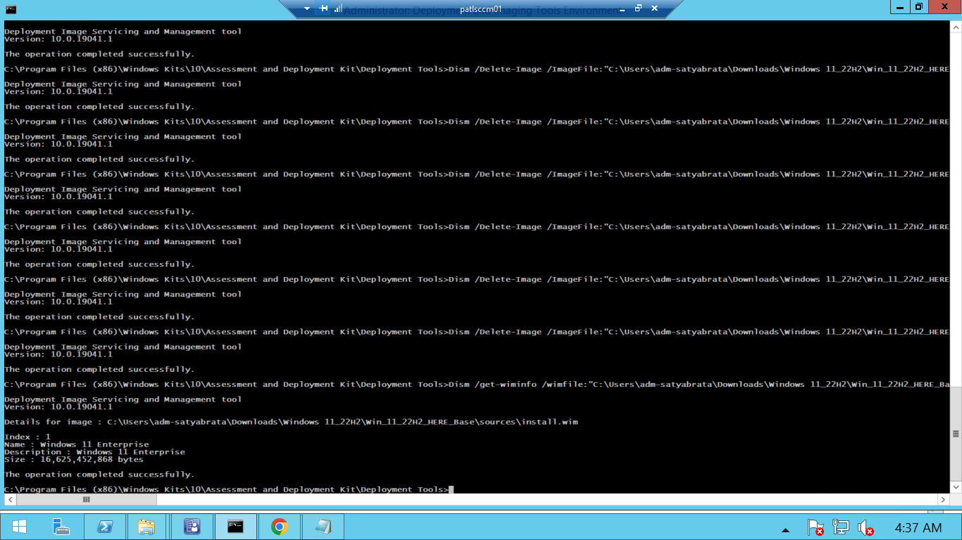

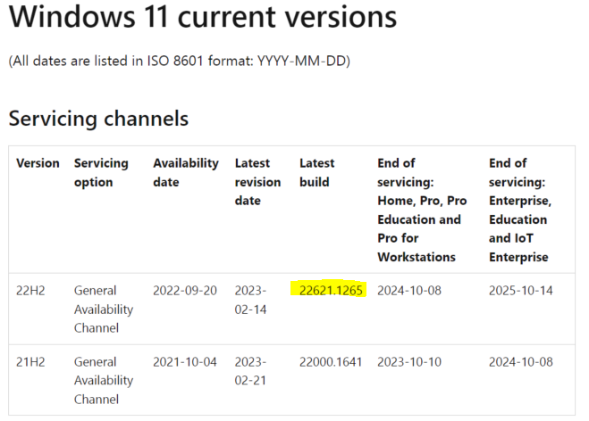

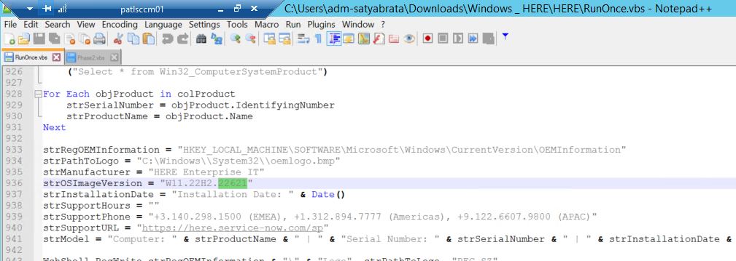

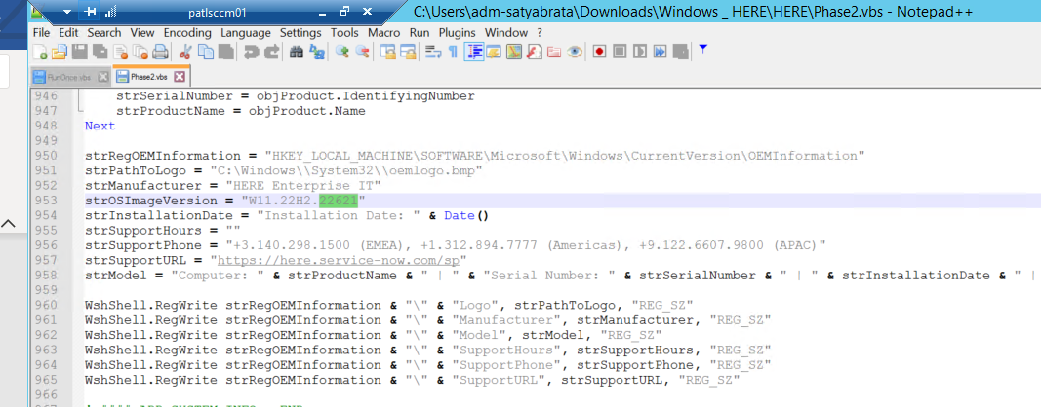

dism /Image:"C:\Users\adm-satyabrata\Downloads\Mount win11" /Remove-ProvisionedAppxPackage /PackageName:Microsoft.WindowsFeedbackHub_2022.106.2230.0_neutral_~_8wekyb3d8bbwe

Deployment Image Servicing and Management tool

Version: 10.0.19041.1

Image Version: 10.0.22621.1105

The operation completed successfully.

