Part I

Consider a computer that you have used or now use. (You may make an assumption on word size if needed.)

* How large is the memory of the computer? 8 GB
* How long is a word in the computer above? 64 bits
* How many bits are required to address the bytes in that memory? 2^32
* How many data lines are required to read data from the computer memory? 64

Part II

* Does your computer have cache? Yes
* If so how big is it? L2 256 KB, L3: 6MB
* How does your cache size compare with the size of main memory? Smaller, but Faster
* Do you know what kind of cache it is? Possible associative
* How did you find out about your computer's cache? Running a report

 Make an assumption that your cache is either:

* Fully associative
* Direct mapped
* Two-way set-associative
* Four-way set-associative

 Using the relationships in Part I above, determine:

 the size of the Tag and Word for Associative cache;

 OR

 the size of the Tag, Line, and Word for Direct-Mapped Cache ;

 Or

 the size of Tag, Set, and Word for K-Way Set-Associative Cache.

Tag Size = 24b, Set = 5b , Word = 3b

You may make any assumptions necessary including the number of Words in each block (recommend 2 or 4 or 8)

Part III

Top of Form

Given the following:

* Logical Memory size of 1000
* Physical Memory size of 2000
* Page (and frame) size of 100
* Block A contains data for a program

Select Block A’s size and its starting point in both memories. Then write the page table for Block A based on your selections.

See below for the layout of both memories and an example of Block A of size 200.

Logical Memory                               Physical Memory

location/ **page**                                    location/**frame**

|  |  |  |
| --- | --- | --- |
| 0     to     99/ **0** |  | 0     to     99/ **0** |
| 100 to 199 /**1**     Block A | 100 to 199/ **1** |
| 200 to 299/ **2**     Block A | 200 to 299/ 2 |
| 300 to 399/ **3 Block A** | 300 to 399/ 3 |
| 400 to 499/ **4 Block A** | 400 to 499/ 4 |
| 500 to 599/ **5** | 500 to 599/ 5 |
| 600 to 699/ **6** | 600 to 699/ 6 |
| 700 to 799/ **7** | 700 to 799/ 7 |
| 800 to 899/ **8** | 800 to 899/ 8 |
| 900 to 999/ **9** | 900 to 999/ 9 |
|  | 1000 to 1099/ 10 |
| 1100 to 1199/ 11 |
| 1200 to 1299/ **12 Block A** |
| 1300 to 1399/ **13**         Block A |
| 1400 to 1499/ **14**         Block A |
| 1500 to 1599/ **15 Block A** |
| 1600 to 1699/ **16 Block A** |
| 1700 to 1799/ **17** |
| 1800 to 1899/ **18** |
| 1900 to 1999/ **19** |

|  |  |
| --- | --- |
| Page | Frame |
| **1** | **13** |
| **2** | **14** |

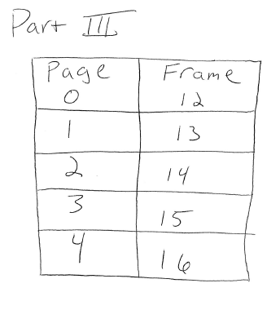

Part IV

Discuss the pros and cons of paging:

The pros and cons of paging are that paging many entail more memory and overhead. In addition, it will require special hardware components / OS support, however, it can result in faster retrieving information and will contain better protection. When the computer is processes at slower speeds or does not simply have enough extra physical memory, it would be less helpful to focus on paging.