Project 2: Database Design

Samuel B. Scalf
School of Cybersecurity and Information Technology, University of Maryland Global Campus
CMIS 320: Relational Database Concepts and Applications
Dr. Karl B. Lloyd
April 13, 2021
Table of Contents
Entities 3
Relationship Sentence Pairs 4
Entity Relationship Diagram 6
Table Metadata 7
CUSTOMER 7
RENTAL 7
APPLIED_FEE 7
FEE 7
MOVIE_RENTAL 7
INVENTORY_MOVIE 8
CATALOG_ENTRY 8
CATALOG 8
DISTRIBUTOR 8
MOVIE_ORDER 9
SHIPMENT 9
MOVIE 9
AWARD 9
DIRECTOR_SEAT 10
DIRECTOR 10
CASTING 10
ACTOR 10

Entities
CUSTOMER
- customerID (PK)
- name
- address
- phoneNumber

RENTAL
- rentalID (PK)
- customerID (FK)
- dateRented
- dueDate
- dateReturned
- taxRate

APPLIED_FEE
- rentalID (PK/FK)
- feeType (PK/FK)

FEE
- feeType (PK)
- charge

MOVIE_RENTAL
- rentalID (PK/FK)
- inventoryID (PK/FK)

INVENTORY_MOVIE
- serialNumber (PK)
- movieID (FK)
- catalogID (FK)
- quantityInStock

CATALOG_ENTRY
- movieID (PK/FK)
- catalogID (PK/FK)
- wholesalePrice

CATALOG
- catalogID (PK)
- distributorID (PK/FK)
- volume

DISTRIBUTOR
- distributorID (PK)
- loyaltyDiscount
MOVIE_ORDER
- catalogEntryID (PK/FK)
- shipmentID (PK/FK)
- quantity
- wholesalePrice (FK)

SHIPMENT
- shipmentID (PK)
- dateOrdered
- dateShipped
- distributorID (FK)

MOVIE
- movieID (PK)
- isDVD
- genre
- runningLength
- rating
- year

AWARD
- name (PK)
- year (PK)
- movieID (FK)

DIRECTOR_SEAT
- movieID (PK/FK)
- directorID (PK/FK)

DIRECTOR
- directorID (PK)
- name

CASTING
- movieID (PK/FK)
- actorID (PK/FK)

ACTOR
- actorID (PK)
- name

Relationship Sentence Pairs
Each CUSTOMER makes one or more RENTAL.
Each RENTAL is made by only one CUSTOMER.

Each RENTAL may have one or more APPLIED_FEE.
Each APPLIED_FEE is applied to one RENTAL.

Each APPLIED_FEE is one type of FEE.
Each FEE may be in one or more APPLIED_FEE.

Each RENTAL has one RENTAL_RATE.
Each RENTAL_RATE is in one or more RENTAL.

Each RENTAL has one or more MOVIE_RENTAL.
Each MOVIE_RENTAL is part of one RENTAL.

Each MOVIE_RENTAL is associated with one INVENTORY_MOVIE.
Each INVENTORY_MOVIE may be part of one or more MOVIE_RENTAL.

Each INVENTORY_MOVIE is associated with one CATALOG_ENTRY.
Each CATALOG_ENTRY is associated with one INVENTORY_MOVIE.

Each CATALOG_ENTRY has one MEDIA.
Each MEDIA is in one or more CATALOG_ENTRY.

Each CATALOG_ENTRY belongs to one CATALOG.
Each CATALOG has one or more CATALOG_ENTRY.

Each CATALOG belongs to one DISTRIBUTOR.
Each DISTRIBUTOR has one or more CATALOG.

Each DISTRIBUTOR can send one or more SHIPMENT.
Each SHIPMENT is sent by one DISTRIBUTOR.

Each CATALOG_ENTRY may be part of one or more MOVIE_ORDER.
Each MOVIE_ORDER relates to one CATALOG_ENTRY.

Each MOVIE_ORDER is part of one SHIPMENT.
Each SHIPMENT has one or more MOVIE_ORDER.

Each CATALOG_ENTRY is about one MOVIE.
Each MOVIE is in one or more CATALOG_ENTRY.

Each MOVIE may have one or more AWARD.
Each AWARD is for one MOVIE.

Each MOVIE has one or more DIRECTOR_SEAT.
Each DIRECTOR_SEAT belongs to one MOVIE.

Each DIRECTOR_SEAT has one DIRECTOR.
Each DIRECTOR is in one or more DIRECTOR_SEAT.

Each MOVIE has one or more CASTING.
Each CASTING is for one MOVIE.

Each CASTING is one ACTOR.
Each ACTOR has one or more CASTING.

Entity Relationship Diagram
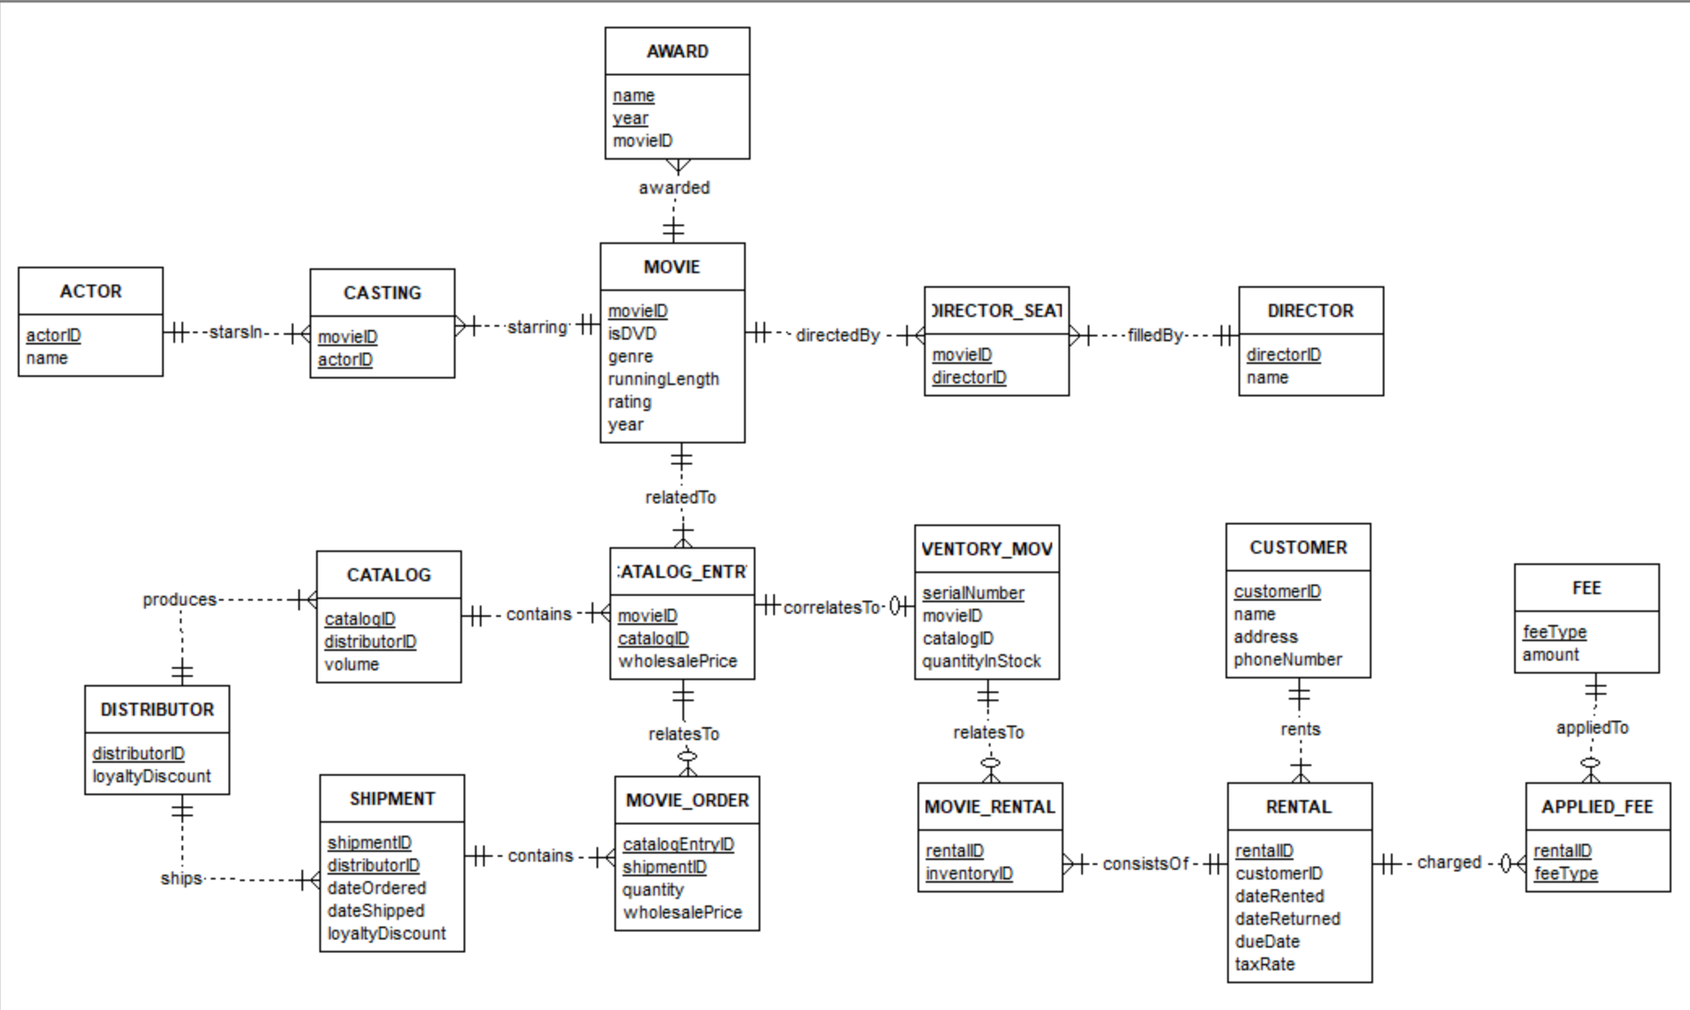

Table Metadata

CUSTOMER
Attribute Name | Stands For | Data Type | Key Type and Relation | Required | Referential Integrity
customerID | Auto Key | INT | PK | Yes | Yes
name | Name | String | N/A | Yes | No
address | Full Address | String | N/A | Yes | No
phoneNumber | Phone Number | String | N/A | No | No

RENTAL
Attribute Name | Stands For | Data Type | Key Type and Relation | Required | Referential Integrity
rentalID | Auto Key | INT | PK | Yes | Yes
customerID | Renting Customer | INT | FK CUSTOMER.customerID | Yes | Yes
dateRented | Date of Rent | Date | N/A | Yes | No
dueDate | Date Rental needs to be returned | Date | N/A | Yes | No
dateReturned | Date Returned | Date | N/A | Yes | No
taxRate | Amount of Tax | Double | N/A | Yes | No

APPLIED_FEE
Attribute Name | Stands For | Data Type | Key Type and Relation | Required | Referential Integrity
rentalID | Rental ID | INT | FK RENTAL.rentalID | Yes | Yes
feeType | Type of Fee | INT | FK FEE.feeType | Yes | Yes

FEE
Attribute Name | Stands For | Data Type | Key Type and Relation | Required | Referential Integrity
feeType | Type of Fee | String | PK | Yes | Yes
charge | Amount of charge for the fee | Double | N/A | Yes | No

MOVIE_RENTAL
Attribute Name | Stands For | Data Type | Key Type and Relation | Required | Referential Integrity
rentalID | Rental ID | INT | PK/FK RENTAL.rentalID | Yes | Yes
inventoryID | Inventory ID | INT | PK/FK INVENTORY_MOVIE.serialNumber | Yes | Yes

INVENTORY_MOVIE
Attribute Name | Stands For | Data Type | Key Type and Relation | Required | Referential Integrity
serialNumber | Internal serialization of movies | INT | PK | Yes | Yes
catalogID | Catalog ID | INT | FK CATALOG_ENTRY.catalogID | Yes | Yes
movieID | Movie ID | INT | FK CATALOG_ENTRY.movieID | Yes | Yes
quantityInStock | Count of movies currently in Stock | INT | N/A | Yes | No

CATALOG_ENTRY
Attribute Name | Stands For | Data Type | Key Type and Relation | Required | Referential Integrity
catalogEntryID | Catalog Entry ID | INT | PK | Yes | Yes
movieID | Movie ID | INT | FK MOVIE.movieID | Yes | Yes
catalogID | Catalog ID | INT | FK CATALOG.ID | Yes | Yes
wholesalePrice | Price for wholesale purchase | Double | N/A | Yes | No

CATALOG
Attribute Name | Stands For | Data Type | Key Type and Relation | Required | Referential Integrity
catalogID | Catalog ID | INT | PK | Yes | Yes
distributorID | Distributor ID | INT | FK DISTRIBUTOR.distributorID | Yes | Yes
volume | Volume Number | INT | N/A | Yes | No

DISTRIBUTOR
Attribute Name | Stands For | Data Type | Key Type and Relation | Required | Referential Integrity
distributorID | Distributor ID | INT | PK | Yes | Yes
loyaltyDiscount | Discount earned for loyalty | Double | N/A | No | No

MOVIE_ORDER
Attribute Name | Stands For | Data Type | Key Type and Relation | Required | Referential Integrity
catalogEntryID | Catalog Entry ID | INT | PK/FK CATALOG_ENTRY.  catalogEntryID | Yes | Yes
shipmentID | Shipment ID | INT | PK/FK SHIPMENT.shipmentID | Yes | Yes
quantity | Amount ordered | INT | N/A | Yes | No
wholesalePrice | Price for wholesale purchase | Double | FK CATALOG_ENTRY.wholesalePrice | Yes | Yes

SHIPMENT
Attribute Name | Stands For | Data Type | Key Type and Relation | Required | Referential Integrity
shipmentID | Shipment ID | INT | PK | Yes | Yes
dateOrdered | Date order was placed | Date | N/A | Yes | No
dateShipped | Date order was shipped | Date | N/A | Yes | No
distributorID | Distributor ID | INT | FK DISTRIBUTOR.distributorID | Yes | Yes

MOVIE
Attribute Name | Stands For | Data Type | Key Type and Relation | Required | Referential Integrity
movieID | Movie ID | INT | PK | Yes | Yes
idDVD | Whether movie is DVD or VHS | Boolean | N/A | Yes | No
genre | Genre of Movie (Horror, Romance, etc.) | String | N/A | Yes | No
runningLength | Length of Movie (in minutes) | INT | N/A | Yes | No
rating | MPAA Rating | String | N/A | Yes | No
year | Release Year | Date | N/A | Yes | No

AWARD
Attribute Name | Stands For | Data Type | Key Type and Relation | Required | Referential Integrity
name | Name of Award | String | PK | Yes | Yes
year | Year awarded | Date | PK | Yes | Yes
movieID | Movie awarded | INT | FK MOVIE.movieID | Yes | Yes

DIRECTOR_SEAT
Attribute Name | Stands For | Data Type | Key Type and Relation | Required | Referential Integrity
movieID | Movie Directed | INT | PK/FK MOVIE.movieID | Yes | Yes
directorID | Director | INT | PK/FK DIRETOR.directorID | Yes | Yes

DIRECTOR
Attribute Name | Stands For | Data Type | Key Type and Relation | Required | Referential Integrity
directorID | Director ID | INT | PK | Yes | Yes
name | Director’s Name as appears in credits | String | N/A | Yes | No

CASTING
Attribute Name | Stands For | Data Type | Key Type and Relation | Required | Referential Integrity
movieID | Movie Starred In | INT | PK/FK MOVIE.movieID | Yes | Yes
actorID | Actor Starring in Movie | INT | PK/FK ACTOR.actorID | Yes | Yes

ACTOR
Attribute Name | Stands For | Data Type | Key Type and Relation | Required | Referential Integrity
actorID | Actor ID | INT | PK | Yes | Yes
name | Name of Actor/Actress | String | N/A | Yes | No

