Table of Contents
SQL Commands 1
SPOOL files 10
Screenshots 17

SQL Commands
Scalf-00-scripts.sql
SPOOL .\scalf-scripts-output.txt;
@scripts\Scalf-00-CreateTables.sql
@scripts\Scalf-01-InsertData.sql
@scripts\Scalf-02-Query.sql
REM @scripts\Scalf-03-Drop.sql
SPOOL OFF;

Scalf-01-queries.sql
SET FEEDBACK OFF;

SPOOL .\scalf-queries-output.txt;

PROMPT 1. All customer's names account numbers, and addresses sorted by account number;
@queries\Scalf-00-Customers.sql

PROMPT ;
PROMPT ;
PROMPT 2. Videos rented in last 30 days, sorted chronologically;
@queries\Scalf-01-Past30DaysRentals.sql

PROMPT ;
PROMPT ;
PROMPT 3. List of all distributor's information, sorted by company name;
@queries\Scalf-02-Distributors.sql

PROMPT ;
PROMPT ;
PROMPT 4. Updating a customer's last name;
@queries\Scalf-03-UpdateSurname.sql

PROMPT ;
PROMPT ;
PROMPT 5. Deleting a customer from the database
@queries\Scalf-04-DeletingCustomer.sql

SPOOL OFF;

SET FEEDBACK ON;

scripts\Scalf-00-CreateTables.sql
CREATE TABLE CUSTOMER (
customerID INT NOT NULL,
firstName VARCHAR(20) NOT NULL,
lastName VARCHAR(20) NOT NULL,
streetAddress VARCHAR(30) NOT NULL,
city VARCHAR(20) NOT NULL,
zipCode INT NOT NULL,
phoneNumber INT,

PRIMARY KEY (customerID)
);

CREATE TABLE RENTAL (
rentalID INT NOT NULL,
customerID INT NOT NULL,
dateRented DATE NOT NULL,
dueDate DATE NOT NULL,
dateReturned DATE,
taxRate NUMBER NOT NULL,

FOREIGN KEY (customerID) REFERENCES CUSTOMER(customerID) ON DELETE CASCADE,
PRIMARY KEY (rentalID)
);

CREATE TABLE FEE (
feeType VARCHAR(16) NOT NULL,
charge NUMBER NOT NULL,

PRIMARY KEY (feeType)
);

CREATE TABLE APPLIED_FEE (
appliedFeeID INT NOT NULL,
rentalID INT NOT NULL,
feeType VARCHAR(16) NOT NULL,

FOREIGN KEY (rentalID) REFERENCES RENTAL(rentalID) ON DELETE CASCADE,
FOREIGN KEY (feeType) REFERENCES FEE(feeType) ON DELETE CASCADE,
PRIMARY KEY (appliedFeeID)
);

CREATE TABLE MOVIE (
movieID INT NOT NULL,
title VARCHAR(30) NOT NULL,
isDVD CHAR(1) NOT NULL,
genre VARCHAR(20),
runningLength INT NOT NULL,
rating VARCHAR(4),
year INT NOT NULL,

PRIMARY KEY (movieID)
);

CREATE TABLE DISTRIBUTOR (
distributorID INT NOT NULL,
distributorName VARCHAR(10),
loyaltyDiscount NUMBER,

PRIMARY KEY (distributorID)
);

CREATE TABLE CATALOG (
catalogID INT NOT NULL,
distributorID INT NOT NULL,
volume VARCHAR(10),

FOREIGN KEY (distributorID) REFERENCES DISTRIBUTOR(distributorID) ON DELETE CASCADE,
PRIMARY KEY (catalogID, distributorID)
);

CREATE TABLE CATALOG_ENTRY (
catalogEntryID INT NOT NULL,
catalogID INT NOT NULL,
distributorID INT NOT NULL,
movieID INT NOT NULL,
wholesalePrice NUMBER NOT NULL,

FOREIGN KEY (catalogID, distributorID) REFERENCES CATALOG(catalogID, distributorID) ON DELETE CASCADE,
FOREIGN KEY (movieID) REFERENCES MOVIE(movieID) ON DELETE CASCADE,
PRIMARY KEY (catalogEntryID)
);

CREATE TABLE SHIPMENT (
shipmentID INT NOT NULL,
distributorID INT NOT NULL,
dateOrdered DATE NOT NULL,
dateShipped DATE NOT NULL,

FOREIGN KEY (distributorID) REFERENCES DISTRIBUTOR(distributorID) ON DELETE CASCADE,
PRIMARY KEY (shipmentID, distributorID)
);

CREATE TABLE MOVIE_ORDER (
movieOrderID INT NOT NULL,
catalogEntryID INT NOT NULL,
shipmentID INT NOT NULL,
distributorID INT NOT NULL,
quantity INT NOT NULL,

FOREIGN KEY (catalogEntryID) REFERENCES CATALOG_ENTRY(catalogEntryID) ON DELETE CASCADE,
FOREIGN KEY (shipmentID, distributorID) REFERENCES SHIPMENT(shipmentID, distributorID) ON DELETE CASCADE,
PRIMARY KEY (movieOrderID)
);

CREATE TABLE INVENTORY_MOVIE (
inventoryID INT NOT NULL,
catalogEntryID INT NOT NULL,
quantityInStock INT NOT NULL,

FOREIGN KEY (catalogEntryID) REFERENCES CATALOG_ENTRY(catalogEntryID) ON DELETE CASCADE,
PRIMARY KEY (inventoryID)
);

CREATE TABLE MOVIE_RENTAL (
movieRentalID INT NOT NULL,
rentalID INT NOT NULL,
inventoryID INT NOT NULL,

FOREIGN KEY (rentalID) REFERENCES RENTAL(rentalID) ON DELETE CASCADE,
FOREIGN KEY (inventoryID) REFERENCES INVENTORY_MOVIE(inventoryID) ON DELETE CASCADE,
PRIMARY KEY (movieRentalID)
);

CREATE TABLE AWARD (
name VARCHAR(10) NOT NULL,
year INT NOT NULL,
movieID INT NOT NULL,

FOREIGN KEY (movieID) REFERENCES MOVIE(movieID) ON DELETE CASCADE,
PRIMARY KEY (name, year)
);

CREATE TABLE ACTOR (
actorID INT NOT NULL,
name VARCHAR(50) NOT NULL,

PRIMARY KEY (actorID)
);

CREATE TABLE CASTING (
castingID INT NOT NULL,
movieID INT NOT NULL,
actorID INT NOT NULL,

FOREIGN KEY (movieID) REFERENCES MOVIE(movieID) ON DELETE CASCADE,
FOREIGN KEY (actorID) REFERENCES ACTOR(actorID) ON DELETE CASCADE,
PRIMARY KEY (castingID)
);

CREATE TABLE DIRECTOR (
directorID INT NOT NULL,
name VARCHAR(50) NOT NULL,

PRIMARY KEY (directorID)
);

CREATE TABLE DIRECTOR_SEAT (
directorSeatID INT NOT NULL,
movieID INT NOT NULL,
directorID INT NOT NULL,

FOREIGN KEY (movieID) REFERENCES MOVIE(movieID) ON DELETE CASCADE,
FOREIGN KEY (directorID) REFERENCES DIRECTOR(directorID) ON DELETE CASCADE,
PRIMARY KEY (directorSeatID)
);

scripts\Scalf-01-InsertData.sql
INSERT INTO
CUSTOMER (customerID, firstName, lastName, streetAddress, city, zipCode, phoneNumber)
SELECT 1, 'First', 'Customer', '1 Easy St.', 'City', 11111, 8005550001 FROM dual UNION ALL
SELECT 2, 'Second', 'Client', '2 Easy St.', 'City', 22222, 8005550002 FROM dual UNION ALL
SELECT 3, 'Third', 'Renter', '3 Easy St.', 'City', 33333, 8005550003 FROM dual UNION ALL
SELECT 4, 'Fourth', 'Consumer', '4 Easy St.', 'City', 44444, 8005550004 FROM dual UNION ALL
SELECT 5, 'Fifth', 'Maiden', '5 Easy St.', 'City', 55555, 8005550005 FROM dual;

INSERT INTO
RENTAL (rentalID, customerID, dateRented, dueDate, dateReturned, taxRate)
SELECT 11, 1, '27-FEB-21', '01-MAR-21', '01-MAR-21', 0.8 FROM dual UNION ALL
SELECT 12, 2, '13-MAR-21', '15-MAR-21', '14-MAR-21', 0.8 FROM dual UNION ALL
SELECT 13, 3, '27-MAR-21', '29-MAR-21', '31-MAR-21', 0.8 FROM dual UNION ALL
SELECT 14, 4, '10-APR-21', '12-APR-21', '17-APR-21', 0.8 FROM dual UNION ALL
SELECT 15, 5, '24-APR-21', '26-APR-21', NULL, 0.8 FROM dual;

INSERT INTO
FEE (feeType, charge)
SELECT 'LATE', 1.0 FROM dual UNION ALL
SELECT 'DAMAGED', 2.5 FROM dual UNION ALL
SELECT 'REWIND', .25 FROM dual UNION ALL
SELECT 'DESTROYED', 25 FROM dual UNION ALL
SELECT 'LOST', 25 FROM dual;

INSERT INTO
APPLIED_FEE (appliedFeeID, rentalID, feeType)
SELECT 110, 11, 'DAMAGED' FROM dual UNION ALL
SELECT 120, 12, 'REWIND' FROM dual UNION ALL
SELECT 130, 13, 'LATE' FROM dual UNION ALL
SELECT 140, 14, 'LATE' FROM dual UNION ALL
SELECT 141, 14, 'REWIND' FROM dual;

INSERT INTO
MOVIE (movieID, title, isDVD, genre, runningLength, rating, year)
SELECT 200, 'Movie1', 'N', 'genre1', 90, 'PG13', 1990 FROM dual UNION ALL
SELECT 210, 'Movie2', 'N', 'genre2', 100, 'R', 1999 FROM dual UNION ALL
SELECT 211, 'Movie3', 'Y', 'genre3', 98, 'G', 1998 FROM dual UNION ALL
SELECT 221, 'Movie4', 'Y', 'genre4', 67, 'PG13', 2000 FROM dual UNION ALL
SELECT 231, 'Movie5', 'Y', 'genre5', 128, 'PG', 2000 FROM dual;

INSERT INTO
DISTRIBUTOR (distributorID, distributorName, loyaltyDiscount)
SELECT 300, 'Dist1', 0.1 FROM dual UNION ALL
SELECT 301, 'Dist2', 0.05 FROM dual UNION ALL
SELECT 302, 'Dist3', NULL FROM dual UNION ALL
SELECT 303, 'Dist4', NULL FROM dual UNION ALL
SELECT 304, 'Dist5', 0.12 FROM dual;

INSERT INTO
CATALOG (catalogID, distributorID, volume)
SELECT 11999, 300, 'JAN1999' FROM dual UNION ALL
SELECT 11999, 301, '1999Q1' FROM dual UNION ALL
SELECT 12099, 302, 'DEC1999' FROM dual UNION ALL
SELECT 12000, 303, 'JAN2000' FROM dual UNION ALL
SELECT 200101, 304, 'JAN2001' FROM dual;

INSERT INTO
CATALOG_ENTRY (catalogEntryID, catalogID, distributorID, movieID, wholesalePrice)
SELECT 400, 11999, 300, 200, 2.75 FROM dual UNION ALL
SELECT 401, 11999, 301, 210, 2.70 FROM dual UNION ALL
SELECT 402, 12099, 302, 211, 3.65 FROM dual UNION ALL
SELECT 403, 12000, 303, 221, 3.59 FROM dual UNION ALL
SELECT 404, 200101, 304, 231, 3.25 FROM dual;

INSERT INTO
SHIPMENT (shipmentID, distributorID, dateOrdered, dateShipped)
SELECT 1234, 300, '01-FEB-99', '07-FEB-99' FROM dual UNION ALL
SELECT 1234, 301, '01-FEB-99', '10-FEB-99' FROM dual UNION ALL
SELECT 1302, 302, '06-DEC-99', '08-DEC-99' FROM dual UNION ALL
SELECT 2300, 300, '09-JAN-00', '13-JAN-00' FROM dual UNION ALL
SELECT 1304, 304, '15-APR-01', '16-APR-01' FROM dual;

INSERT INTO
MOVIE_ORDER (movieOrderID, catalogEntryID, shipmentID, distributorID, quantity)
SELECT 10, 400, 1234, 300, 10 FROM dual UNION ALL
SELECT 11, 401, 1234, 301, 10 FROM dual UNION ALL
SELECT 12, 402, 1302, 302, 10 FROM dual UNION ALL
SELECT 13, 403, 2300, 300, 10 FROM dual UNION ALL
SELECT 14, 404, 1304, 304, 10 FROM dual;

INSERT INTO
INVENTORY_MOVIE (inventoryID, catalogEntryID, quantityInStock)
SELECT 91, 400, 10 FROM dual UNION ALL
SELECT 92, 401, 10 FROM dual UNION ALL
SELECT 93, 402, 10 FROM dual UNION ALL
SELECT 94, 403, 10 FROM dual UNION ALL
SELECT 95, 404, 10 FROM dual;

INSERT INTO
MOVIE_RENTAL (movieRentalID, rentalID, inventoryID)
SELECT 501, 11, 91 FROM dual UNION ALL
SELECT 502, 12, 92 FROM dual UNION ALL
SELECT 503, 13, 93 FROM dual UNION ALL
SELECT 504, 14, 94 FROM dual UNION ALL
SELECT 505, 15, 95 FROM dual;

INSERT INTO
AWARD (name, year, movieID)
SELECT 'Award1', 1991, 200 FROM dual UNION ALL
SELECT 'Award2', 2000, 210 FROM dual UNION ALL
SELECT 'Award3', 1999, 211 FROM dual UNION ALL
SELECT 'Award4', 2001, 221 FROM dual UNION ALL
SELECT 'Award5', 2001, 231 FROM dual;

INSERT INTO
ACTOR (actorID, name)
SELECT 1101, 'Actor1' FROM dual UNION ALL
SELECT 1102, 'Actor2' FROM dual UNION ALL
SELECT 1103, 'Actor3' FROM dual UNION ALL
SELECT 1104, 'Actor4' FROM dual UNION ALL
SELECT 1105, 'Actor5' FROM dual;

INSERT INTO
CASTING (castingID, movieID, actorID)
SELECT 1111, 200, 1101 FROM dual UNION ALL
SELECT 1112, 210, 1102 FROM dual UNION ALL
SELECT 1113, 211, 1103 FROM dual UNION ALL
SELECT 1114, 221, 1104 FROM dual UNION ALL
SELECT 1115, 231, 1105 FROM dual;

INSERT INTO
DIRECTOR (directorID, name)
SELECT 1201, 'Director1' FROM dual UNION ALL
SELECT 1202, 'Director2' FROM dual UNION ALL
SELECT 1203, 'Director3' FROM dual UNION ALL
SELECT 1204, 'Director4' FROM dual UNION ALL
SELECT 1205, 'Director5' FROM dual;

INSERT INTO
DIRECTOR_SEAT (directorSeatID, movieID, directorID)
SELECT 1211, 200, 1201 FROM dual UNION ALL
SELECT 1212, 210, 1202 FROM dual UNION ALL
SELECT 1213, 211, 1203 FROM dual UNION ALL
SELECT 1214, 221, 1204 FROM dual UNION ALL
SELECT 1215, 231, 1205 FROM dual;

scripts\Scalf-02-Query.sql
SELECT * FROM CUSTOMER;
SELECT * FROM RENTAL;
SELECT * FROM FEE;
SELECT * FROM APPLIED_FEE;
SELECT * FROM MOVIE;
SELECT * FROM DISTRIBUTOR;
SELECT * FROM CATALOG;
SELECT * FROM CATALOG_ENTRY;
SELECT * FROM SHIPMENT;
SELECT * FROM MOVIE_ORDER;
SELECT * FROM INVENTORY_MOVIE;
SELECT * FROM MOVIE_RENTAL;
SELECT * FROM AWARD;
SELECT * FROM ACTOR;
SELECT * FROM CASTING;
SELECT * FROM DIRECTOR;
SELECT * FROM DIRECTOR_SEAT;

scripts\Scalf-03-Drop.sql
DROP TABLE DIRECTOR_SEAT;
DROP TABLE DIRECTOR;
DROP TABLE CASTING;
DROP TABLE ACTOR;
DROP TABLE AWARD;
DROP TABLE MOVIE_RENTAL;
DROP TABLE INVENTORY_MOVIE;
DROP TABLE MOVIE_ORDER;
DROP TABLE SHIPMENT;
DROP TABLE CATALOG_ENTRY;
DROP TABLE CATALOG;
DROP TABLE DISTRIBUTOR;
DROP TABLE MOVIE;
DROP TABLE APPLIED_FEE;
DROP TABLE FEE;
DROP TABLE RENTAL;
DROP TABLE CUSTOMER;

queries\Scalf-00-Customers.sql
SELECT customerID AS account_Number, lastName, firstName, streetAddress, zipCode
FROM CUSTOMER
ORDER BY customerID;

queries\Scalf-01-Past30DaysRentals.sql
SELECT R.*, MR.title
FROM RENTAL R
INNER JOIN (
SELECT MR.*, I.title
FROM MOVIE_RENTAL MR
INNER JOIN (
SELECT I.*, CE.title
FROM INVENTORY_MOVIE I
INNER JOIN (
SELECT CE.*, M.title
FROM CATALOG_ENTRY CE
INNER JOIN (
SELECT movieID, title FROM MOVIE
) M
ON M.movieID = CE.movieID
) CE
ON CE.catalogEntryID = I.catalogEntryID
) I
ON I.inventoryID = MR.inventoryID
) MR
ON MR.rentalID = R.rentalID
WHERE R.dateRented >= sysdate-30
ORDER BY R.dateRented;

queries\Scalf-02-Distributors.sql
SELECT *
FROM DISTRIBUTOR
ORDER BY distributorName;

queries\Scalf-03-UpdateSurname.sql
SAVEPOINT update_customer;
SELECT *
FROM CUSTOMER
WHERE customerID = 5;

UPDATE CUSTOMER
SET lastName = 'Married'
WHERE customerID = 5;

SELECT *
FROM CUSTOMER
WHERE customerID = 5;
ROLLBACK TO update_customer;

queries\Scalf-04-DeletingCustomer.sql
SAVEPOINT delete_customer;
SELECT * FROM CUSTOMER;

DELETE FROM CUSTOMER WHERE customerID = 3;

SELECT * FROM CUSTOMER;
ROLLBACK TO delete_customer;

SPOOL files
scalf-scripts-output.txt
Table CUSTOMER created.

Table RENTAL created.

Table FEE created.

Table APPLIED_FEE created.

Table MOVIE created.

Table DISTRIBUTOR created.

Table CATALOG created.

Table CATALOG_ENTRY created.

Table SHIPMENT created.

Table MOVIE_ORDER created.

Table INVENTORY_MOVIE created.

Table MOVIE_RENTAL created.

Table AWARD created.

Table ACTOR created.

Table CASTING created.

Table DIRECTOR created.

Table DIRECTOR_SEAT created.

5 rows inserted.

5 rows inserted.

5 rows inserted.

5 rows inserted.

5 rows inserted.

5 rows inserted.

5 rows inserted.

5 rows inserted.

5 rows inserted.

5 rows inserted.

5 rows inserted.

5 rows inserted.

5 rows inserted.

5 rows inserted.

5 rows inserted.

5 rows inserted.

5 rows inserted.

CUSTOMERID FIRSTNAME LASTNAME STREETADDRESS CITY ZIPCODE PHONENUMBER
---------- -------------------- -------------------- ------------------------------ -------------------- ---------- -----------
1 First Customer 1 Easy St. City 11111 8005550001
2 Second Client 2 Easy St. City 22222 8005550002
3 Third Renter 3 Easy St. City 33333 8005550003
4 Fourth Consumer 4 Easy St. City 44444 8005550004
5 Fifth Maiden 5 Easy St. City 55555 8005550005

RENTALID CUSTOMERID DATERENTE DUEDATE DATERETUR TAXRATE
---------- ---------- --------- --------- --------- ----------
11 1 27-FEB-21 01-MAR-21 01-MAR-21 .8
12 2 13-MAR-21 15-MAR-21 14-MAR-21 .8
13 3 27-MAR-21 29-MAR-21 31-MAR-21 .8
14 4 10-APR-21 12-APR-21 17-APR-21 .8
15 5 24-APR-21 26-APR-21 .8

FEETYPE CHARGE
---------------- ----------
LATE 1
DAMAGED 2.5
REWIND .25
DESTROYED 25
LOST 25

APPLIEDFEEID RENTALID FEETYPE
------------ ---------- ----------------
110 11 DAMAGED
120 12 REWIND
130 13 LATE
140 14 LATE
141 14 REWIND

MOVIEID TITLE I GENRE RUNNINGLENGTH RATI YEAR
---------- ------------------------------ - -------------------- ------------- ---- ----------
200 Movie1 N genre1 90 PG13 1990
210 Movie2 N genre2 100 R 1999
211 Movie3 Y genre3 98 G 1998
221 Movie4 Y genre4 67 PG13 2000
231 Movie5 Y genre5 128 PG 2000

DISTRIBUTORID DISTRIBUTO LOYALTYDISCOUNT
------------- ---------- ---------------
300 Dist1 .1
301 Dist2 .05
302 Dist3
303 Dist4
304 Dist5 .12

CATALOGID DISTRIBUTORID VOLUME
---------- ------------- ----------
11999 300 JAN1999
11999 301 1999Q1
12099 302 DEC1999
12000 303 JAN2000
200101 304 JAN2001

CATALOGENTRYID CATALOGID DISTRIBUTORID MOVIEID WHOLESALEPRICE
-------------- ---------- ------------- ---------- --------------
400 11999 300 200 2.75
401 11999 301 210 2.7
402 12099 302 211 3.65
403 12000 303 221 3.59
404 200101 304 231 3.25

SHIPMENTID DISTRIBUTORID DATEORDER DATESHIPP
---------- ------------- --------- ---------
1234 300 01-FEB-99 07-FEB-99
1234 301 01-FEB-99 10-FEB-99
1302 302 06-DEC-99 08-DEC-99
2300 300 09-JAN-00 13-JAN-00
1304 304 15-APR-01 16-APR-01

MOVIEORDERID CATALOGENTRYID SHIPMENTID DISTRIBUTORID QUANTITY
------------ -------------- ---------- ------------- ----------
10 400 1234 300 10
11 401 1234 301 10
12 402 1302 302 10
13 403 2300 300 10
14 404 1304 304 10

INVENTORYID CATALOGENTRYID QUANTITYINSTOCK
----------- -------------- ---------------
91 400 10
92 401 10
93 402 10
94 403 10
95 404 10

MOVIERENTALID RENTALID INVENTORYID
------------- ---------- -----------
501 11 91
502 12 92
503 13 93
504 14 94
505 15 95

NAME YEAR MOVIEID
---------- ---------- ----------
Award1 1991 200
Award2 2000 210
Award3 1999 211
Award4 2001 221
Award5 2001 231

ACTORID NAME
---------- --------------------------------------------------
1101 Actor1
1102 Actor2
1103 Actor3
1104 Actor4
1105 Actor5

CASTINGID MOVIEID ACTORID
---------- ---------- ----------
1111 200 1101
1112 210 1102
1113 211 1103
1114 221 1104
1115 231 1105

DIRECTORID NAME
---------- --------------------------------------------------
1201 Director1
1202 Director2
1203 Director3
1204 Director4
1205 Director5

DIRECTORSEATID MOVIEID DIRECTORID
-------------- ---------- ----------
1211 200 1201
1212 210 1202
1213 211 1203
1214 221 1204
1215 231 1205

scalf-queries-output.txt
1. All customer's names account numbers, and addresses sorted by account number

ACCOUNT_NUMBER LASTNAME FIRSTNAME STREETADDRESS ZIPCODE
-------------- -------------------- -------------------- ------------------------------ ----------
1 Customer First 1 Easy St. 11111
2 Client Second 2 Easy St. 22222
3 Renter Third 3 Easy St. 33333
4 Consumer Fourth 4 Easy St. 44444
5 Maiden Fifth 5 Easy St. 55555

2. Videos rented in last 30 days, sorted chronologically

RENTALID CUSTOMERID DATERENTE DUEDATE DATERETUR TAXRATE TITLE
---------- ---------- --------- --------- --------- ---------- ------------------------------
13 3 27-MAR-21 29-MAR-21 31-MAR-21 .8 Movie3
14 4 10-APR-21 12-APR-21 17-APR-21 .8 Movie4
15 5 24-APR-21 26-APR-21 .8 Movie5

3. List of all distributor's information, sorted by company name

DISTRIBUTORID DISTRIBUTO LOYALTYDISCOUNT
------------- ---------- ---------------
300 Dist1 .1
301 Dist2 .05
302 Dist3
303 Dist4
304 Dist5 .12

4. Updating a customer's last name

CUSTOMERID FIRSTNAME LASTNAME STREETADDRESS CITY ZIPCODE PHONENUMBER
---------- -------------------- -------------------- ------------------------------ -------------------- ---------- -----------
5 Fifth Maiden 5 Easy St. City 55555 8005550005

CUSTOMERID FIRSTNAME LASTNAME STREETADDRESS CITY ZIPCODE PHONENUMBER
---------- -------------------- -------------------- ------------------------------ -------------------- ---------- -----------
5 Fifth Married 5 Easy St. City 55555 8005550005

5. Deleting a customer from the database

CUSTOMERID FIRSTNAME LASTNAME STREETADDRESS CITY ZIPCODE PHONENUMBER
---------- -------------------- -------------------- ------------------------------ -------------------- ---------- -----------
1 First Customer 1 Easy St. City 11111 8005550001
2 Second Client 2 Easy St. City 22222 8005550002
3 Third Renter 3 Easy St. City 33333 8005550003
4 Fourth Consumer 4 Easy St. City 44444 8005550004
5 Fifth Maiden 5 Easy St. City 55555 8005550005

CUSTOMERID FIRSTNAME LASTNAME STREETADDRESS CITY ZIPCODE PHONENUMBER
---------- -------------------- -------------------- ------------------------------ -------------------- ---------- -----------
1 First Customer 1 Easy St. City 11111 8005550001
2 Second Client 2 Easy St. City 22222 8005550002
4 Fourth Consumer 4 Easy St. City 44444 8005550004
5 Fifth Maiden 5 Easy St. City 55555 8005550005

Screenshots
Creating Tables
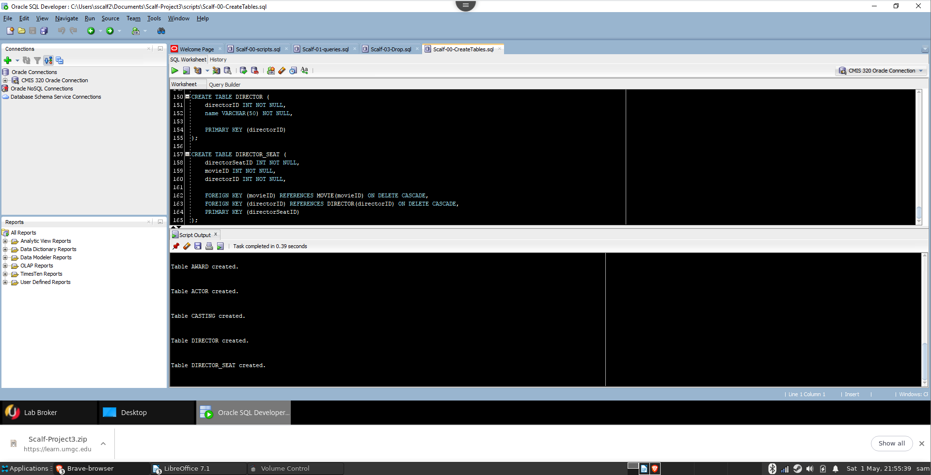
Inserting Data
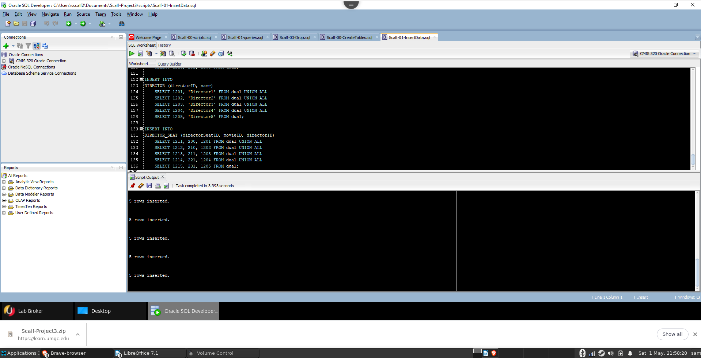
Running Queries
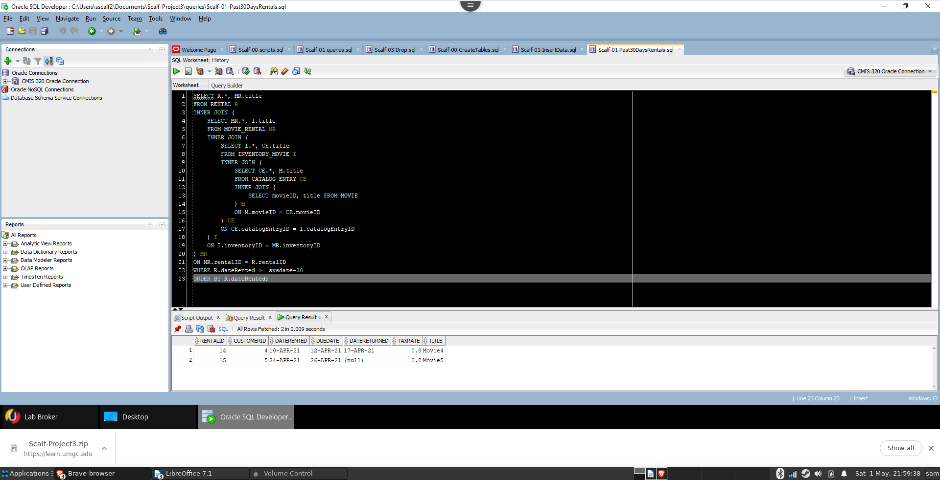
NOTE: The query results in this screenshot differ from the scalf-queries-output.txt because scalf-queries-output.txt was generated on 24 April 2021, three days before the due date, while this snapshot was generated on 01 MAY 2021 in response to a change to project requirements made on 29 APR 2021, two days after the due date.

