Name:____________________________
HOMEWORK #2 – Week 2

This homework is worth 10% of your course grade.

Read each problem carefully. Failure to follow the instructions for a problem will result in a zero score for that problem.

Submit the completed Homework via Assignment in LEO.

1. Construct a truth table for the Boolean equation:
M = A’B C’ + A’B C + A B’C + A B C

A | B | C | M
0 | 0 | 0
1 | 1 | 1

2. Draw a simple NOT, AND, OR circuit in sum of products (SOP) form that represents the equation above.

3. The truth table for a Boolean expression is shown below. Write the Boolean expression on SOP form

x | y | z | F
0 | 0 | 0 | 1
0 | 0 | 1 | 0
0 | 1 | 0 | 0
0 | 1 | 1 | 1
1 | 0 | 0 | 1
1 | 0 | 1 | 1
1 | 1 | 0 | 0
1 | 1 | 1 | 1
4. Find the truth table that describes the following circuit:

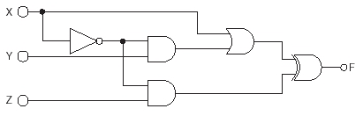

5. Describe the function of a decoder circuit;

identify the types and quantity of gates needed to implement a 3-to-8 decoder;

either create (or give the location in the text) of a logic diagram of a decoder circuit

