# Java Monkey Engine

## Installation Steps

1. Download installer.  
   Graphical user interface, text, application

   Description automatically generated
2. Run installer and click “Yes” to allow installation.
3. On the first window frame, click Next.  
   Graphical user interface, text, application

   Description automatically generated
4. Check the box for “I accept the terms in the license agreement” and click Next.  
   Graphical user interface, text, application, email

   Description automatically generated
5. Leave the install at its default location, uncheck any unwanted items, and click Next.  
   Graphical user interface, text, application, email

   Description automatically generated
6. For the Blender 3D Editor, uncheck any unwanted items, and click Next.  
   Graphical user interface, text, application

   Description automatically generated
7. Verify the information and click Install.  
   Graphical user interface, text, application

   Description automatically generated
8. Wait for the installation to finish.  
   Graphical user interface, text, application

   Description automatically generated  
   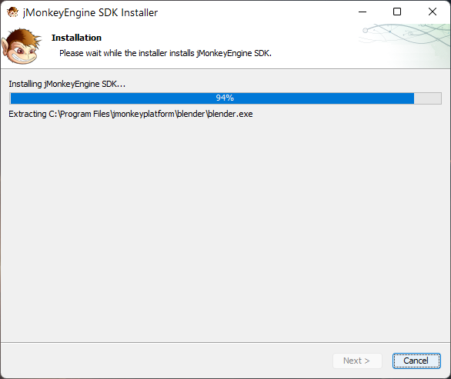
9. Click Finish to complete the installation.  
   Graphical user interface, text, application, email

   Description automatically generated

## Issues

I didn’t have any issues during the installation. Following the steps detailed above, the installer ran without error.

# Hello SimpleApplication

NOTE: Many of the steps below come directly from the jMonkeyEngine website (<https://wiki.jmonkeyengine.org/docs/3.3/tutorials/beginner/hello_simpleapplication.html>)

## Open the SDK

1. Click on the start menu item or double-click on the desktop icon to run.
2. Navigate to a folder for storing projects  
   Graphical user interface, text, application

   Description automatically generated
3. Click “Set Project Folder”.

## Create a project

1. Choose File > New Project from the main menu  
   Graphical user interface, text

   Description automatically generated
2. In the New Project wizard, select the template JME3 > Basic Game.  
   A screenshot of a computer

   Description automatically generated with medium confidence
3. Click [ Next ].
   1. Specify a project name, e.g. “HelloWorldTutorial”.
   2. Specify a path where to store your new project, e.g. a jMonkeyProjects directory in your home directory.  
      Graphical user interface, application

      Description automatically generated
4. Click [ Finish ].  
   Graphical user interface, text

   Description automatically generated

## Extend SimipleApplication

1. In the Source Packages node of your project, [ RMB ] select the “mygame” package.
   1. Choose: Refractor > Rename  
      A screenshot of a computer

      Description automatically generated with medium confidence
   2. Enter the New Name: jme3test.helloworld  
      Graphical user interface, text

      Description automatically generated
   3. Click [ Refactor ] when ready.  
      Graphical user interface, text

      Description automatically generated
2. In the newly refactored package, [ RMB ] select the Main.java class.
   1. Choose: Refactor > Rename  
      A screenshot of a computer

      Description automatically generated with medium confidence
   2. Enter the New Name: HelloJME3  
      Graphical user interface, text

      Description automatically generated
   3. Click [ Refactor ] when ready.  
      Graphical user interface, text, chat or text message

      Description automatically generated

## Code Sample

Replace the contents of the HelloJME3.java file with the code provided under “Code Sample” on the tutorial page (also in Appendix A): <https://wiki.jmonkeyengine.org/docs/3.3/tutorials/beginner/hello_simpleapplication.html#code-sample>

[ RMB ] select the HelloJME3 class and choose Run. If a jME3 settings dialog pops up, confirm the default settings.

Running the application:

# Appendix A: Code Sample

**package** jme3test.helloworld;

**import** com.jme3.app.SimpleApplication;

**import** com.jme3.material.Material;

**import** com.jme3.scene.Geometry;

**import** com.jme3.scene.shape.Box;

**import** com.jme3.math.ColorRGBA;

*/** Sample 1 - how to get started with the most simple JME 3 application.*

*\* Display a blue 3D cube and view from all sides by*

*\* moving the mouse and pressing the WASD keys. */*

**public** **class** **HelloJME3** **extends** **SimpleApplication** {

**public** **static** **void** **main**(String[] args){

HelloJME3 app = **new** HelloJME3();

app.start(); *// start the game*

}

**@Override**

**public** **void** **simpleInitApp**() {

Box b = **new** Box(1, 1, 1); *// create cube shape*

Geometry geom = **new** Geometry("Box", b); *// create cube geometry from the shape*

Material mat = **new** Material(assetManager,

"Common/MatDefs/Misc/Unshaded.j3md"); *// create a simple material*

mat.setColor("Color", ColorRGBA.Blue); *// set color of material to blue*

geom.setMaterial(mat); *// set the cube's material*

rootNode.attachChild(geom); *// make the cube appear in the scene*

}

}