**Project 1: Java 2D Graphics**

Samuel B. Scalf

School of Cybersecurity and Information Technology, University of Maryland Global Campus

CMSC 405: Computer Graphics

Dr. Cynthia V. Marcello

25 January 2022

Test Cases

**Table 1**

*Test Cases for the Manipulation of Graphics2D Objects*

|  |  |  |  |  |
| --- | --- | --- | --- | --- |
| Frame | Task | Expected Output | Actual Output | Pass/Fail |
| 1 | Translate -5 in x direction, translate +7 in the y direction | Images should move left 5 pixels and down 7 pixels | Images moved left 5 pixels and down 7 pixels | Pass |
| 2 | Rotate 45° counterclockwise | Images should pivot 45° counterclockwise about their upper-left corner | Images pivoted 45° counterclockwise about their upper-left corner | Pass |
| 3 | Rotate 90° clockwise | Images should pivot 90° clockwise about their upper-left corner | Images pivoted 90° clockwise about their upper-left corner | Pass |
| 4 | Scale 2 times for the x component, scale 0.5 times for the y component | Images should stretch to double their width and shrink to half their height | Images stretch to double their width and shrink to half their height | Pass |
| 0/5 | Reset to start | All images should return to their original state | Images returned to their original state | Pass |

*Note*. The task in each row of this table is compounding. For example, the task for Frame 3, “Rotate 90° clockwise” is performed on images that have had the tasks for both frames 1 and 2 applied previously. The task for Frame 4 would then be applied to images after the task for Frame 3 was applied: this fulfills project requirement 3.e.

Source Code

The source code for this project contains four Java classes: CMSC405P1, CMSC405P1Frame, CMSC405P1Panel, and PixelImage. CMSC405P1 contains the main method of the program and is responsible for instantiating and starting the program. CMSC405P1Frame specifically handles the window of the program and contains one instance of CMSC405P1Panel. CMSC405P1Panel handles the painting of images, as well as the transformations done to those same images; both CMSC405P1 and CMSC405P1Frame are unaware of these actions. PixelImage is an enum rather than a class. Pixel image maps stored as 2D integer arrays can be specifically referenced by a human-readable, meaningful name.

Screen Captures

In order to capture frames easier, a breakpoint was placed at Line 36 of the CMSC405P1Panel class, which is the first statement of the overridden paintComponent(Graphics g) method. When the debugger was run within the Eclipse IDE, the program paused before displaying any graphics. Upon clicking resume, the first graphics, or Frame 0, was displayed. Each successive click of resume would advance the program through the next “frame” and pause. Upon saving screen captures all frames, the program was closed, and the breakpoint removed.

Each of the screen captures contain the full window of the running Java program. The screen captures also contain the console output from the Eclipse IDE. This was done to demonstrate the screen captures were taken in succession as part of the whole program, not individually crafted displays. These screen captures were also used as the actual output of the program for the test cases. Each screen shot corresponds with one frame, which, in turn, meets one project requirement: Figure 2, Frame 1, meets project requirement 3.a.; Figure 3, Frame 2, meets project requirement 3.b.; Figure 4, Frame 3, meets project requirement 3.c.; and Figure 5, Frame 4, meets project requirement 3.d.

**Figure 1**

*Screen Capture of Frame 0: The Default Configuration*

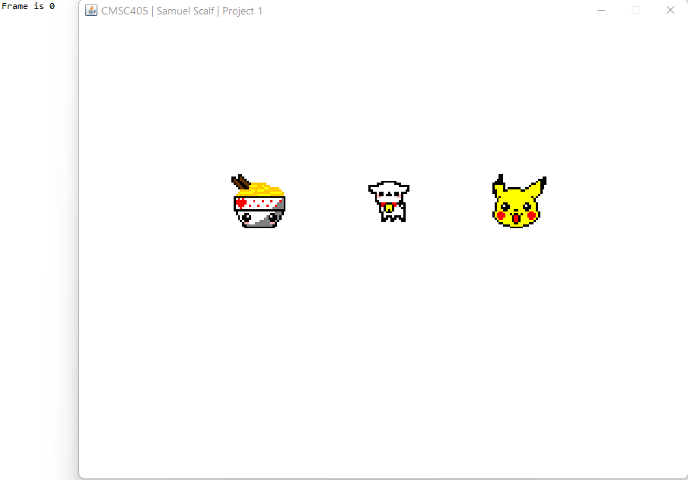

**Figure 2**

*Screen Capture of Frame 1: Translate -5 in x Direction and 7 in y Direction*

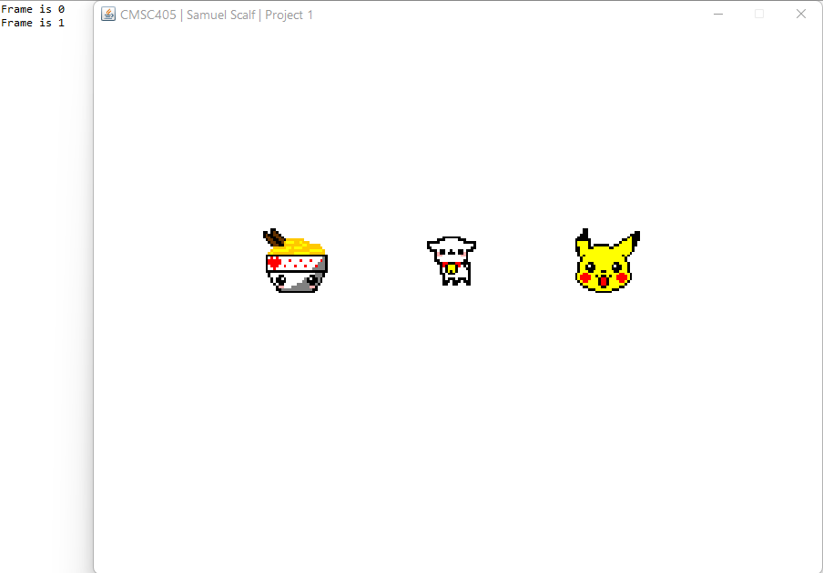

**Figure 3**

*Screen Capture of Frame 2: Rotate 45° Counterclockwise*

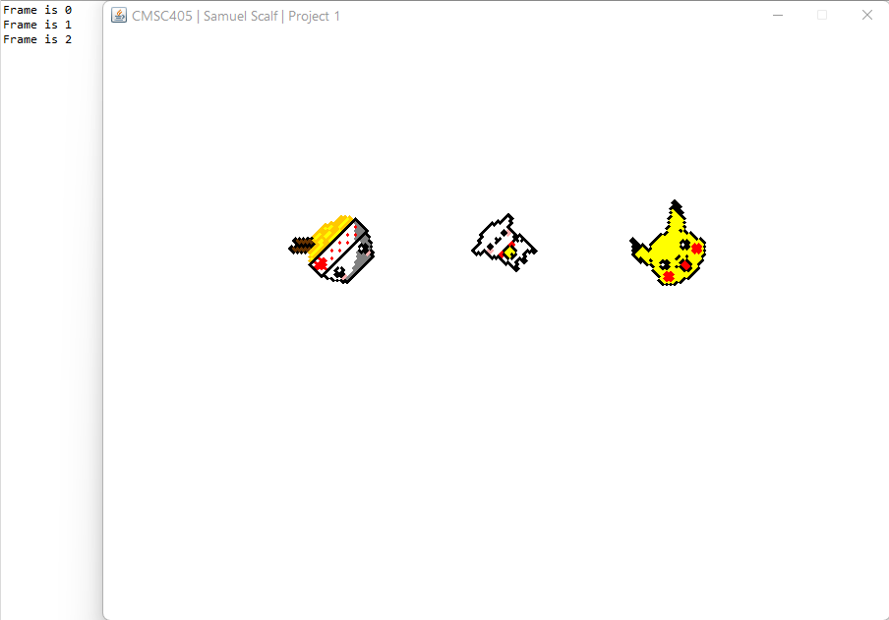

**Figure 4**

*Screen Capture of Frame 3: Rotate 90° Clockwise*

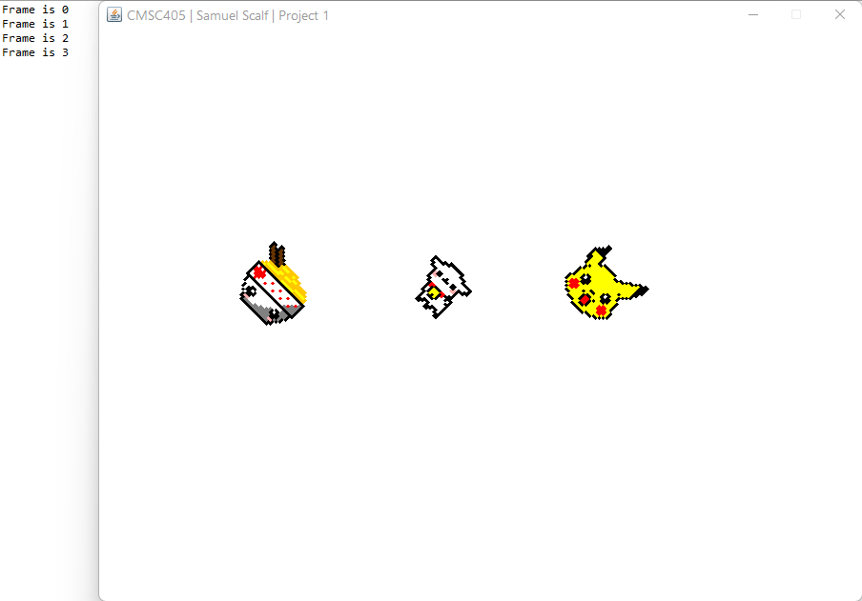

**Figure 5**

*Screen Capture of Frame 4: Stretch 2 in x Direction and 0.5 in y Direction*

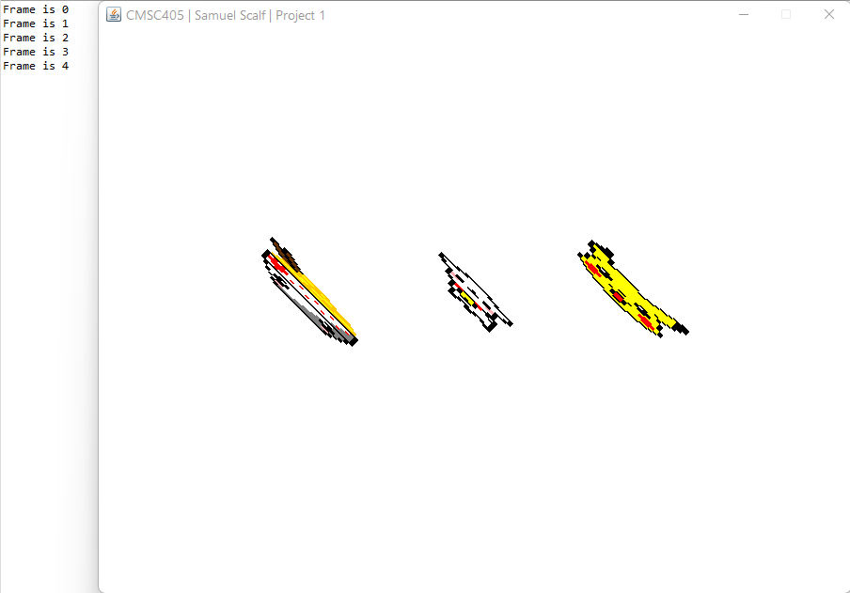

**Figure 6**

*Screen Capture of Frame 5: Cycle Back to Frame 0*

