**Project 3: Three.js Project**

Samuel B. Scalf

School of Cybersecurity and Information Technology, University of Maryland Global Campus

CMSC 405: Computer Graphics

Dr. Cynthia V. Marcello

22 February 2022

Test Cases

**Table 1**

*Test Cases for JOGL transformations*

|  |  |  |  |  |
| --- | --- | --- | --- | --- |
| Control | Function | Expected Output | Actual Output | Pass/Fail |
| Light1 checkbox | Toggles Light1 | Light1 should toggle on/off | Light1 toggles on/off | Pass |
| Light2 checkbox | Toggles Light2 | Light2 should toggle on/off | Light2 toggles on/off | Pass |
| Light1 Color | Change color of Light1 | When Green is selected, Light1 should be green | When Green is selected, Light1 is green | Pass |
| Light2 Color | Change color of Light2 | When Red is selected, Light2 should be red | When Red is selected, Light2 is red | Pass |
| Light1 Intensity | Change the intensity of Light1 | The intensity of Light1 should change with the slider | The intensity of Light1 changes with the slider | Pass |
| Light2 Intensity | Change the intensity of Light2 | The intensity of Light2 should change with the slider | The intensity of Light2 changes with the slider | Pass |

*Note*. The effects of the controls are permanent, except in the case of a page refresh. As such, a refresh is done between each screen capture to isolate the effects of the function in question. The only exception being checks for one light were done with the other light turned off.

Source Code

The source code for this project contains three JavaScript files and one HTML file: OrbitControls.js, three.min.js, scalf-homework3.js, and scalf-homework3.html. OrbitControls.js and three.min.js are provided by Threejs.org. Three.min.js is a minified version of three.js, a JavaScript 3D library. OrbitControls.js provides mouse click controls for manipulating the view of the 3D scene. The scalf-homework3.html file provides the webpage that displays the controls and 3D scene. Finally, scalf-homework3.js contains the JavaScript logic for building and updating the 3D scene.

Screen Captures

I did not capture any screen captures for the OrbitControls.js functions as they were not created by me; they were included for ease of “looking around.” I have captured no more than three screen captures for each of the HTML form controls despite having more than two settings. The screen captures cover turning lights off, changing the lights’ colors, and changing the lights’ intensities. Since the lights are on by default, I’ve only included a screen capture of the lights turning off. Please keep in mind that the scene will not be completely dark due to a minor ambient light being used. Furthermore, to better display the effect of a control on one light, the other light was turned off. Finally, the rotateScene() method call within my update() method was commented out so all screen captures were from the exact same angle.

**Figure 1**

*Screen Capture of Default Configuration*

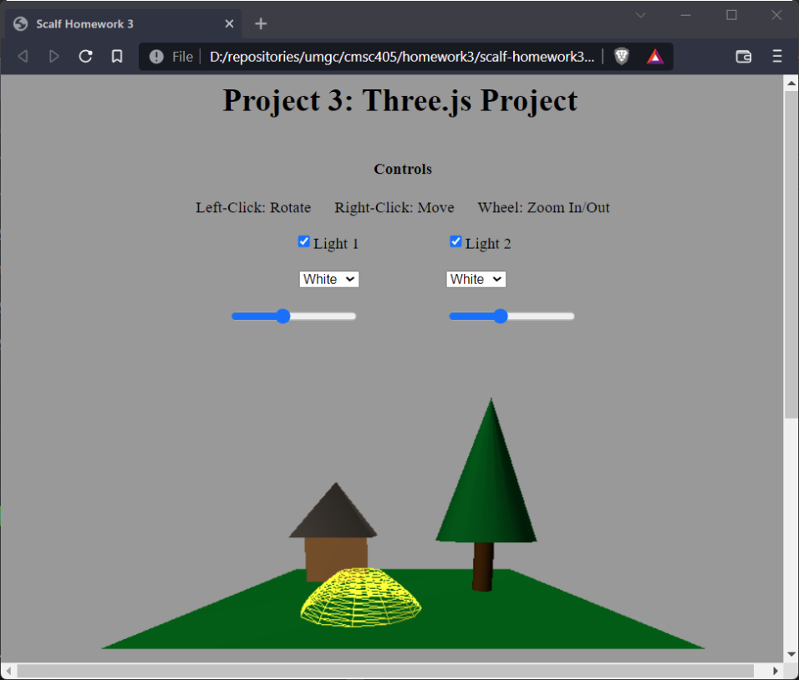

**Figure 2**

*Screen Capture of Light 1 Turned Off*

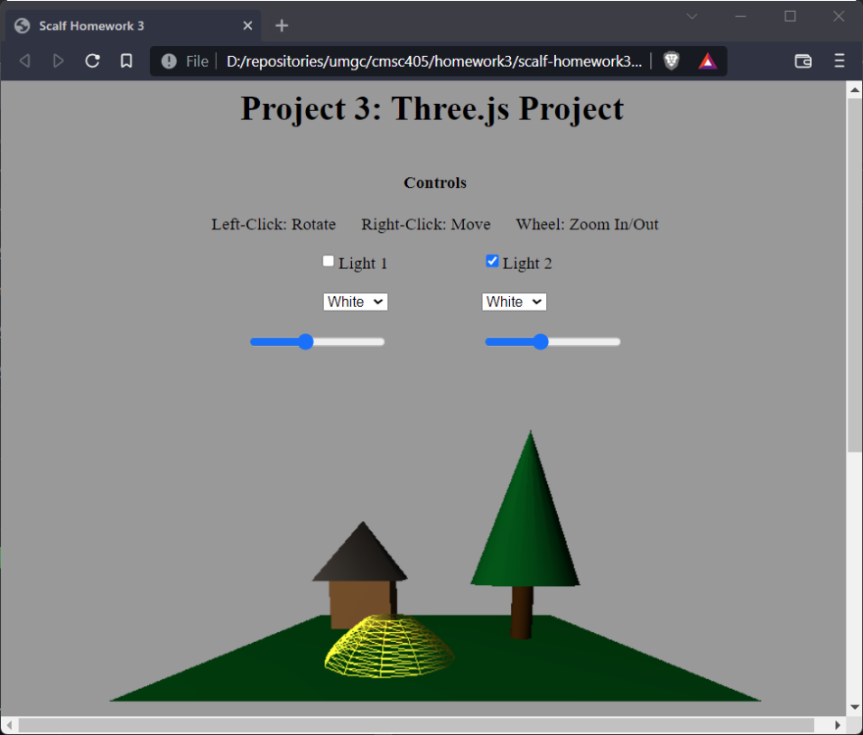

**Figure 3**

*Screen Capture of Light 2 Turned Off*

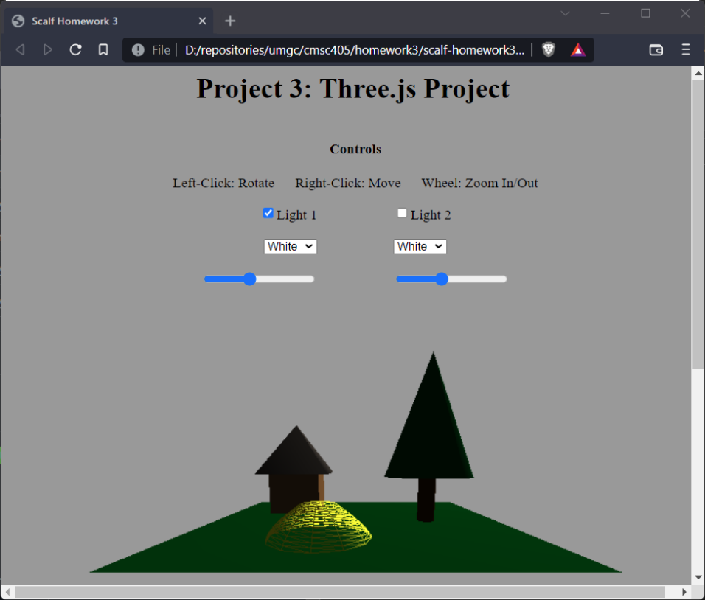

**Figure 4**

*Screen Capture of Both Lights Turned Off*

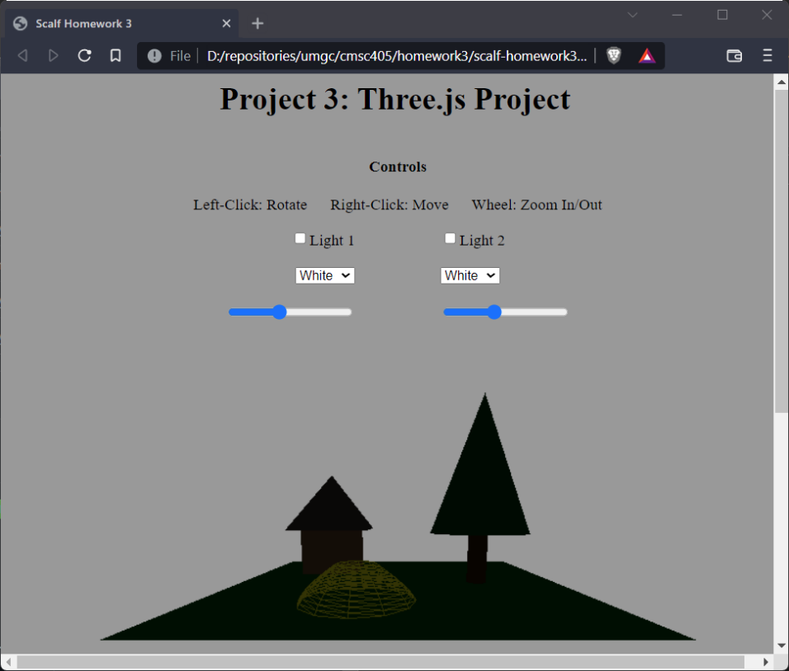

**Figure 5**

*Screen Capture of Light 1 Set to Green*

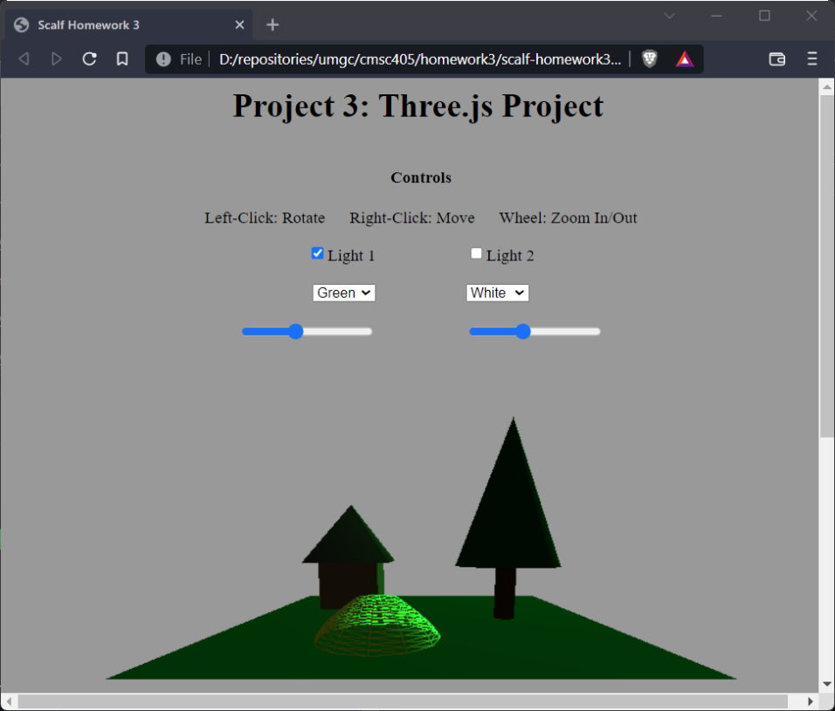

**Figure 6**

*Screen Capture of Light 2 Set to Red*

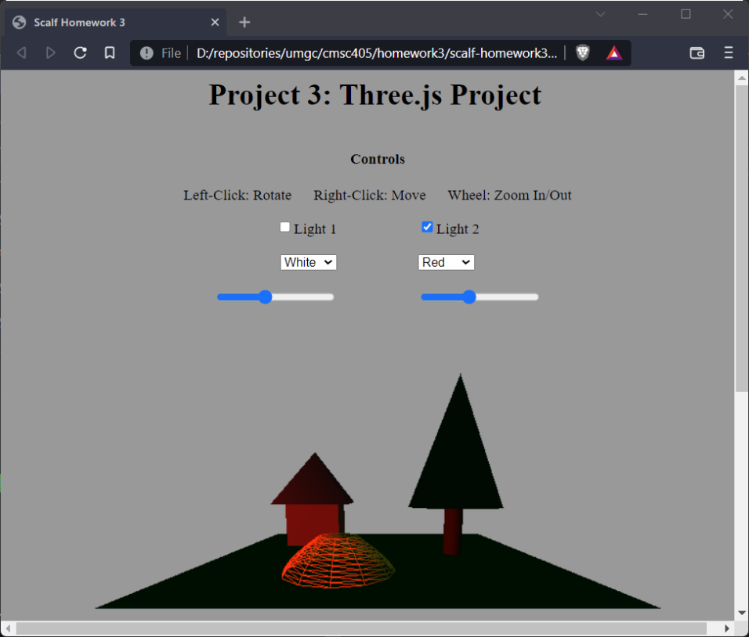

**Figure 7**

*Screen Capture of Light 1 Set to High Intensity*

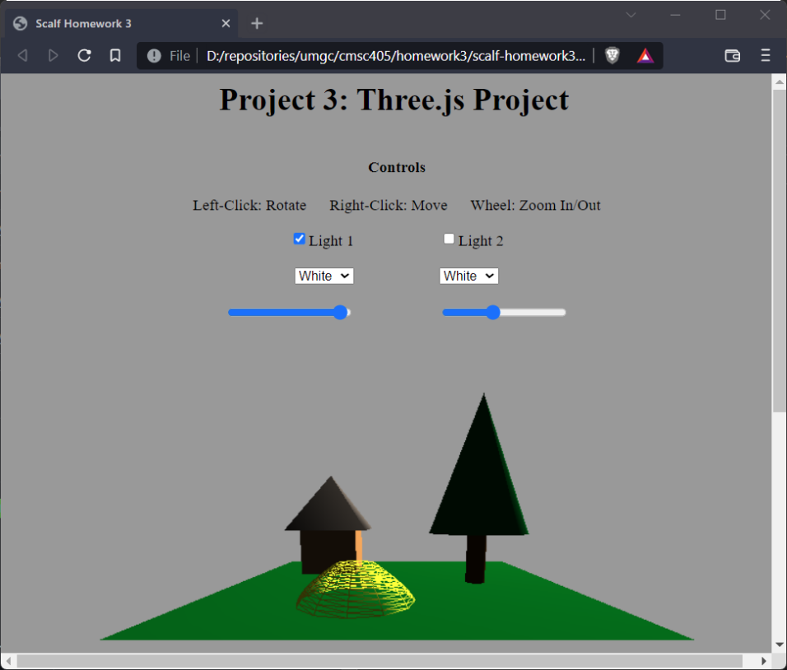

**Figure 8**

*Screen Capture of Light 1 Set to Low Intensity*

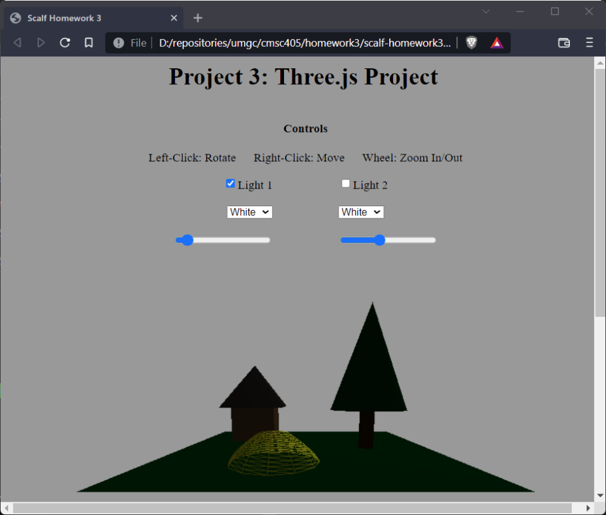

**Figure 9**

*Screen Capture of Light 2 Set to High Intensity*

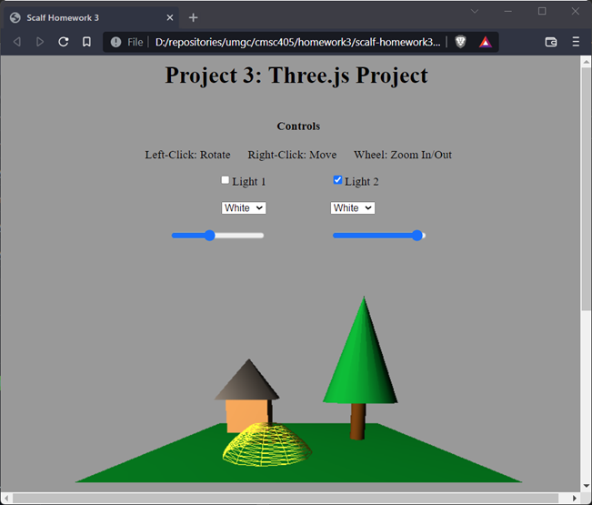

**Figure 10**

*Screen Capture of Light 2 Set to Low Intensity*

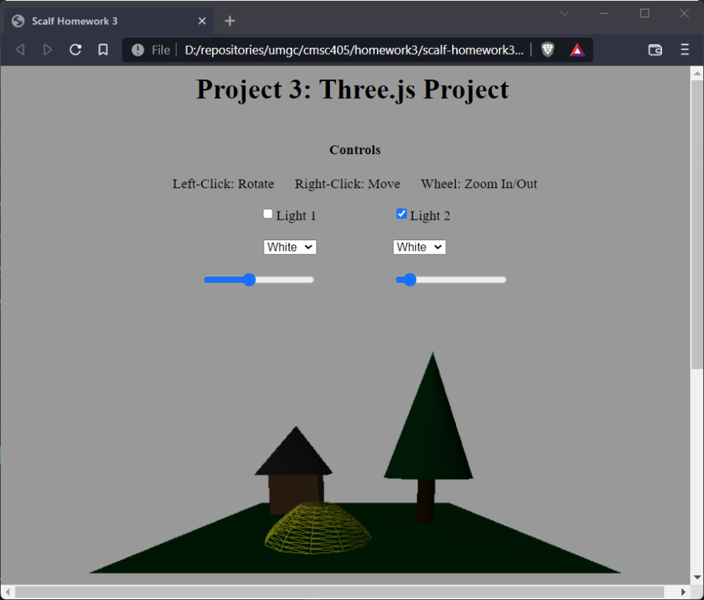

**Figure 11**

*Screen Capture of Mixed Color Lights at High Intensity*

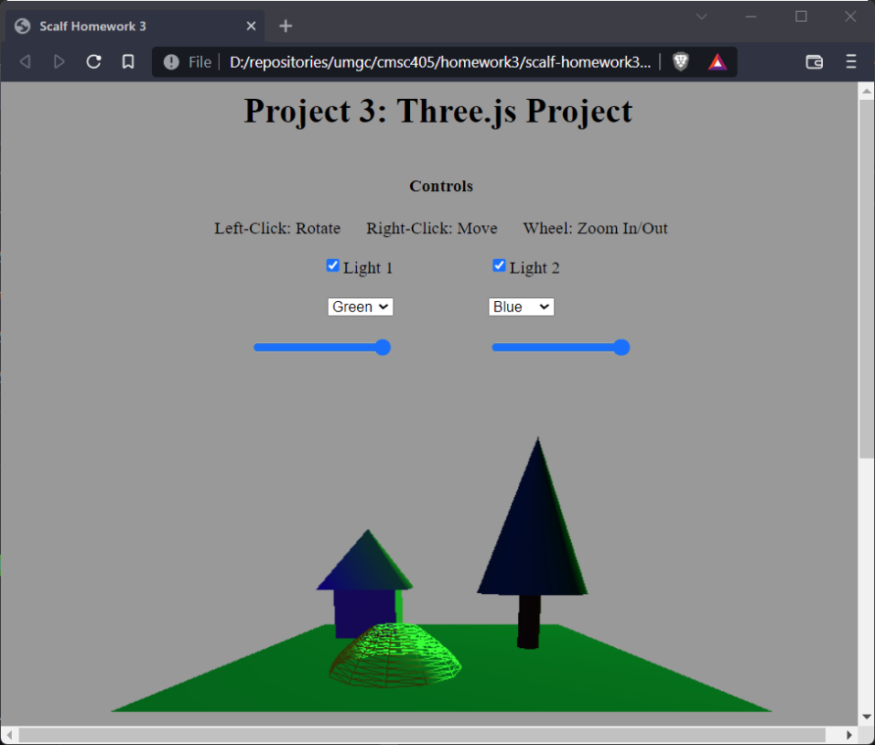

**Figure 12**

*Screen Capture of “Black” Lights*

