TEST PLAN
MILESTONE 2
Just Parry
Team A++ :: Group 25
- Armaan Sawhney , 44616670
- Nic Ung, 67524991
- Roy Tao, 17267535
- Siddh Patel, 24495285
- Shaun Gao, 74620345
- Jenny Zeng, 48191399

Test Environments
- Platform: PC (Windows/Mac/Linux)
- Game Mode: Player VS Player / Bot

Controls
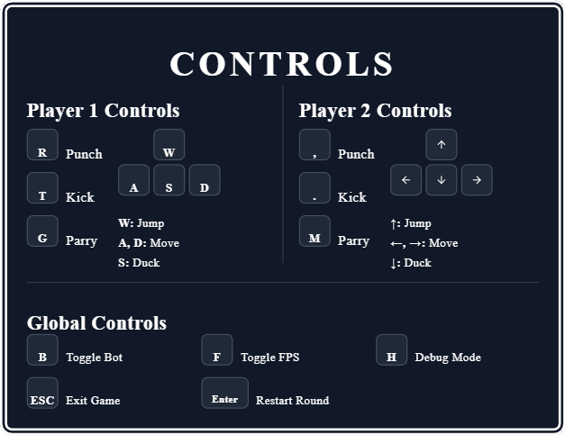

Test Cases
1.1 Game Initialization
- Action: Launch the game.
- Expected: Game window (1024x786) opens, menu background is displayed with team member names and game name, along with buttons START, HELP, and SETTINGS.
1.2 Help Menu
- Action: Click on HELP in the main menu..
- Expected: A pop up menu opens and shows all the controls of the game. There is a close button on the top right, which when clicked, closes the pop-up.
1.2 Settings Menu
- Action: Click on SETTINGS in the main menu.
- Expected: A pop up menu opens and shows a blue image, as this is to be implemented. There is a close button on the top right, which when clicked, closes the pop-up.
1.3 Game Start
- Action: Click on Start in the main menu.
- Expected: Game 1 loads with 2 players entering the screen from the sides. The timer starts down from 99. Entities like floor and player healths are visible.
1.4 FPS Toggle
- Action: After clicking start, press F.
- Expected: An fps indicator of green color appears in the top left, showing the current fps. Can be toggled on/off with F.
1.5 Debug mode Toggle
- Action: Toggle debug mode with H.
- Expected: When in debug mode, the stage boundaries, along with the hitboxes and hurtboxes of both players are drawn to debug collisions.
1.6 Bot Toggle
- Action: Toggle bot and disable P2 controls with B
- Expected: When toggled, the bot performs randomized moves based on player 1’s current state and distance.
1.7 Stage Boundary Collisions and Parallax
- Action: Move Player 1 to stage edges (A/D).
- Expected: Player 1 stops at stage boundaries and stays on the screen. There are no floor exits when a player jumps with W.
1.8 Jump over another player
- Action: Run towards P2 and jump with W while holding down the key corresponding to the direction towards P2 over it.
- Expected: Player 1 is able to jump over p2, and both players turn around and are facing each other.
1.9 Player 1’s Punch Reduces Player 2’s Health
- Action: Approach and punch p2 with R, ensuring hitbox collides with P2.
- Expected: P2’s health decreases by 10 when hit.
2.0 Player parry
- Action: When fighting the other player, press G to parry.
- Expected: If successful parry, the other player gets stunned and turns blue.
2.1 Round Win Condition
- Action: Deplete P2’s health to 0 by hitting with R or T.
- Expected: "Player 1 Wins" animation screen is displayed, and pressing enter restarts the game. Pressing ESC exits the game, and resources are cleared. P1’s score gets incremented by 1.
2.2 Round End Condition (Timer)
- Action: Wait until the timer reaches 0.
- Expected: Round ends when timer hits 0, round end animation screen is displayed, and pressing enter starts the next round. ESC exits, resources cleared.
2.3 Round End Animations
- Action: The following cases, Timer runs out with P1 Health == P2 Health, Timer runs out with P1 Health > P2, Timer runs out with P2 Health > P1, P1 Health hits 0, P2 Health hits 0
- Expected: In the same order for cases: Tie animation neither score is incremented, P1 Win animation and P1 score increments, P2 Win animation and P2 score increments, P2 Win animation and P2 score increments, P1 Win animation and P1 score increments

