Use the “File”, “Export” from Waveforms and select Logic Analyzer as shown below:

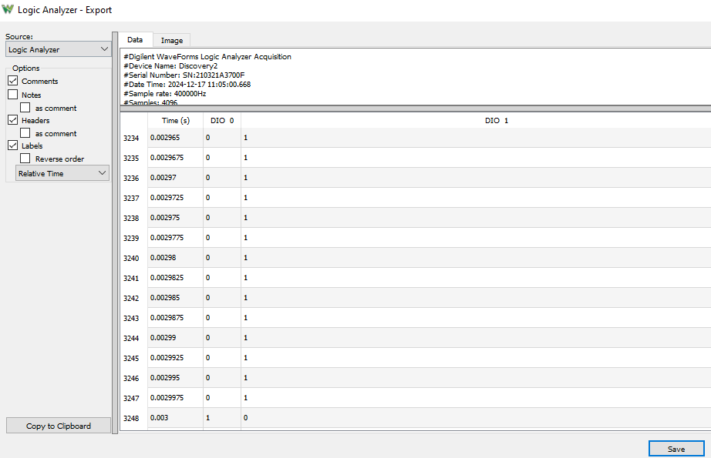

<https://forum.digilent.com/topic/18919-continuous-data-logging-from-logic-analyzer-on-waveforms-2/>

The Logic Analyzer has multiple operation modes:  
- Repeated: Oscilloscope like operation, intended to analyze signal timing or short protocol captures  
- Scan Screen/Shift: for monitoring slow signals continuously  
- Record: to capture large amount of data  
- Sync: allows recording samples synchronized with the chosen clock and enable signals

The Analog Discovery has 4/16k sample device buffer for Repeated or Scan captures, at up to 100MHz. For 16k buffer select the 4th device configuration under Settings/Device Manager.  
In Record/Sync mode this is used as buffer and data stream to host over USB, limiting the rate to about 1Msps. The buffer overflow is indicated by "samples lost/could be lost message".  
The data compression option for Record lets you capture higher rate signals, like high speed burst with idle portions.

The Digital Discovery has 2Gb 'buffer', which lets you Record:  
- 256M samples from 8 channels at up to 800MHz  
- 128M samples from 16 channels at up to 400Mhz  
- 64M samples from 32 at up to 200MHz

You can find "Raw Data" option under File/Export and View/Logging/ Source.