**Important Notes**

**The user will need to log back into all web apps:**

**While Clearing Browser Cache Remember**:

* When we ask the user to clear all local Cookies and Cache it will affect their other web-based tools and applications. If the end user has configured a browser to automatically authenticate and log into Gmail, Facebook, and Amazon, iTunes, clearing all cookies and cache results in their need to log into those applications again.
* As good testing practice to close all apps; YouTube, Amazon Music, iTunes etc. While troubleshooting you eliminate as many unneeded elements involved. Including any non-web-based apps that they would normally have open, such as Visual Studio or Visual Studio Code.
* Explain this is for troubleshooting purposes. They have a problem and we are trying to eliminate possible reasons.
* I have never found it to be beneficial to step up to clearing all items. If the cookies failed, just wipe everything out. You could easily waste an extra hour or two of time trying every selectable item in the cache clear window. By the time we are asking a student to try this they are frustrated. Let’s get them working quickly.
* When we press the Control and F5 key combinations on a browser that does NOT clear cache. All it does is reload the existing web pages. (CTL-F5) ~ Does NOT clear cache.

**STEPS:**

**Cookies** **First**

* Open the browser window and select that to be the active window.
* Press the ***Control-Shift-Delete*** this should enable the user to clear cache.
* This control combination should open a browser-based dialog box that enables you to select options to clear.
* Each browser may be slightly different, and the student should read before the next step.
* Select the ‘Cookies’ options first and last 24 Hours
* CLOSE the browser before re-logging in to the LMS
* Ask the student to NOT restart any other web-based applications before they re-start the LMS.
* Ask the student to try authentication again.
* NOTE!!! I did NOT say, Control-**ALT{key}**-Delete)

Chrome Basic View:

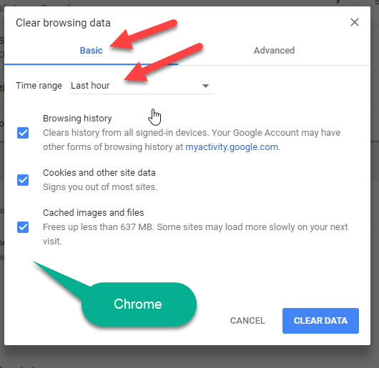

**Clear everything**

* As before CTL ~ Shift ~ Delete to open the window to clear browser cache.
* This time set the time window to be ‘All Time’ or in FF “Everything”
* As in Chrome you may need to scroll down to select everything listed.
* After cleared, close the browser window.
* As before do not restart any other web-based applications before they re-start the LMS.
* Re-open the browser and retry the issue.

Chrome Advanced or clear all View:

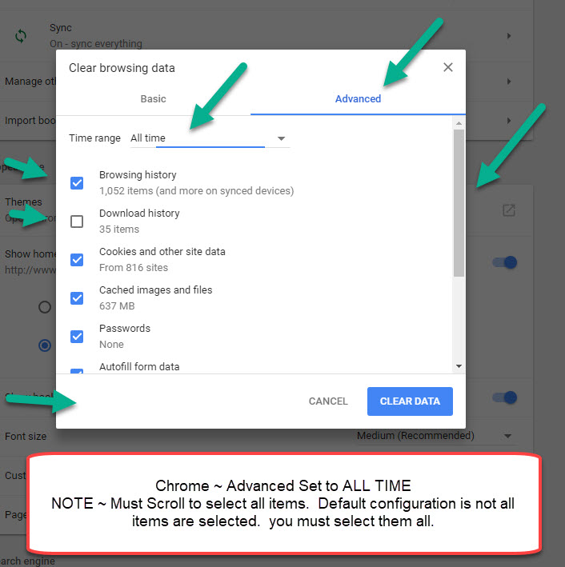

If the student is still having troubles with authentication there may be another issue.