**Important Notes**

We are expecting the student to be running absolutely nothing else while we are troubleshooting issues. As good testing practice to close all apps; YouTube, Amazon Music, iTunes etc.

When we press the Control and F5 key combinations on a browser that does NOT clear cache. All it does is reload the existing web pages.

**HOW TO**

**Clearing Browser Cache**:

* When we ask the student to clear their local Cookies and Cache it will affect their other web-based tools and applications.
* This means when they have configured a browser to automatically authenticate and log into Gmail, Facebook, and Amazon, iTunes, clearing all cookies and cache results in their need to log into those applications again.
* We want to clear minimum items at first but prepare the student. Best to explain this is for troubleshooting purposes.
* I have never found it to be beneficial to step up to clearing all items. If the cookies failed, just wipe everything out. You could easily waste an extra hour or two of time trying every selectable item in the cache clear window. By the time we are asking a student to try this they are frustrated. Let’s get them working quickly.

**STEPS**

JUST cookies First

* Touch the ***Control-Shift-Delete*** this should enable the user to clear cache.
* NOTE!!! I did NOT say, Control-**ALT{key}**-Delete)
* This control combination should open a browser-based dialog box that enables you to select options to clear.
* Each browser may be slightly different, and the student should read before the next step.
* Select the ‘Cookies’ options first and last 24 Hours
* CLOSE the browser before re-logging in to the LMS
* Ask the student to NOT restart any other web-based applications before they re-start the LMS.

Next Step Clear everything

* As before CTL ~ Shift ~ Delete to open the window to clear browser cache.
* This time set the time window to be ‘All Time’ or in FF “Everything”
* As in Chrome you may need to scroll down to select everything listed.
* After cleared, close the browser window.
* As before do not restart any other web-based applications before they re-start the LMS.
* Re-open the browser and retry the issue.

Chrome Basic View:

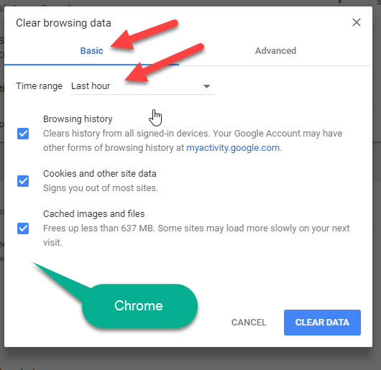

Chrome Advanced or clear all View:

