**HOW TO CONFIGURE AND USE JIRA QUERY LANGUAGE**

JIRA has built in a query language they call JQL. All we are going to do today is show you how to get to a collection of prebuilt queries and how to create one of your own.   
  
All the nuances of how to use JQL can be found on line. Yet, the initial how to find out where the queries are can be a little vague. This is how to create a query. Images are listed in the text incase they get out of order but will be done inline with this set of instructions.

1. Where are the JIRA Queries, and how do I get to them?

* This is what JIRA looks like when you first open it, (img=OpenPage.jpg) After you hit the opening page then you click on the link called ‘Issues and filters’ it’s identified in the open page image and the result is shown in the QueryList Image.

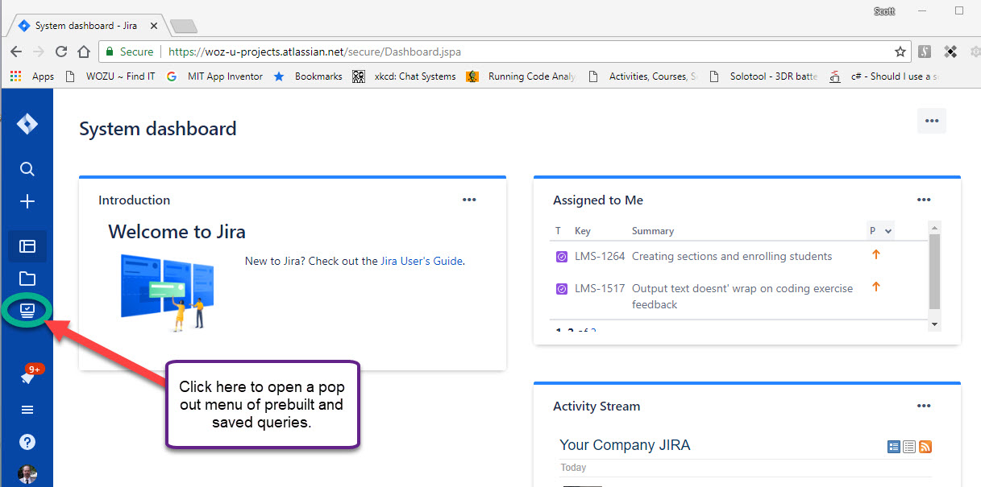

* Then we have the list of Filters / Queries / Searches ~ What ever you want to refer to these as. I’ll refer to this process as a JQL Query from now on.

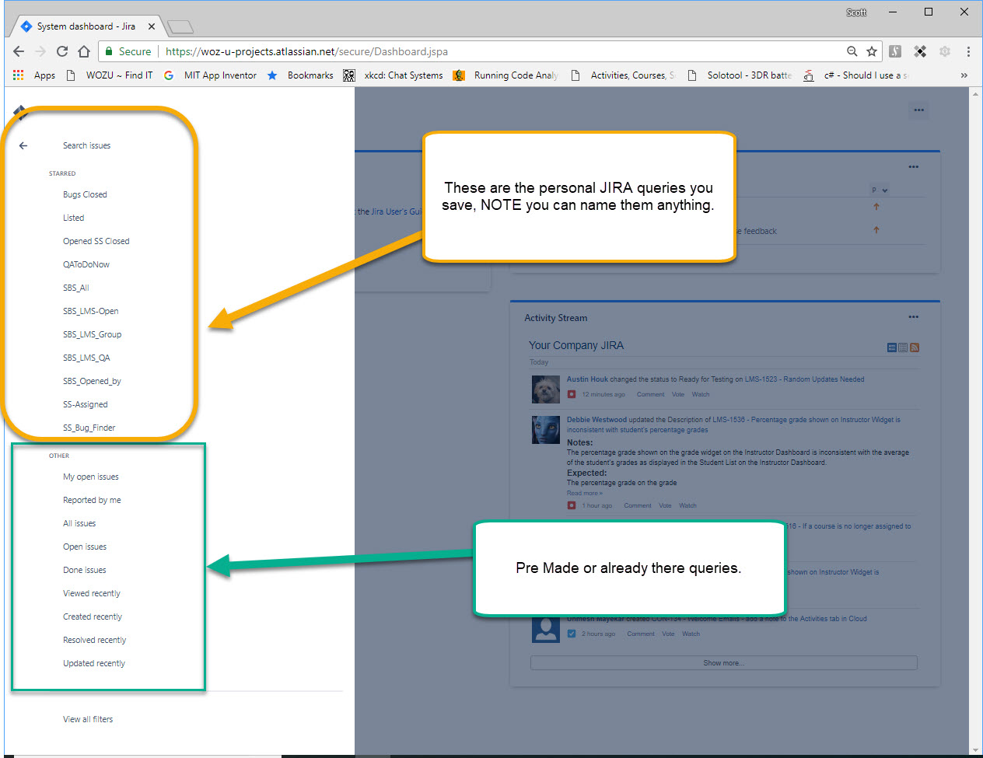

* If you have never saved a query, then you will only probably see the links in the green box. Let’s open one of those links and start there. I am going to select the link titled, “Reported By Me”. Most of the combinations are easy to decipher but this is a great one to start with. If you ever made a JIRA ticket it will probably return results.
* Click on it and you will see something like the screen below. Let’s make a couple of notes before we edit anything on this page.
  + One, you cannot screw this up! The canned query is going to be something that your JIRA account can’t overwrite. So dig in.
  + Some of the query items are going to be very specific, but this one uses a variable item ‘currentUser()’ That format can be used in your own queries.
  + Over write all of the text in the box I have highlighted in YELLOW with the text below.
  + This image is called FirstQuery.JPG
* reporter = collin.clark order by created DESC
* That will list all the Bugs, or issues created by Collin.
* It can’t be saved as, “Reported By Me” because that’s a canned query, so save it as “OpenedBy Others” and you can edit it in the future.

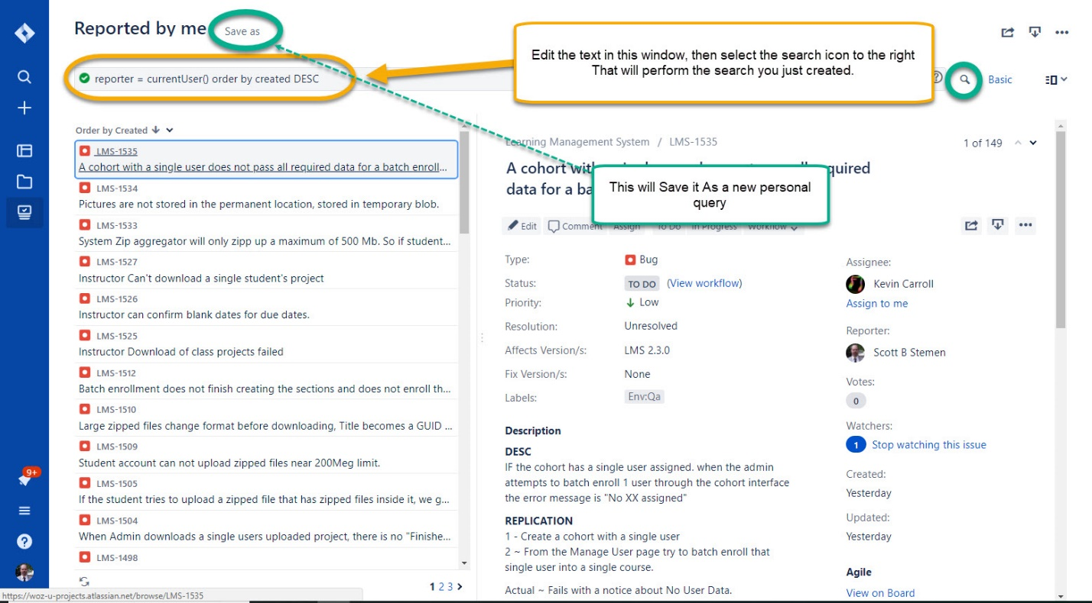

* Now go back to the open JIRA page, you should then be able to select / click on the query Icon I pointed out in the first image. When you do there should be a new query in the top section that is now called “OpenedBy” because that is the name you gave it.
* You now know how to open, create, and save your own query filters.

**LIST OF COMMON QUERIES USED AND SAVED**

* **BUGs** opened no matter who opened them, and look for a status.
  + **type = bug AND status in ("In Progress", "Ready for Testing", "To Do") ORDER BY key DESC**
* **Opened By ME**, is it being worked on by a Developer, or ready for me to test.
  + **status in ("In Progress", "Ready for Testing", "To Do") AND reporter in (scott.stemen) ORDER BY Key DESC**
* **Ready for QA** to work on.
  + **type in (Bug, Task, Story, "QA task") AND status in ("Ready for Testing") ORDER BY key DESC**
* **CLOSED** bugs, Tasks, QA Tasks. THIS is where to start looking for items that need to be regression tested. Anything this returns as a result would be something we want to check because it’s limited to this sprint.
  + **type in (Bug, "QA Task", Task) AND project = LMS AND Sprint = 91 AND status in (Done, Closed, Canceled) ORDER BY created DESC**
* Added to the Query above is the assignee’s name. This is where we cross train on new issues you haven’t seen before. Exchange your name C or B for the one listed ~ I put in Austin so there would be items in this query. YOU will need to change it and save it in your personal JIRA location. This will show what you worked on.
  + **type in (Bug, "QA Task", Task) AND project = LMS AND Sprint = 91 AND status in (Done, Closed, Canceled) AND assignee = austin.houk ORDER BY created DESC**
* **INVERSE** ~ What you didn’t touch! This will be a bigger list. Change the operator from **‘=’** to **‘!=’**
  + **type in (Bug, "QA Task", Task) AND project = LMS AND Sprint = 91 AND status in (Done, Closed, Canceled) AND assignee != austin.houk ORDER BY created DESC**
* **BRENAN**
  + **type in (Bug, "QA Task", Task) AND project = LMS AND Sprint = 91 AND status in (Done, Closed, Canceled) AND assignee != brenan.mayhew ORDER BY created DESC**
* **COLLIN**
  + **type in (Bug, "QA Task", Task) AND project = LMS AND Sprint = 91 AND status in (Done, Closed, Canceled) AND assignee != collin.clark ORDER BY created DESC**