# -*- coding: utf-8 -*-

"""

Created on Thu Jun 28 16:51:21 2018

@author: shubham b thorat

"""

# importing the libraries

"""

university ranking prediction

"""

import pandas as pd

import matplotlib.pyplot as plt

import numpy as np

# importing the data set

dataset=pd.read_csv('university_ranking.csv')

X = dataset.iloc[:,1:13].values

Y = dataset.iloc[:,0].values

# taking care of missing data

from sklearn.preprocessing import Imputer

imputer = Imputer(missing_values="NaN", strategy="mean",axis=0)

imputer = imputer.fit(X[:,2:13], y=None)

X[:,2:14] = imputer.transform(X[:,2:14])

# handling categorical (encoding) data

from sklearn.preprocessing import LabelEncoder

label_encoder_X = LabelEncoder()

label_encoder_Y = LabelEncoder()

X[:,0] = label_encoder_X.fit_transform(X[:,0])

X[:,1] = label_encoder_X.fit_transform(X[:,1])

#onehotencoder = OneHotEncoder(categorical_features= [0])

#onehotencoder = OneHotEncoder(categorical_features= [1])

#X = onehotencoder.fit_transform(X).toarray()

# dividing dataset into test and training dataset

from sklearn.model_selection import train_test_split

X_train, X_test, Y_train, Y_test = train_test_split(X,Y, test_size = .3, random_state = 0)

# feature scaling

from sklearn.preprocessing import StandardScaler

sc_X = StandardScaler()

X_train = sc_X.fit_transform(X_train)

X_test = sc_X.fit_transform(X_test)

from sklearn.linear_model import LinearRegression

regressor = LinearRegression()

regressor.fit(X_train,Y_train)

#predicting the test set result

y_pred = regressor.predict(X_test)

“””

Y_test =

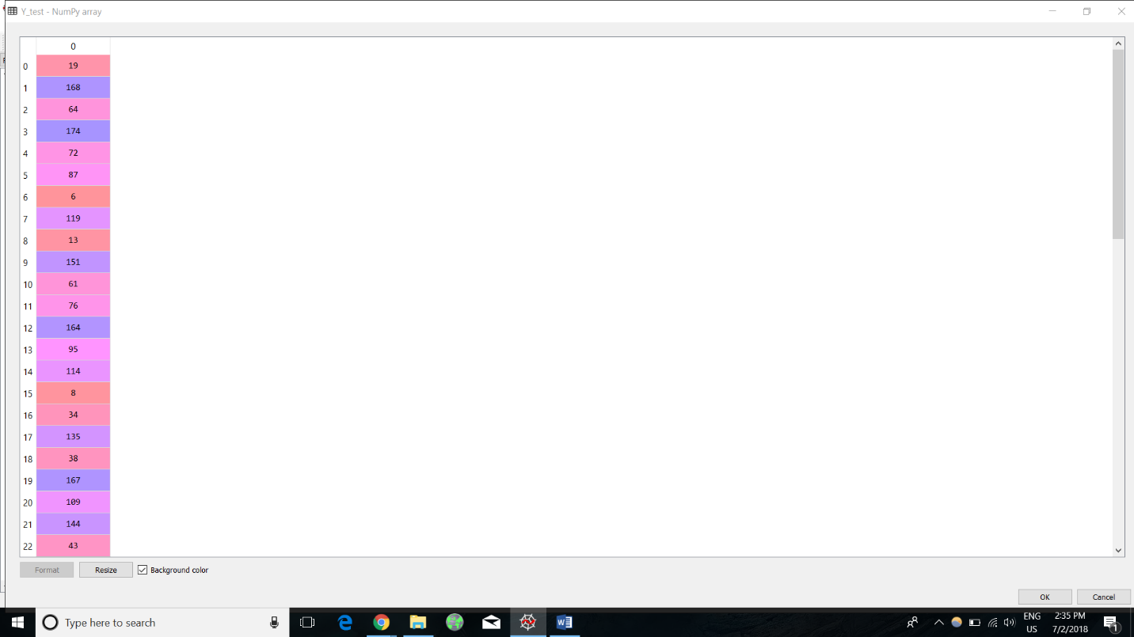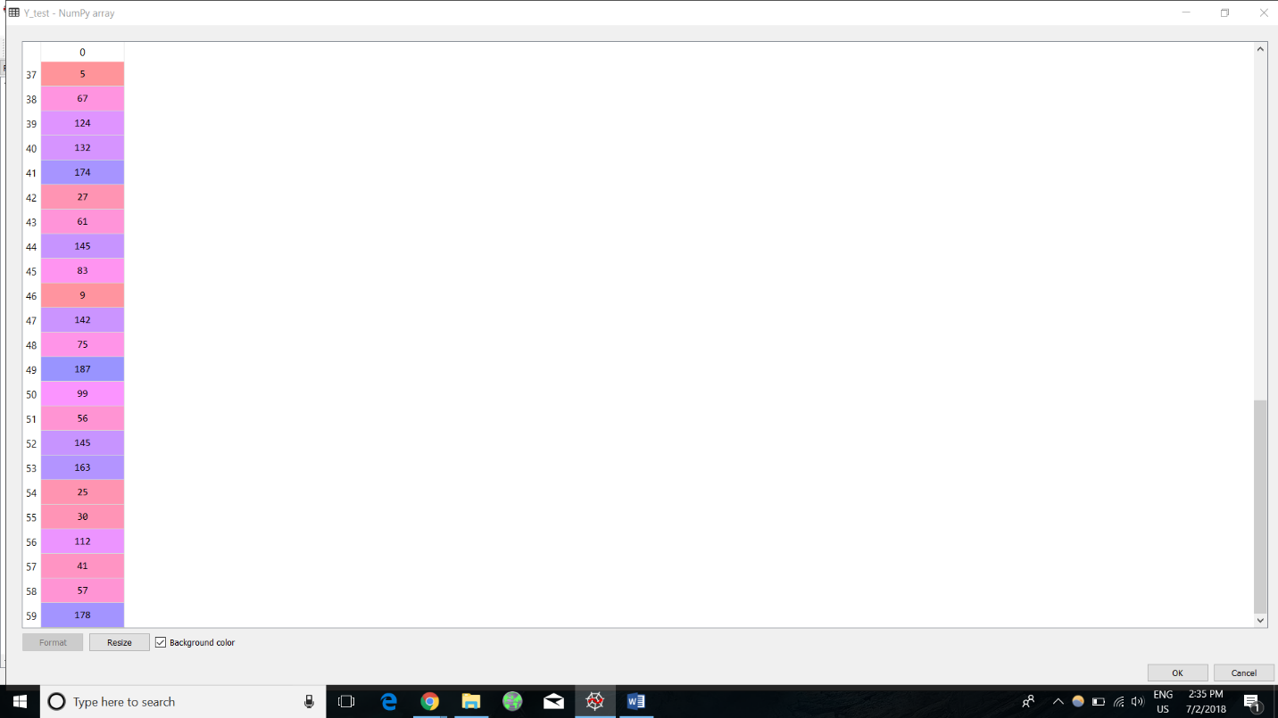

Y_pred =



