# -*- coding: utf-8 -*-

"""

Created on Mon Jul 2 15:27:32 2018

@author: shubham b thorat

"""

# -*- coding: utf-8 -*-

"""

Created on Thu Jun 28 16:51:21 2018

Indian-Institutes_ranking

@author: shubham b thorat

"""

# importing the libraries

import pandas as pd

import matplotlib.pyplot as plt

import numpy as np

# importing the data set

dataset=pd.read_csv('Indian_college_ranking.csv', sep = "\t")

dataset2=pd.read_csv('VIT_data.csv')

X = dataset.iloc[:,1:5].values

Y = dataset.iloc[:,0].values

X_VIT = dataset2.iloc[:,1:5].values

# dividing dataset into test and training dataset

from sklearn.model_selection import train_test_split

X_train, X_test, Y_train, Y_test = train_test_split(X,Y, test_size = 1/5, random_state = 1)

# feature scaling

from sklearn.preprocessing import StandardScaler

sc_X = StandardScaler()

X_train = sc_X.fit_transform(X_train)

X_test = sc_X.fit_transform(X_test)

X_VIT = sc_X.fit_transform(X_VIT)

from sklearn.linear_model import LinearRegression

regressor = LinearRegression()

regressor.fit(X_train,Y_train)

#predicting the test set result

y_pred = regressor.predict(X_test)

y_vit = regressor.predict(X_VIT)

data_sheet =

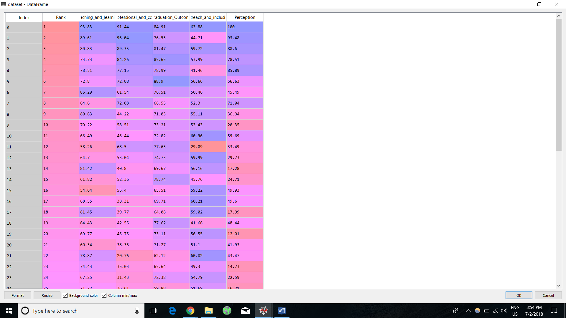

Datasheet2 = (Info Of VIT)

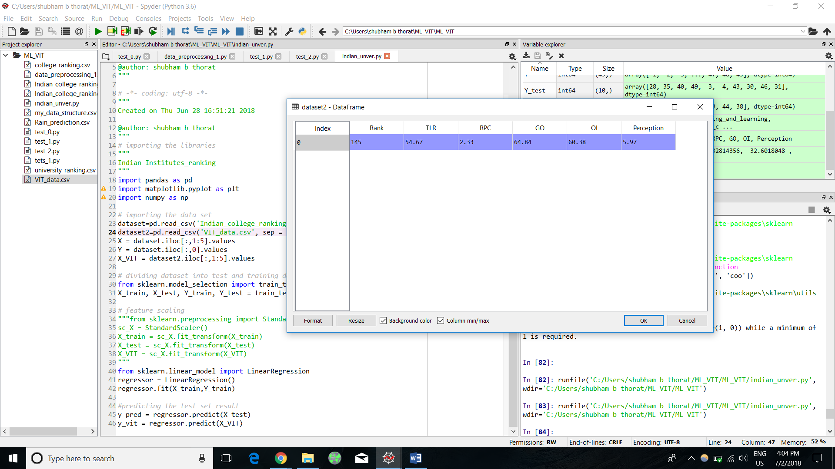

Rank_of_VIT

Y_VIT = 43.583

