# -*- coding: utf-8 -*-

"""

Created on Thu Jun 28 21:57:49 2018

@author: shubham b thorat

Rain_prediction

"""

import pandas as pd

import matplotlib.pyplot as plt

import numpy as np

dataset=pd.read_csv('rain_prediction.csv')

X = dataset.iloc[:,:-1].values

Y = dataset.iloc[:,10].values

"""from sklearn.preprocessing import Imputer

imputer = Imputer(missing_values="NaN", strategy="mean",axis=0)

imputer = imputer.fit(X[:,2:11], y=None)

X[:,2:11] = imputer.transform(X[:,2:11])"""

from sklearn.preprocessing import LabelEncoder

label_encoder_X = LabelEncoder()

label_encoder_Y = LabelEncoder()

X[:,0] = label_encoder_X.fit_transform(X[:,0])

X[:,1] = label_encoder_X.fit_transform(X[:,1])

"""onehotencoder = OneHotEncoder(categorical_features= [0])

X = onehotencoder.fit_transform(X).toarray()

onehotencoder = OneHotEncoder(categorical_features= [1])

X = onehotencoder.fit_transform(X).toarray()"""

from sklearn.model_selection import train_test_split

X_train, X_test, Y_train, Y_test = train_test_split(X,Y, test_size = .2 , random_state = 0)

# feature scaling

#from sklearn.preprocessing import StandardScaler

#sc_X = StandardScaler()

#X_train = sc_X.fit_transform(X_train)

#X_test = sc_X.fit_transform(X_test)

from sklearn.linear_model import LinearRegression

regressor = LinearRegression()

regressor.fit(X_train,Y_train)

#predicting the test set result

y_pred = regressor.predict(X_test)

y_test =

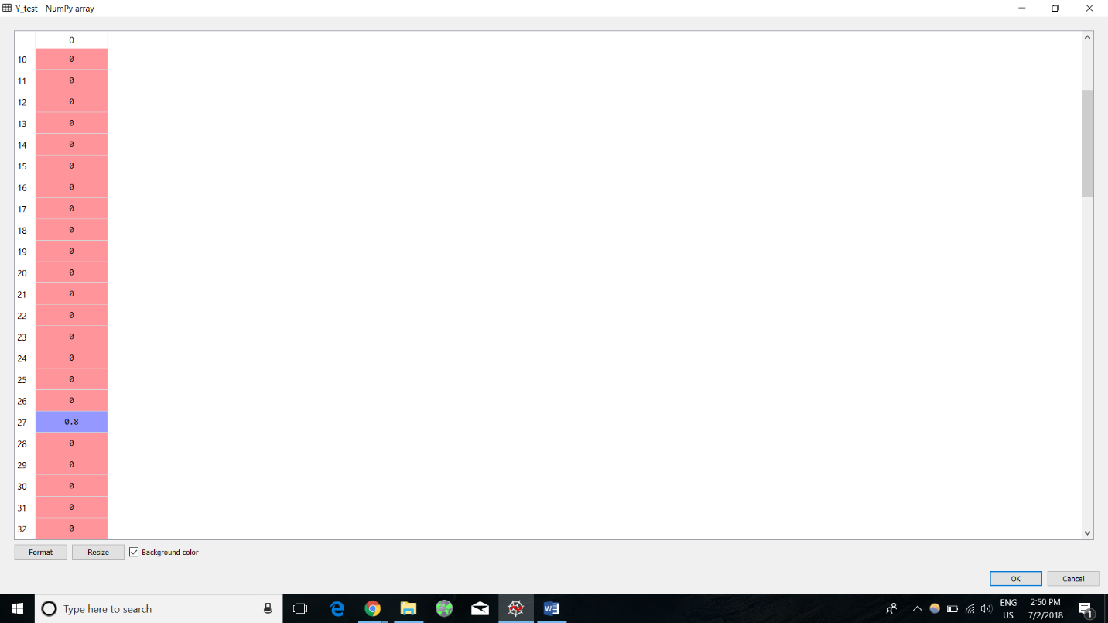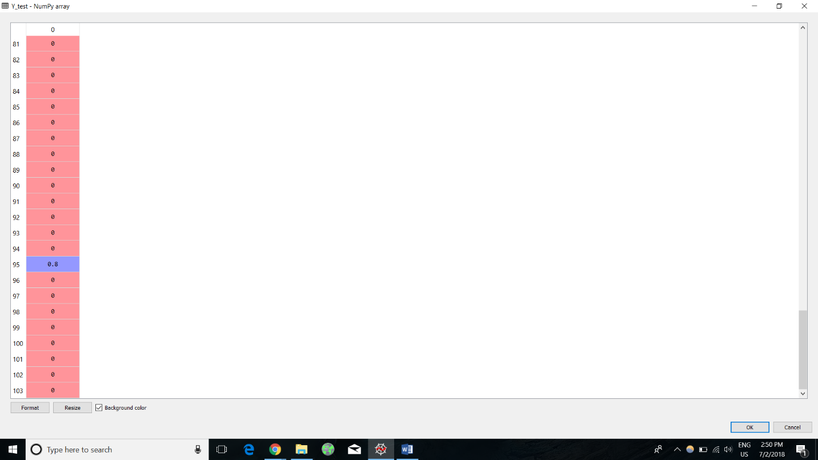

Y_pred =

