**Assignment 9**

1. Create a JSON File representing array of 5 Customers with the following Customer Class

class Customer {

int custId;

String custName;

String address;

double accountBalance;

}

1. Design the following HTML Form with POST method

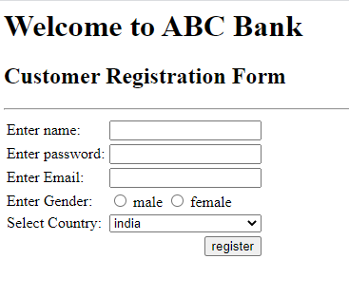

1. Add validations to all the text fields in the above form (use Java script)
2. Set border color of each input text field to blue
3. Align the form to the center of the page
4. Set the color of the headers to green with font style ‘verdana’
5. When you press register button, it should generate JSON Data displayed in an alert Box.