Java Garbage Collection — A Fresher-Friendly Guide
From Serial and Parallel GC to G1, ZGC and Shenandoah
Updated for modern HotSpot Java; examples use Java 21+ command-line syntax.

1. What you should learn
Garbage Collection (GC) is the JVM's automatic mechanism for finding Java objects that are no longer reachable by the running application and reclaiming the memory they occupy. A GC is not simply 'deleting unused objects'. Modern collectors also decide when to collect, how much work to perform, how to move live objects, and how to balance application throughput against pause time.
By the end of this guide, a fresher should be able to:
- Explain why Java needs garbage collection.
- Describe reachability, GC roots, young/old generations and object promotion.
- Explain mark, sweep, compact and evacuation in simple terms.
- Distinguish stop-the-world, parallel and concurrent GC work.
- Run the same Java program with different collectors.
- Read basic GC logs and identify pauses, allocation pressure and Full GC.
- Explain the design goals of Serial, Parallel, G1, ZGC and Shenandoah.
- Choose a collector based on latency, throughput, heap size and operational requirements.

2. The first mental model: objects live on the heap
When Java code creates an object with new, the object normally lives in the JVM heap. A reference such as Customer c = new Customer() gives the application a way to reach that object. If no live reference can reach an object, the object is eligible for collection.
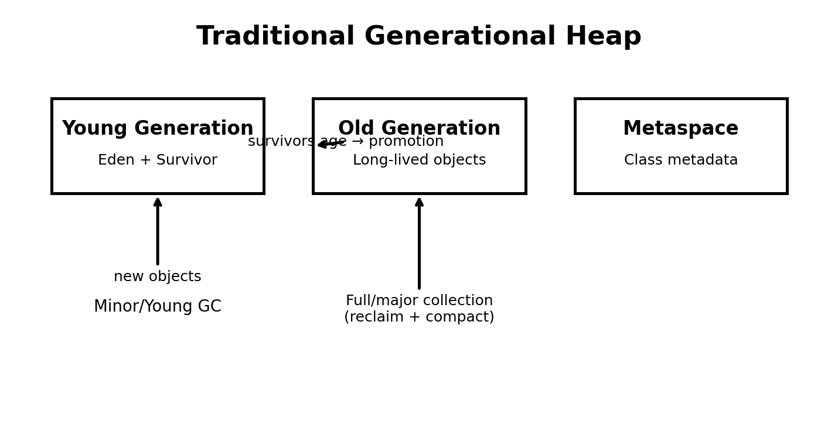
Important: the exact physical arrangement is collector-dependent. The familiar Eden/Survivor/Old picture is the traditional generational model. G1 uses regions rather than one large contiguous young and old area.

3. Reachability: how does the JVM know an object is garbage?
The JVM starts from a set of GC roots. Typical roots include references from active thread stacks, static fields, JNI references and other JVM-managed structures. It follows references from these roots. Objects reachable through this graph are considered live; objects that cannot be reached are candidates for reclamation.
Example:
Customer c = new Customer("A");
Order order = new Order(c);
order = null;
c = null;
// If no other live reference reaches the Customer or Order objects,
// they can eventually become eligible for GC.
GC timing is not deterministic. Becoming unreachable means 'eligible for collection', not 'immediately destroyed'.

4. The three words that explain many collectors

Mark
Find and identify objects that are still reachable.

Sweep
Reclaim memory occupied by objects that were not marked as live.

Compact
Move live objects together so that free memory becomes contiguous and fragmentation is reduced.
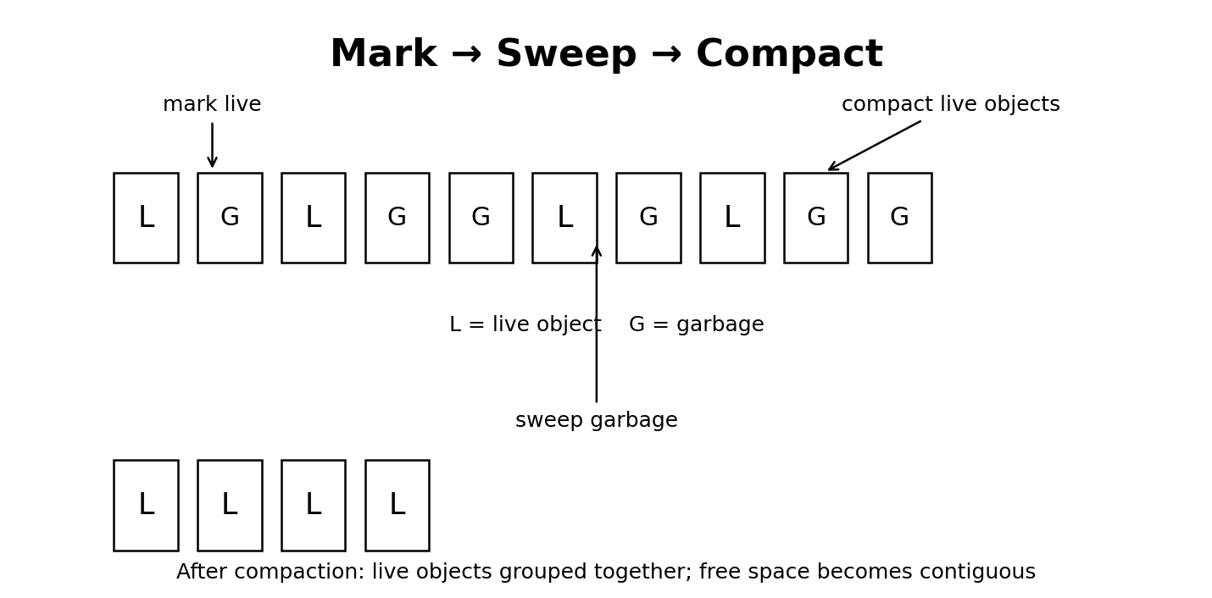

5. Why generations exist
Most Java applications create many short-lived objects: temporary strings, request objects, collections, DTOs and intermediate calculation objects. A smaller portion survives for a long time. Generational collectors exploit this behavior: collect young areas frequently and cheaply, while treating long-lived objects differently.
Typical lifecycle:
- New object → Eden
- Survives a young collection → Survivor space
- Survives repeatedly → age increases
- Long-lived object → Old generation
The exact aging and promotion policy is collector-specific and adaptive; do not treat a particular object age as a universal Java rule.

6. Stop-the-world (STW) does not mean the JVM is broken
A stop-the-world pause means application threads are temporarily stopped so the JVM can perform a particular GC phase safely. Some collectors do substantial work concurrently with the application and still require short STW pauses for certain phases.
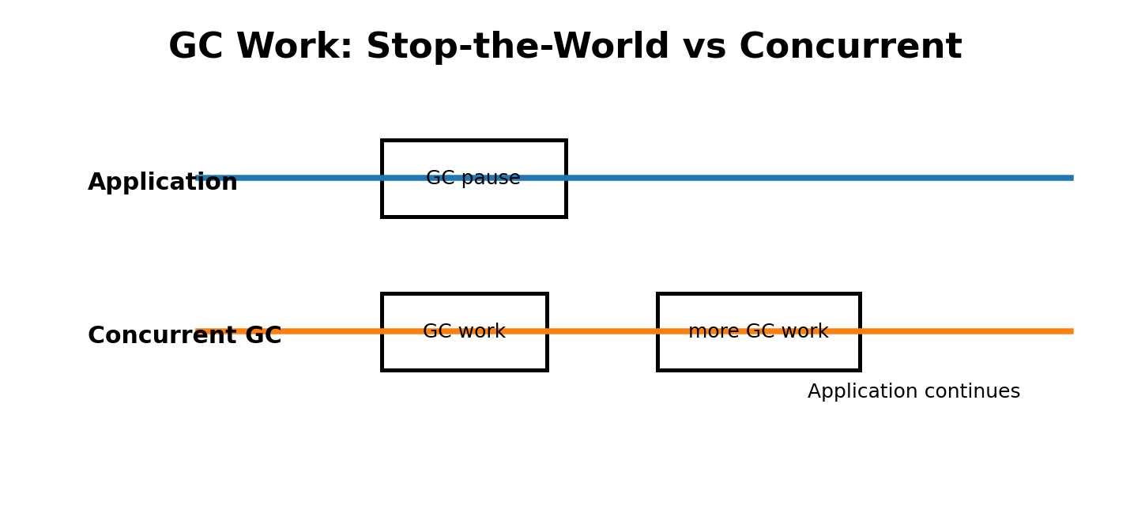
A useful performance vocabulary is: throughput = how much useful application work is completed; latency = how long a request can be delayed; pause time = time during which application threads are stopped by GC.

7. Traditional collectors

7.1 Serial GC
Serial GC performs GC work with a single GC thread. It is simple and can be appropriate for small heaps, small applications, or environments where low GC overhead matters more than high concurrency.
Enable it:
java -XX:+UseSerialGC -Xms256m -Xmx512m MyApp

7.2 Parallel GC — throughput first
Parallel GC is a generational collector that uses multiple GC threads. Its design emphasizes application throughput. It can be a good choice for batch-style or compute-heavy workloads where longer pauses are acceptable.
Enable it:
java -XX:+UseParallelGC -Xms2g -Xmx2g MyApp
The number of GC threads can be influenced with -XX:ParallelGCThreads=N, but beginners should normally let the JVM choose.

8. CMS: important historically, but not a modern choice
Concurrent Mark Sweep (CMS) was an important step toward lower-pause collection because it performed significant marking and sweeping concurrently. It was deprecated and then removed from modern JDKs. G1 became the mainstream successor for balanced latency and throughput. Therefore, learn CMS to understand GC evolution, but do not design a new application around CMS.

9. G1 — the modern general-purpose collector
G1 (Garbage-First) divides the heap into many equal-sized regions. Regions can belong to young or old generations, and the collector selects a collection set of regions to reclaim. G1 prefers regions that offer a high amount of reclaimable space for the amount of GC work required.
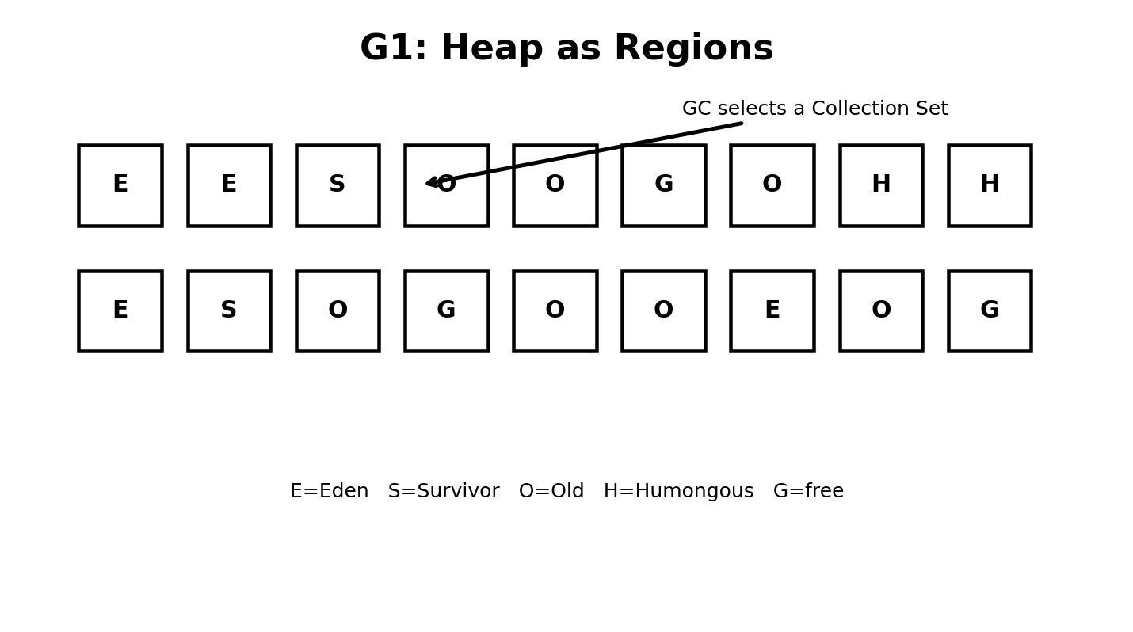
G1 is generational, incremental, parallel, mostly concurrent and evacuating. It uses short stop-the-world pauses for selected reclamation work and performs other expensive work concurrently.

9.1 How a simplified G1 cycle works
- Application allocates into Eden regions.
- Young collections evacuate live objects from selected regions into Survivor or Old regions.
- G1 performs concurrent marking to learn which old regions contain relatively little live data.
- G1 enters space-reclamation work and performs Mixed collections that include young regions plus selected old regions.
- Live objects are evacuated; reclaimed regions become available for new allocation.
- If the heap becomes critically constrained, G1 can fall back to a Full GC.

9.2 G1 setup
G1 is the default collector on server-class HotSpot configurations in current Java releases, so you often need no GC flag.
Explicit:
java -XX:+UseG1GC -Xms2g -Xmx4g -XX:MaxGCPauseMillis=200 MyApp
MaxGCPauseMillis is a goal, not a guarantee. Do not interpret it as 'every pause will be below 200 ms'.
For diagnostics, start with:
java -Xlog:gc*=info -Xms2g -Xmx4g MyApp
For deeper G1 phase information, Oracle recommends using logging such as -Xlog:gc*=debug and refining it as needed.

10. ZGC — low latency at large scale
ZGC is designed for very low pause times. Most expensive GC work is performed concurrently with application execution. Modern ZGC is generational: as of JDK 24, generational ZGC is the standard ZGC design and the older ZGenerational switch was removed.
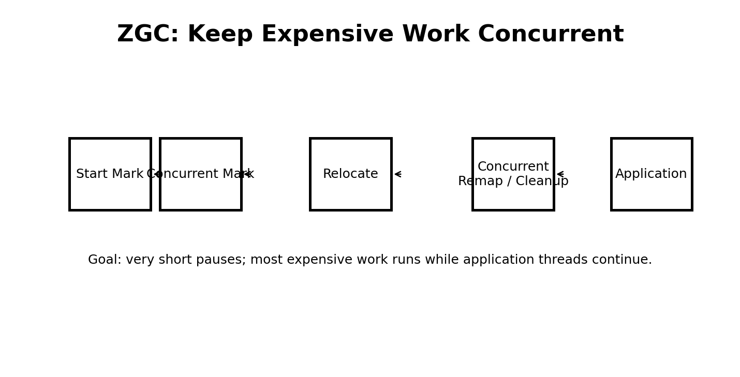
The important beginner idea is not memorizing every ZGC phase name. Remember the design principle: keep the application running while the collector marks and relocates objects, using barriers and metadata to keep references correct.

10.1 ZGC setup
java -XX:+UseZGC -Xms4g -Xmx8g MyApp
ZGC is highly adaptive and usually needs less manual tuning than older collectors. Heap size is still important: the application needs enough headroom for allocation while concurrent collection is running.

11. Shenandoah — another low-pause design
Shenandoah is a low-pause concurrent collector. A key design goal is to make pause behavior much less dependent on heap size by performing substantial marking, evacuation and reference-update work concurrently.
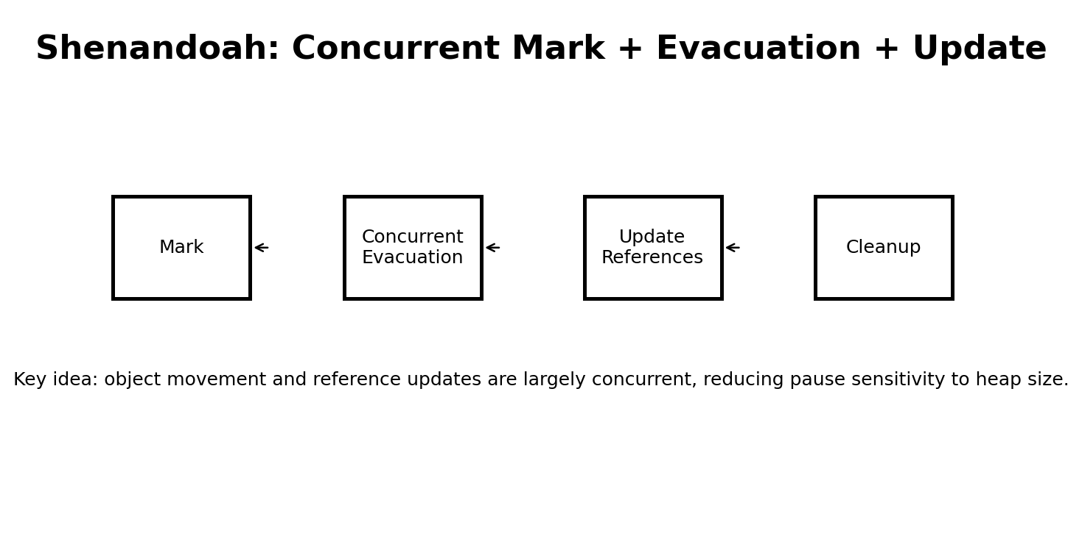
Modern Shenandoah also supports a generational mode in current HotSpot documentation. Availability and defaults can depend on the JDK distribution and release, so verify the collector options for the exact JDK you deploy.

11.1 Shenandoah setup
java -XX:+UseShenandoahGC -Xms4g -Xmx8g MyApp
Current HotSpot documentation exposes Shenandoah modes including satb and generational. For a first application, start with the collector defaults before experimenting with modes and heuristics.

12. Collector comparison
Collector | Main goal | Concurrency | Typical beginner use | Pause tendency | Enable
Serial | Simplicity / small workloads | Low | Small apps, learning | Can be longer | -XX:+UseSerialGC
Parallel | Throughput | Parallel GC work | Batch / CPU-heavy | Usually longer than low-latency collectors | -XX:+UseParallelGC
G1 | Balanced throughput + latency | Mostly concurrent | General server applications | Controlled, usually short | -XX:+UseG1GC
ZGC | Very low latency | Highly concurrent | Latency-sensitive services | Very short | -XX:+UseZGC
Shenandoah | Very low pause sensitivity | Highly concurrent | Low-latency workloads | Very short | -XX:+UseShenandoahGC

13. How to experiment safely
Use the same application, workload, heap limits and measurement method when comparing collectors. Changing the collector and the workload at the same time makes the comparison meaningless.
- Use a fixed Xms/Xmx when doing controlled experiments.
- Run a repeatable workload for several minutes rather than judging from startup.
- Record GC pause times, allocation rate, CPU usage, heap occupancy and application latency.
- Compare p95/p99 request latency if the program is a service.
- Look for Full GC or allocation stalls rather than focusing on the number of GC events alone.
- Change one JVM parameter at a time.

14. Useful JVM commands
Check Java version: java -version
See selected GC: java -XX:+PrintCommandLineFlags -version
See many JVM flags: java -XX:+PrintFlagsFinal -version
Enable GC logging: java -Xlog:gc*=info MyApp
More detailed GC logging: java -Xlog:gc*=debug MyApp
Heap information: jcmd <pid> GC.heap_info
Print JVM flags: jcmd <pid> VM.flags
Generate a class histogram: jcmd <pid> GC.class_histogram
Trigger a heap dump: jcmd <pid> GC.heap_dump /tmp/heap.hprof

15. A simple Java program for GC experiments
import java.util.*;
public class GCDemo {
public static void main(String[] args) throws Exception {
List<byte[]> objects = new ArrayList<>();
for (int i = 0; i < 20_000; i++) {
objects.add(new byte[64 * 1024]);
if (objects.size() > 200) {
objects.subList(0, 100).clear();
}
if (i % 1000 == 0) {
Thread.sleep(20);
}
}
System.out.println("Finished");
Thread.sleep(10_000);
}
}
Compile:
javac GCDemo.java
Run with G1:
java -Xms512m -Xmx512m -Xlog:gc*=info -XX:+UseG1GC GCDemo
Run with ZGC:
java -Xms512m -Xmx512m -Xlog:gc*=info -XX:+UseZGC GCDemo
Run with Parallel GC:
java -Xms512m -Xmx512m -Xlog:gc*=info -XX:+UseParallelGC GCDemo

16. Reading a GC log — what should a fresher look for?
- Collector name: confirms which collector is active.
- Pause duration: tells you how long application threads were stopped.
- Before → after heap usage: shows how much memory was reclaimed.
- Young vs mixed vs full collection: tells you the kind of work performed.
- Frequency: frequent collections may indicate high allocation pressure or insufficient headroom.
- Full GC: investigate carefully; repeated Full GC can indicate severe memory pressure or an application problem.
- CPU/concurrent activity: low-pause collectors spend CPU while the application is running.

17. Common beginner misunderstandings
GC immediately deletes unreachable objects. False. Unreachable means eligible for collection; the JVM chooses when and how to reclaim it.
System.gc() forces an immediate full collection. Do not rely on that. It is only a request and is generally inappropriate as application-level memory management.
More GC means the JVM is broken. Not necessarily. A busy application can allocate and collect huge numbers of short-lived objects normally.
A bigger heap always makes an application faster. Not always. More memory can reduce collection pressure, but it can also increase footprint and change collector behavior.
G1 has no pauses. False. G1 is mostly concurrent and still has stop-the-world pauses.
ZGC and Shenandoah are always faster than G1. False. They optimize for low latency and can use more CPU or have different throughput characteristics.
GC tuning starts with dozens of -XX flags. Usually false. Start with defaults, measure, then tune the smallest number of settings necessary.

18. A practical decision guide
- Start with the JVM default unless you have a reason to change it.
- For a typical modern server application, G1 is a strong baseline.
- If maximum throughput is the primary concern and longer pauses are acceptable, evaluate Parallel GC.
- If very low latency is a hard requirement, benchmark ZGC and/or Shenandoah.
- Use Serial GC for small/simple workloads where its simplicity is useful.
- Never choose a collector from folklore. Measure the actual workload on production-like hardware.

19. The evolution in one picture
A useful way to remember the evolution is: first make memory management automatic → exploit object lifetimes with generations → parallelize collection → perform more work concurrently → divide the heap into manageable regions → make object relocation concurrent so that pause time becomes much less dependent on heap size.

20. Suggested fresher learning path
- Day 1: Heap, stack, references, reachability and GC roots.
- Day 2: Generational GC, Eden, Survivor and promotion.
- Day 3: Mark, sweep, compact, copying and stop-the-world pauses.
- Day 4: Serial and Parallel GC experiments.
- Day 5: G1 regions, young collections, concurrent marking and mixed collections.
- Day 6: ZGC and Shenandoah concepts and experiments.
- Day 7: GC logs, jcmd, heap dumps and simple performance comparisons.

21. Key takeaways
- Java GC is about reachability, not simply object age.
- Generational collectors exploit the fact that many objects die young.
- Stop-the-world pauses are normal; modern collectors try to keep them short.
- Serial and Parallel emphasize simplicity/throughput; G1 balances goals; ZGC and Shenandoah emphasize very low latency.
- G1 is the modern general-purpose baseline in HotSpot.
- ZGC became generational by default in JDK 24; do not use old tutorials that tell you to add -XX:+ZGenerational.
- Shenandoah supports both traditional SATB and generational modes in current HotSpot documentation.
- Measure first. Tune second.

22. Official references
- Oracle Java 26 HotSpot GC Tuning Guide — https://docs.oracle.com/en/java/javase/26/gctuning/index.html
- Oracle Java 26 G1 GC — https://docs.oracle.com/en/java/javase/26/gctuning/garbage-first-g1-garbage-collector1.html
- Oracle Java 26 Parallel GC — https://docs.oracle.com/en/java/javase/26/gctuning/parallel-collector1.html
- Oracle Java command reference — https://docs.oracle.com/en/java/javase/26/docs/specs/man/java.html
- Oracle Java 25 ZGC documentation — https://docs.oracle.com/en/java/javase/25/gctuning/z-garbage-collector.html
- OpenJDK Shenandoah GC documentation — https://wiki.openjdk.org/display/shenandoah/Main

