Hello Candidates,

Thank you for participating in the next stage of our interview process! Below, you’ll find detailed instructions for creating the two games required for your assessment. These are simple 2D Unity games, and all necessary assets have been provided in the Google Drive folder. Feel free to use additional assets if needed, as we encourage creativity and strong UI design skills.

Here is a link for the google drive with all assets - [Assessment - Game dev](https://drive.google.com/drive/folders/15aKwlLx51yHx_hym3NzkFnKMWCUb4ADU?dmr=1&ec=wgc-drive-hero-goto)

### **Submission Requirements**

* **Unity Version:** Please develop both games using **Unity 2022.3.21f**.
* **Single Project Setup:** Submit both games within the **same Unity project**. Include a **main menu page** that allows users to select either game.
* **Source Code:** Ensure the **full source code** for both games is included so we can review your programming approach and skills.
* **File Submission:**
  + Zip up all project files and email them to **amaan@bluadvisory.in**.
  + If the files are too large for email, please upload them to a cloud drive (such as Google Drive) and add **amaan@bluadvisory.in** as a collaborator.

# Game 1: Dice Roll (Decision-making Game)

#### **Game Overview**

* **Objective:** Players must reach a target score by adding dice face values to their score.
* **Gameplay:**
  + A panel displays dice faces in random order (from 1 to 6), which will shuffle each time the game restarts. Instead of the numbers here the face of the dice will appear

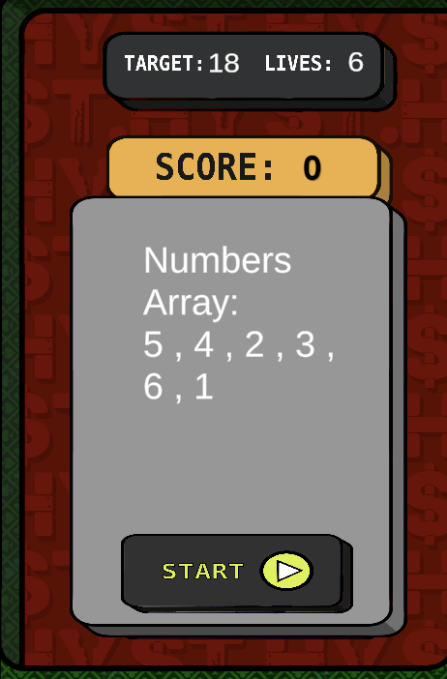

* + Players start the game by pressing the “Start” button, which initiates a timer.
  + Dice faces will change at regular intervals (dependent on the difficulty level), requiring players to click an “Add” button to add the displayed dice face value to their score in pursuit of the target score.
  + **Animation:** Create a dice roll effect that changes at the interval specified for each difficulty level.

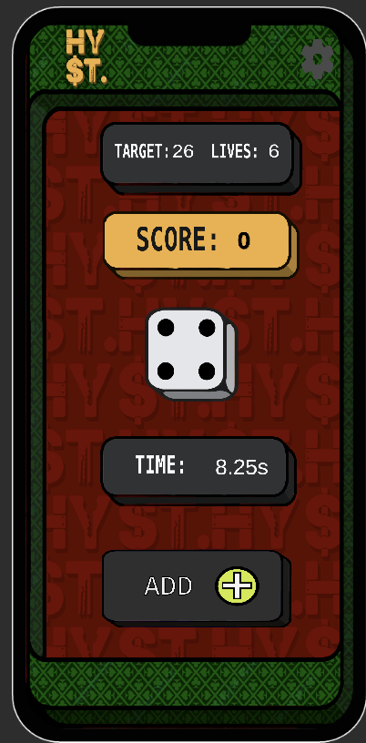

#### **Difficulty Levels & Scoring**

Each level has different timings for dice face changes and criteria for awarding stars:

* **Easy:**
  + Dice changes every 0.6 seconds.
  + Target score: 17-20.
  + Star rating: Achieve target score within:
    - 15 seconds for **1 star**.
* **Medium:**
  + Dice changes every 0.4 seconds.
  + Target score: 21-25.
  + Star rating: Achieve target score within:
    - 15 seconds for **2 stars**.
    - 20 seconds for **1 star**.
* **Hard:**
  + Dice changes every 0.2 seconds.
  + Target score: 25-30.
  + Star rating: Achieve target score within:
    - 15 seconds for **3 stars**.
    - 20 seconds for **2 stars**.
    - 25 seconds for **1 star**.

Design references for the difficulty panel, game over screen, and other UI elements are included in the folder under “Difficulty and Game Over.” You’re welcome to design or customise the panels and screens as you see fit.

# Game 2 - F1 Timer (Reflex Game)

Below are the detailed instructions for the second game you need to develop as part of your assessment. This game tests players' reflex timings and includes a single difficulty level with a maximum of 3 stars available.

This game simulates the start of an F1 race and challenges players to achieve the fastest possible reaction time.

Game reference - https://f1-start.glitch.me/

#### **Game Overview**

* **Objective -** Players must tap the screen as soon as all the lights go out in an F1 simulation to achieve the fastest reaction time possible.
* **Gameplay** -
  + At the start of the game, **5 empty lights** will be displayed, simulating the lights at the start of an F1 race. The lights will gradually fill up, one by one.
  + After all 5 lights are filled, they will **go out**, and the player must tap the screen to record their reaction time.
  + The time between each light filling will range from **1.5 to 2 seconds**. However, the time before the last light goes out (after all lights are filled) will vary randomly between **3 to 10 seconds**.
  + If a player taps the screen **before the lights go out**, it will be considered a **false start**. If the player commits **2 false starts**, the game ends immediately.
  + Make sure the time is displayed under the lights
* **Scoring -** 
  + **3 Stars:** Reaction time under **0.2 seconds** with **0 false starts**.
  + **2 Stars:** Reaction time under **0.25 seconds**.
  + **1 Star:** Reaction time under **0.35 seconds**.

The faster the reaction time, the higher the star rating. Please ensure that the game ends correctly when 2 false starts occur or when the game is completed.