Gate Man from DEPO (Gate In / Out Data Sample)

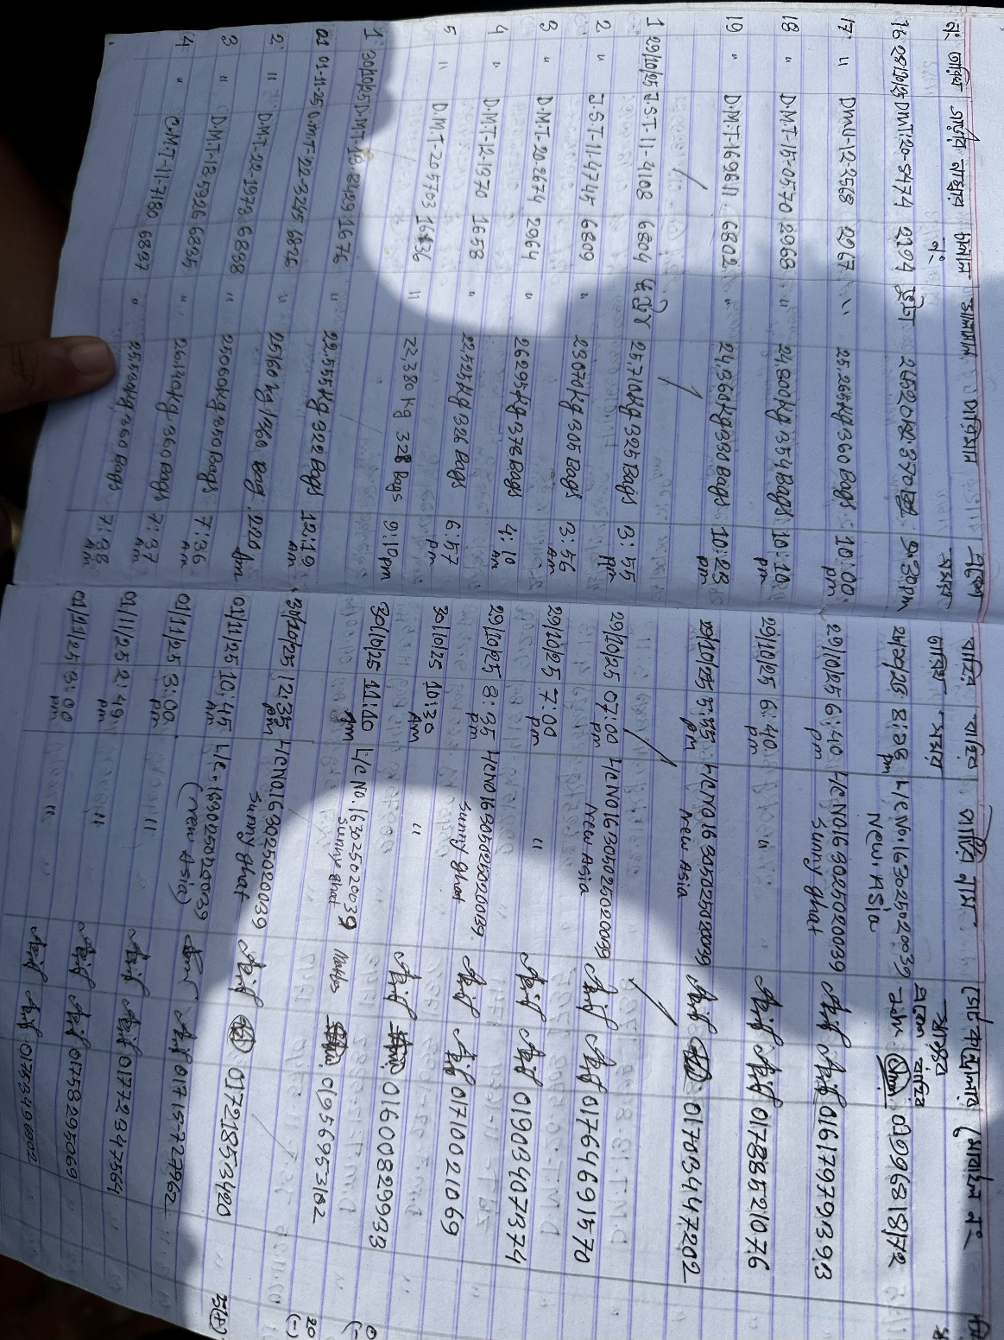

Delivery Challan for Raw Material (Data Sample)

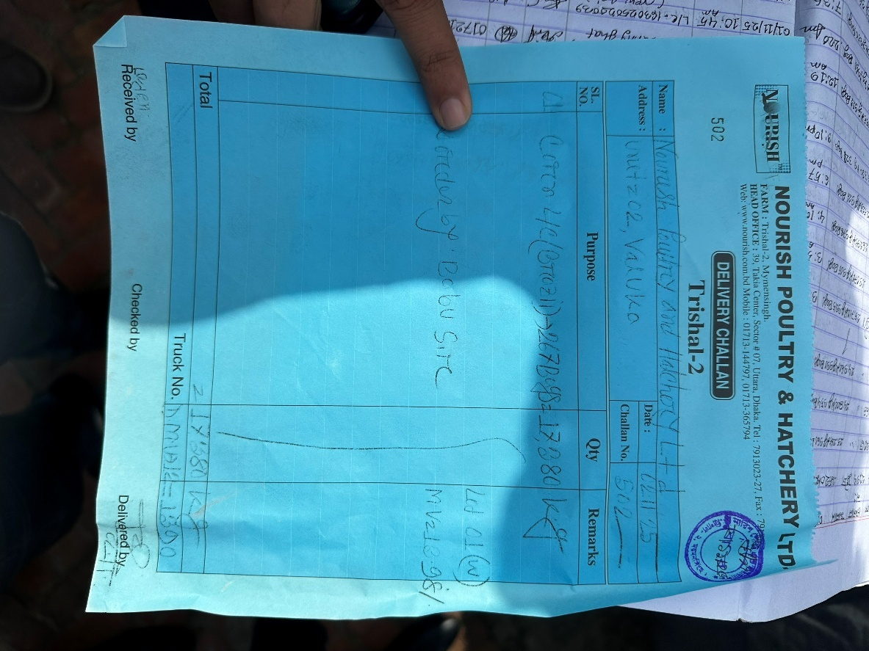

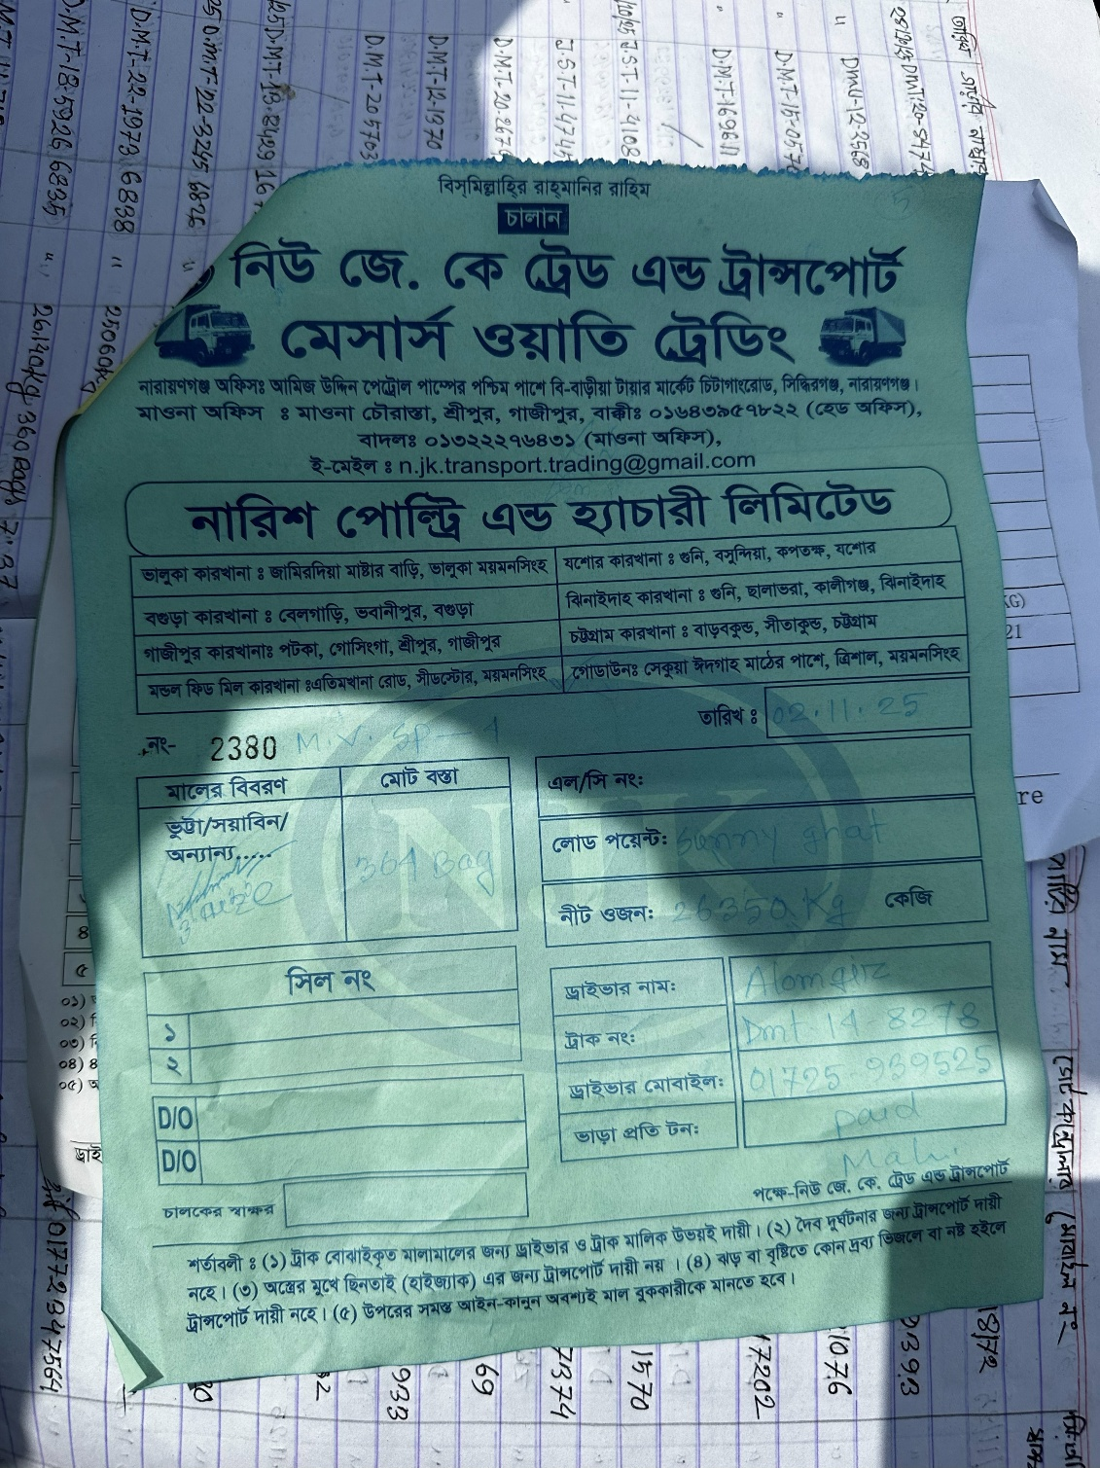
Vendor Challan for Raw Material (Data Sample)

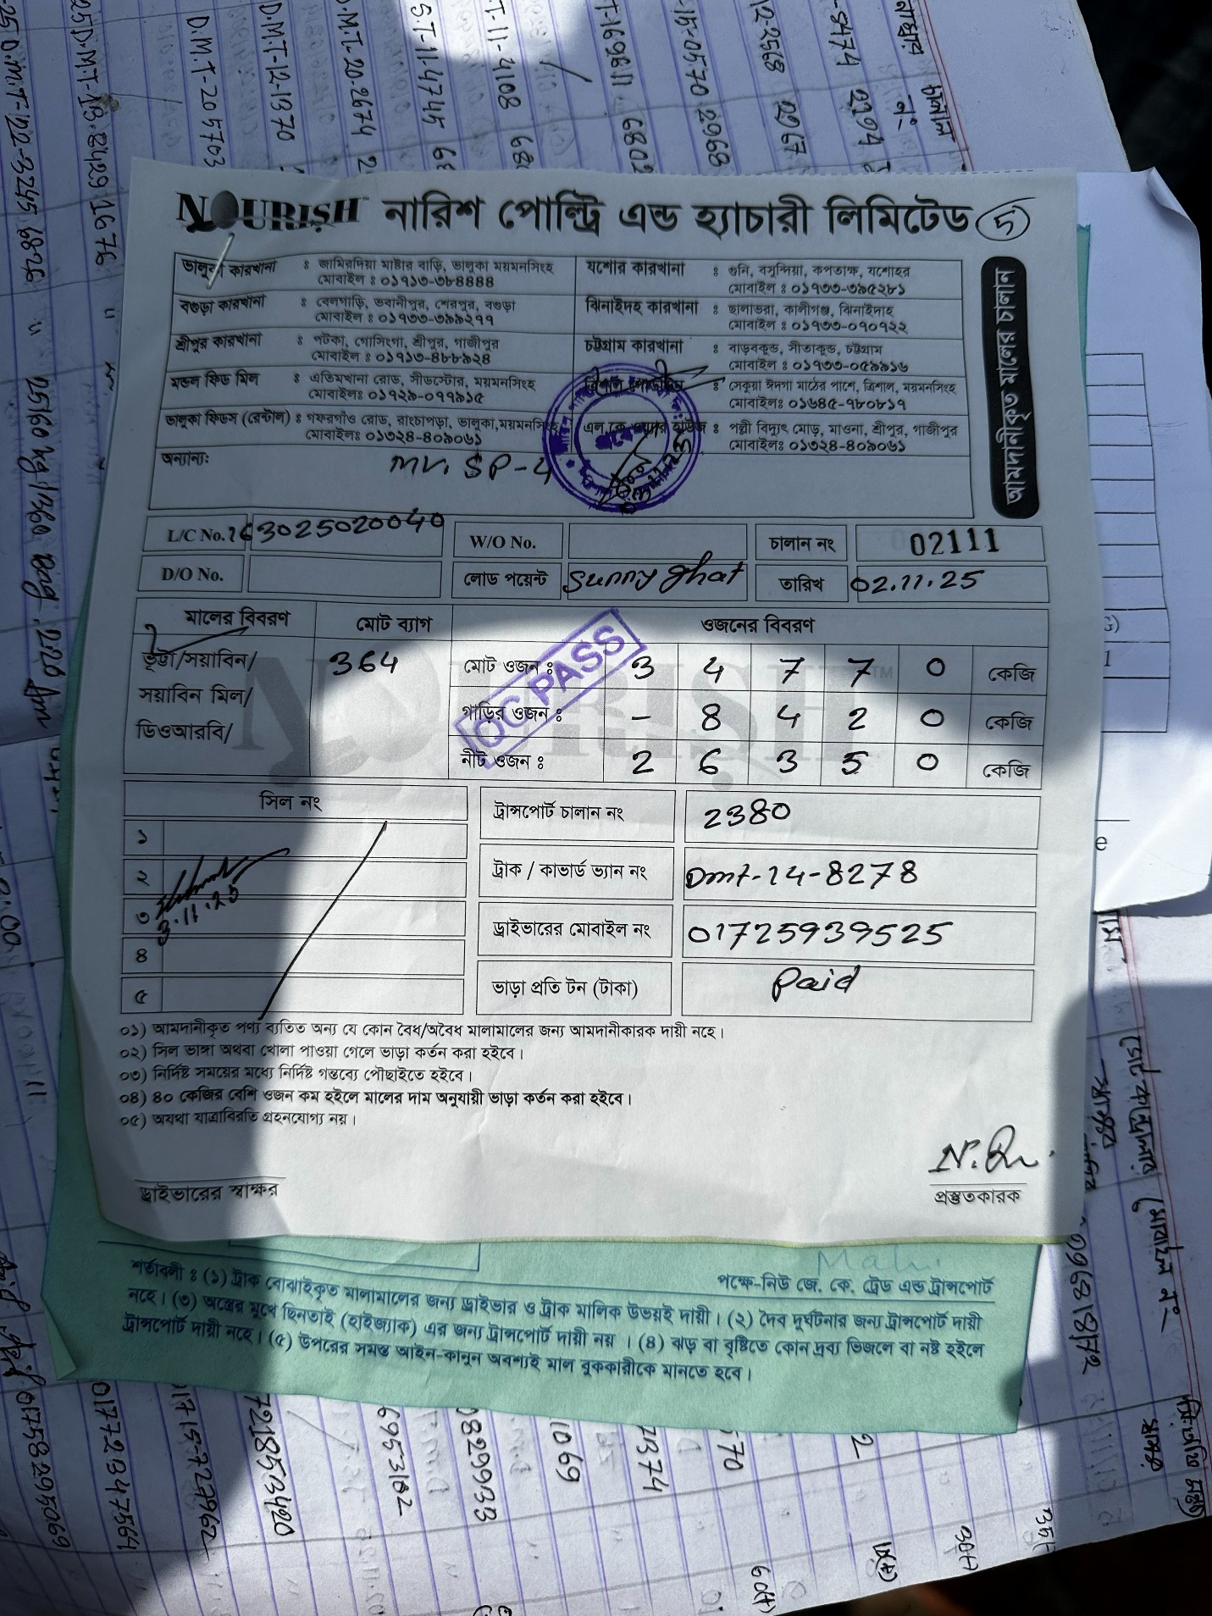
Internal Challan after QC Pass (Imported Raw Materials)

Vendor Details Sample
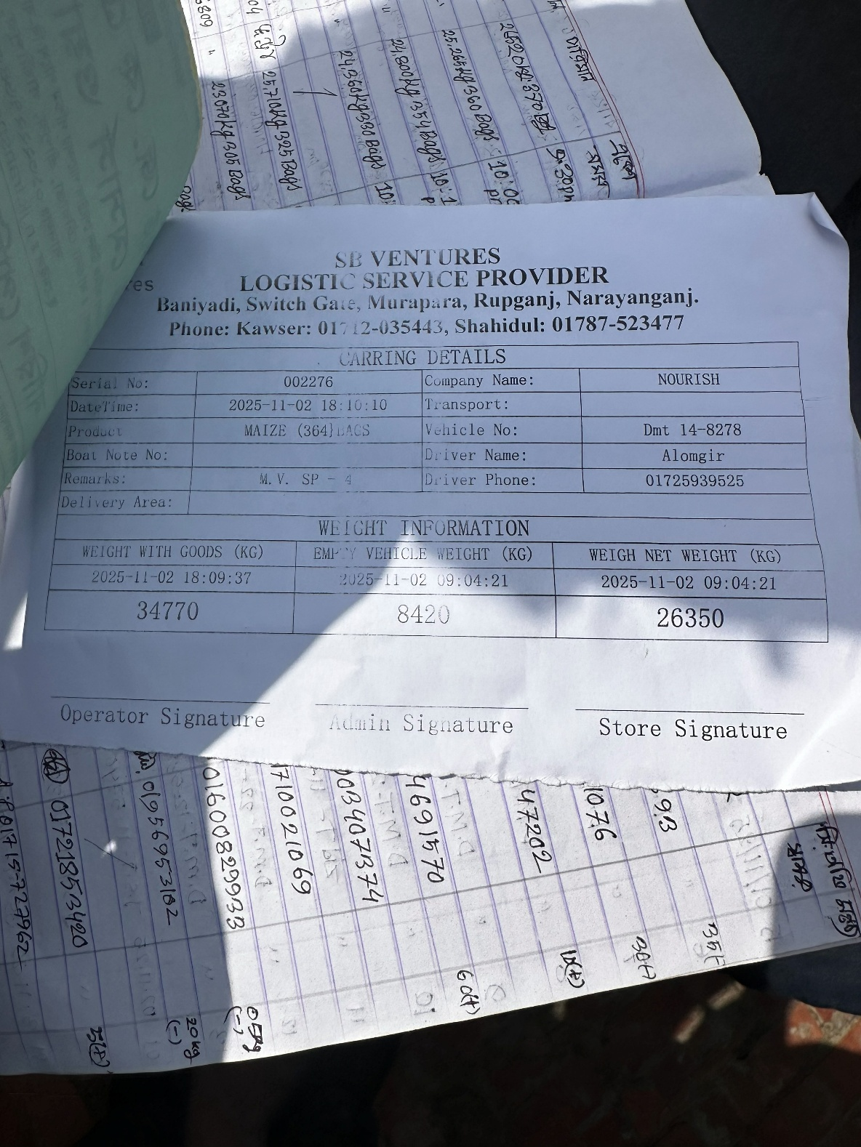

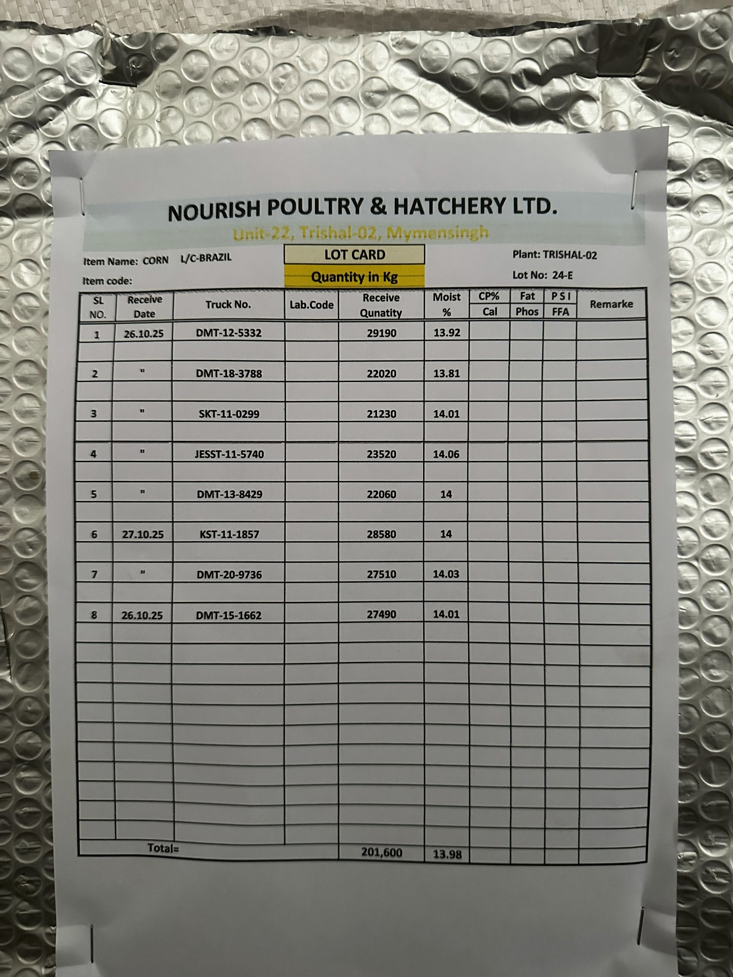
Warehouse Tracking Data Sample for Raw Materials

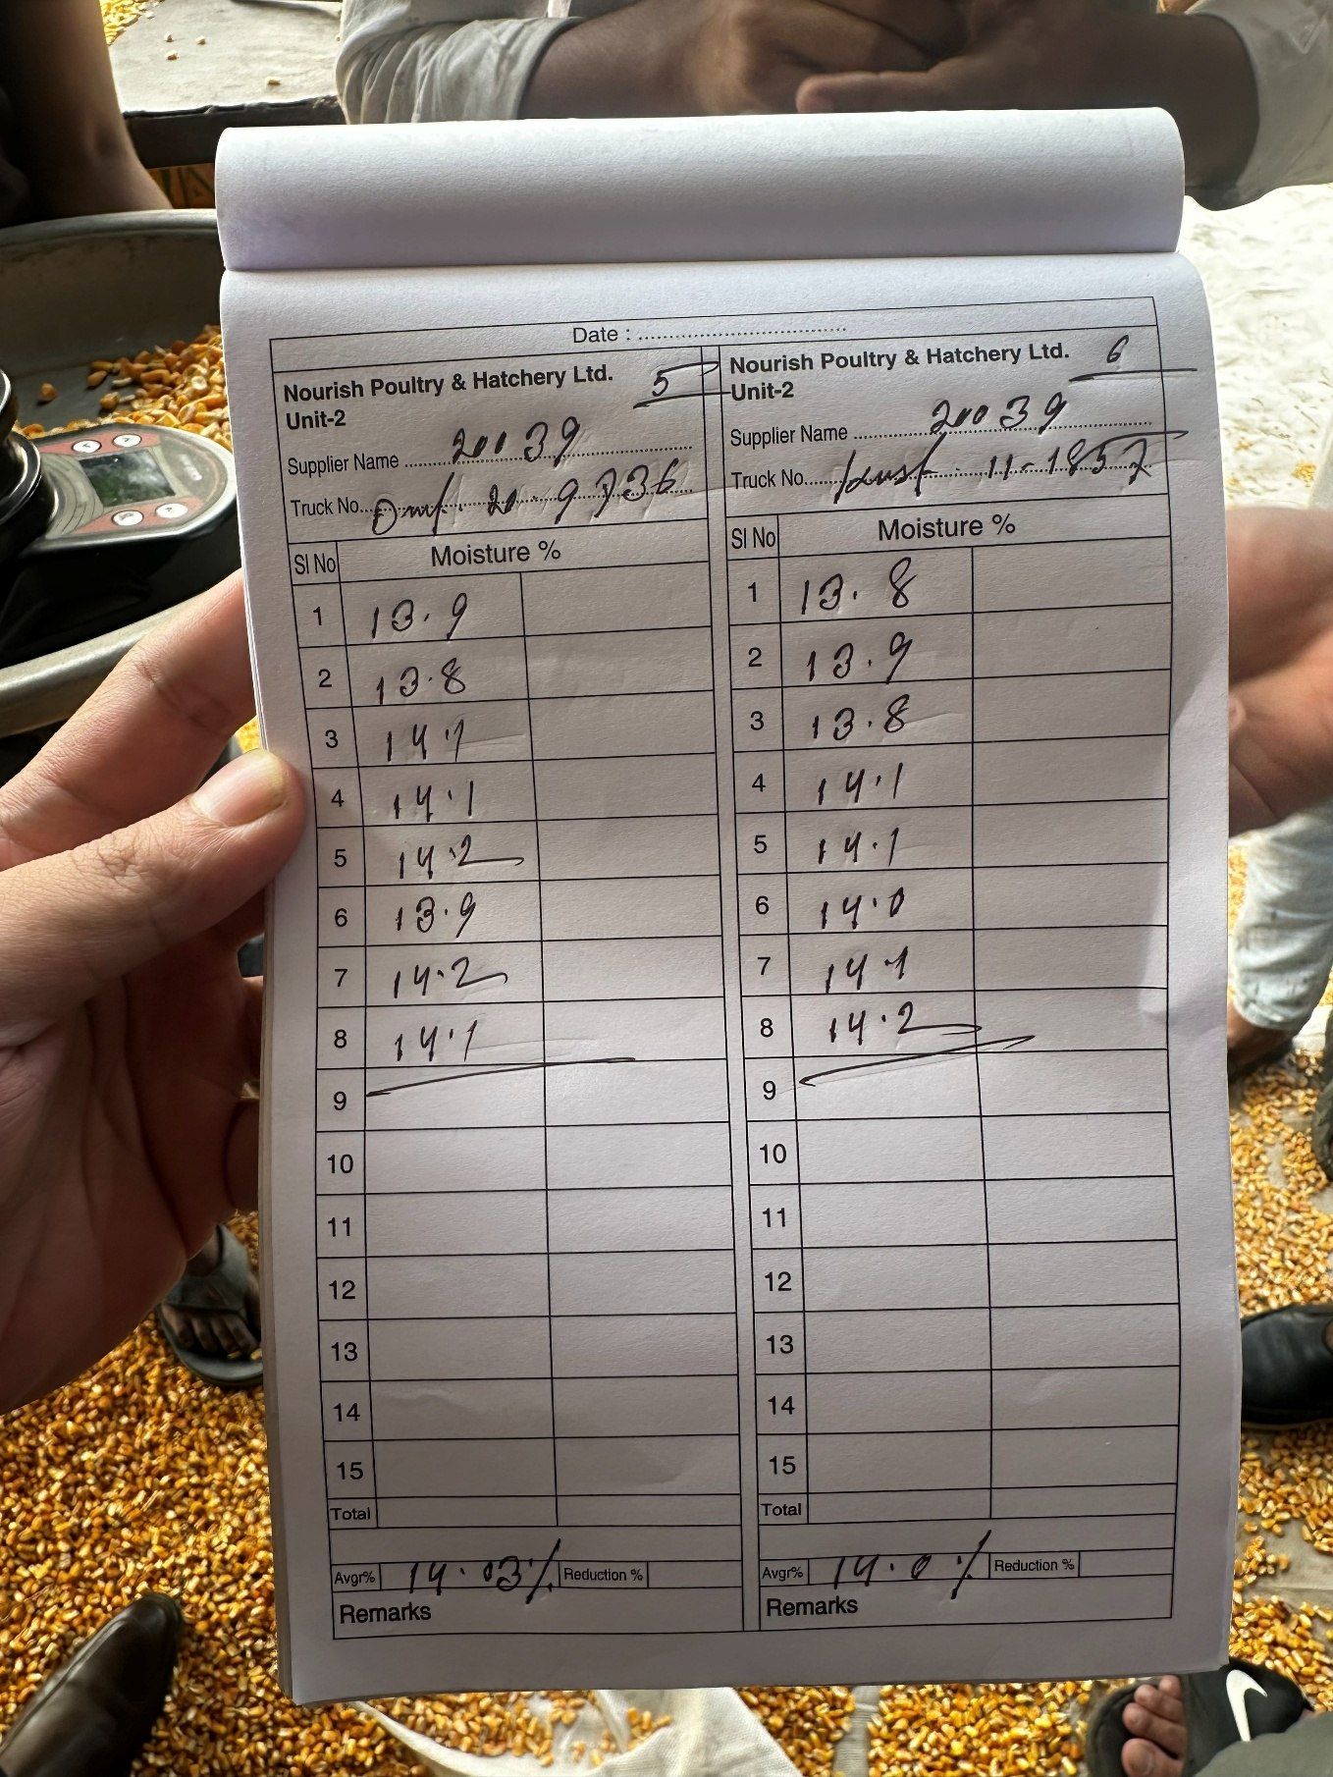
DEPO QC Form (Physical Analysis)
Multiple samples collecting from one vehicle to measure an average data

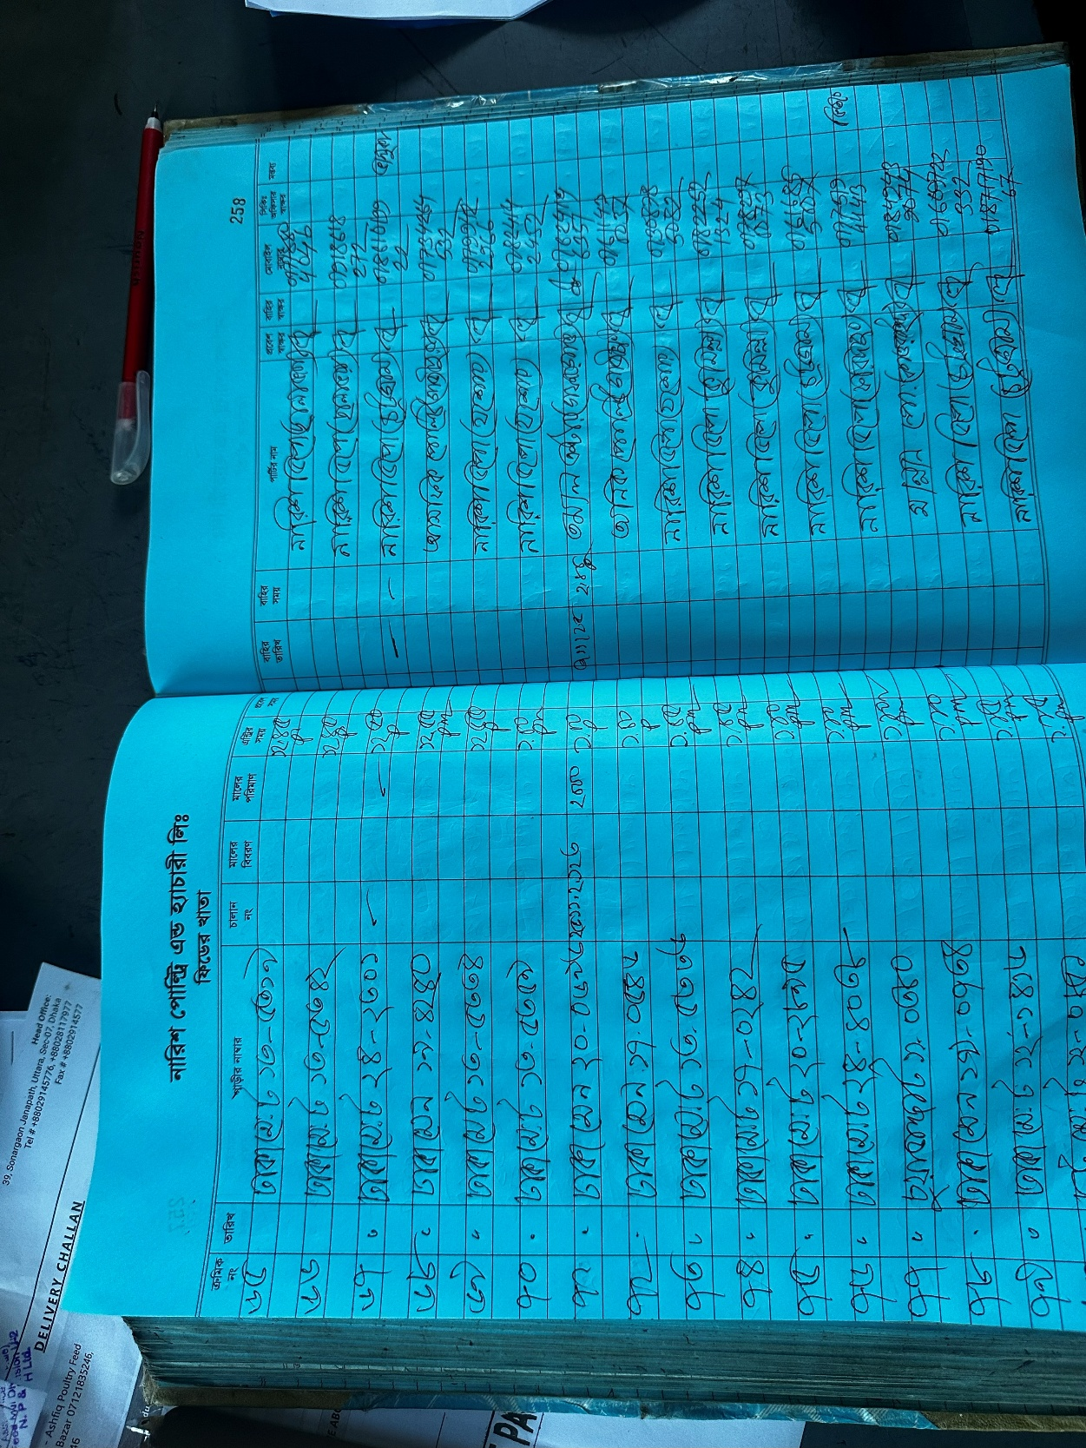
Feedmill Gate in and Out Time

Feedmill to Agent (Delivery Challan Copy) Agent sent their own vehicle
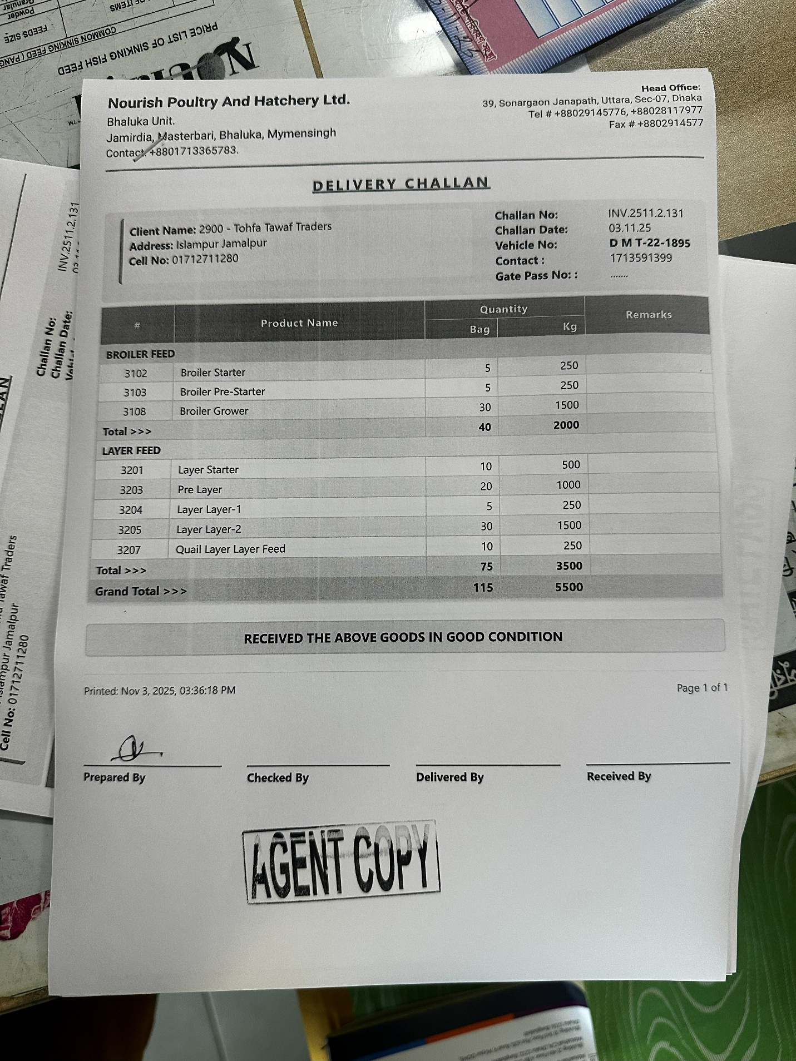
Gate Pass Copy
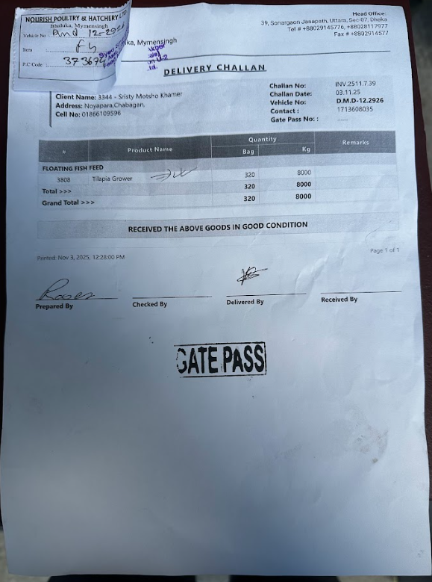
serial number the vehicle receives at the scale during first scale
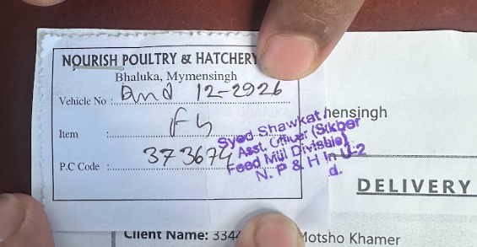
Vendor Delivery challan Copy
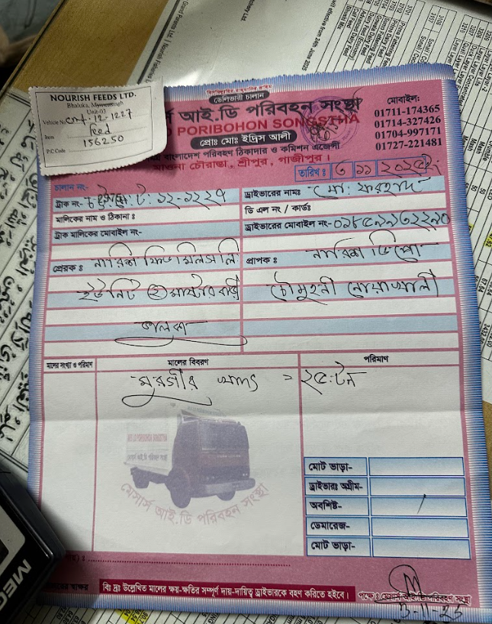
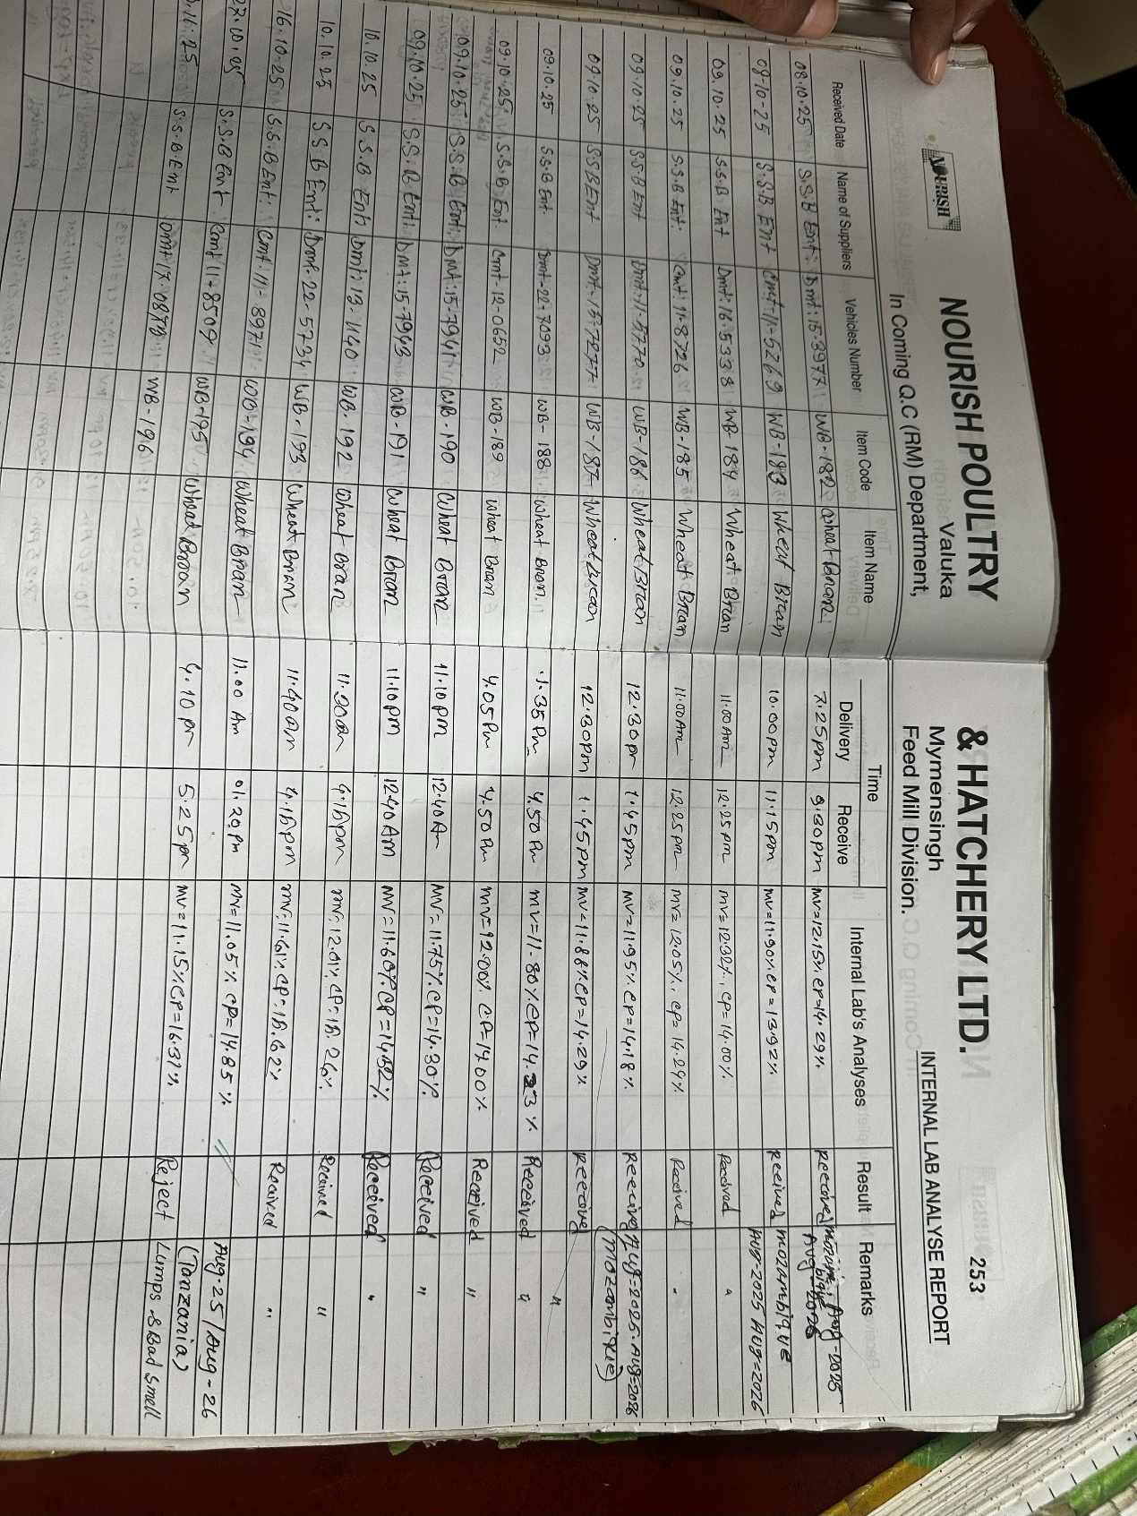
QC Data Entry

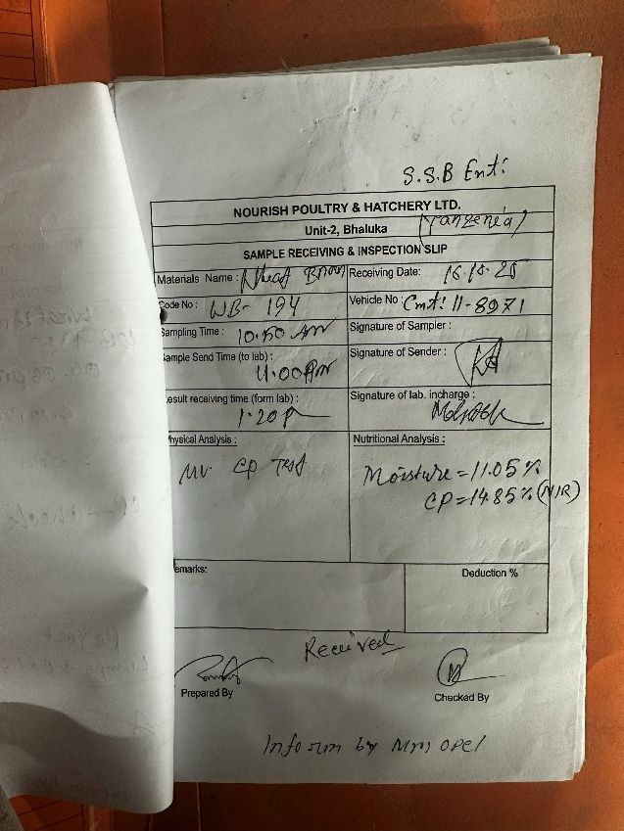
QC Data Sample
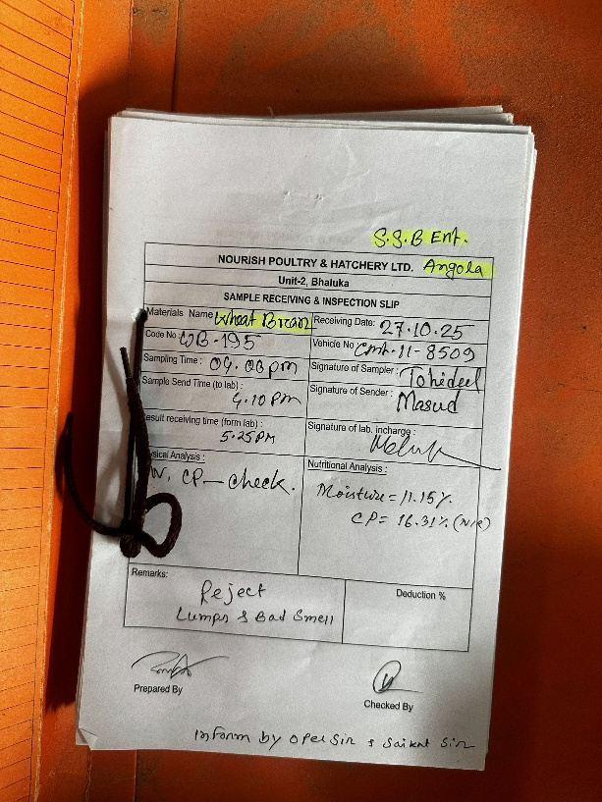
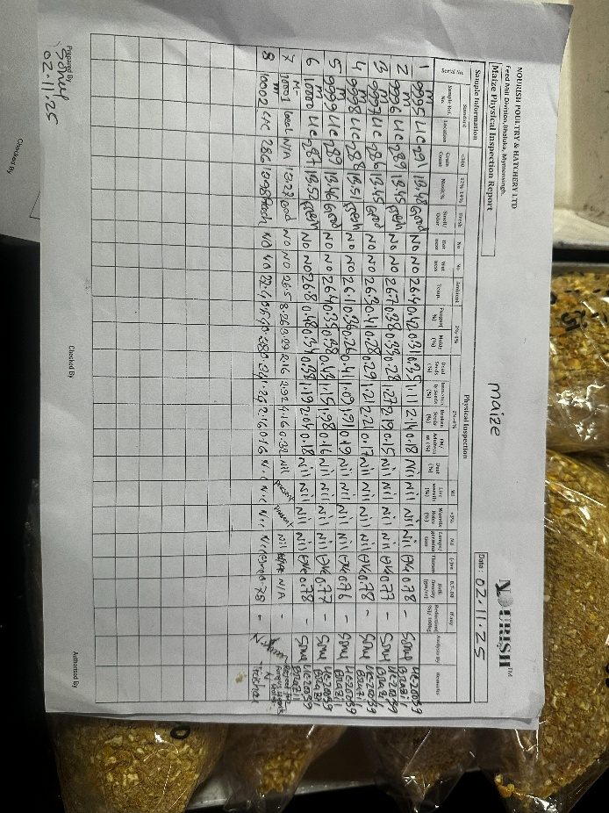
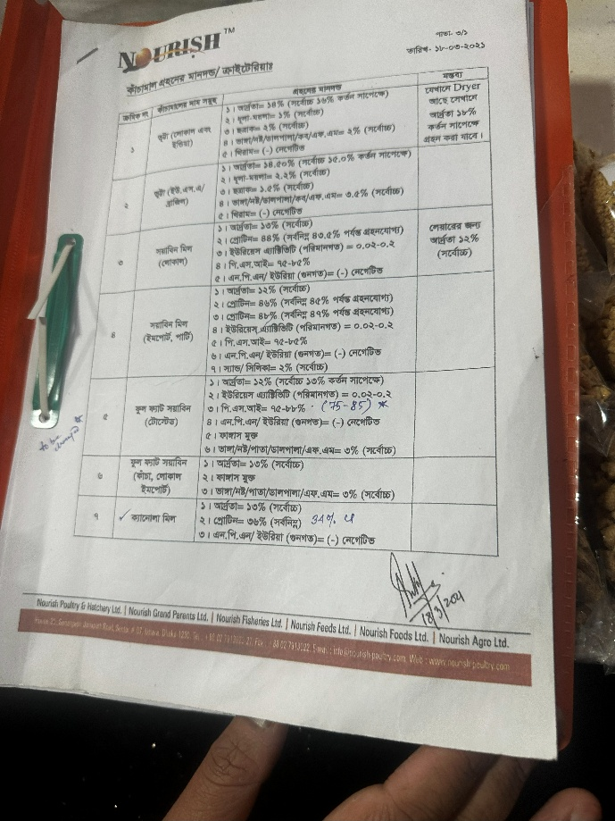
Physical Inspection Report
Standard of each items full details document will be shared by nourish team

