Nourish Transport Management System
Product Requirement Document
Document Version – 1.4

Problem Statement and Context

Nourish has a fleet of multiple types of vehicles, It has a fleet of 120 covered Vans and Trucks for Delivering across various locations in Bangladesh

- Finished Goods
- Raw Materials

Pain points across various departments

Production
- Delay in loading/Unloading
- Discrepancy in received quantity

QC
- Procurement-Production dispute regarding rebate on received quantity
- Unavailability of drivers in the premises during QC

Procurement
- Unavailability of trucks
- Higher rates compared to outside vendors

Commercial
- Unavailability of trucks
- Higher rates than outside vendors

Sales
- Unavailability of trucks
- Higher rates compared to outside vendors
- No tracking of stock transfer
- Lack of streamlined process in delivery and internal transfers (leading to more manual work)

Transport
- Delay in Truck requisition from users
- Lack of full-scale visibility of truck & driver management
- Unavailability of Information for key decisions in transport assignment
The trucks move across different points across various locations in the country.

- Port
- Raw Material Warehouse
- Finished Feed Depot
- Feed Mill
- Feed Dealer
- Direct Customer
- Mango pulp factory
- Rice kernel factory
- Silage project
- WMP (Waste management plant)
- RMG factory
- Machinery

Broad Problems

- Trucks' loading or unloading times are unclear
- consistently a delay in the process.
- There is no existing system to measure lead time at specific points
- There is currently no data being recorded of scale measurements when entering or leaving each location.
- There is no data of truck availability and per trip cost of each truck.

Solution and Requirements
At each of the locations the truck can either load or unload. At each of the points the following data must be recorded.

Loading
- Date-Time of entry
- Location
- Project from
- Project To
- Name of Receiver
- Truck number
- Driver Name
- Driver ID
- Loading start date-time
- Loading end date-time
- Scale before Loading
- Scale after Loading
- Scale Reading
- Gate in KM
- Gate out KM
- Gate in Fuel Reading
- Gate out Fuel Reading

Unloading
- Date-Time of entry
- Location
- Project from
- Name of Supplier
- Truck number
- Driver Name
- Driver ID
- Unloading start date-time
- Unloading end date-time
- Scale before Unloading
- Scale after Unloading
- Scale Reading
- Sample Collection date-time
- Sample Send date-time
- Lab Code
- Lab Report date-time
- QC start date-time
- QC end date-time
- Q.C Pass date-time
- Gate in KM
- Gate out KM
- Gate in Fuel Reading
- Gate out Fuel Reading

In order to validate and Coordinate all members a Transport Operations Control team will track

- State of Truck
  - Waiting to load
  - On the move (Laden/Empty)
  - Waiting to unload
  - Waiting for next plan
  - Maintenance
- Trip History of Each Truck

Each of the locations can request to send or receive items based on requirements with quantity and destinations on the software. These are analyzed by the Transport Operations Control by priority and schedule a dispatched to the respective trucks or generate an order open to bid by vendors.

Process Diagram
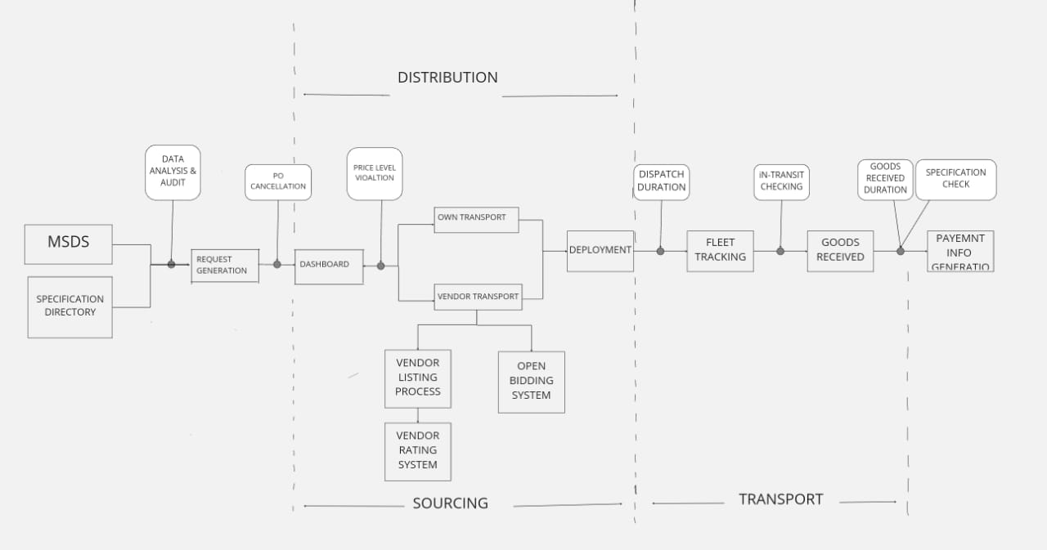

Legend
- MSDS –Material Safety Datasheet Specification
- Specification Directory – Product Grade Specification
- Check and Balance System between every process flows
- Diverging Branches are Decision Nodes

Detailed Process For Finished Goods

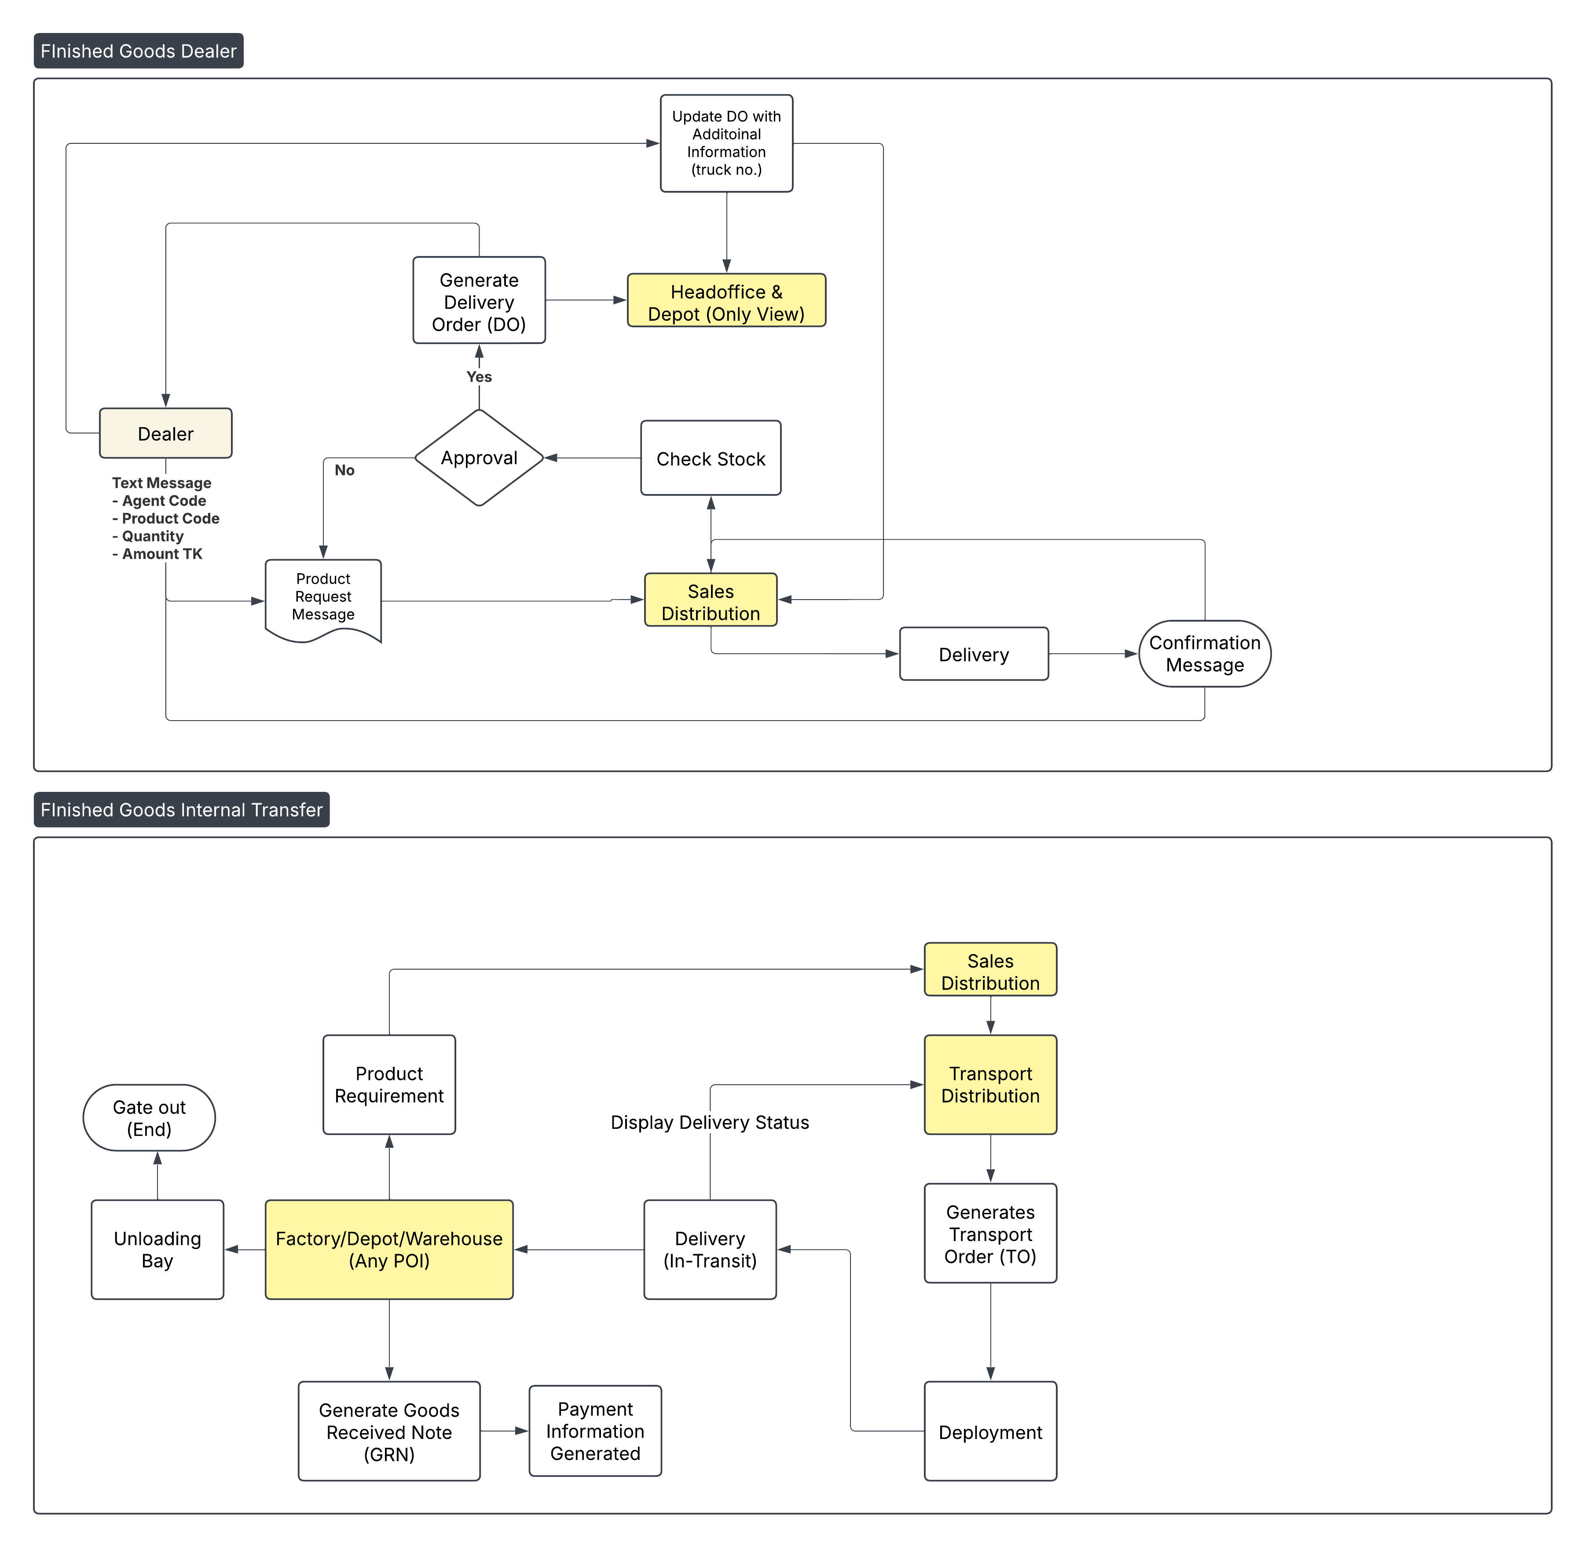

Detailed Process For Raw Material

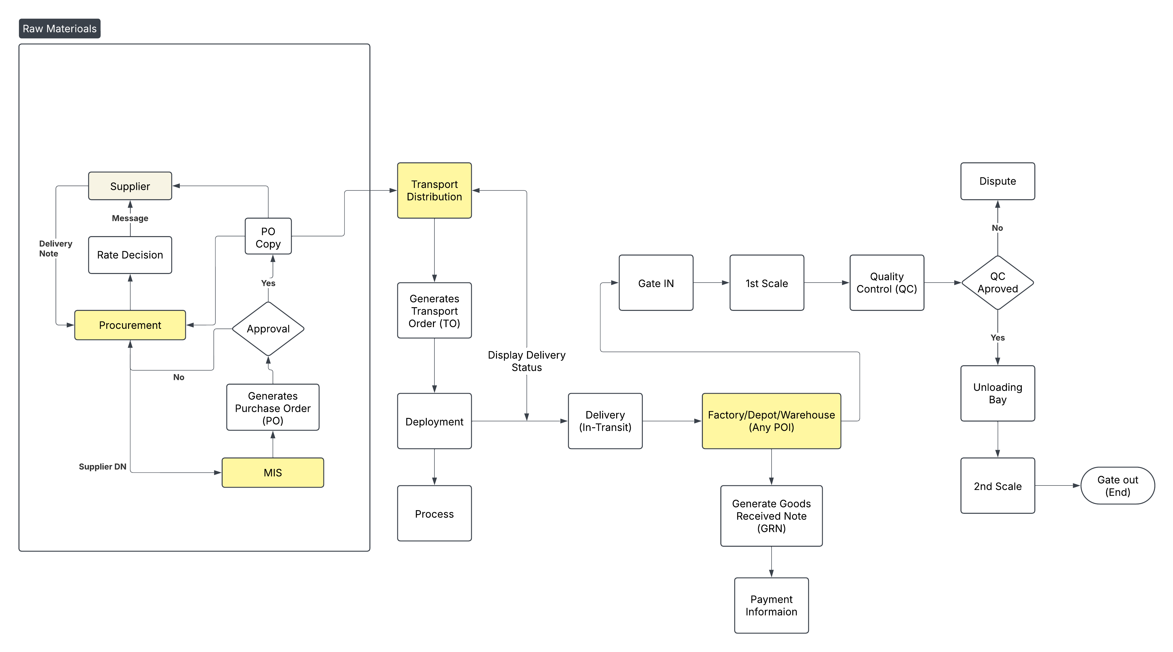

Key Features and Requirements
Core Features
- Fleet Tracking and Monitoring
  - GPS-enabled real-time location tracking.
  - Vehicle health monitoring (engine status, maintenance alerts).
  - Real-time monitoring within vehicles.
  - Alerts for deviations from set thresholds.
  - Audit logs for compliance reporting.

- Route Optimization
  - Delivery priority and load type considerations in routing.
  - Scheule According to maximum route efficiency

- Fleet Maintenance Management`
  - Scheduling for vehicle maintenance.
  - Tracking maintenance history.
  - Spare parts inventory management integration.
  - Tracking licenses, permits, and vehicle inspections.
  - New Vehicle Acquisition

- Analytics and Reporting
  - Performance dashboards (fuel efficiency, delivery times, costs).
  - Customizable reporting tools.
  - Driver Management
  - Vehicle Management
  - Fuel Management
  - Maintenance and Repair
  - Accounting and Reporting
  - Legal Issues and Accident Management

- User Roles and Permissions
- Admin: Add/Change Vendors, Add/Change Specifications. Full access to all features, configuration, and analytics
- Fleet Manager: Access to tracking, scheduling, and maintenance features.
- Driver: Limited access via mobile app for route details and compliance alerts.
- Auditor: Read-only access to compliance and records.

- Integration Requirements
- ERP Integration: Sync with enterprise systems for seamless data exchange (inventory, orders, etc.).
- IoT Devices: Compatibility with sensors, trackers, and vehicle diagnostic systems.
- APIs: Open APIs for third-party integration.

- User Acceptance Testing (UAT)
  - UAT Scope: Clearly outline which features and functionalities will be included in the UAT phase, specifying any exclusions.
  - Target Users: Identify the user groups who will be involved in UAT, including their roles and responsibilities.
  - Test Environment: Describe the dedicated testing UAT environment
  - Test Scenarios: List key user flows and scenarios that will be tested during UAT, ensuring they cover critical business processes and user interactions.
  - Acceptance Criteria: Define clear and measurable criteria that must be met for the product to be considered "accepted" by the users during UAT.

