Nourish (Fleet Management System)
Requirements provided to Brain Station 23:

Problem Statement and Context

Nourish has a fleet of multiple types of vehicles, It has a fleet of 120 covered Vans and Trucks for delivering finished feed to multiple locations across the country and receiving raw materials from various locations. A GPS system is installed in all vehicles to locate the current locations of all trucks. Current system is HIGHLY INEFFICIENT as the transport team receives orders of trucks on a day-to-day basis in the morning and then the transport team schedules the trucks according to the position of trucks by communicating over the phone or assigns registered vendors trucks. A truck can either move laden with goods or empty and according to the current system, significant empty trips are made.

The trucks move across different points across various locations in the country.
- Port
- Raw Material Warehouse
- Finished Feed Depot
- Feed Mill
- Feed Dealer
- Direct Customer
- Mango pulp factory
- Rice kernel factory
- Silage project
- WMP (Waste management plant)
- RMG factory
- Machinery

Trucks' loading or unloading times are unclear and there is consistently a delay in the process. Truck drivers call the transport department to notify when loading or unloading is done. There is no existing system to measure specific date, timing and Kilometers run of each truck entering or exiting these points. There is currently no data being recorded of scale measurements when entering or leaving each location. There is no data of truck availability and per trip cost of each truck.

Solution and Requirements

At each of the locations the truck can either load or unload. At each of the points the following data must be recorded.

  - Loading
- Date-Time of entry
- Location
- Project from
- Project To
- Name of Receiver
- Truck number
- Driver Name
- Driver ID
- Loading start date-time
- Loading end date-time
- Scale before Loading
- Scale after Loading
- Scale Reading
- Gate in KM
- Gate out KM
- Gate in Fuel Reading
- Gate out Fuel Reading

  - Unloading
- Date-Time of entry
- Location
- Project from
- Name of Supplier
- Truck number
- Driver Name
- Driver ID
- Unloading start date-time
- Unloading end date-time
- Scale before Unloading
- Scale after Unloading
- Scale Reading
- Sample Collection date-time
- Sample Send date-time
- Lab Code
- Lab Report date-time
- QC start date-time
- QC end date-time
- Q.C Pass date-time
- Gate in KM
- Gate out KM
- Gate in Fuel Reading
- Gate out Fuel Reading

In order to validate and Coordinate all members a Transport Operations Control team will track

- State of Truck
  - Waiting to load
  - On the move (Laden/Empty)
  - Waiting to unload
  - Waiting for next plan
  - Maintenance
- Trip History of Each Truck

Raw Material Warehouse, Finished Feed Depot, Feed Mill each of the locations can request to send or receive items based on requirements with quantity and destinations on the software. These are analyzed by the Transport Operations Control by priority and dispatched to the respective trucks or generated an order open to bid by vendors.

Process Diagram
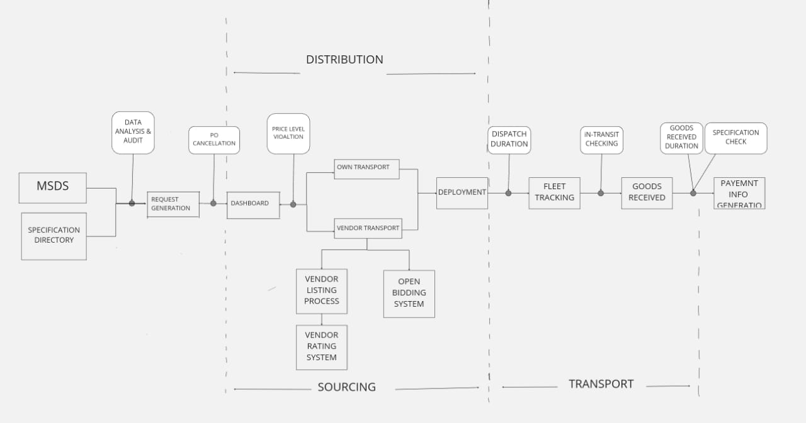

Legend
- MSDS –Material Safety Datasheet Specification
- Specification Directory – Product Grade Specification
- Check and Balance System between every process flows
- Diverging Branches are Decision Nodes

Key Features and Requirements
Core Features
- Fleet Tracking and Monitoring
  - GPS-enabled real-time location tracking.
  - Vehicle health monitoring (engine status, maintenance alerts).
  - Real-time monitoring within vehicles.
  - Alerts for deviations from set thresholds.
  - Audit logs for compliance reporting.

- Route Optimization
  - Delivery priority and load type considerations in routing.

- Fleet Maintenance Management`
  - Scheduling for vehicle maintenance.
  - Tracking maintenance history.
  - Spare parts inventory management integration.
  - Tracking licenses, permits, and vehicle inspections.
  - New Vehicle Acquisition

- Analytics and Reporting
  - Performance dashboards (fuel efficiency, delivery times, costs).
  - Customizable reporting tools.
  - Driver Management
  - Vehicle Management
  - Fuel Management
  - Maintenance and Repair
  - Accounting and Reporting
  - Legal Issues and Accident Management

- User Roles and Permissions
- Admin: Add/Change Vendors, Add/Change Specifications. Full access to all features, configuration, and analytics
- Fleet Manager: Access to tracking, scheduling, and maintenance features.
- Driver: Limited access via mobile app for route details and compliance alerts.
- Auditor: Read-only access to compliance and records.

- Integration Requirements
- ERP Integration: Sync with enterprise systems for seamless data exchange (inventory, orders, etc.).
- IoT Devices: Compatibility with sensors, trackers, and vehicle diagnostic systems.
- APIs: Open APIs for third-party integration.

- User Acceptance Testing (UAT)
  - UAT Scope: Clearly outline which features and functionalities will be included in the UAT phase, specifying any exclusions.
  - Target Users: Identify the user groups who will be involved in UAT, including their roles and responsibilities.
  - Test Environment: Describe the dedicated testing UAT environment
  - Test Scenarios: List key user flows and scenarios that will be tested during UAT, ensuring they cover critical business processes and user interactions.
  - Acceptance Criteria: Define clear and measurable criteria that must be met for the product to be considered "accepted" by the users during UAT.

Brain Station 23 observations:
- A dashboard that will contain 5-7 categories and the categories will be provided to us later.
- There are 2 primary points –
1. Source point/Loading point
2. Destination point/Unloading point
- The source points are across various locations in Bangladesh –
- Port
- Raw Material Warehouse
- Finished Feed Depot
- Feed Mill
- Feed Dealer
- Direct Customer
- Mango Pulp Factory
- Rice Kernel Factory
- Silage project
- WMP (Waste Management Plant)
- RMG Factory
- Machinery
- Fleet-wise generated reports which will include 10 fleets for each page.
Process diagram (As mentioned):
- Stakeholders and User Roles:
- Depot/Dealer: Initiates trip requests and tracks progress.
- Factory/Sales/Marketing Teams: Coordinate product dispatch and delivery.
- Trip Request Creation:
- Trip requests are created by specifying products and required specifications, along with the origin and destination points.
3. Purchase Order (PO/Challan) Generation:
- A PO is automatically generated upon trip request submission and becomes accessible on the admin dashboard.

4. Transportation Decision:
- The admin overseeing the dashboard evaluates truck availability at the loading point to decide between:
  - Own Transport: Internal fleet management.
  - Vendor Transport: External vendor selection.
5. Transport Selection Process:
- Own Transport:
  - Automated calculations generate trip costs based on distance and trip rate.
- Vendor Transport:
    - A vendor list with pre-defined trip ratings is displayed.
    - Alternatively, an open bidding system allows vendors to submit bids within a specific time frame.
    - Post-bid closing, all bid details are displayed, assisting the admin in choosing the best fleet vendor.
6. Final Trip Confirmation:
- After fleet selection:
  - Vehicle, transport, and PO details are shared with the trip origin and receiver for confirmation.
7. Loading Point Workflow (Phase 1):
Data recorded at the loading point includes:
- Entry and exit details:
  - Date-Time of Entry/Exit
  - Loading Start and End Time
- Vehicle and driver information:
  - Truck Number
  - Driver Name
  - Driver ID

- Loading metrics:
  - Scale Readings (Before and After Loading)
  - Gate-in and Gate-out KM
  - Fuel Readings (Gate-in and Gate-out)
8. Fleet Tracking (Phase 2):
- Live Tracking: IoT-enabled devices allow real-time tracking of vehicles, with geofencing capabilities can be an option.
- In-Transit Automated Checks: Notifications or updates are triggered for route deviations or delays.
9. Unloading Point Workflow (Phase 1):
Data captured during unloading includes:
- Entry and exit details:
  - Date-Time of Entry/Exit
  - Unloading Start and End Time
  - Location
- Vehicle and supplier information:
  - Truck Number
  - Driver Name
  - Driver ID
  - Supplier Name
- Unloading metrics:
  - Scale Readings (Before and After Unloading)
  - Sample Collection, Dispatch, and QC Data:
    - Sample Collection/Dispatch Time
    - Lab Code and Lab Report Date-Time
    - QC Start, End, and Pass Times
  - Gate-in and Gate-out KM
  - Fuel Readings (Gate-in and Gate-out)
10. Goods Received Verification (Phase 2):
- Mobile App Entry:
  - Assigned personnel log goods received, which is automatically shared with the audit team.
- Verification and Reconciliation:
  - Confirmation of goods sent and received triggers payment processing.
  - Payment information is shared with relevant departments:
    - Finance
    - Accounts
    - Dealers
Key supporting points:
- Checkpoints are necessary and important to make the VTS robust.
- Purchase-Order:
- All PO generation, cancellation, and alteration will be identified and shown as a report.
- Any cancellation or alteration will require the assigned personnel to fill in the remarks section.
- Without remarks the personnel will not be able to step in to the next page.
- An auditing process is needed for own transport and vendor transport to check for any violation or discrepancy.
- Vendors can have partial loading/partial unloading.
Report Analysis:
- The audit team will review all the reports for any sort of updates, issues, and alterations.
- Remarks on the report analysis will be a must to evaluate how the issues were resolved.
- Reports will be generated on deviations in the volume of products, fleet duration, fleet path, fleet sequence, and QC duration at the loading and unloading points.

Complexities facing:
- Manual entry of date and time can be manipulated.
- Different formats for writing are followed for weight measurement.
- Vehicle numbers are not correctly written.
- Unable to register vendor vehicles as there maybe different vehicles from time to time.

