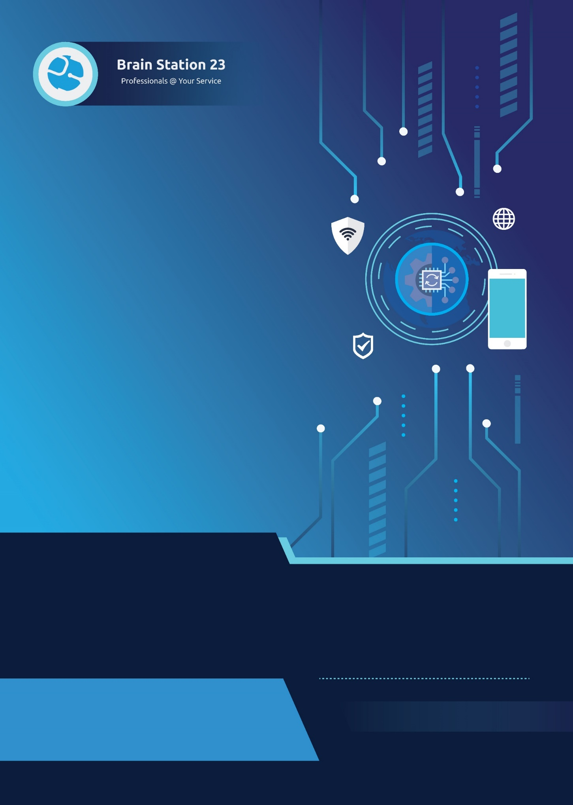


Date: January 20, 2025 2025
Product Name: Distribution & Fleet Management System (DFMS)
info@brainstation-23.com
www.brainstation-23.com

Table of Contents
Executive Summary: 3
Problem Statement: 3
Product Features: 3
Technology Specification: 5
Process Flow: 6
System Architecture: 6
Product Business Model: 11
Client Collaboration: 13
Conclusion: 15

Executive Summary:
Brain Station 23 is pleased to offer a specialized, product-based SaaS solution named Distribution & Fleet Management System (DFMS) designed to support Nourish Poultry’s Supply Chain Distribution and Fleet Management operations. The target users for this platform are Logistics Companies, Manufacturers, FMCG Companies, Government Distribution Programs, and 3PL Providers. This proposal outlines a service delivery approach built around a robust, scalable, enterprise-grade platform that streamlines and digitizes critical logistics processes.
Delivered as a Software-as-a-Service (SaaS) model, the DMFS platform enables end-to-end management of fleet operations—including trip scheduling, vehicle tracking, vendor coordination, compliance monitoring, and operational reporting. It includes a secure, web-based portal for administrative and logistics teams, along with mobile applications for field personnel such as drivers, auditors, and supervisors. The platform is modular, user-friendly, and capable of scaling with business growth—empowering Nourish with a reliable digital foundation for its day-to-day distribution and logistics operations.
While the platform includes a comprehensive set of standard features, BS23 also offers flexibility for future enhancements. If Nourish requires custom features beyond the existing scope of the product, such functionality can be developed under a cost-sharing model, ensuring long-term adaptability while optimizing development investment. With more than 18 years of experience delivering enterprise-grade digital solutions, BS23 is committed to providing continuous value through this SaaS offering, helping Nourish Poultry achieve operational excellence, transparency, and scalability in its supply chain operations.

Problem Statement:
Nourish Poultry currently lacks a centralized and integrated platform to manage fleet operations, trip scheduling, and reporting efficiently. At present, these processes are handled manually or through fragmented systems, resulting in operational inefficiencies, data inaccuracies, and limited visibility into fleet activities. The absence of a unified system hinders the ability to optimize routes, track vehicles in real-time, and analyze trip costs effectively. Additionally, the lack of automated data capture at loading and unloading points contributes to delays and inconsistencies in key metrics such as fuel usage, scale readings, and trip histories. To address these challenges, Nourish Poultry requires a comprehensive solution that streamlines fleet management, enhances data accuracy, ensures operational transparency, and improves resource utilization across all fleet operations.

Product Features:
The DMFS platform is a comprehensive, modular SaaS solution designed to digitize, automate, and optimize the logistics and fleet operations for Nourish Poultry. It supports all core distribution workflows—from procurement to last-mile delivery—while enabling transparency, operational control, and scalability.
- Multi-Tenant Access Control
Purpose: Support for multiple organizations with secure data separation.
Features:
- Tenant isolation with organization-level sandboxing
- Role-based access for HQ, T&D, POI, Vendor, Driver, Admin
- Audit logs to trace every action by user and role.
- Purchase Request & Purchase Order Management
Purpose: Manage and track procurement requests and approvals.
Features:
- PR submission form with item, quantity, and urgency fields
- PO creation from approved PRs
- Document versioning and approval workflows
- Real-time notifications to HQ and POI stakeholders
- Transport Order (TO) Planning
Purpose: Streamline the process of assigning transport for approved POs
Features:
- TO creation based on PO
- Smart vehicle and driver assignment suggestions
- Auto Trip Requests to vendors if no internal resources are available
- Transport schedule planning with visual calendar.
- Quality Control (QC) Workflow
Purpose: Ensure vehicle and goods quality at both origin and destination.
Features:
  - Pre-loading checks: mileage, fuel, vehicle status
  - Post-loading and unloading checks: packaging, seals, temperature
  - Mobile photo/video capture during QC
  - QC checklist templates with pass/fail logic.
- GPS Tracking & Monitoring
Purpose: Provide live visibility into vehicles and goods movement.
Features:
  - Real-time GPS tracking
  - Geofencing and auto-status updates
  - Trip route playback and ETA predictions
  - Mobile & web-based tracking dashboards.
- Vendor Bidding & Trip Assignment
Purpose: Manage third-party logistics efficiently.
Features:
- Trip requests sent to vendors
- Bidding interface with minimum bid logic
- Auto/manual bid winner selection
- Vendor compliance verification process
- Mobile App for Drivers and Helpers
Purpose: Enable field teams to participate in and update trip activities.
Features:
- Trip assignment view
- Route navigation
- QC checklist submission
- Offline mode with data sync
- Trip Costing and Invoicing
Purpose: Automate internal and vendor financial reconciliation.
Features:
- Trip cost calculator based on distance, load, vehicle type
- Invoice generation for internal fleet use
- Vendor invoice upload, review, and ERP integration
- Operational Dashboard
Purpose: Centralize operational insights and live tracking.
Features:
- Live map with vehicle & trip status
- KPIs like On-time % and QC pass rate
- Alerts for delays, exceptions
- Role-based data visualization
- Reporting & Analytics
Purpose: Enable data-driven decision-making.
Features:
- Custom report builder
- Pre-built analytics on trip cost, vendor performance, QC issues
- Export to Excel, PDF
- Integration with BI tools (Tableau, Power BI)
- Master Data & Configuration
Purpose: Provide a centralized control for system settings.
Features:
- Master data: vehicles, routes, drivers, vendors
- SLA configurations and rule settings
- QC checklist builder
- Barcode/QR support (optional)
- Integration Layer
Purpose: Connect with external systems and tools.
Features:
- RESTful API for ERP, GPS, Vendor apps
- Webhooks for real-time sync
- SSO and OAuth2 for identity integration
- Notification & Alerts Engine
Purpose: Keep users informed at the right time.
Features:
- Real-time alerts via push, SMS, email
- Configurable templates for each event type
- Alert log with delivery status tracking

Technology Specification:
- Backend: Python, Django
- Frontend: Vue.js
- Mobile: Flutter
- Cloud: AWS.

Process Flow:

System Architecture:

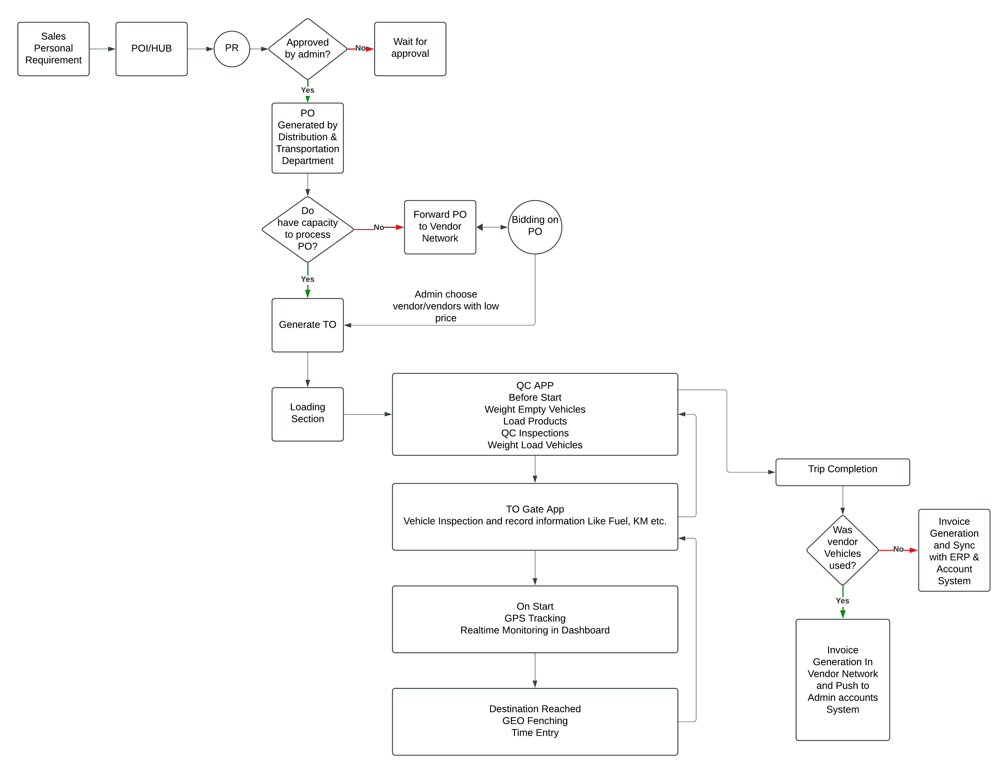
Figure 1: Process Flow Diagram

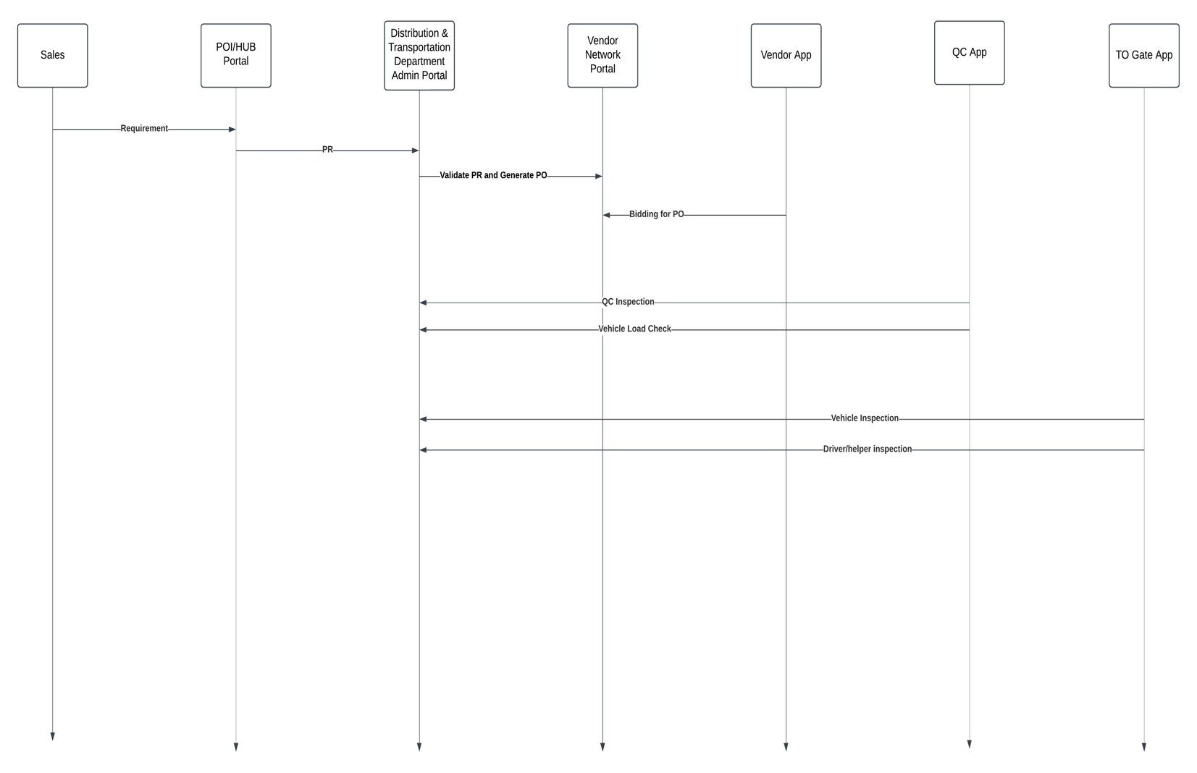
Figure 2: Sequence Diagram

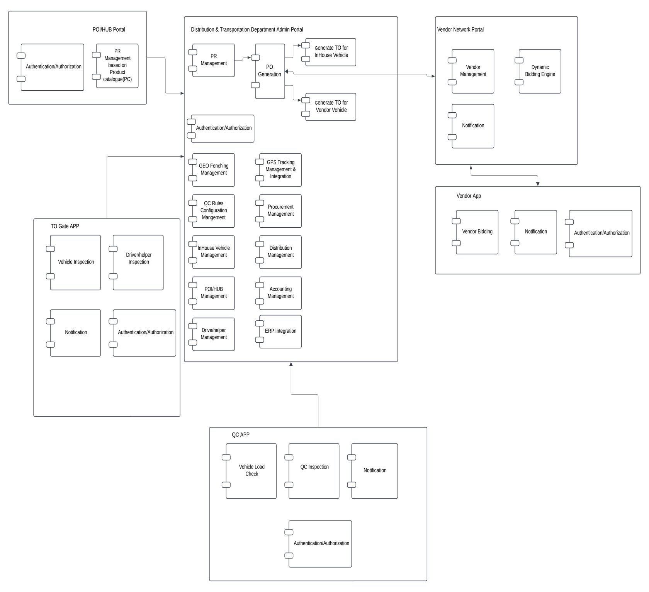
Figure 3: Component Diagram
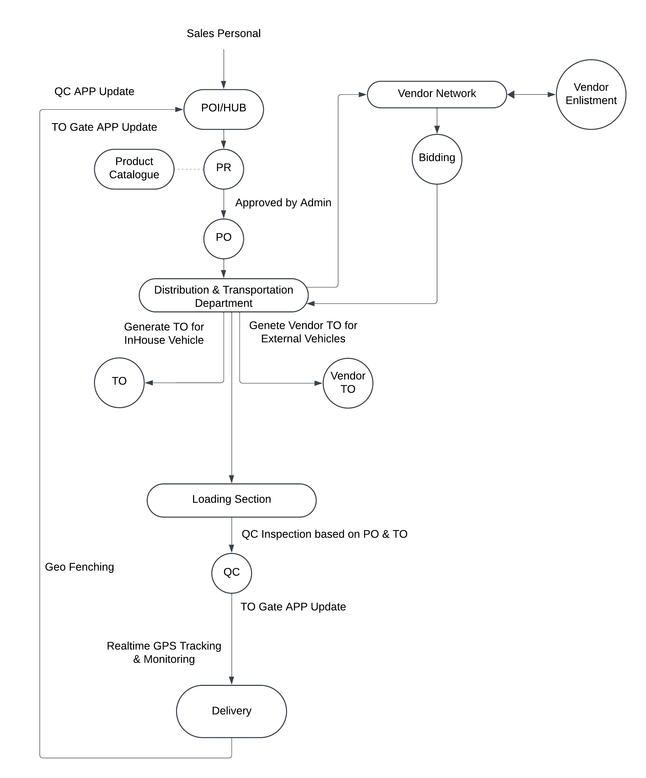
Figure 4: Context Diagram

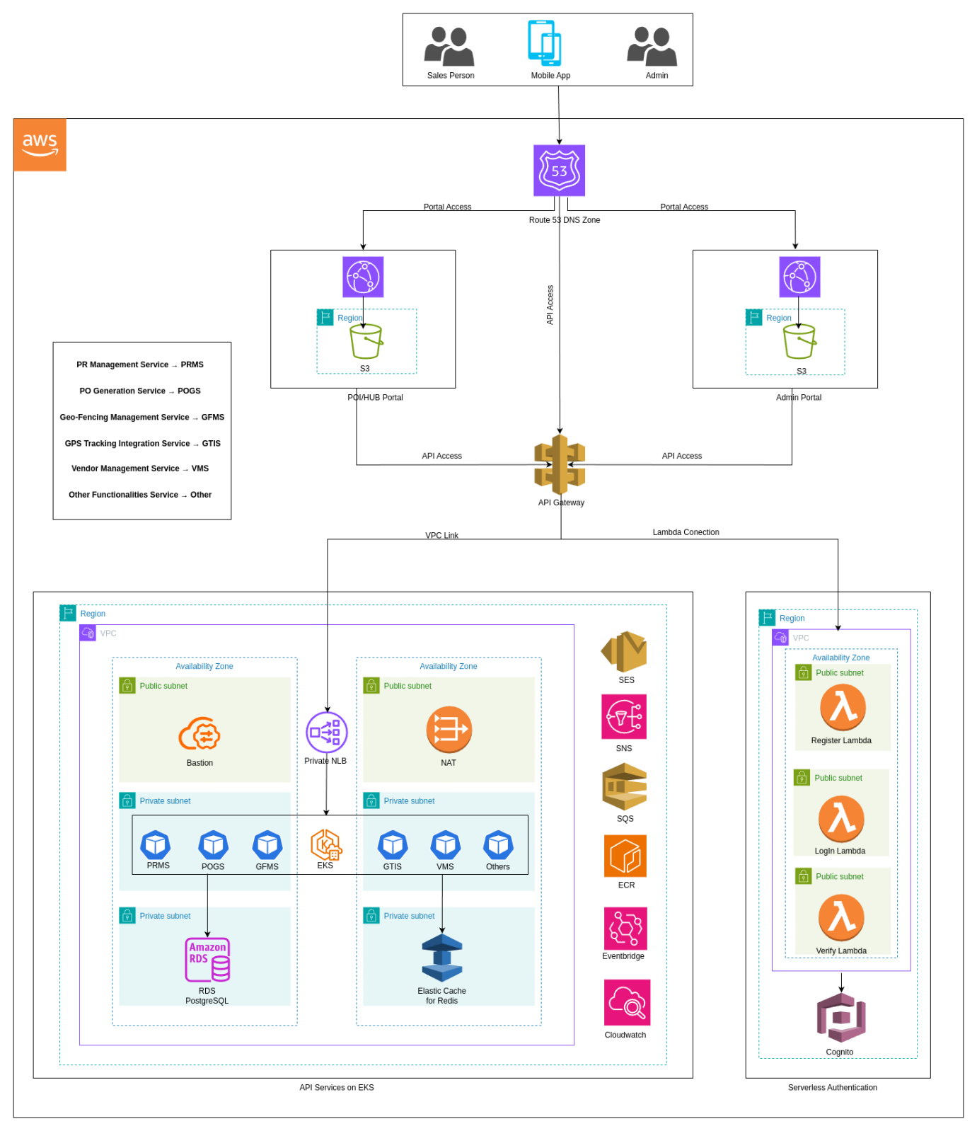
Figure 5: Infrastructure Architecture Diagram

Product Business Model:
Deployment Phase:
Advance Onboarding Price –
Phase | Scope | Timeline | UAT Period | Price (BDT)
1 | - Core business flow with PR, PO, TO  - Fleet management  - Trip planning  - QC supervisor app (Version 1),  - QC Audit workflows  - GPS/geofencing tracking  - Cost Invoice | 20 Weeks | 2 Weeks
2 | - Advance QC Workflows  - Fleet maintenance  - Operation Dashboard  - Basic Reporting Analytics  - Vendor management  - Vendor Basic App | 8 Weeks | 1 Week
3 | - Vendor Bidding  - Vendor Invoice Submits  - PO and TO without PR for internal transfer  - QC for raw materials transported from ports/vendors | 8 Weeks | 1 Week
4 | - Advance analytics  - Reporting dashboards  - Integration modules  - Driver-Helper App  - Advance Notifications  - Log and Alerts | 8 Weeks | 1 Week

Yearly Subscription Model:

Year 1 – Free Service Offerings Scope:
- Full access to platforms (web, mobile apps, GPS integration, etc.)
- Modular release of features based on readiness
- Maintenance, support, updates, bug fixes
- Training & client collaboration
Year 2 Onward – Subscription-Based Pricing Model:
Plan Tier | Ideal For | Description
Basic | Small teams with limited needs | Core features like trip scheduling, fleet tracking, QC supervisor app (Version 1), mobile audit workflows, GPS/geofencing, PO/TO integrations
Starter | Medium-sized Operations | Adds vendor management, PO/TO workflows, and mobile supervisor support.
Growth | Larger, growing businesses | Includes analytics, QC audits, geofencing, and GPS integration.
Enterprise | Large-scale enterprise clients | Full platform with all modules, API/ERP integration, and dedicated support.
Bundle Packages:
Features/Plan | Basic | Starter | Growth | Enterprise
Max Trips/Month | 25 | 100 | 500 | Unlimited
Internal Fleet Support | ✅ | ✅ | ✅ | ✅
Fleet & Vehicle Management | ✅ | ✅ | ✅ | ✅
Trip Scheduling | ✅ | ✅ | ✅ | ✅
Driver and Vehicle Assignment | ✅ | ✅ | ✅ | ✅
Mobile Supervisor/QC App | ✅ | ✅ | ✅ | ✅
PO/TO Management | ❌ | ✅ | ✅ | ✅
GPS Integration & Real-time Tracking | ❌ | ✅ | ✅ | ✅
Compliance & Digital Documentation | ❌ | ✅ | ✅ | ✅
Vendor Network Portal (Basic) | ❌ | ❌ | ✅ | ✅
Vendor Fleet Support | ❌ | ❌ | Limited | ✅
Performance Dashboards & Reports | ❌ | ❌ | ✅ | ✅
Geofencing Alerts | ❌ | ❌ | ✅ | ✅
Vendor Bidding + Contract Management | ❌ | ❌ | ❌ | ✅
ERP Integration/API Access | ❌ | ❌ | ❌ | ✅
QC Workflow | Basic | Standard | Advanced | Advanced with AI Powered
Reporting | Limited | Basic | Advanced | BI Integration
Support | Email | Email + Chat | SLA | Premium SLA

Client Collaboration:
We prioritize client collaboration as an essential component of our development process. We are committed to maintaining open communication, involving you in key decisions, and adapting the project based on your input. Here's how we plan to collaborate effectively:
Agile Methodology:
We follow Agile methodologies, which are inherently collaborative. We organize our work into sprints, typically lasting two to four weeks, with clear objectives and deliverables. This allows for regular feedback and adaptation, ensuring that the project stays aligned with your evolving needs.
Daily Scrum:
We will conduct daily standup calls with you. These brief meetings serve to provide updates on progress, discuss any challenges, and outline priorities for the day. This daily interaction ensures that we are aligned with your expectations and can promptly address any issues that may arise.
Regular Work Updates:
You will receive regular work updates, including progress reports, completed tasks, and any issues that require attention. Our goal is to keep you well-informed about project developments.
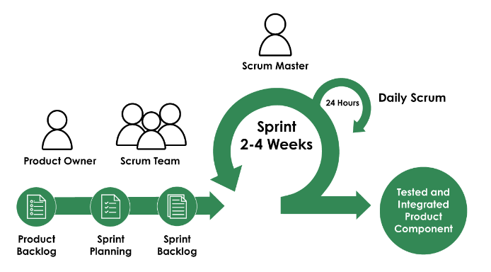
Figure: Scrum Flow
Sprint-wise Task Delivery:
Our development process is structured around sprints, each with specific goals and tasks. At the end of each sprint, you can expect a delivery of completed work. This allows you to review, provide feedback, and influence the project's direction.
Change Requests:
We fully embrace Agile's capacity to accommodate change. If you have change requests or evolving requirements, we will assess them within the Agile framework and incorporate them as needed. Your satisfaction with the final product is our priority.
Open Communication:
We emphasize open and transparent communication. You can reach out to us at any time with questions, feedback, or concerns. We believe that effective communication is the foundation of a successful collaboration.
Involving You in Key Decisions:
We value your insights and consider you an integral part of the decision-making process. Your input will guide critical choices, such as feature prioritization, design considerations, and adaptations to the project scope.
Adaptation Based on Your Input:
We are committed to adapting the project based on your input. Your feedback and preferences will be actively incorporated into the development process. Our goal is to ensure that the Super Market Product Price Comparison system aligns precisely with your vision and objectives.
Our collaboration plan follows Agile methodologies, emphasizes open communication, and involves you in key decisions. We are flexible, responsive, and dedicated to ensuring that the project evolves to meet your expectations. Your input is invaluable, and together, we will create a solution that not only meets but exceeds your needs.
Project Tracking, Control & Reporting
Project monitoring and control is a key component in the project management cycle. Properly executing this process will contribute significantly to successful project management. Project monitoring and control also provide information to support status reporting, progress measurement, forecasting and updating current cost and schedule information. We use Atlassian product for Project Monitoring, Tracking, Reporting and for Helpdesk.
Jira & Confluence
Confluence is a collaboration wiki tool used to help teams to collaborate and share knowledge efficiently. With confluence, we can capture project requirements, assign tasks to specific users, and manage several calendars at once with the help of Team Calendars add-on.
JIRA is a fully customizable platform for organizing teams around tasks, projects, and initiatives. Confluence has easy integration with JIRA, so these assets become an integrated piece. Combining they provide great visibility into software projects management.
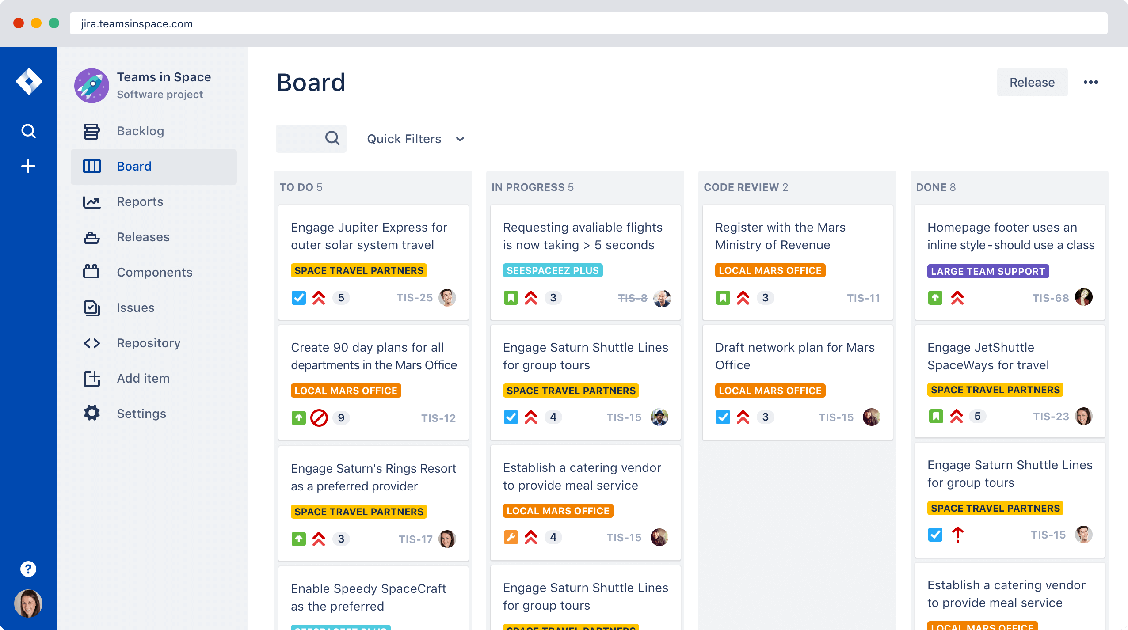
Figure: Jira

Conclusion:
The Distribution & Fleet Management System (DFMS) by Brain Station 23 presents a strategic, future-ready solution tailored to streamline Nourish Poultry’s supply chain and fleet operations. With a proven SaaS-based architecture, DFMS delivers the flexibility, scalability, and robustness needed to manage complex logistics workflows while reducing manual intervention and operational inefficiencies.

Through real-time visibility, automated processes, and seamless collaboration between all supply chain stakeholders—drivers, vendors, supervisors, and administrators—Nourish will be equipped with a powerful digital toolset to enhance accountability, responsiveness, and decision-making. Furthermore, our modular platform ensures that the solution can evolve with your growing operational needs, supported by Brain Station 23’s commitment to continuous improvement and enterprise-grade support.
We look forward to partnering with Nourish Poultry in its digital transformation journey—empowering your distribution ecosystem with innovation, control, and long-term value.



www.brainstation-23.com

