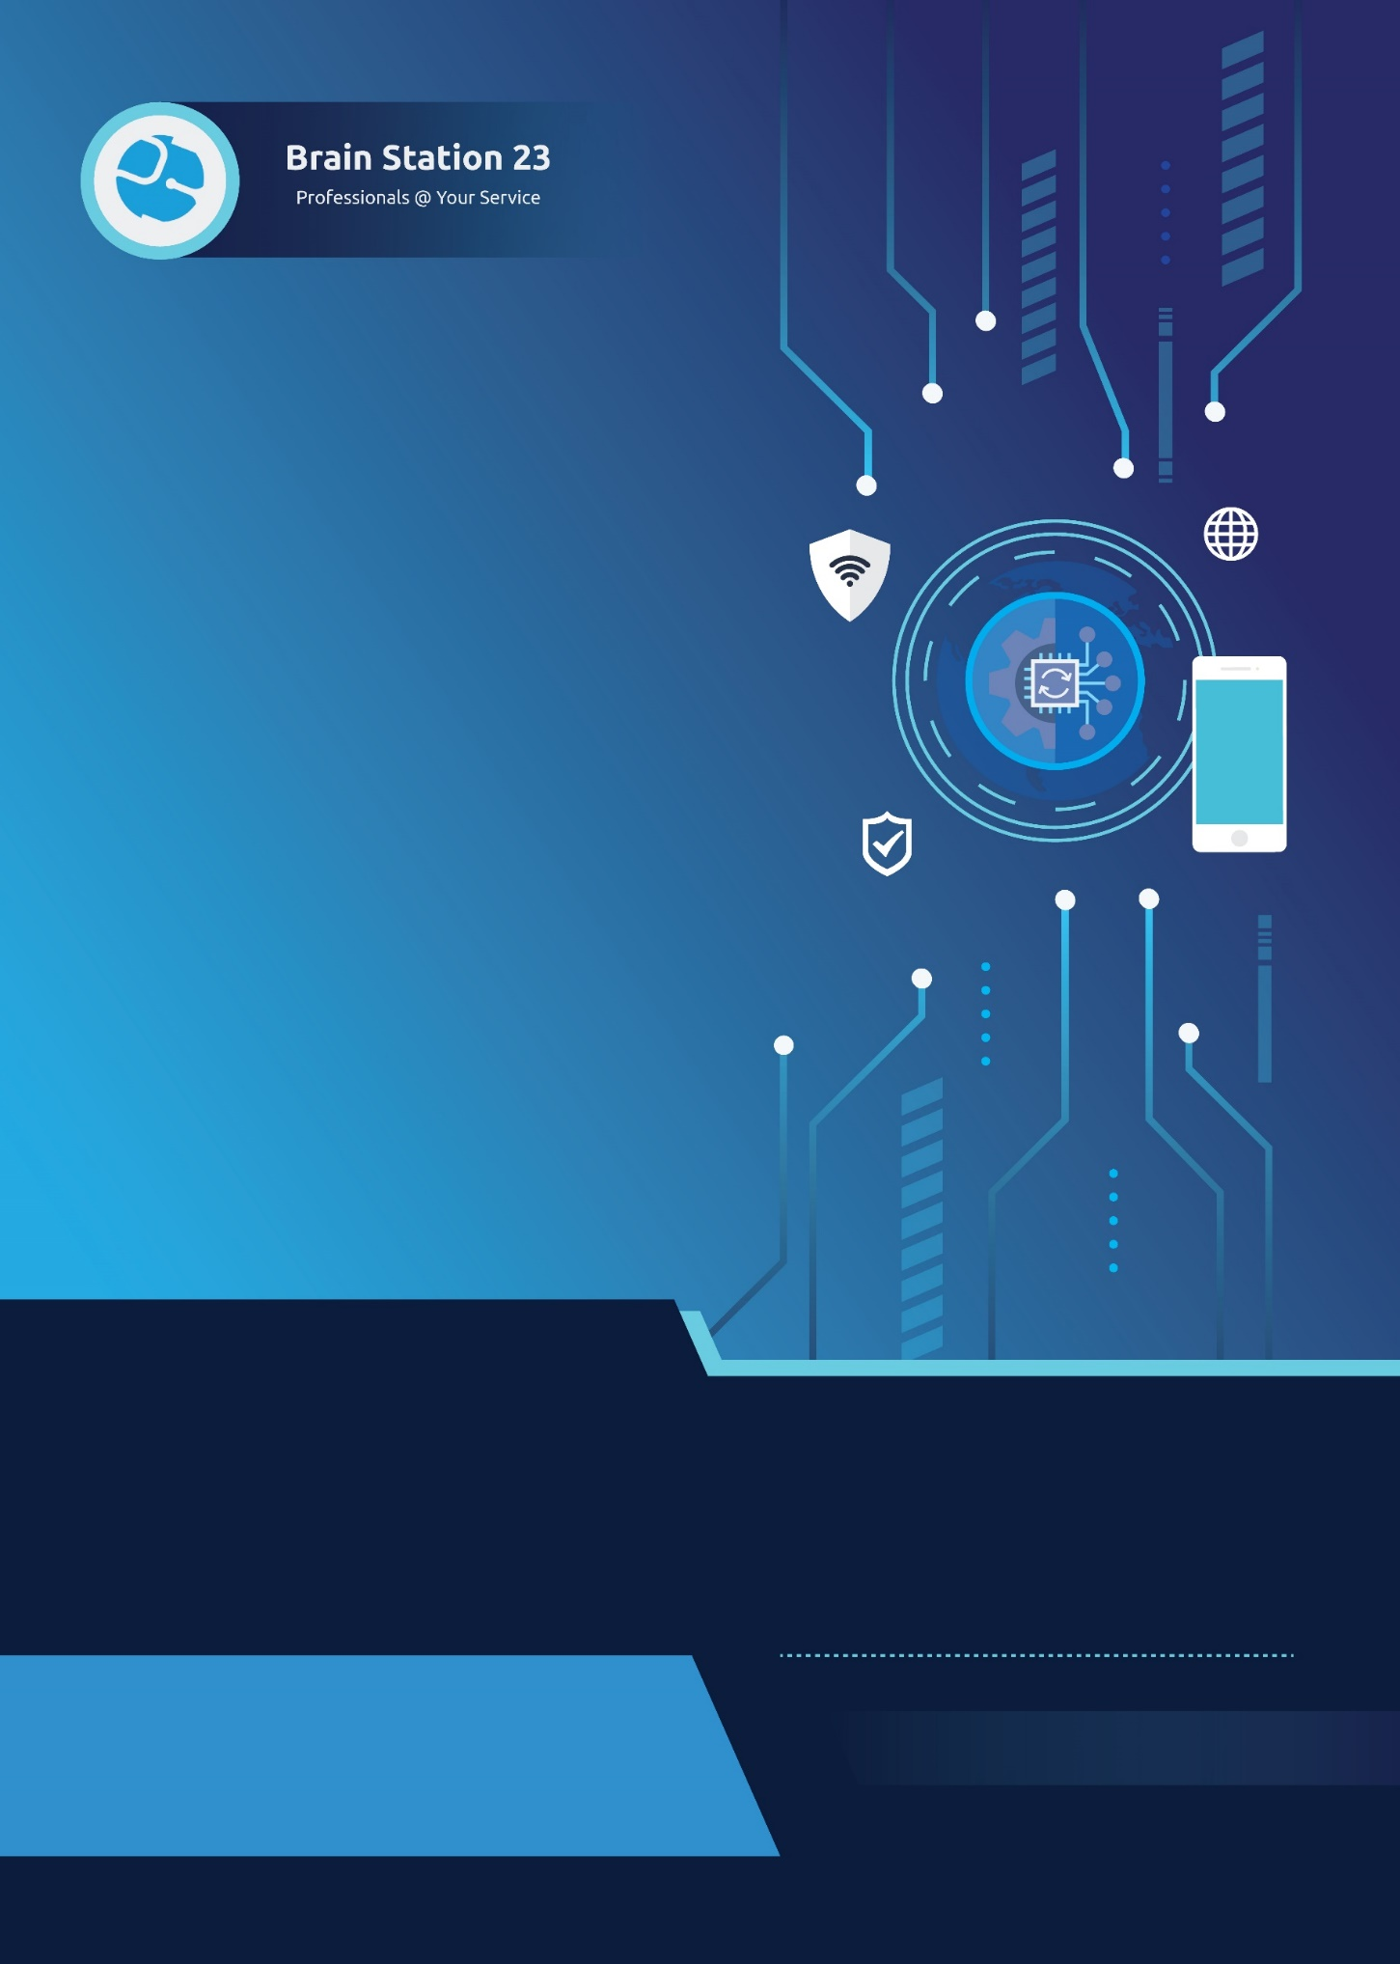


Product Name: Distribution & Fleet Management System (DFMS)

Proposed For: Nourish
Date: August 08, 2025
info@brainstation-23.com
www.brainstation-23.com

Table of Contents
Executive Summary: 3
Problem Statement: 3
Product Features: 3
Technology Specification: 5
Process Flow: 6
System Architecture: 7
Product Service Pricing Model: 11
Deployment Phase: 11
Yearly Subscription Model: 12
Conclusion: 13

Executive Summary:
Brain Station 23 is pleased to offer a specialized, product-based SaaS solution named Distribution & Fleet Management System (DFMS) designed to support Nourish Poultry’s Supply Chain Distribution and Fleet Management operations. The target users for this platform are Logistics Companies, Manufacturers, FMCG Companies, Government Distribution Programs, and 3PL Providers. This proposal outlines a service delivery approach built around a robust, scalable, enterprise-grade platform that streamlines and digitizes critical logistics processes.
Delivered as a Software-as-a-Service (SaaS) model, the DMFS platform enables end-to-end management of fleet operations—including trip scheduling, vehicle tracking, vendor coordination, compliance monitoring, and operational reporting. It includes a secure, web-based portal for administrative and logistics teams, along with mobile applications for field personnel such as drivers, auditors, and supervisors. The platform is modular, user-friendly, and capable of scaling with business growth—empowering Nourish with a reliable digital foundation for its day-to-day distribution and logistics operations.
While the platform includes a comprehensive set of standard features, BS23 also offers flexibility for future enhancements. If Nourish requires custom features beyond the existing scope of the product, such functionality can be developed under a cost-sharing model, ensuring long-term adaptability while optimizing development investment. With more than 18 years of experience delivering enterprise-grade digital solutions, BS23 is committed to providing continuous value through this SaaS offering, helping Nourish Poultry achieve operational excellence, transparency, and scalability in its supply chain operations.

Problem Statement:
Nourish Poultry currently lacks a centralized and integrated platform to manage fleet operations, trip scheduling, and reporting efficiently. At present, these processes are handled manually or through fragmented systems, resulting in operational inefficiencies, data inaccuracies, and limited visibility into fleet activities. The absence of a unified system hinders the ability to optimize routes, track vehicles in real-time, and analyze trip costs effectively. Additionally, the lack of automated data capture at loading and unloading points contributes to delays and inconsistencies in key metrics such as fuel usage, scale readings, and trip histories. To address these challenges, Nourish Poultry requires a comprehensive solution that streamlines fleet management, enhances data accuracy, ensures operational transparency, and improves resource utilization across all fleet operations.

Product Features Phase-wise Scope:
The DMFS platform is a comprehensive, modular SaaS solution designed to digitize, automate, and optimize the logistics and fleet operations for Nourish Poultry. It supports all core distribution workflows—from procurement to last-mile delivery—while enabling transparency, operational control, and scalability.

Key Modules and Features –
Phase 1 (MVP – 26 weeks)
Focus: Core Foundation, TR/TO Lifecycle, Fleet basic, Vendor Onboarding, Mobile field applications.
- Multi-Tenant Access Control
Purpose: Support for multiple organizations with secure data separation.
Features:
- Tenant isolation with organization-level sandboxing
- Role-based access for HQ, T&D, POI, Vendor, Driver, Admin
- Audit logs to trace every action by user and role.
- User Management & Authentication Service
Purpose: Secure user access and role-based system control.
Features:
- User role definitions (Admin, Logistics, Auditor, Vendor, Driver, Maintenance).
- Role-based access control.
- Secure login (MFA, SSO).
- User account lifecycle (create/modify/delete).
- Activity logs for audit.
- Vendor/driver onboarding workflows.
- Driver registration & vehicle assignment.
- Product Inventory Management (PIM)
Purpose: Centralized product data management with transport integration.
Features:
- Define and manage product categories, attributes, and specifications
- Catalogue design and data model configuration (Categories, Products, Attributes)
- Product catalogue management with transport and QC requirements
- Link products with specific transport requirements and constraints
- Transport Request (TR) and Transport Order (TO) Management
Purpose: Streamline the process of transport request creation and order processing.
Features:
- Define metrics for TR creation (product listing, quantity, pickup/drop locations, delivery date)
- On-demand TR creation at gate
- Handle internal transfers with product inventory tracking
- TO creation from TR with product-specific business logic after manual admin approval
- Automated TO creation from TR with product-specific business logic upon approval basis (Configurable - via admin/system)
- Trip Management and Tracking (Baseline)
Purpose: Complete trip lifecycle management with real-time monitoring.
Features:
- Assign vehicles based on product type, weight, and special requirements
- End-to-end trip management from creation to completion
- Partial delivery option with new vehicle assignment for incidents
- Integration with IoT devices for live vehicle monitoring
- Dynamic POI creation with geofencing boundaries and alerts
- Basic trip cost calculation (Distance-based, manual cost entry) and invoice generation
- ERP integration for financial data synchronization
- System-generated invoices with ERP synchronization
- Fleet and Vehicle Management
Purpose: Complete vehicle entity management and performance tracking.
Features:
- Vehicle registration with unique identifiers (Type, Capacity, Mileage, Purchase Information) and tracking
- 8/10 point checklist for vehicle licenses and health check renewals (TBD)
- Track vehicle assignments to TOs and utilization
- Assign vehicle, driver, and driver helper
- Allow TO sharing with Vendor Network Portal
- Manual workshop entry system for activities and costs
- Driver & Helper Management
Purpose: Complete driver lifecycle, helper and performance management.
Features:
- Driver registration with unique identifiers and profile management
- Driver-vehicle assignment and pairing management
- Track driver states (on trip, present/unassigned, absent) with driving hours via GPS
- Driver attendance captures for efficiency analysis (manual forms + GPS tracking)
- Driver helper registration and profile management
- Assign helpers to drivers based on route and product requirements
- Vendor Network Portal
Purpose: Comprehensive third-party logistics management platform.
Features:
- Region/location-based TO listing to vendors with app interface to observe active bids, active trips, completed trips
- Enable real-time updates on TO status for vendors
- Vendor fleet management and enlisting driver/helper information
- Distribution Hub/POI/Warehouse Management
Purpose: Dynamic point of interest and warehouse operations management.
Features:
- Develop dynamic POI management module (TBD)
- CRUD operations - add, edit, and remove POIs in real-time
- Integrate POI data with TO creation and live GPS monitoring
- GPS Tracking and Geofencing
Purpose: Real-time location tracking with intelligent boundary management.
Features:
- Define geofencing boundaries for POIs
- Track vehicle arrival at POI geofence
- Log arrival and departure times for dwell time tracking
- Quality Control (QC) Workflow
Purpose: Comprehensive quality assurance throughout the transport process.
Features:
- Basic inspection for in-premise stations with time-lapse monitoring
- Mobile Application
Purpose: Comprehensive quality assurance throughout the transport process.
Features:
- View of assigned trip, route navigation via driver mobile interface
- Comprehensive QC inspection interface
- Photo/video capture capabilities for inspection documentation for QC interface
- Mobile access to vendor portal with bidding and trip management
- System Automation and Integrations
Purpose: Automated processes and external system connectivity
Features:
- Automate TO completion and invoice creation
- Sync submitted invoices with ERP/Accounting system
- Develop integration APIs for syncing invoices
- System supporting partial claims and provide flexibility to raise additional claims as required
- Integration with recommended VTS providers (TBD)
- Notification and Alert Service
Purpose: Intelligent stakeholder communication and alert management.
Features:
- Standard alerts for TO updates and operational events
Phase 2 (MVP – 13 weeks)
Focus: Fleet Optimization, Billing, QC enhancement, Analytics, and Audits.
- Transport Request (TR) and Transport Order (TO) Management
Purpose: Streamline the process of transport request creation and order processing.
Features:
- System suggestions to conjoin multiple TRs for efficient distribution based on destination and product type
- Trip Management and Tracking Service
Purpose: Complete trip lifecycle management with real-time monitoring.
Features:
  - Route-price analysis for vehicle decisions with AI/ML integration
  - Sync with accounting systems for financial data
- Fleet and Vehicle Management Service
Purpose: Complete vehicle entity management and performance tracking.
Features:
  - Treat vehicles as individual entities with utilization tracking (kilometers, fuel, maintenance, parts, lifecycle)
  - Fleet health dashboard showing vehicle health, availability, and maintenance status
  - Individual vehicle utilization metrics and efficiency monitoring
  - Preventive maintenance scheduling with trip planning impact
  - Manual entry system for workshop activities, costs, problems, estimated/actual time within vehicle management
  - Vehicle downtime logging with reasons and availability impact
- Fuel Management System
Purpose: Comprehensive fuel consumption tracking and cost management.
Features:
  - Track mileage, fuel intake, and calculate consumption per kilometer
  - Capture current mileage readings and refuel entries
- Driver and Helper Registration and Management
Purpose: Complete driver lifecycle, helper and performance management.
Features:
- Driver license validation, renewal tracking, and certification management
- Vendor Network Portal
Purpose: Comprehensive third-party logistics management platform.
Features:
- Enable vendors to merge multiple trips into one invoice
- Vendors can view invoices with consolidated billing capability
- Dispute resolution system for vendors
- Vendor rating system based on performance
- GPS Tracking and Geofencing
Purpose: Real-time location tracking with intelligent boundary management.
Features:
- GPS location-based vehicle maintenance tracking
- Quality Control (QC) Workflow
Purpose: Comprehensive quality assurance throughout the transport process.
Features:
- Capture pre-loading vehicle weight with product-specific QC functionality (manual input of metrics)
- Record and validate goods quality and quantity during loading
- Perform QC checks for delivered goods (quality, quantity).
- Attach images/videos of delivered goods for documentation
- Manual entry with later upload capability for low-connectivity areas
- Mobile Applications
Purpose: Field operations enablement through mobile interfaces.
Features:
- Mobile access to vendor portal with bidding and trip management (Vendor App)
- System Automation and Integration
Purpose: Automated processes and external system connectivity.
Features:
- Develop integration APIs for syncing invoices.
- System Audit & Compliance
Purpose: Complete audit trail and regulatory compliance management.
Features:
- Audit log for system events (user actions, TO/TR edits, cost changes)
- Incident Handling
Purpose: Document exceptions or deviations for audit and accountability.
Features:
- Incident reporting during trips or operations
- Bypass log entry with justification
- Categorization and severity tagging
- Incident logs for audit team reference
Phase 3 (MVP – 13 weeks)
Focus: Enterprise-grade expansion, compliance, predictive analytics, multilingual support.
- Purchase Request & Purchase Order Management
Purpose: Manage and track procurement requests and approvals.
Features:
- PR submission form with item, quantity, and urgency fields
- PO creation from approved PRs with approval workflows
- Document versioning and approval workflows
- Real-time notifications to HQ and POI stakeholders
- Link PO with transportation operations (TO generation)
- Transport Request (TR) and Transport Order (TO) Management
Purpose: Streamline the process of transport request creation and order processing.
Features:
- AI/ML-based suggestions for own vs rental vehicle optimization.
- Trip Management and Tracking Service
Purpose: Complete trip lifecycle management with real-time monitoring.
Features:
  - System-generated invoices with ERP synchronization
- Fuel Management System
Purpose: Comprehensive fuel consumption tracking and cost management.
Features:
  - Monitor vehicle fuel performance (mileage, wear and tear)
  - Fuel expense tracking and reporting with cost analysis
- Driver and Helper Registration and Management
Purpose: Complete driver lifecycle, helper and performance management.
Features:
- Performance-based driver rating and evaluation system
- Monitor driver performance metrics, delivery times, and efficiency
- Vendor Network Portal
Purpose: Comprehensive third-party logistics management platform.
Features:
- Vendor self-registration with company preference selection
- Vendor fleet management and driver/helper information
- Mobile Applications
Purpose: Field operations enablement through mobile interfaces.
Features:
- Driver attendance captures through mobile app with GPS integration
- Workshop Management Service
Purpose: Vehicle maintenance operations and resource management.
Features:
- Vehicle maintenance logging and scheduling
- System Automation and Integration
Purpose: Automated processes and external system connectivity.
Features:
- Setup alerts for TO updates (assignment, bidding, loading, delivery)
- Multi-Language Support
Purpose: Provide accessibility in multiple languages for broader user adoption.
Features:
- Language toggle option in web and mobile interfaces
- Maintain dictionaries for system texts, labels, menus
- Vendor app bilingual (English & Bangla)
- Multilingual support in notifications
- Advanced Analytics and Reporting
Purpose: Data-driven insights and business intelligence.
Features:
- Basic reports and dashboards with custom report generation (up to 5 reports initially)
- Monitor on-time delivery rates, average dwell times, and vehicle uptime
- Comprehensive fleet health dashboard with utilization and maintenance insights
- Notification & Alert Service
Purpose: Intelligent stakeholder communication and alert management.
Features:
- Standard alerts for TO updates and operational events
- Notification triggers for vehicle license renewals and health check.

Technology Specification:
- Backend: Python, Django
- Frontend: Vue.js
- Mobile: Flutter
- Cloud: AWS.

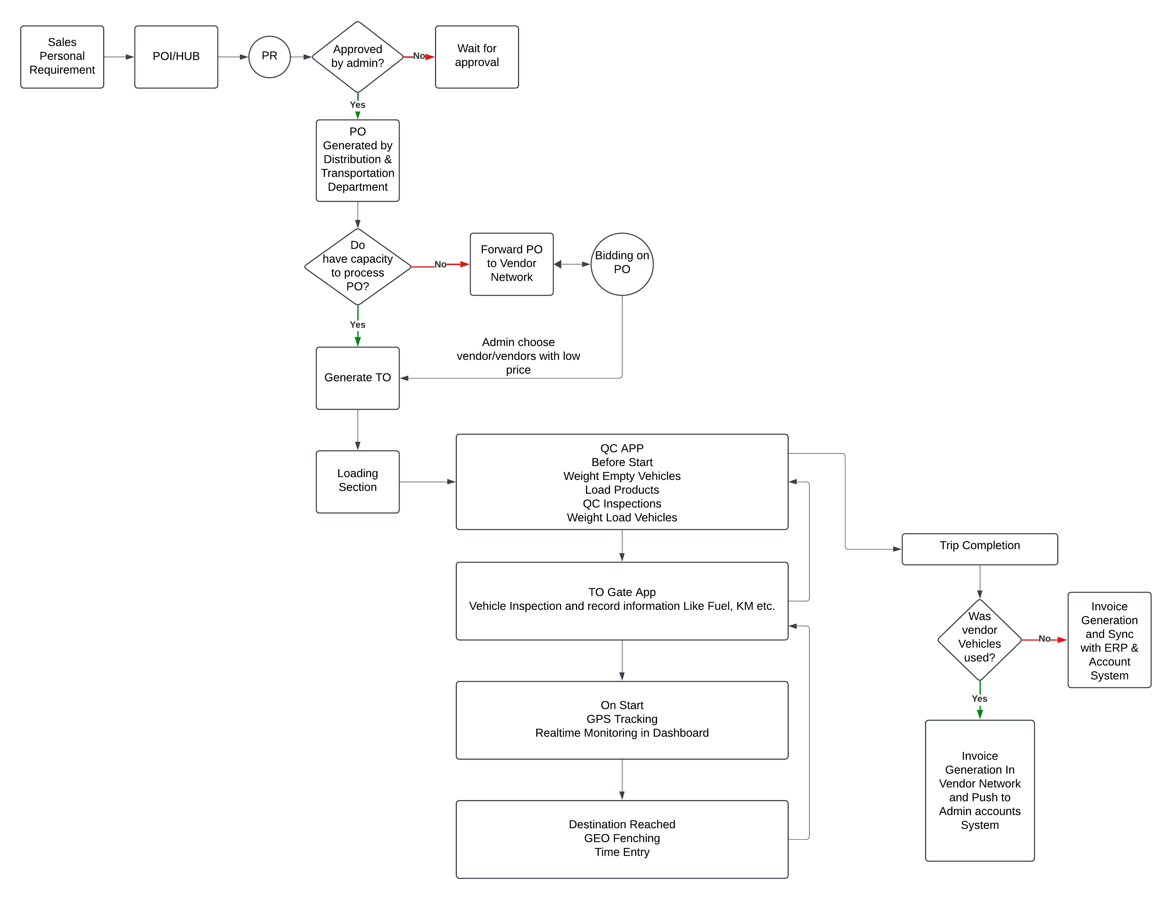
Process Flow:
Figure 1: Process Flow Diagram

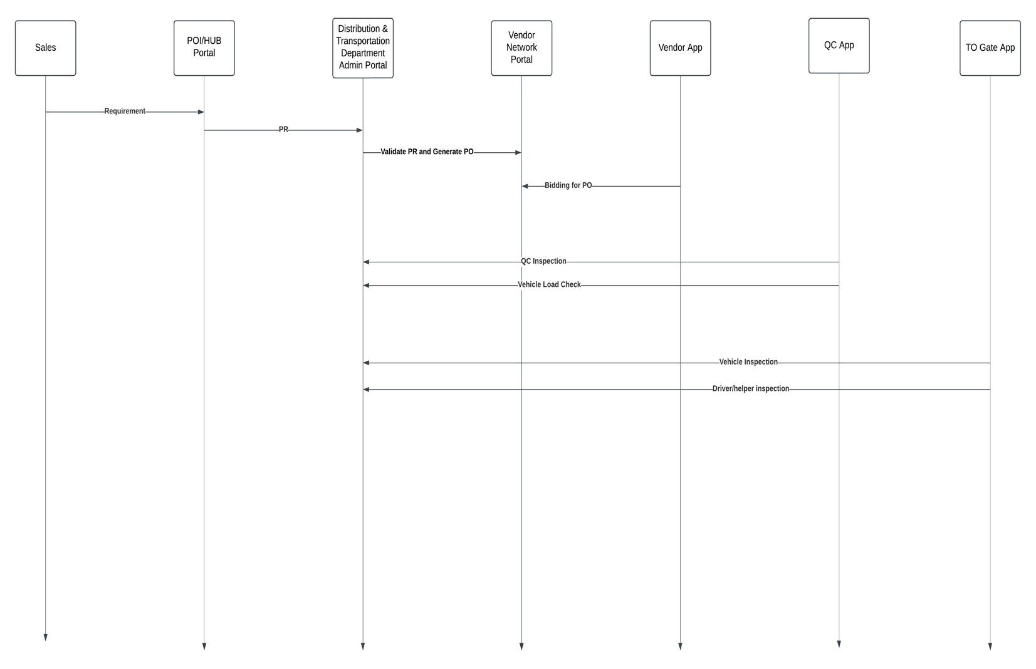
System Architecture:
Figure 2: Sequence Diagram

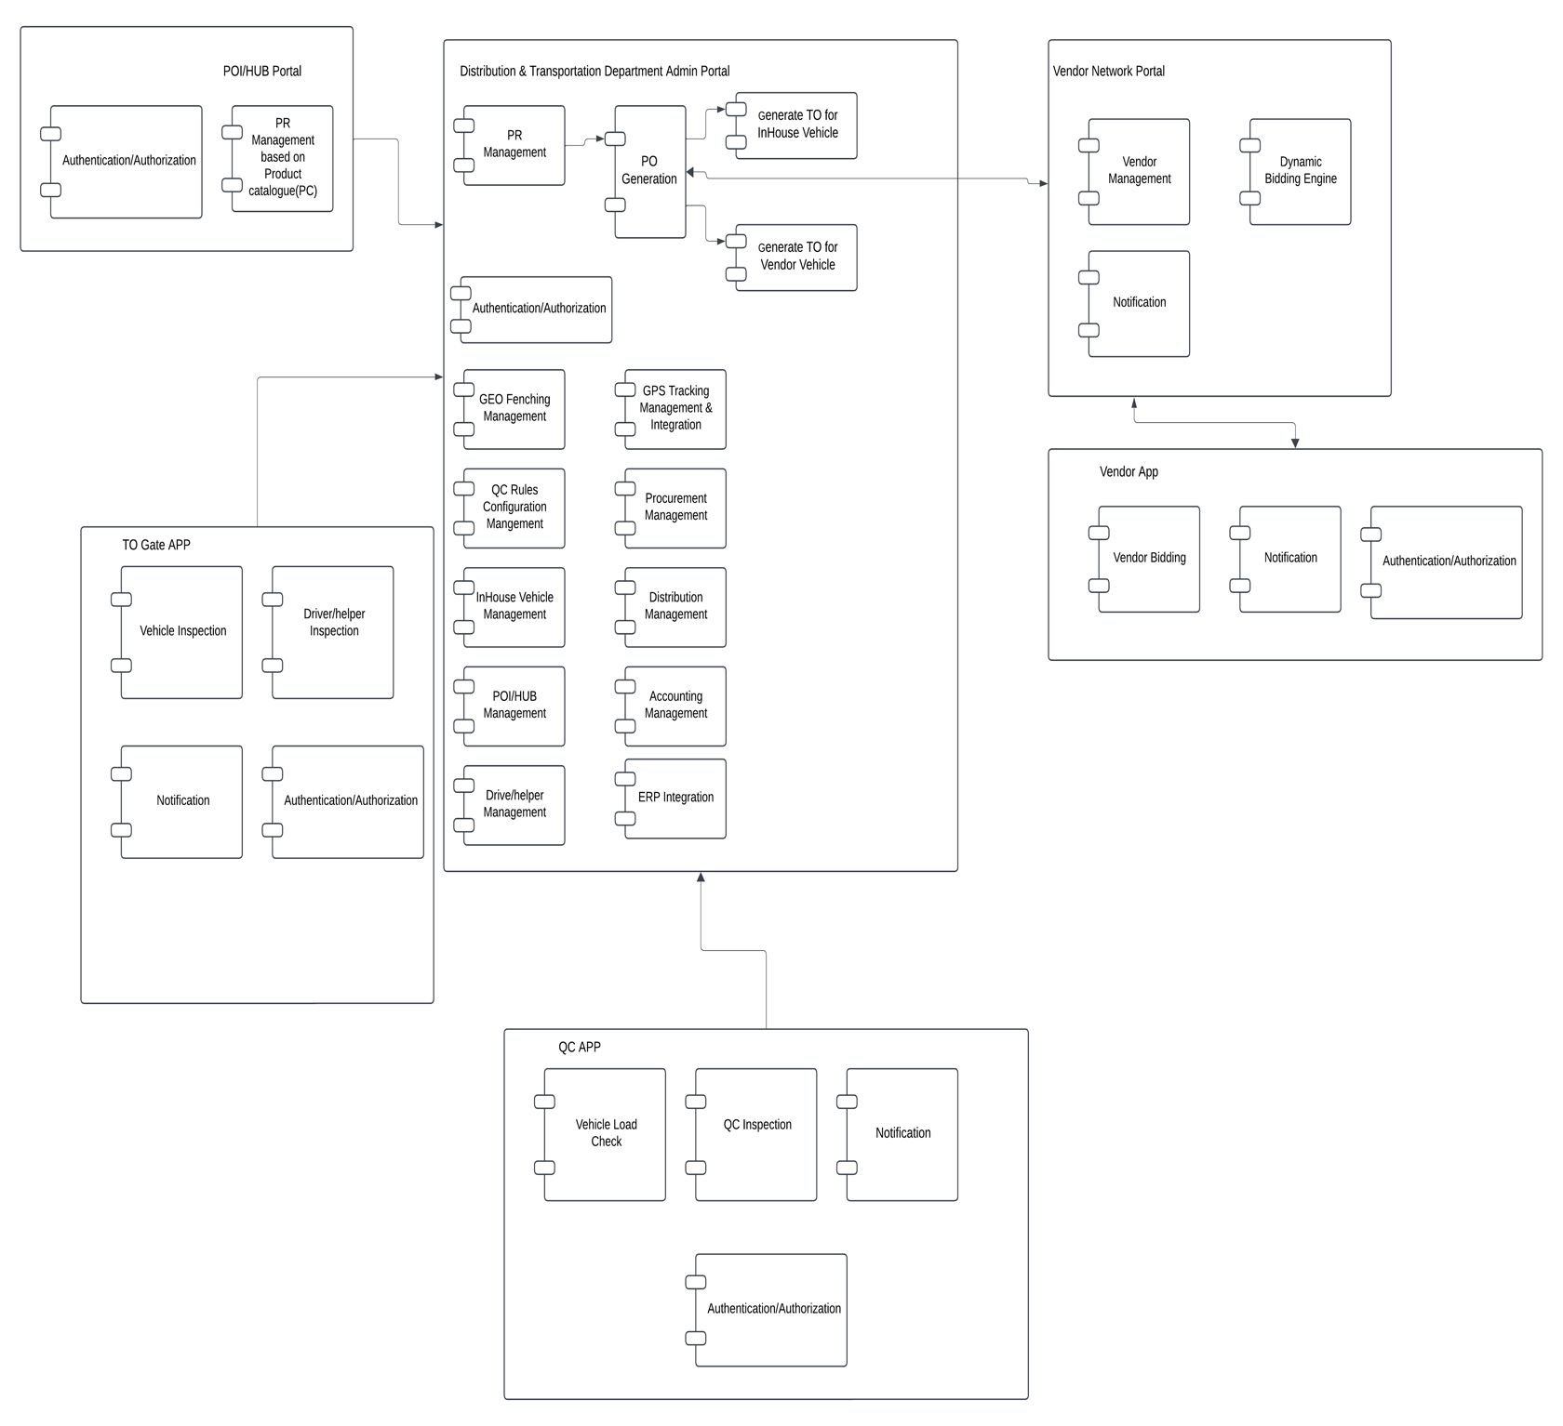
Figure 3: Component Diagram
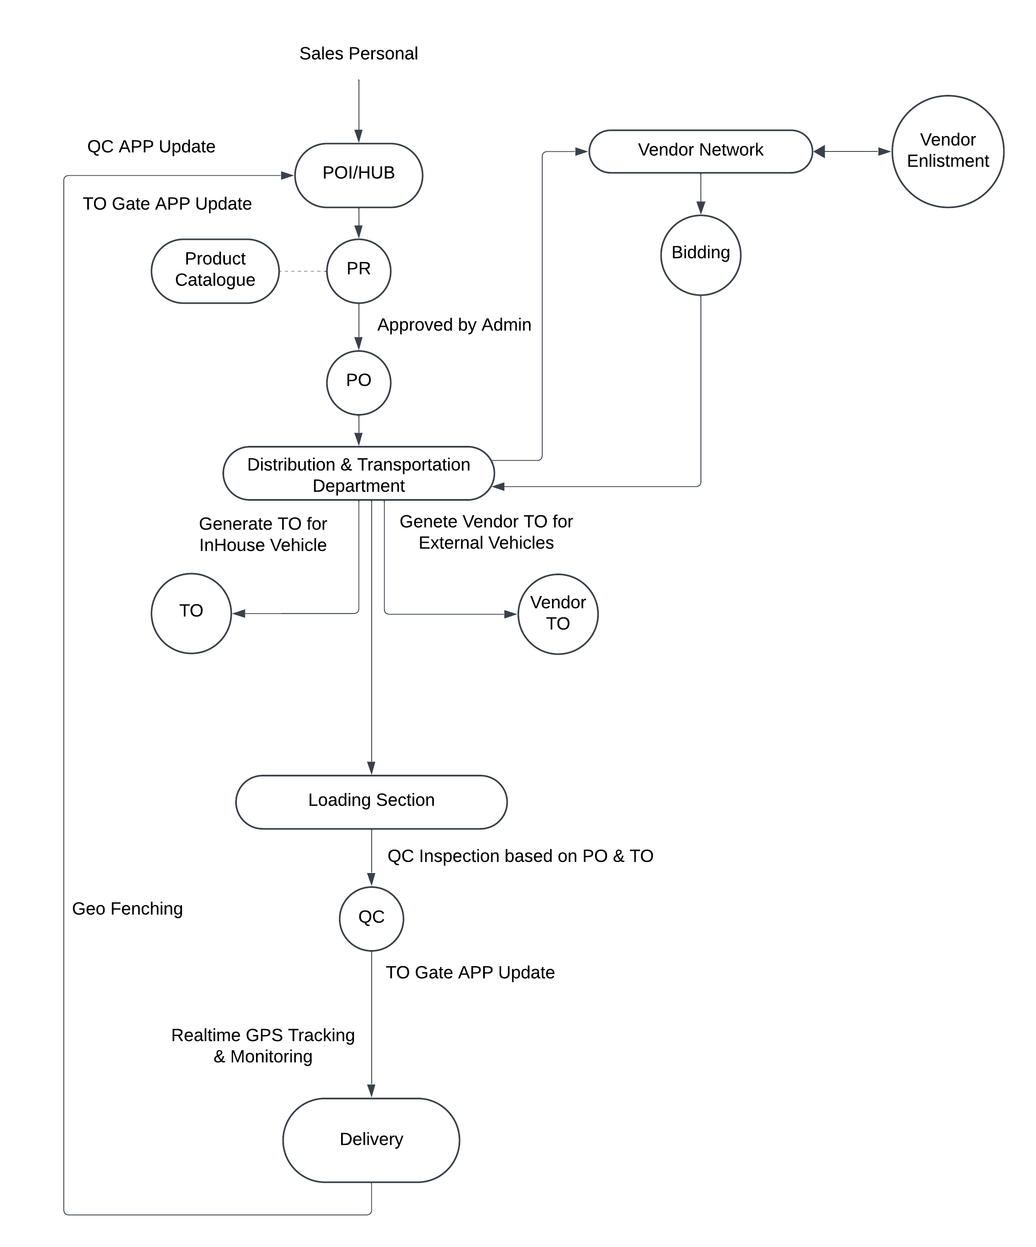
Figure 4: Context Diagram

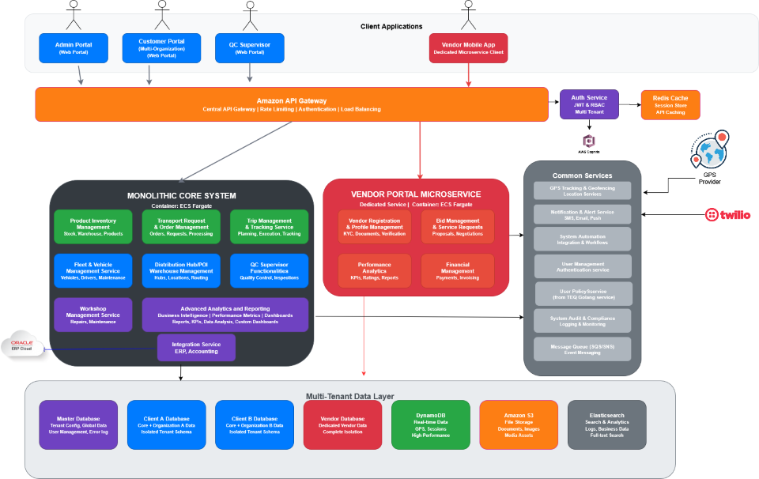
Figure 5: Infrastructure Architecture Diagram

Product Service Pricing Model:

Deployment Phase:
Advance Onboarding Price – BDT
Phase | Scope | Timeline | UAT Period | Price (BDT)
1 (MVP Scope) | - User & Entity Management (drivers, helpers, vehicles, vendors)  - TR/TO creation and trip lifecycle execution  - GPS tracking & geofencing with POI  - QC Supervisor App v1 (basic inspections)  - Basic costing & draft invoicing  - Vendor portal (bidding, TO updates)  - Mobile apps (Driver, Vendor, QC) | 26 Weeks | 2 Weeks
2 | - TR optimization (conjoinment, route-price)  - ERP finance integration  - Fleet health dashboards & preventive maintenance  - Fuel logs (refuel, mileage, consumption)  - Advanced QC (pre-load, delivery, offline mode)  - Vendor invoicing & claims processing  - KPI dashboards (on-time %, QC, trip cost)  - System audit logs | 13 Weeks | 1 Week
3 | - AI/ML optimization (own vs rental, routes, vendor ranking)  - PR & PO workflows with internal transfers  - Automated invoicing with ERP sync  - Vendor registration & invoice submission  - Workshop management module  - Predictive fuel monitoring & cost dashboards  - Driver KPIs & rating system  - Advanced alerts & multilingual support  - Notifications & alerts (trip delays, license renewals, compliance warnings) are automated.  - System supports English/Bangla (UI, mobile, notifications). | 13 Weeks | 1 Week
Total Pricing (Onboarding + 4 Phases): 41,00,000 BDT
In Words: Forty-one lakh BDT
Note:
• This Costing Covers all the Deployment Costs.
• During the deployment phase there will be no Yearly Subscription Fee
• This Total costing is excluded VAT, TAX or any Govt. Duty.

Yearly Subscription Model:
Subscription-Based Pricing Model:
Plan Tier | Ideal For | Monthly Pricing (BDT) | Yearly Pricing (BDT)
Basic | Small Logistics team with limited needs | 10,000 | 1,10,000
Starter | Medium-sized Operations | 35,000 | 4,00,000
Growth | Larger, growing businesses | 75,000 | 8,50,000
Enterprise | Large-scale enterprise clients | 1,25,000 | 13,75,000
Note:
• This Costing Covers all the Cloud, Support and Maintenance Costing.
• Yearly Subscription Free is non-refundable
• This Total costing is excluded VAT, TAX or any Govt. Duty
Bundle Packages:
Features/Plan | Basic | Starter | Growth | Enterprise
Max Trips/Month | 25 | 100 | 500 | Unlimited
Max Vehicles | 8 | 25 | 100 | Unlimited
Internal Fleet Support | ✅ | ✅ | ✅ | ✅
Fleet & Vehicle Management | ✅ | ✅ | ✅ | ✅
Trip Scheduling | ✅ | ✅ | ✅ | ✅
Driver and Vehicle Assignment | ✅ | ✅ | ✅ | ✅
Mobile Supervisor/QC App | ✅ | ✅ | ✅ | ✅
PO/TO Management | ❌ | ✅ | ✅ | ✅
GPS Integration & Real-time Tracking | ❌ | ✅ | ✅ | ✅
Compliance & Digital Documentation | ❌ | ✅ | ✅ | ✅
Vendor Network Portal (Basic) | ❌ | ❌ | ✅ | ✅
Vendor Fleet Support | ❌ | ❌ | Limited | ✅
Performance Dashboards & Reports | ❌ | ❌ | ✅ | ✅
Geofencing Alerts | ❌ | ❌ | ✅ | ✅
Vendor Bidding + Contract Management | ❌ | ❌ | ❌ | ✅
ERP Integration/API Access | ❌ | ❌ | ❌ | ✅
Notification | App | App, Email | App, Email, SMS | App, Email, SMS, Incident Call
QC Workflow | Basic | Standard | Advanced | Advanced with AI Powered
Reporting | Limited | Basic | Advanced | BI Integration
Support | Email | Email + Chat | SLA | Premium SLA

Service Level Highlights:
- Customization Effort Limit:
A defined scope of customization or development effort will be included at no additional cost post-subscription initiation. Any effort beyond this threshold may be billed separately, subject to prior agreement.
- Ongoing System Updates:
The platform will receive regular feature enhancements and updates. All existing subscribers will receive these updates in accordance with the active subscription policy.
- Trial Period:
A 6-month trial period will be offered following the completion of the initial development phase, allowing customers to evaluate the system before standard subscription billing begins.
- Subscription Rate Adjustment:
Subscription fees are subject to change based on fluctuations in the USD exchange rate. Any adjustments will be communicated in advance.

Conclusion:
The Distribution & Fleet Management System (DFMS) by Brain Station 23 presents a strategic, future-ready solution tailored to streamline Nourish Poultry’s supply chain and fleet operations. With a proven SaaS-based architecture, DFMS delivers the flexibility, scalability, and robustness needed to manage complex logistics workflows while reducing manual intervention and operational inefficiencies.
Through real-time visibility, automated processes, and seamless collaboration between all supply chain stakeholders—drivers, vendors, supervisors, and administrators—Nourish will be equipped with a powerful digital toolset to enhance accountability, responsiveness, and decision-making. Furthermore, our modular platform ensures that the solution can evolve with your growing operational needs, supported by Brain Station 23’s commitment to continuous improvement and enterprise-grade support.
We look forward to partnering with Nourish Poultry in its digital transformation journey—empowering your distribution ecosystem with innovation, control, and long-term value.



www.brainstation-23.com

