Department of Physics
Ph.D. Preliminary Examination

January 2004

Quantum Mechanics

Please do 4 of the 5 problems
Begin each problem on a separate page

Possibly useful formulas:

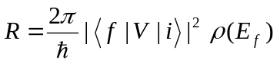

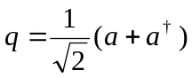
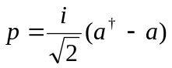
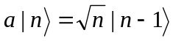
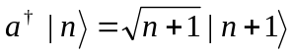

- Calculate the lowest order Born cross section for an electron scattering from the three-dimensional potential:
V(r)=Ae^{-Kr} .

- A particle of mass m and energy E is moving in the potential
z<0
V_{o}
z=0
z>0
V(x,y,z)=0, z<0
V(x,y,z)=V_{o}, z≥0.
Assume E>V_{o}>0.

- It the particle is incident from z<0 perpendicular to the z-axis, what is the probability that it will penetrate to z>0?
- If the particle is incident from z<0 at an angle θ relative to the z-axis, what is the probability that it will penetrate to z>0?
- For (b) above, at what angle will it propagate in the region z>0?

- A complex potential energy may be used to describe the decay of a particle of mass m in a bound state of a potential well. Consider the case of a complex delta function potential in one dimension (with U and Y real, positive constants):
V(x)=-(U+iY)δ(x)
  - Determine the wave function and energy of the bound state before the decay (do not bother to normalize the wave function).
  - Find the time dependent wave function Ψ(x,t) (there is no need to normalize).
  - At what rate does the probability of finding the particle in the state decay?

- The Hamiltonian of a one-dimensional harmonic oscillator is
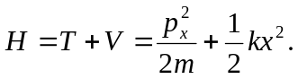
Considering the n^{th} state and employing the raising a† and lowering a operators,
- determine the following expectation values: <x>, <p_{x}>, <x²>, <p_{x}²>,<T>, <V>, and total energy <E>;
- calculate the minimum uncertainty product Δx⋅Δp_{x.}

- Consider the wave equation of an electron in a weak periodic potential U(x) for a linear (one-dimensional) lattice with periodicity a. Both the wave functions and the potential may be expanded as a Fourier series in the reciprocal lattice vectors G.
  - Write down a general equation relating the coefficients of the expansions.
  - Deduce an approximate solution for the wave function near the zone boundary.
  - In the same approximation, find an expression for the imaginary part of the wave vector in the energy gap at the zone boundary.
  - Give the explicit result for Im(k) near the center of the gap and discuss its significance.

