There is a loop on the first could slides I can’t get out of on these two slides…..

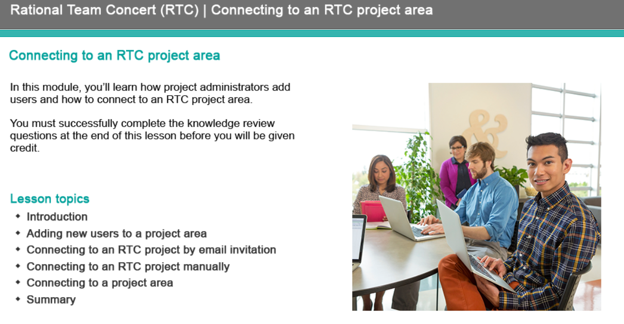

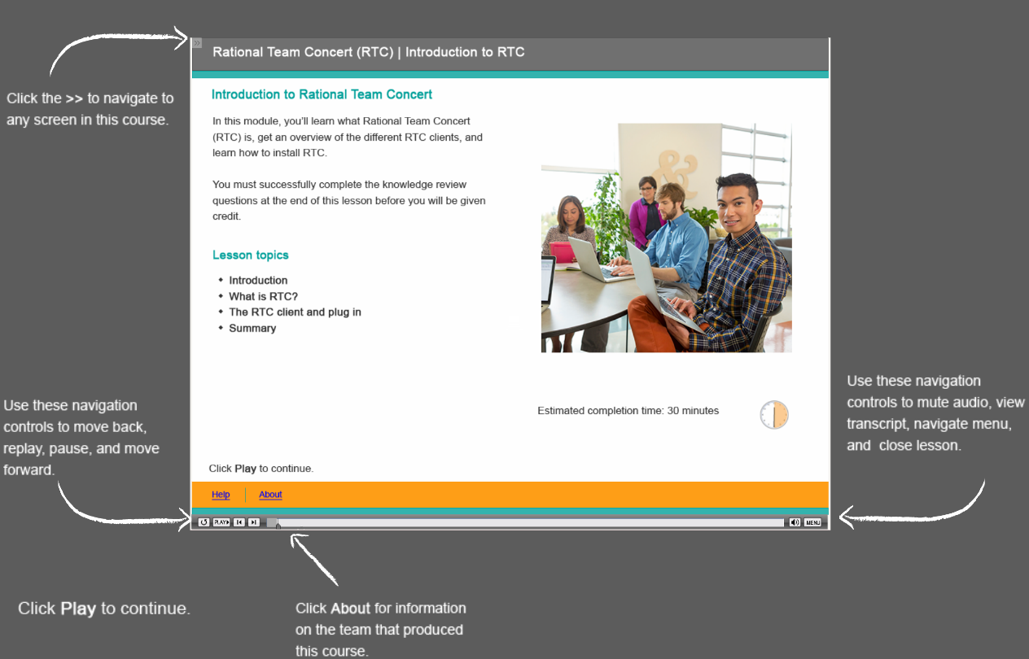

Need to remind people that they are in one of the eclipse development perspectives like the java perspective and not making changes on the file system and they have a text box that reminds them to save the file

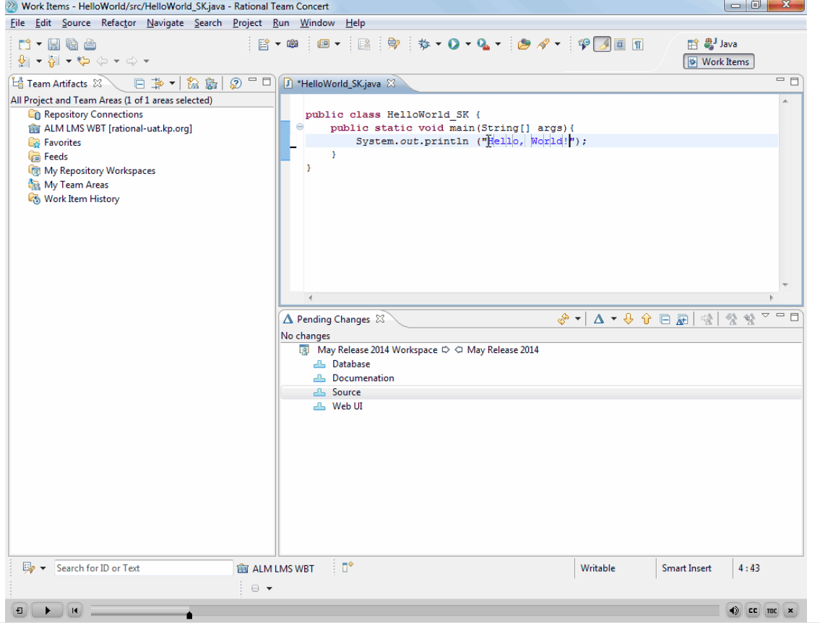

We should put the icon by each change set here.

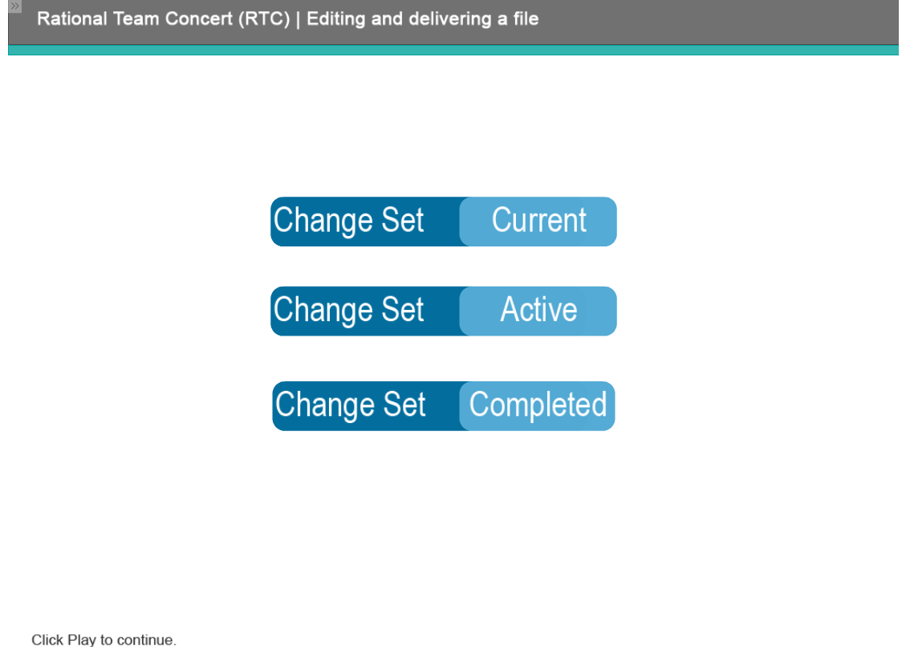

Text Change. “When you don’t want any more changes to be applied to a change set, you can set it Completed. A completed change set is essentially locked down and no further changes can be added”

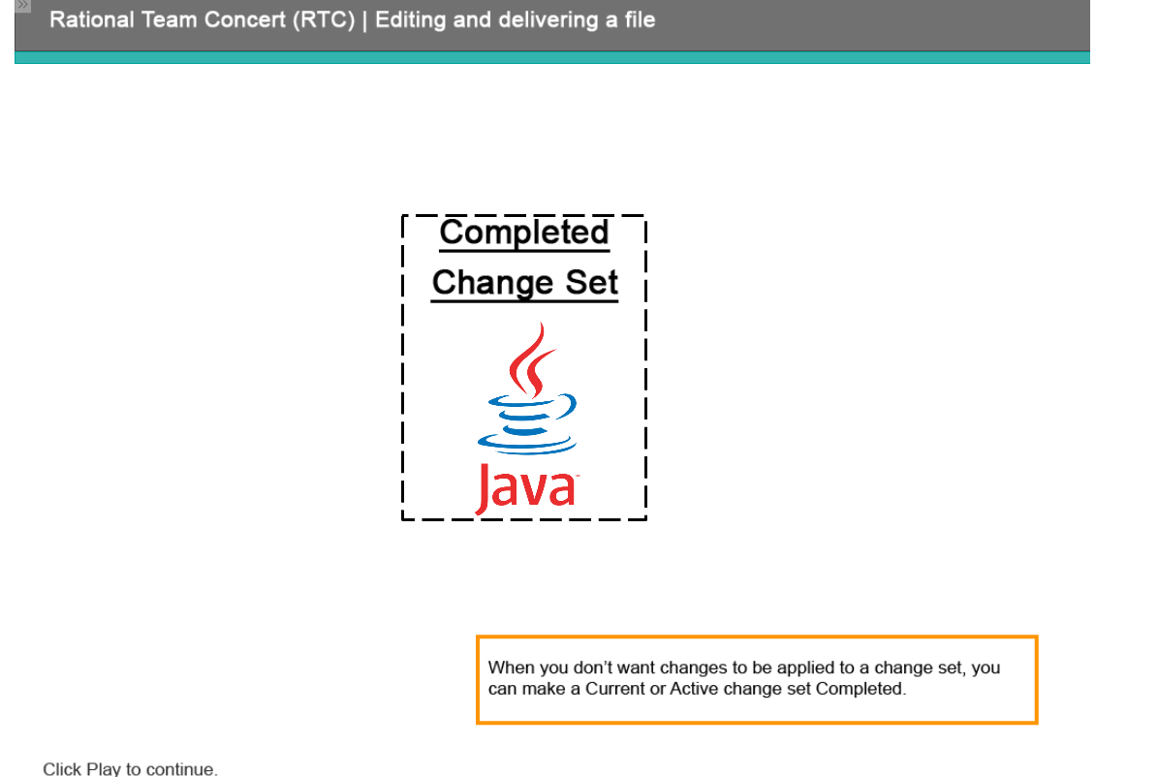

This slides cuts off abruptly. It is the one right after the previous

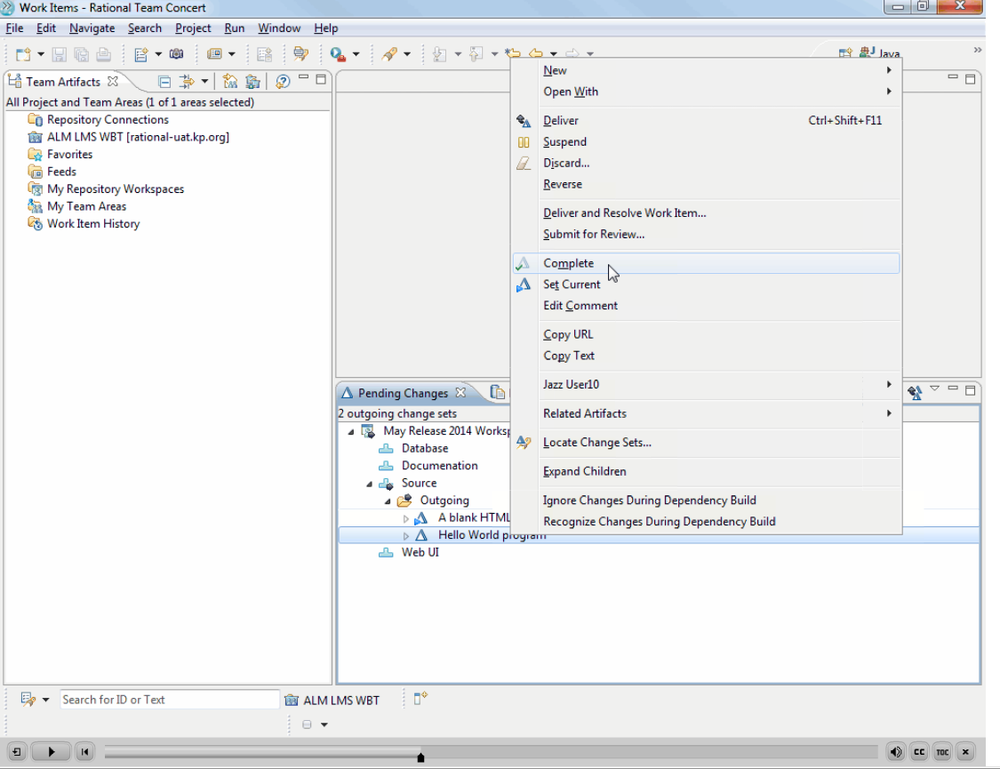

Let’s explain the icons. Each type of change set has an icon

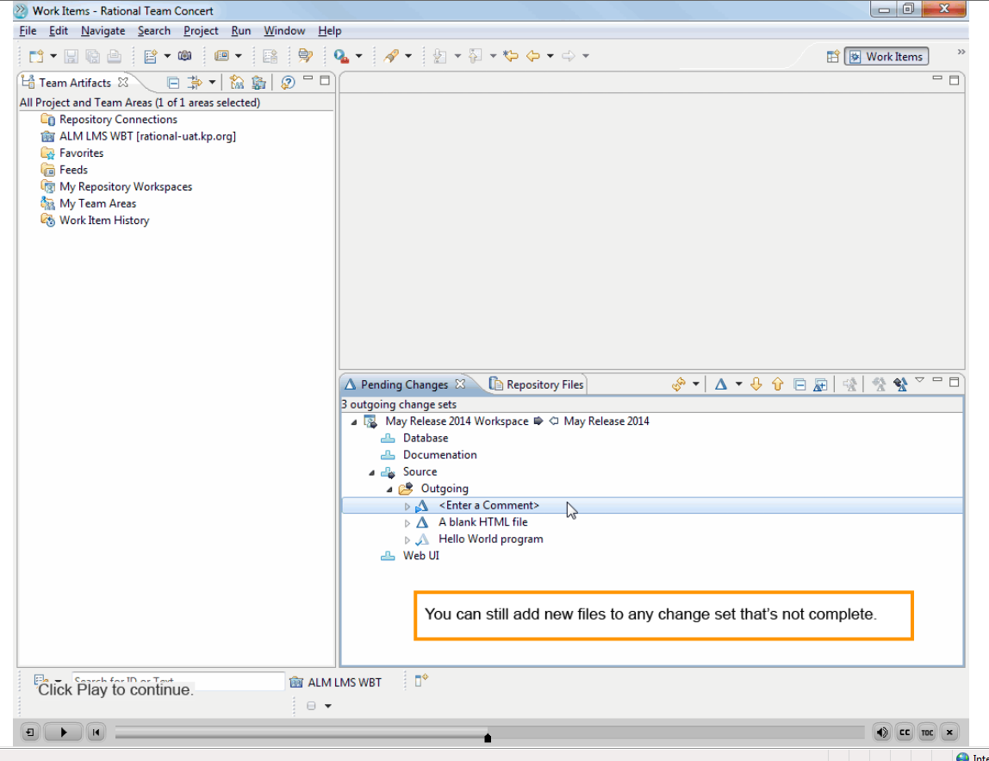

Change Text: Add at the end “as long as it is not a completed change set

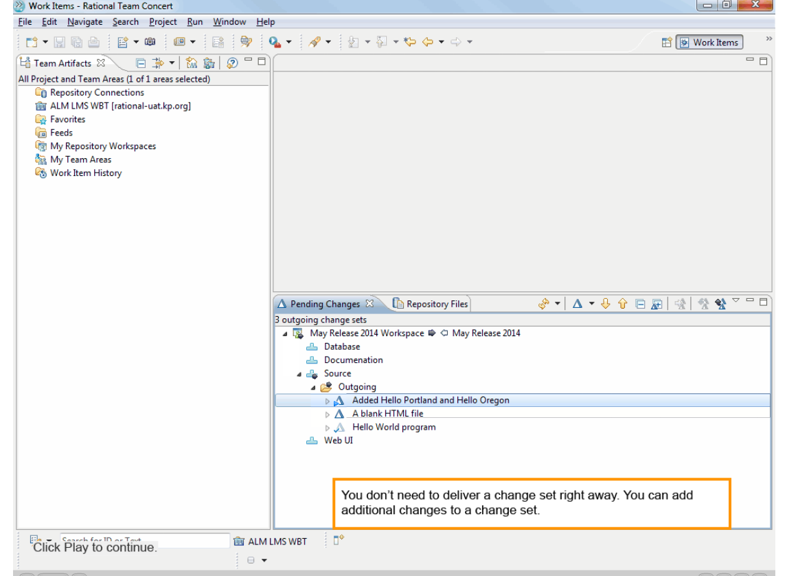

Change text…….that work item can be associated with one or more change sets

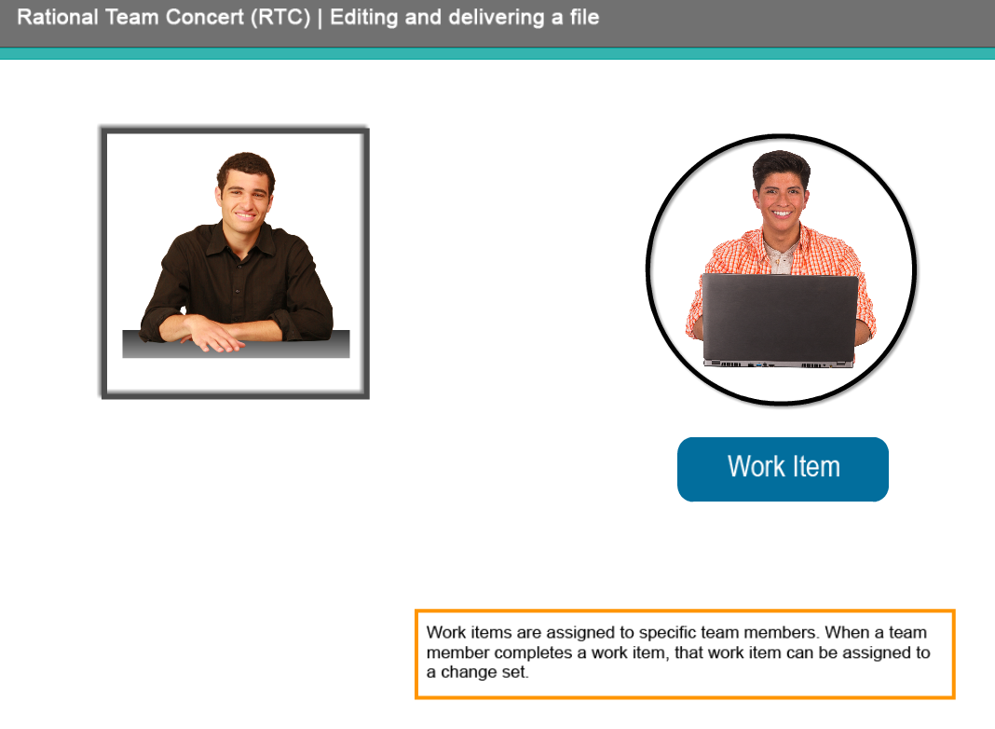

I think it is really important here to show the work item nested under the change set before deliver.

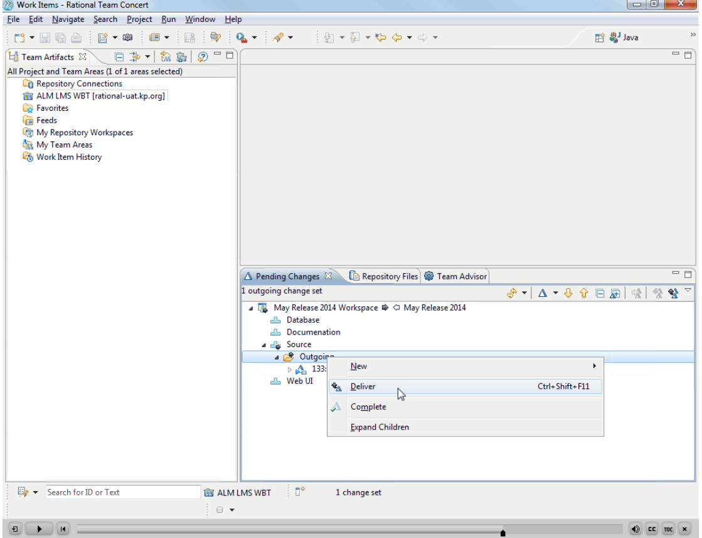

This is incorrect. You have to right click on the component and select show history. We are showing right clicking on a file. So expand the stream, find the component and right click on the component where you will see all change sets.

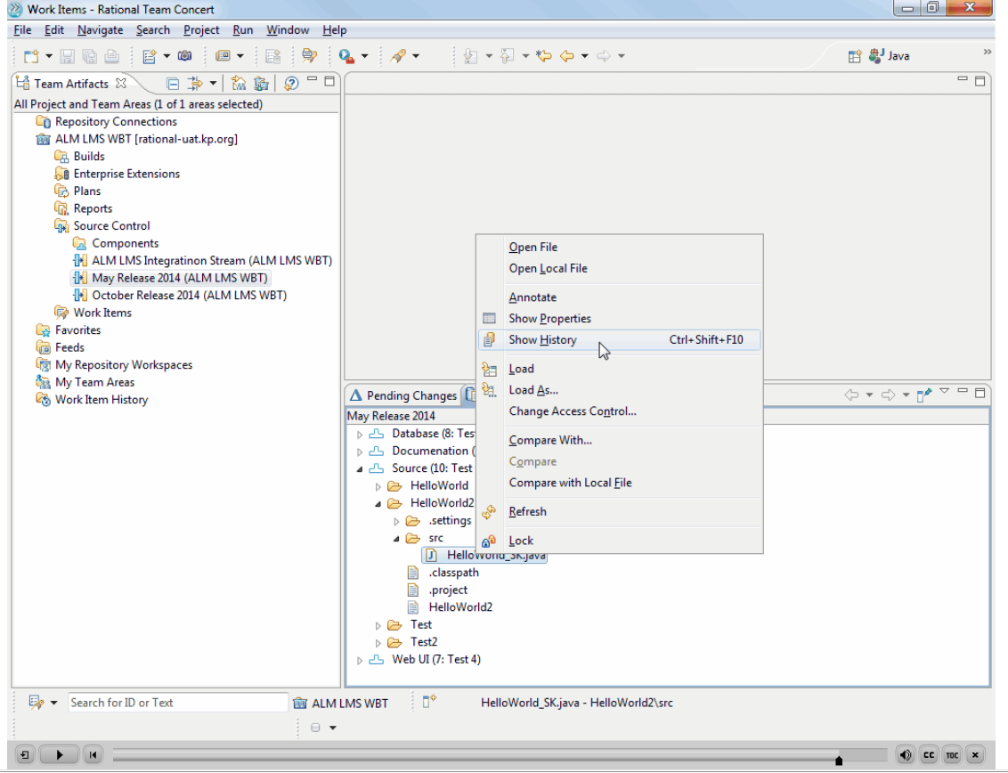

You show the correctly result here but the previous slide didn’t show correctly how to get here

