Move the text box down a little, it is overlapping

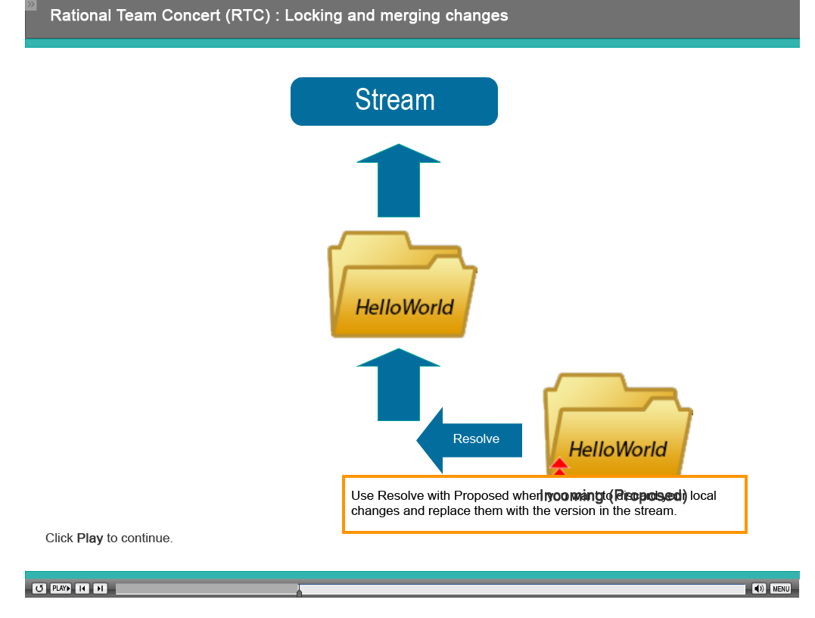

The audio on the next two slides are correct but this not the compare editor, I don’t see the any of the editor options. On the next slide the audio talks about the arrows to move the file from left to right. They are not there, we probably need to go over this. This was in the last version as well

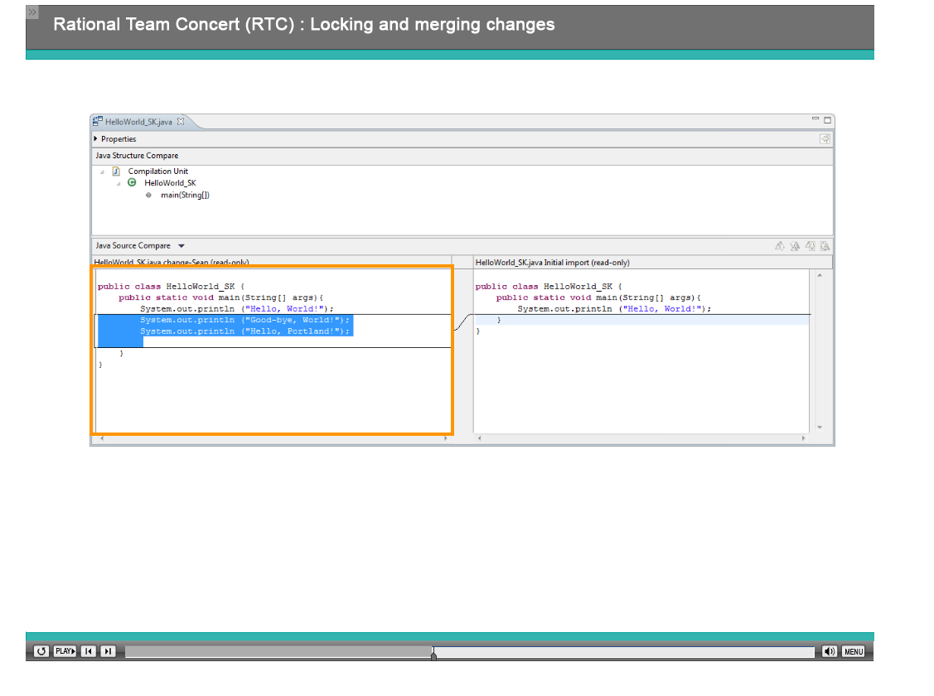

We need to see the arrow to move files from left to right. I don’t see it in the tool so I think you launched something else, we need to show the compare editor and show the arrow being talked about in the audio

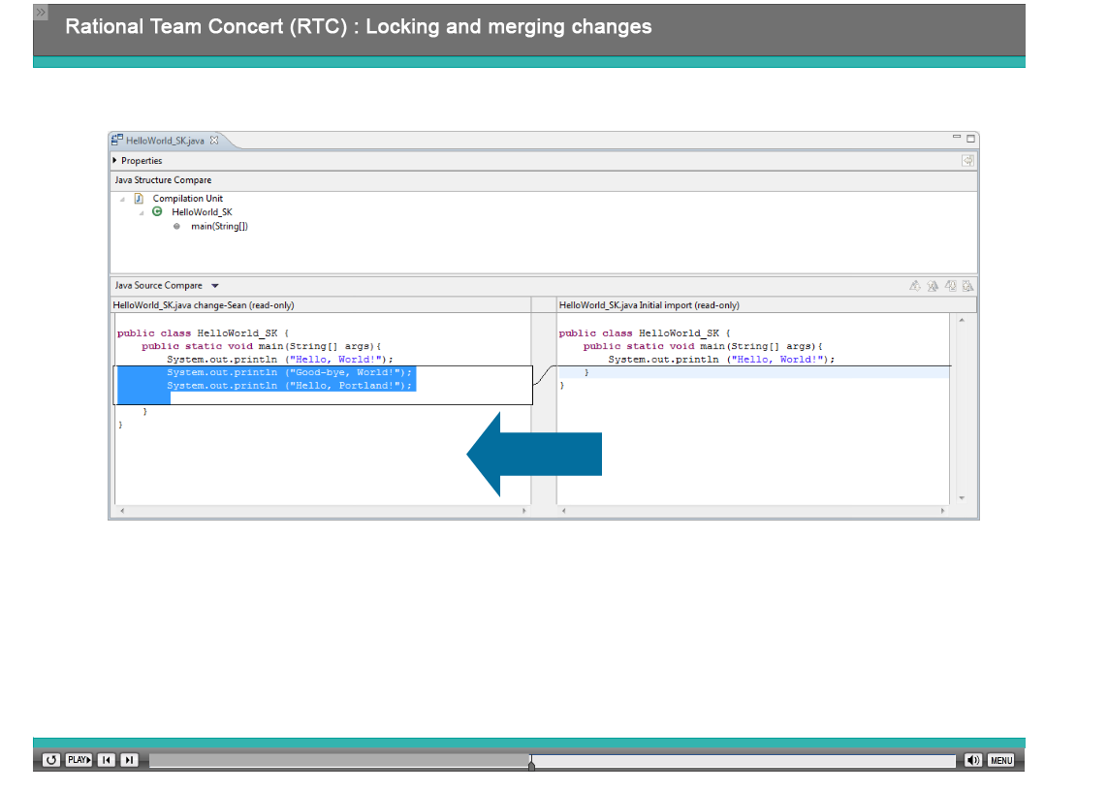

The audio talks about the resolved as merge button. It needs to be shown in the tool.

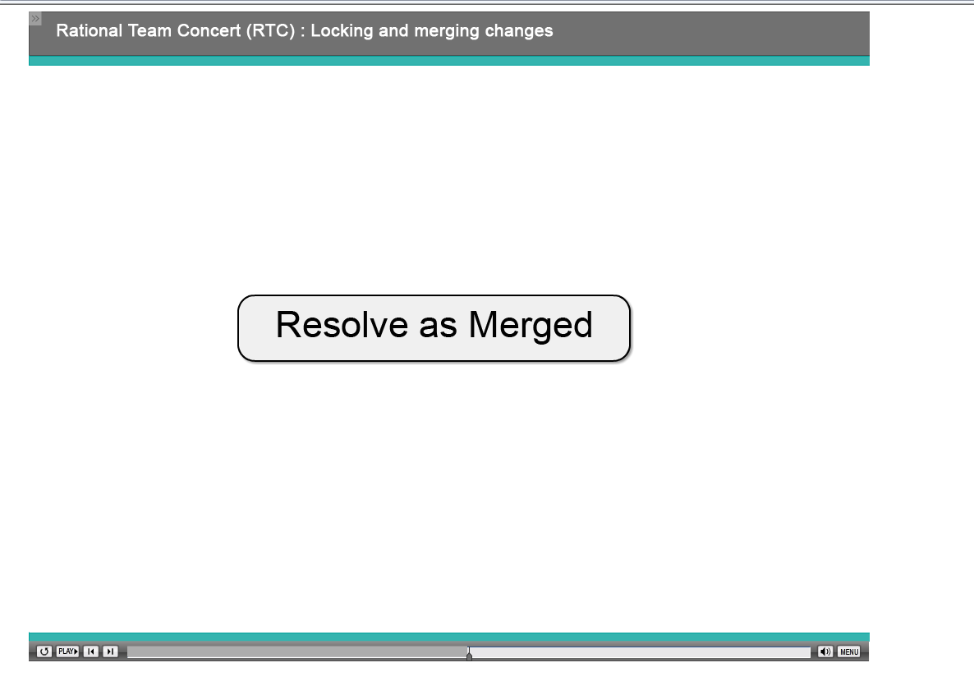

This should be shown in the tool as well.

