Guide to the Software and Programming

Connecting the Debugger

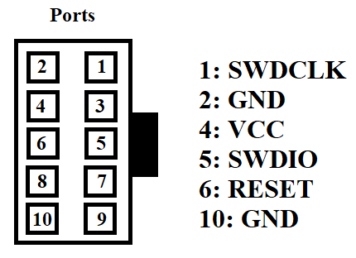

The ATMEL-ICE cable must be plugged into the AVR port of the ATMEL-ICE. Then you must connect ports 1,5, and 6 to the corresponding pins of the device (the three SWD pins), with the other pins being simply grounded or powered. If connected correctly, you can read the device signature via device programming in Microchip Studio.

Notes about the implant software

Symbols must be enabled by going to:

project file->toolchain->ARM/GNU C Compiler-> symbols

miwi_config.h: used mostly to assist with the sleep function, the RFD wakeup interval is set here which partially defines the time spent asleep.

task files: this contains a lot of the program specific configurations, such as the channel selection and periodic transmission.

demo_output: this only affect what is seen in the terminal, can be used for testing

p2p_demo: the bulk of the operational code is in here