Contents

Manager Home Screen (Karan) 2

Request Soft lock Screen 2

Work Force Manager Home Screen (lokesh) 2

Approve Soft lock Screen 3

Manager Home Screen (Karan) 3

Node Implementation 4

ReactJS Implementation 4

### Manager Home Screen (Karan)

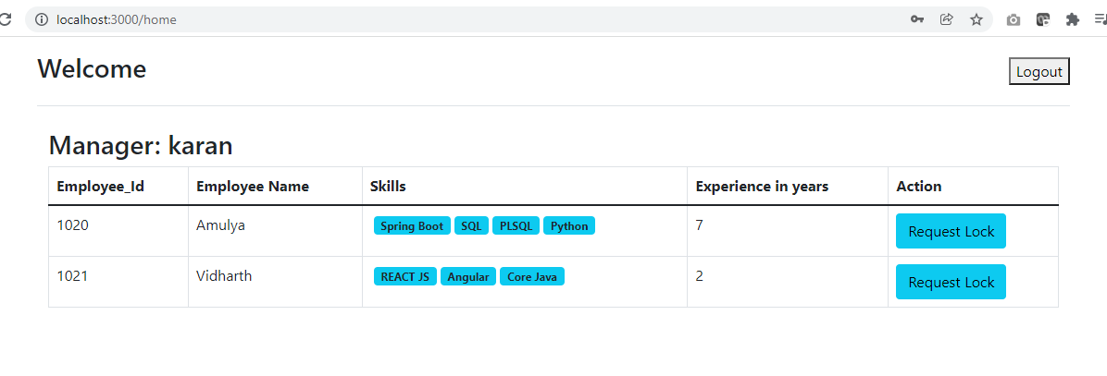

### Request Soft lock Screen

### 

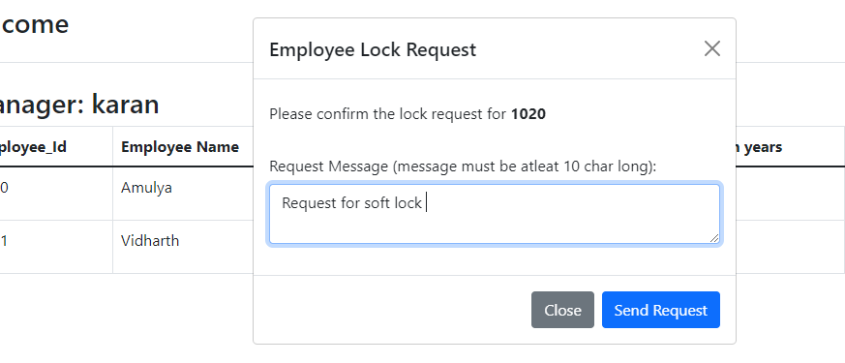

### Work Force Manager Home Screen (lokesh)

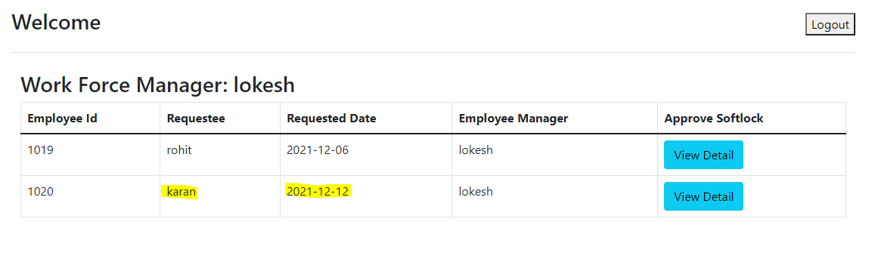

### Approve Soft lock Screen

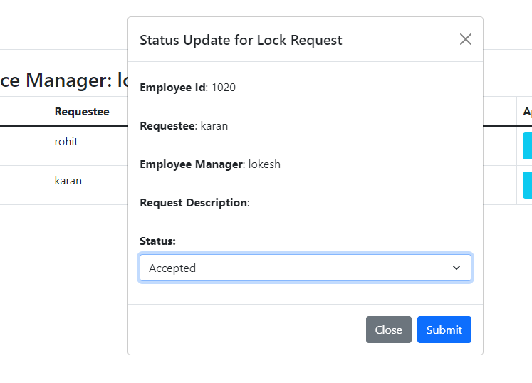

### Manager Home Screen (Karan)

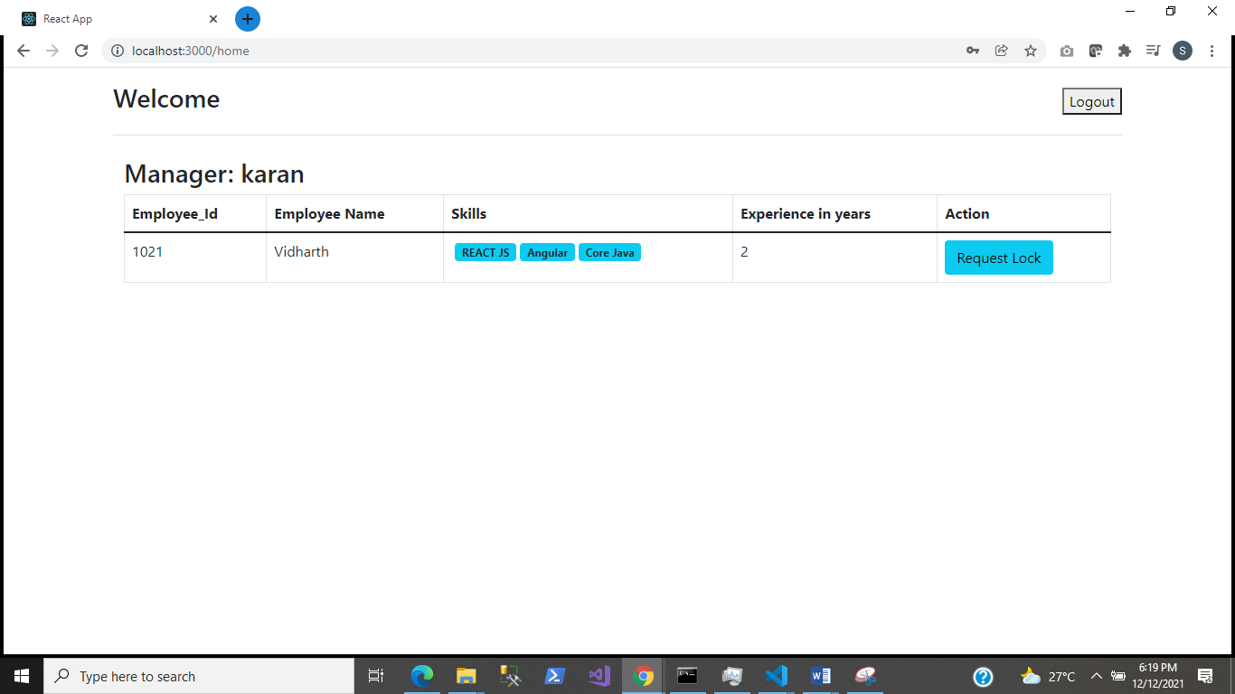

### Node Implementation

#### Manager Login

* Creating API for fetching employees based on the logged in user (manager)
* Creating API for to insert record in the softlock table.

#### Work force Manager Login

* Creating API for getting the list softlock, with ‘waiting’ status for the workflow manager logged in.
* Creating API for updating softlock status and employee status.

### ReactJS Implementation

* Logout Option
* Listing screen for Manager
* Softlock request screen
* Listing screen for Work force Manager
* Approval screen for work force manager