ICS344-03 Project
Saad W.(202337730) and Mohamed K.(202338790)
http://dvsa-website-project-238043187633-us-east-1.s3-website.us-east-1.amazonaws.com/cart
US-EAST-1
12-4-2026
Lesson 2: Broken Authentication

Goal and Vulnerability Summary

This lesson demonstrates an Over-Privileged Function vulnerability caused by excessive IAM permissions assigned to a Lambda execution role in the DVSA application. The affected component is the AWS Lambda execution role associated with the DVSA-SEND-RECEIPT-EMAIL function. The vulnerability allows a compromised function to access AWS resources far beyond its intended purpose, such as S3 buckets and DynamoDB tables. As a result, an attacker who gains execution within the function can perform unauthorized actions across multiple AWS services. The main weakness is that the execution role grants broad permissions that are not required for the function’s actual operation, leading to an increased blast radius in case of compromise.

Why This Works / Root Cause

This vulnerability occurs because the Lambda execution role is configured with excessive permissions instead of following the principle of least privilege. In AWS serverless systems, any code executed within a Lambda function automatically inherits temporary credentials associated with its execution role. These credentials allow the function to perform any action permitted by the role’s policies.

In this case, the role includes permissions such as full S3 access, broad DynamoDB access, and unnecessary SES administrative privileges. However, the function itself only needs limited permissions to send receipt emails. Because of this mismatch, if the function is exploited or misused, the attacker can leverage the role’s permissions to access unrelated resources. The root cause is therefore improper IAM role design and failure to restrict permissions to only those required for the function’s intended behavior.

Environment and Setup

The vulnerability was tested using a deployed DVSA instance running in AWS. The application frontend is hosted on an S3 website endpoint, while backend operations are handled through API Gateway and AWS Lambda functions. The specific function analyzed in this lesson is DVSA-SEND-RECEIPT-EMAIL.
The execution role associated with this function was accessed through the AWS Console under the Lambda configuration tab. The IAM role was then inspected to review its attached policies.
The tools used in this demonstration included:
• AWS Management Console
• IAM Policy Simulator
• AWS CloudTrail
• CloudWatch Logs

Reproduction Steps
The process begins by locating the DVSA-SEND-RECEIPT-EMAIL Lambda function in the AWS Console and navigating to its execution role through the Permissions tab. The attached IAM policies are then reviewed to identify potential over-privilege indicators.

The role includes permissions such as AWSLambdaBasicExecutionRole, AmazonSESFullAccess, and policies granting access to S3 and DynamoDB using wildcard resources. These wildcard permissions indicate that the role can access all buckets and all tables rather than being restricted to DVSA-specific resources.

Next, the IAM Policy Simulator is used to test the role’s permissions. The role is selected, and actions such as s3:GetObject and s3:PutObject are simulated. The results show that both actions are allowed. Similarly, DynamoDB actions including Scan, GetItem, PutItem, and DeleteItem are tested and found to be allowed. This confirms that the role has broad access to AWS resources beyond its intended purpose.

Table 1) IAM Policy Simulator Showing Broad Permissions for S3
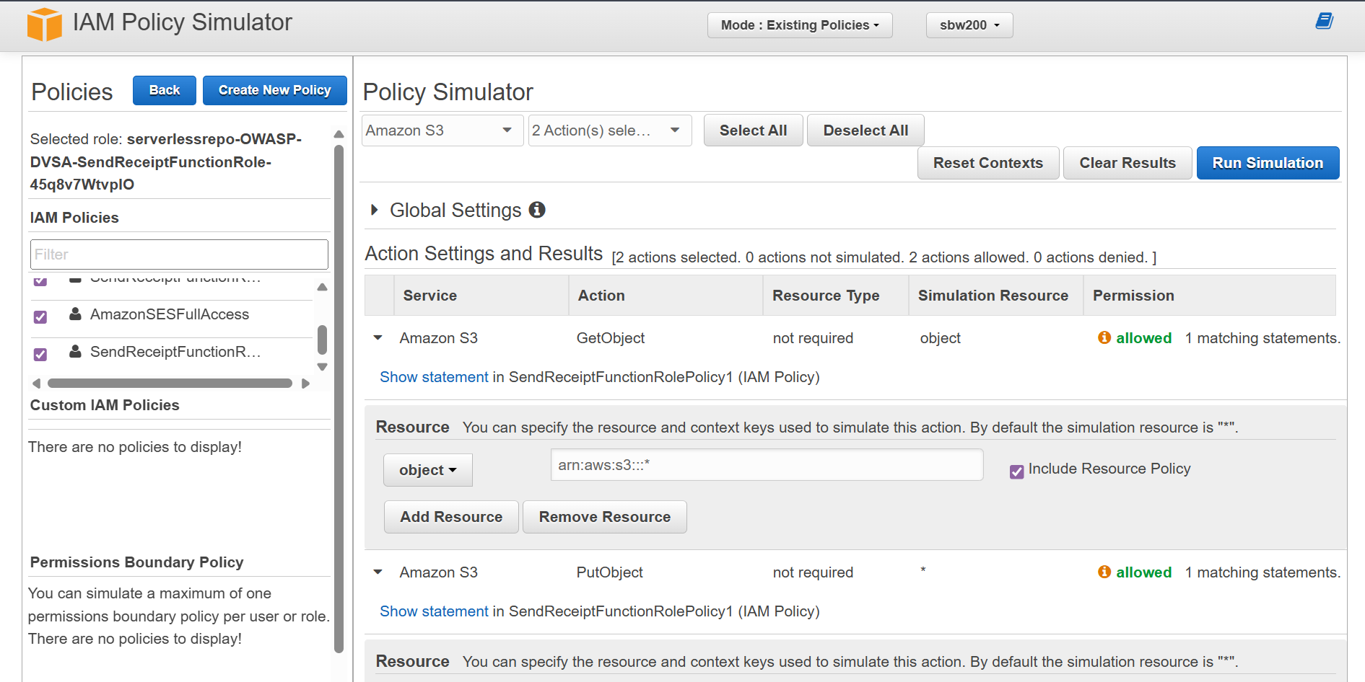

Table 2) IAM Policy Simulator Showing Wide Acess for Scan, GetItem, PutItem, and DeleteItem
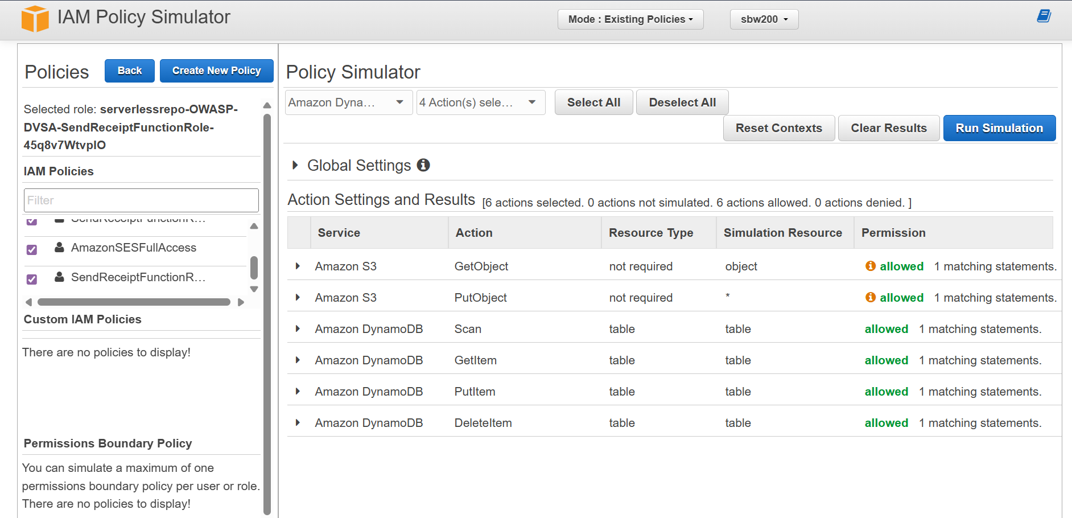

To further validate the hypothesis, CloudTrail is enabled to capture real activity. After triggering the function by placing an order in the DVSA application, a policy is generated based on observed activity. The generated policy reveals that the function only uses a small set of permissions, including CloudWatch Logs, KMS Decrypt, and STS GetCallerIdentity.

Table 3) Generate policy configuration (time range, region, and trail selected)
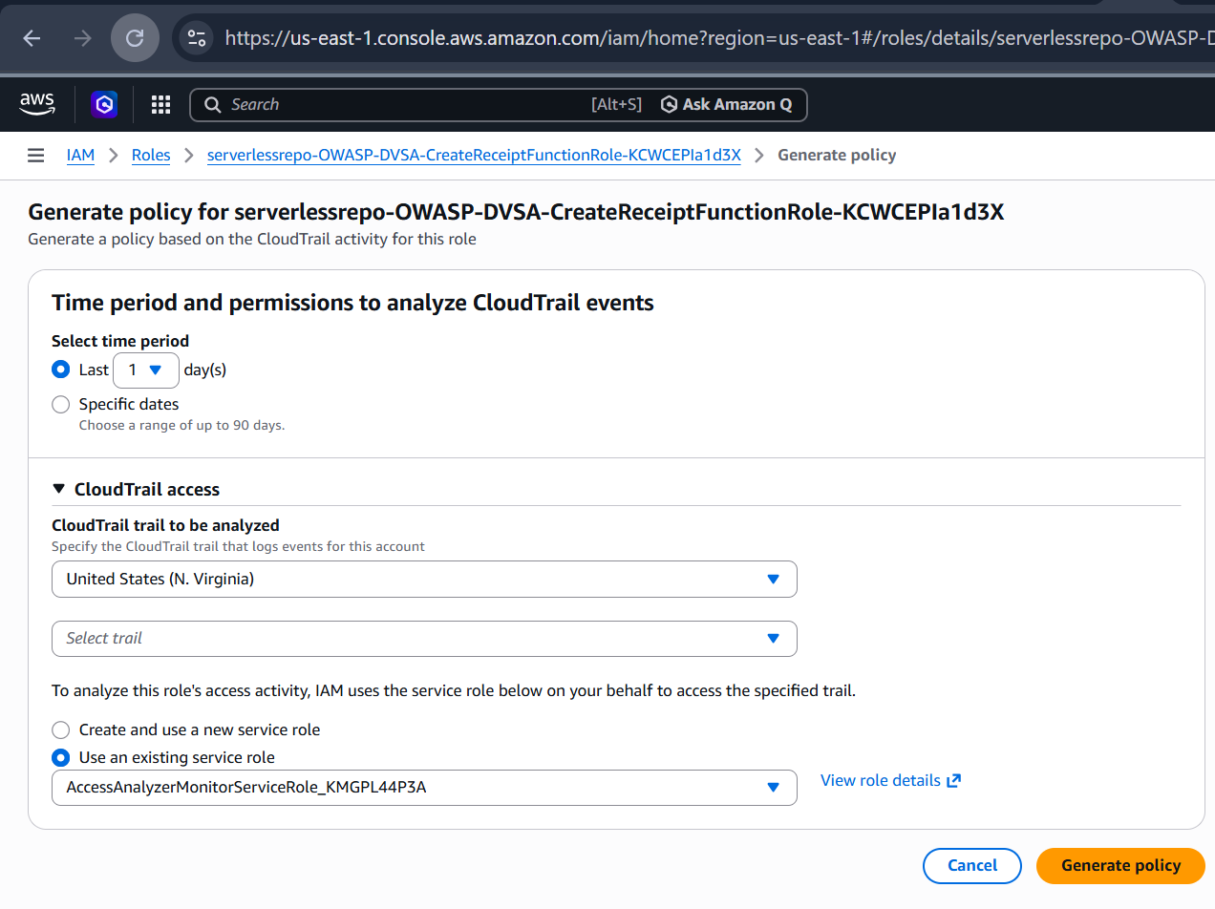

Evidence and Proof

The vulnerability is confirmed by comparing the permissions allowed by the role with the permissions actually used by the function. The IAM Policy Simulator demonstrates that the role allows access to S3 and DynamoDB resources across the account. However, CloudTrail logs show that the function only uses minimal permissions related to logging and identity verification.
This discrepancy proves that the role is over-privileged. The presence of unused permissions significantly increases the attack surface and potential impact if the function is compromised. The key evidence is the mismatch between allowed permissions and observed behavior.

Table 4) Generated policy showing actual permissions used (CloudWatch Logs, KMS Decrypt, STS GetCallerIdentity)
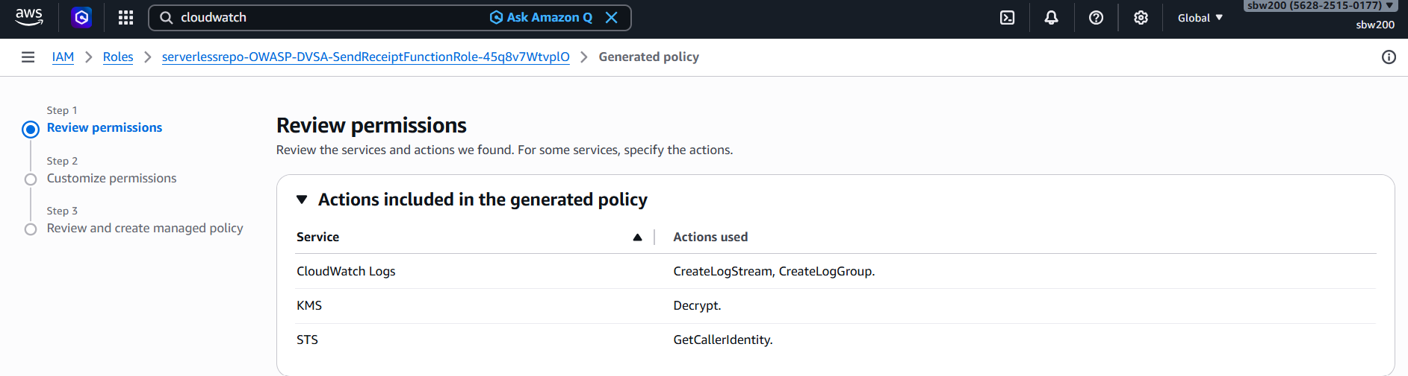

Fix Strategy / Probable Mitigation

The appropriate fix for this vulnerability is to enforce the principle of least privilege when designing IAM roles. The execution role should be restricted to only the actions and resources required for the receipt workflow.

Specifically:
• S3 access should be limited to the DVSA receipts bucket only
• DynamoDB access should be restricted to specific DVSA tables
• SES permissions should be reduced to only email sending actions
• All wildcard resource permissions should be removed
By applying these restrictions, the role will no longer grant unnecessary access to unrelated AWS resources, reducing the blast radius in case of compromise.

Code / Config Changes

To fix the vulnerability, the IAM policies attached to the Lambda execution role were modified. Previously, the role included wildcard permissions such as full S3 and DynamoDB access. These were replaced with resource-specific permissions.
The main changes included:
• Removing wildcard resource permissions
• Restricting access to specific S3 buckets and DynamoDB tables
• Limiting SES permissions to required send actions only
These configuration changes ensure that the Lambda function can perform its intended tasks without exposing unnecessary capabilities.

Verification After Fix

After applying the least-privilege policy changes, the system was tested again to verify that functionality remained intact while reducing risk. The DVSA workflow was executed by placing an order to trigger the receipt function.
The function successfully completed its intended task, confirming that the fix did not break legitimate behavior. Additional tests showed that access to unrelated S3 buckets and DynamoDB tables was no longer permitted, indicating that excess permissions had been removed.
This confirms that the role is now properly restricted and that the vulnerability has been mitigated.

Structured Operation and Security Analysis

1) Intended Logic and Security Rule(s)

Under normal conditions, the Lambda function should only have permissions required to send receipt emails. The execution role should not allow access to unrelated AWS resources.
The main security rules are:
• IAM roles must follow the principle of least privilege
• Functions must only access required resources
• Excess permissions must be avoided

2) Evidence Sources and Behavior Trace

The analysis was based on IAM Policy Simulator results, CloudTrail logs, and AWS Console observations.
The behavior comparison is as follows:
• Normal Behavior:
The function uses only logging, KMS, and identity-related permissions.
• Exploit / Risk Behavior:
The role allows access to S3 and DynamoDB resources that are not required.
• Post-Fix Behavior:
The role is restricted, and unnecessary access is removed.

3) Deviation Analysis and Classification

The deviation occurs because the role grants permissions beyond what is required for the function’s operation. This violates the least privilege principle and allows excessive access to AWS resources.

This case is classified as:
Intentional misuse / security-relevant abuse, since an attacker can exploit over-privileged roles after gaining execution within the function.

4) Explainable Fix and Post-Fix Validation
The incorrect assumption in the system was that broad permissions would not pose a risk. The fix corrects this by restricting permissions to only those required for the function.

The fix was applied at the IAM configuration level. After the fix, testing confirmed that:
• The function still operates correctly
• Unnecessary permissions are removed
• The blast radius is reduced

Table 5) Intended Logic and Behavior Comparison
Vulnerability | Intended Rule(s) | Artifacts Used to Infer Rule | Normal Behavior Evidence | Exploit Behavior Evidence
Over-Privileged Function | Lambda execution roles must follow least privilege and only access required resources | IAM Policy Simulator, CloudTrail logs, AWS Console role policies | Function uses only minimal permissions (logs, KMS, STS) as shown in CloudTrail | Role allows broad access to S3 and DynamoDB as shown in IAM Policy Simulator

Table 6) Security Analysis and Fix
Vulnerability | Why This Is a Deviation | Deviation Class | Fix Applied (Where) | Post-Fix Verification | Optional Latency
Over-Privileged Function | The role grants permissions beyond what is required for the function’s intended behavior, violating least privilege | Intentional misuse / security-relevant abuse | IAM role policy (execution role configuration) | After restricting permissions, the function still works correctly and excess access is removed | N/A

Takeaway / Lessons Learned

This lesson highlights the importance of properly configuring IAM roles in serverless applications. The execution role represents the security boundary of the function, and any compromise of the function results in immediate access to all permissions granted by the role.
Over-privileged roles significantly increase the blast radius of an attack, allowing access to multiple AWS services beyond the function’s intended purpose. This demonstrates that security in cloud environments depends not only on application logic but also on proper access control design.
Applying the principle of least privilege ensures that even if a function is compromised, the attacker’s capabilities remain limited. Proper IAM configuration is therefore essential for maintaining secure serverless systems.

