ICS344-03 Project
Saad W.(202337730) and Mohamed K.(202338790)
http://dvsa-website-project-238043187633-us-east-1.s3-website.us-east-1.amazonaws.com/cart
US-EAST-1
15-4-2026
Lesson 5: Broken Access Control

Goal and Vulnerability Summary

The goal of this exercise was to demonstrate a Broken Access Control vulnerability in the DVSA application by bypassing the normal payment process. The application exposes an API endpoint that processes user actions, including order creation, shipping, and billing.

By exploiting improper access control and unsafe handling of the action parameter, it was possible to invoke an admin-only function (DVSA-ADMIN-UPDATE-ORDERS) and directly modify an order. This allowed the order to be marked as paid without completing the billing process.

Why This Works / Root Cause

The vulnerability exists because the API endpoint handling user actions does not properly restrict access to privileged backend functionality. Specifically:
- The system allows dynamic execution of input provided in the action field.
- The backend function handling requests has permissions to invoke other internal Lambda functions, including admin-only functions.
- There is no proper validation to ensure that only authorized users can trigger privileged operations.

As a result, an attacker can inject a crafted payload into the action field and invoke administrative functionality that should not be accessible through normal API calls.

Environment and Setup
• AWS Cloud environment with DVSA deployed
• API Gateway endpoint for /order
• AWS Lambda functions handling order processing
• DynamoDB table storing order data
• Postman used to send API requests
• Browser Developer Tools used to retrieve the Authorization token

Reproduction Steps
• Send a request to create a new order
• Send a request to add shipping information
• Attempt billing (fails or incomplete)
• Send a crafted request with a malicious action payload
• Observe API response (may return error)
• Verify order state directly in DynamoDB

Evidence and Proof

The following evidence demonstrates the successful exploitation of the Broken Access Control vulnerability:
- Order Creation Request and Response
A valid order was created using the standard API (action: new). The response returned a valid order-id, confirming that the normal workflow was functioning correctly.

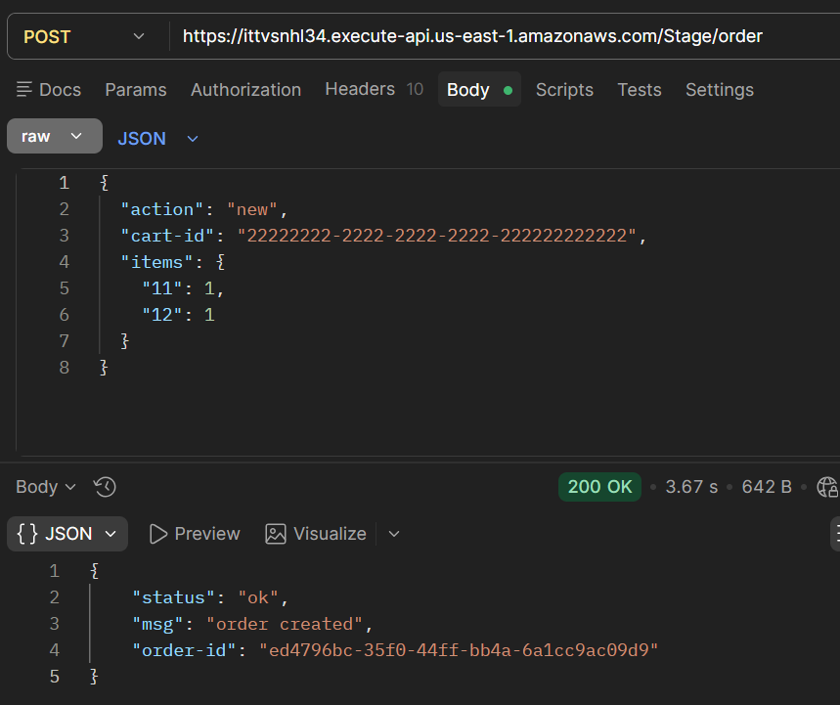
Figure 1) Order Creation

- Shipping Request and Response
Shipping information was successfully added to the order using the shipping action. The response confirmed that the address was updated.

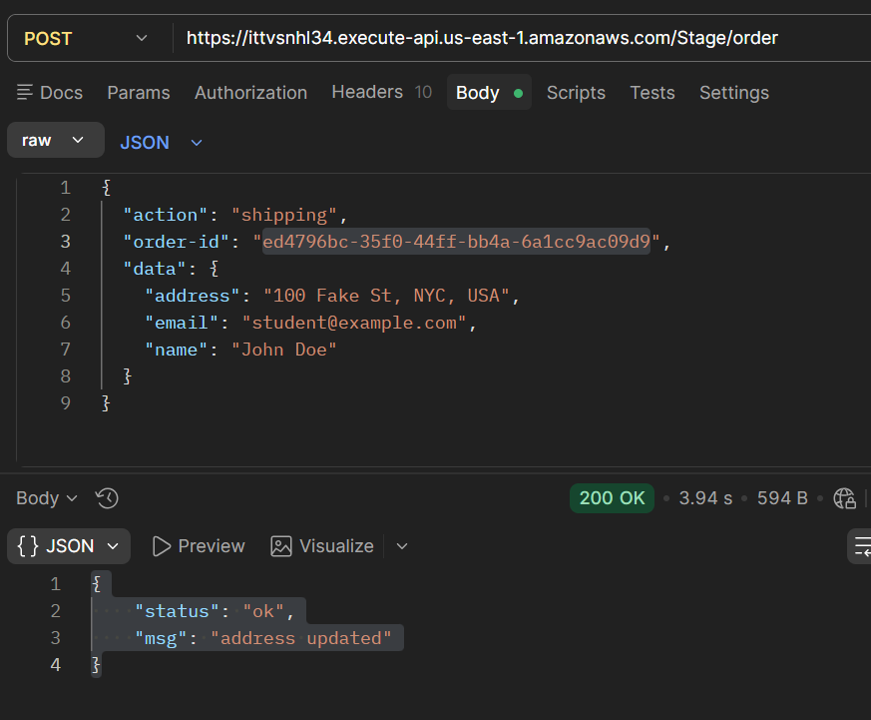
Figure 2) Shipping Request
- Exploit Request and API Response
A crafted request containing a malicious action payload was sent to invoke the hidden admin function. The API returned an "unknown action" error, indicating that the request was not processed through normal logic. However, this does not reflect backend execution.

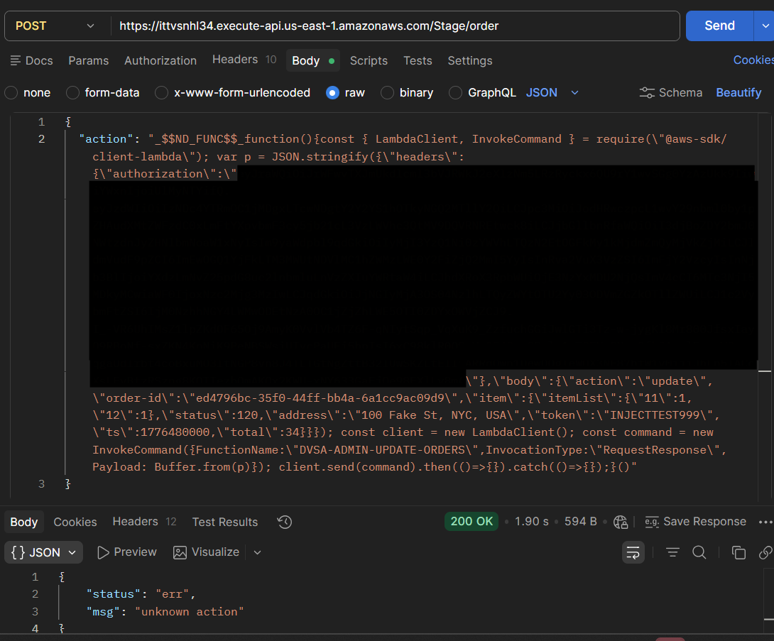
Figure 3) Exploit Request and Response
- DynamoDB Verification (Proof of Exploit)
The DynamoDB table was inspected after the exploit request. The order record showed the following changes:
  - orderStatus updated to 120 (paid)
  - totalAmount updated
  - confirmationToken populated
  - paymentTS set

These changes confirm that the admin function was successfully executed and the order was modified directly, bypassing the normal billing process.

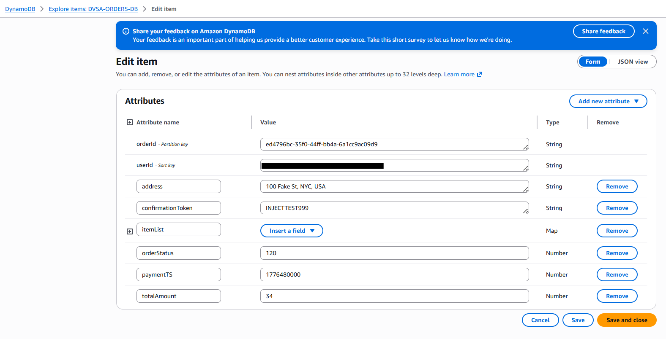
Figure 4) DynamoDB Updated Record

Fix Strategy / Probable Mitigation

The vulnerability can be mitigated by removing unsafe deserialization of user input and enforcing strict access control on backend functions.

The application previously used node-serialize to unserialize the request body, which allowed execution of arbitrary code embedded in the action field. This enabled attackers to inject malicious payloads and invoke internal Lambda functions.

To fix this:
- Unsafe deserialization must be removed and replaced with safe parsing (e.g., JSON.parse)
- The application must treat all user input strictly as data, not executable code
- Access to administrative functions must be restricted so they cannot be invoked from user-controlled inputs
- Proper validation and authorization checks must be enforced before executing any privileged operation

This ensures that user input cannot be used to execute arbitrary code or bypass access controls.

Code / Config Changes

The vulnerable code in the DVSA-ORDER-MANAGER Lambda function was modified.

Original Vulnerable Code:

var req = serialize.unserialize(event.body);
var headers = serialize.unserialize(event.headers);

This allowed execution of injected payloads such as _$$ND_FUNC$$_.

Updated Secure Code:

let req = {};
let headers = {};
try {
req = typeof event.body === "string" ? JSON.parse(event.body) : event.body;
headers = event.headers || {};
} catch (e) {
const response = {
statusCode: 400,
headers: {
"Access-Control-Allow-Origin" : "*"
},
body: JSON.stringify({"status": "err", "msg": "invalid request body"})
};
return callback(null, response);
}

Additional Changes
- Removed the node-serialize dependency
- Ensured only one headers variable is defined
- Added validation for missing authorization headers

These changes prevent execution of injected code and ensure that all request data is treated as plain JSON.

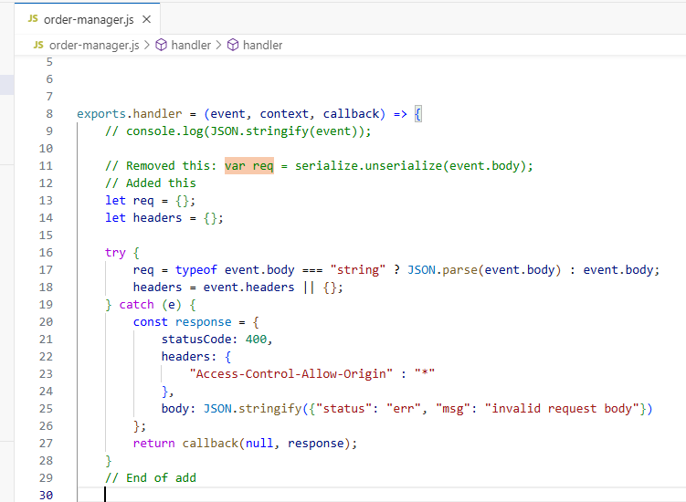
Figure 5) Updated Secure Code

Verification After Fix

After applying the fix, the system was tested to confirm that both normal functionality and security controls were working correctly.
- Normal Functionality Test
- A new order was successfully created using the action: new request
- Shipping information was successfully added using the action: shipping request
- This confirmed that legitimate application functionality was not affected by the fix

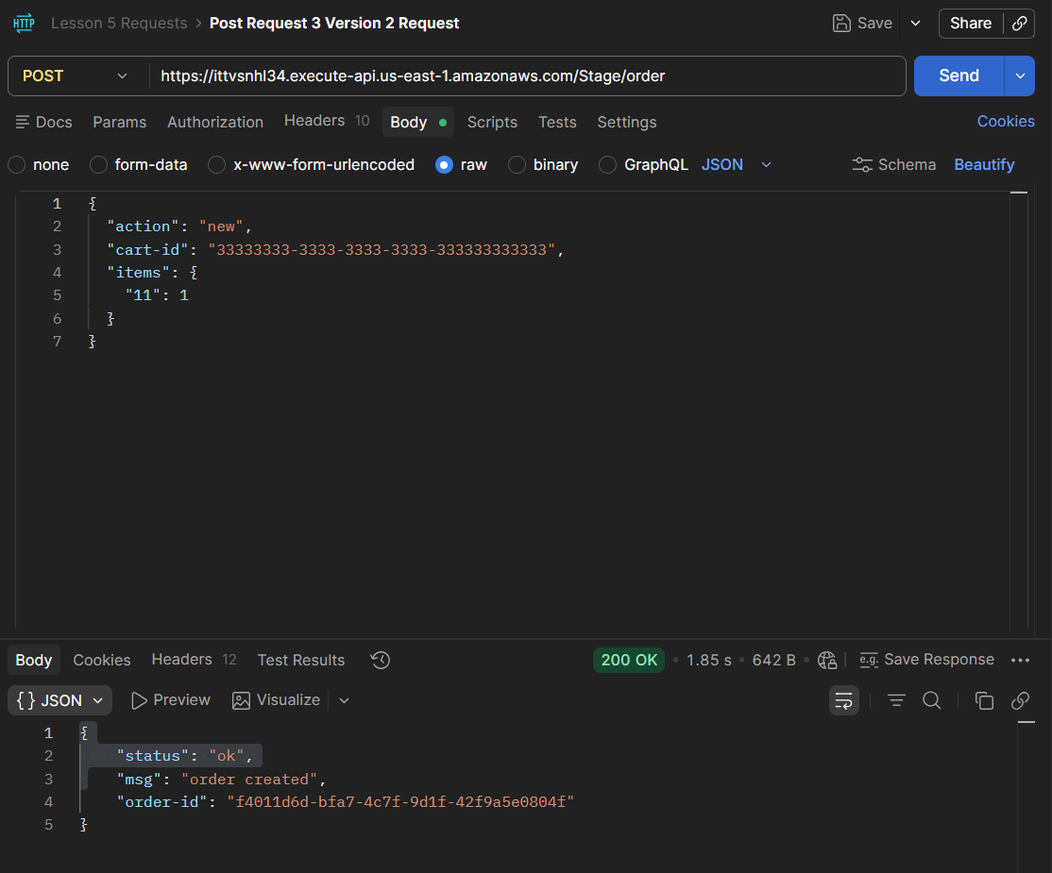
Figure 6) New Order with Updated Code
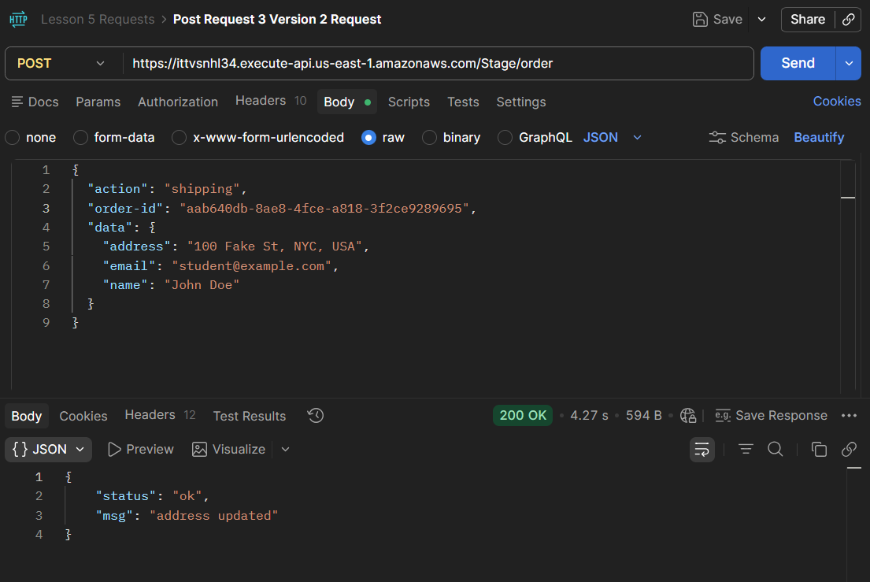
Figure 7) Shipping with Updated Code
- Exploit Replay Test
- The previously used _$$ND_FUNC$$_ exploit payload was sent again with modified marker values
- The API returned an error response and did not execute the injected function

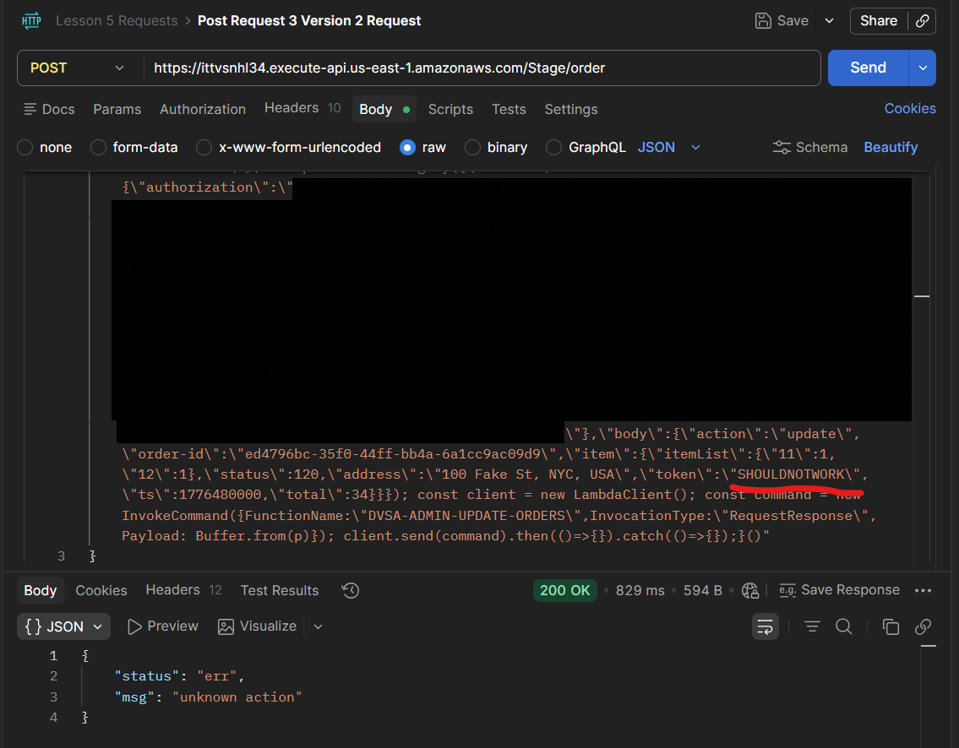
Figure 8) Injection Attempt After Code Fix (Did Not Work)
- DynamoDB Verification
- The corresponding order record in DynamoDB was inspected
- No unauthorized changes were observed:
  - orderStatus remained unchanged
  - confirmationToken was not modified
  - totalAmount was not altered

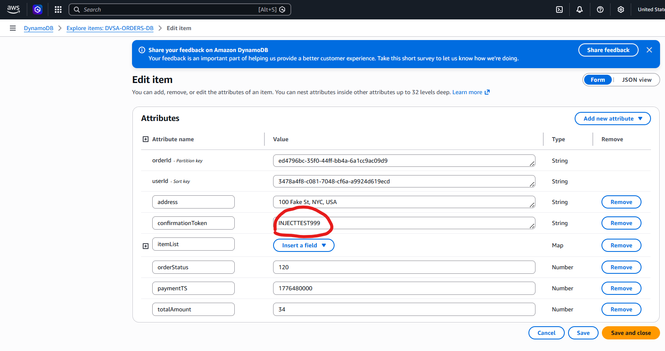
Figure 9) Unchanged DynamoDB Details Proving Injection Request Did Not Work

This confirms that the exploit is no longer effective and that arbitrary code execution through the action field has been successfully prevented.

Structured Operation and Security Analysis

The DVSA application follows a serverless architecture where API Gateway routes incoming requests to a central Lambda function (DVSA-ORDER-MANAGER). This function processes user input and dispatches requests to other backend Lambda functions based on the action field.

Previously, the system used unsafe deserialization (node-serialize) on user-controlled input. This violated trust boundaries by allowing user input to be interpreted as executable code within the Lambda environment.

Because the DVSA-ORDER-MANAGER function has permission to invoke other Lambda functions, including administrative ones, this resulted in a privilege escalation path:
- User input → code execution → internal Lambda invocation → database modification

This demonstrates a combination of:
- Insecure Deserialization
- Broken Access Control
- Privilege Escalation

After the fix, the application enforces proper data handling and ensures that user input is not executed. This restores the intended trust boundary and prevents unauthorized access to internal services.

Takeaway / Lessons Learned

This exercise demonstrates how insecure handling of user input can lead to critical vulnerabilities such as remote code execution and Broken Access Control.

Key lessons include:
- User input must never be executed or deserialized using unsafe methods
- Administrative functionality must be strictly protected and never exposed through indirect paths
- Access control must be enforced at every layer, not just at the API surface
- Serverless architectures require careful permission management, as functions often have broad access to internal services

Overall, the vulnerability highlights how a single insecure coding practice can compromise the entire system and allow attackers to bypass critical security controls such as payment processing.

